Mirai组建教程

今天交到家如何来组建mirai，首先需要准备debian

国内要把apt-get 源换了

#vi /etc/apt/sources.list

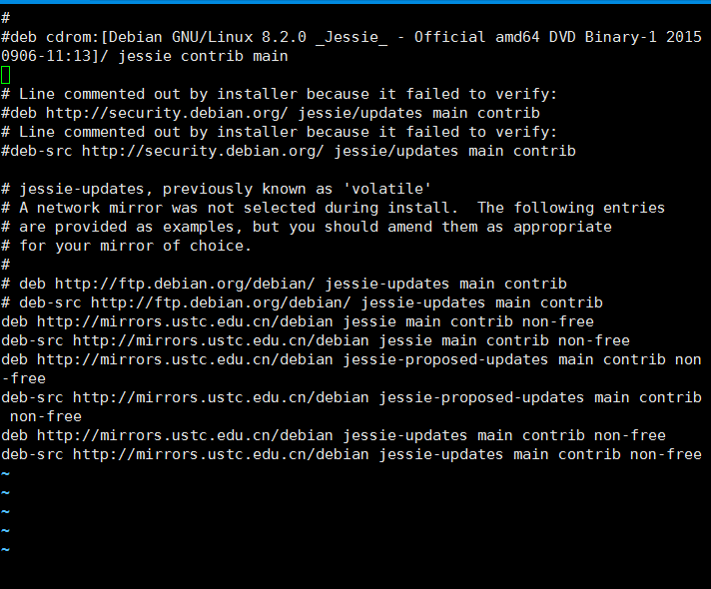

deb http://mirrors.163.com/debian/ stable main

deb-src http://mirrors.163.com/debian/ stable main

## 安装

#apt-get install gcc golang electric-fence git mysql-server mysql-client

## MDZZ

#mkdir /etc/xcompile

#cd /etc/xcompile

#wget <https://www.uclibc.org/downloads/binaries/0.9.30.1/cross-compiler-armv4l.tar.bz2>

#wget https://www.uclibc.org/downloads/binaries/0.9.30.1/cross-compiler-armv5l.tar.bz2

#wget https://www.uclibc.org/downloads/binaries/0.9.30.1/cross-compiler-i586.tar.bz2

#wget https://www.uclibc.org/downloads/binaries/0.9.30.1/cross-compiler-m68k.tar.bz2

#wget https://www.uclibc.org/downloads/binaries/0.9.30.1/cross-compiler-mips.tar.bz2

#wget https://www.uclibc.org/downloads/binaries/0.9.30.1/cross-compiler-mipsel.tar.bz2

#wget https://www.uclibc.org/downloads/binaries/0.9.30.1/cross-compiler-powerpc.tar.bz2

#wget https://www.uclibc.org/downloads/binaries/0.9.30.1/cross-compiler-sh4.tar.bz2

#wget <https://www.uclibc.org/downloads/binaries/0.9.30.1/cross-compiler-sparc.tar.bz2>

#tar -jxf cross-compiler-armv4l.tar.bz2

#tar -jxf cross-compiler-i586.tar.bz2

#tar -jxf cross-compiler-m68k.tar.bz2

#tar -jxf cross-compiler-mips.tar.bz2

#tar -jxf cross-compiler-mipsel.tar.bz2

#tar -jxf cross-compiler-powerpc.tar.bz2

#tar -jxf cross-compiler-sh4.tar.bz2

#tar -jxf cross-compiler-sparc.tar.bz2

## 嘿嘿

或者使用# find -maxdepth 1 -name "*.bz2"|xargs -i tar xvjf {}

## 换个名字

mv cross-compiler-armv4l armv4l

mv cross-compiler-armv5l armv5l

mv cross-compiler-i586 i586

mv cross-compiler-m68k m68k

mv cross-compiler-mips mips

mv cross-compiler-mipsel mipsel

mv cross-compiler-powerpc powerpc

mv cross-compiler-sh4 sh4

mv cross-compiler-sparc sparc

## 加个环境

export PATH=$PATH:/etc/xcompile/armv4l/bin

export PATH=$PATH:/etc/xcompile/armv6l/bin

export PATH=$PATH:/etc/xcompile/i586/bin

export PATH=$PATH:/etc/xcompile/m68k/bin

export PATH=$PATH:/etc/xcompile/mips/bin

export PATH=$PATH:/etc/xcompile/mipsel/bin

export PATH=$PATH:/etc/xcompile/powerpc/bin

export PATH=$PATH:/etc/xcompile/powerpc-440fp/bin

export PATH=$PATH:/etc/xcompile/sh4/bin

export PATH=$PATH:/etc/xcompile/sparc/bin

## 这一步最重要

#shutdown –h now

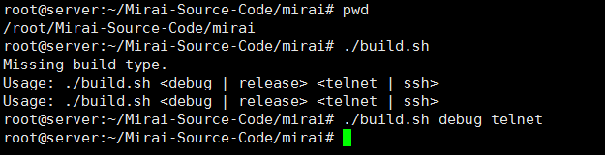

到这里mirai就组建完毕了，如果有不会的问题就发邮件admin@ddos.date