We learn from the course that “encapsulation” is used frequently in networking. In this project, we will emulate TCP sender and receiver in the application layer and call UDP protocol to transmit TCP packets. That is, TCP packets will be encapsulated and sent in the UDP layer by the source and decapsulated in the receiver. In this project, both directions need to be implemented.
The TAs will tell you how to test your program. That is, TAs will write clients to test your server and server to test your clients. Therefore, it becomes very important to follow TAs’ formats so your program can be tested. The TCP segment structure is as enclosed and you must follow the segment format and implement at least the following fields: source port, destination port, sequence number, acknowledgment number, and checksum for primitive TCP, TCP Tahoe, TCP Reno, and TCP SACK. The state diagram is shown on the last page of the project. Additionally, The round trip delay is first set to be 15 ms for each connection. The variable threshold is initially set to 64 Kbytes. The MSS is 1 Kbytes. The TCP buffer size is assumed to have a buffer size of 512 Kbytes. The maximum transmission rate for each TCP connection from the server-side to the client-side is assumed to be 10 Mbps. The TAs will provide you with four video files whose sizes range between one Mbytes to 100 Mbytes.
- The server performs DNS functions for the clients. The server also performs mathematical calculations including power and square root, and provides some video files for clients to retrieve.
- A client can request multiple jobs of different kinds within each request. The clients will display the results from the server for DNS, and mathematical equations and play received video files using a video player on the screen.
Step 1: First, you would write one server and one client, and the server and client can both transmit packets and ACKs. The server must be able to handle multiple requests from the client. The client would randomly request different kinds of jobs.
Step 2: The clients are increased to two clients. The server side has to implement some prevention mechanisms to handle simultaneous requests from clients. Since the parent process has to have a method to handle input requests, the parent process can fork some child processes responsible for various input requests from different clients.
Step 3: The clients begin to request various services from the server and display results on the screen.
Step 4: Channels may have losses. That is to say, both data and ACKs are subject to losses. You would begin to introduce losses for packets sent by the server or clients. For simplicity, we implement packet loss rates instead of channel lost rates. The packet error rate is set to have a random distribution with a mean of 10⁻⁶. For each generated packet, we first decide if it is lost. If we determine the packet to be a lost packet, we deliberately insert the wrong checksum in the checksum field of the packet.
Step 5: Delayed ACKs are added to senders and receivers.
Step 6: The TCP congestion control consists of the slow start and the congestion avoidance mechanisms. In step 4, you implement the slow start mechanism and the congestion avoidance mechanism.
Step 7: The fast retransmit mechanism is added (Tahoe).
For the moment, there are still only two states, slow start state, and congestion avoidance state. However, the fast retransmit mechanism is already included in TCP Tahoe. For TCP Tahoe, when a loss happens, fast retransmit is triggered and the slow start state is entered. Only for this step and the next step, to trigger the fast retransmit you would gradually increase the packet loss rates until fast transmit is triggered.
Step 8: The fast recovery mechanism is added (TCP Reno). It would be a plus if both cases of returning to slow start state and returning to congestion avoidance state are demonstrated. Please draw the changes of window sizes vs. time on the screen during the connections or after connections.
Step 9: Now increase the number of clients to 100.
Step 10: DHCP functions are added to the server. We just need three clients in this step. (This step is a bonus. If you finish this step, you will get 20 points.)

The program consists of nine subprojects.
- A server and a client. (10)
- Two clients. (10)
- Displaying requested results on the screen. (10)
- Losses added. (10)
- Delayed ACKs. (10)
- TCP slow start and TCP congestion avoidance. (20)
- TCP with fast retransmit (TCP Tahoe). (10)
- TCP with fast retransmit and fast recovery (TCP Reno). (10)
- Increase the number of clients to 100. (10)
- DHCP functions (only three clients) (20)

Due: June 12, 2021
References:
The first five papers are suggested for understanding the mechanisms. The last three papers are for additional readings. They are listed below. The last two references are about the relationship between bandwidth x delay and TCP receiver window size.
[1] F. M. Allman, V. Paxson, and W. Stevens, “TCP congestion control,” RFC 2581, Apr. 19999, http://www.rfc-editor.org/rfc/rfc2581.txt.
[2] S. Floyd and T. Henderson, “The New Reno Modification to TCP’s Fast Recovery Algorithm,” RFC 2582, Apr 1999, http://www.rfc-editor.org/rfc/rfc2582.txt.
[3] M. Mathis, J. Mahdavi, S. Floyd, and A. Romanow, “TCP selective acknowledge options, RFC 2018,” Oct. 1996, http://www.rfc-editor.org/rfc/rfc2018.txt.
[4] V. Jacobson and R, Braden, “TCP extensions for long-delay paths,” RFC 1072, http://www.rfc-editor.org/rfc/rfc1072.txt.
[5] J. F. Kurose and K. W. Ross, Computer Networking: A Top-Down Approach Featuring the Internet, sixth edition, Addison Wesley, Reading, 2012
[6] K. Fall and S. Floyd, Simulation-based Comparisons of Tahoe, Reno, and SACK TCP, Computer Communication Review, vol. 26, No. 3, July 1996.
[7] S. Floyd, “A report on some recent developments in TCP congestion control,” IEEE Communications Magazine, Apr 2001, http://www.aciri.org/floyd/papers/report_Jan01.pdf.
[8] W. R. Stevens, TCP/IP Illustrated vol. 1: The Protocols, Addison-Wesley, Reading, MA, 1994. (Due: Dec 17, 2007)
[9] http://speedtest.raketforskning.com/tuning-tcp-window-size.html
[10] http://en.wikipedia.org/wiki/TCP_tuning

PS. The TA will tell you how to test your program.
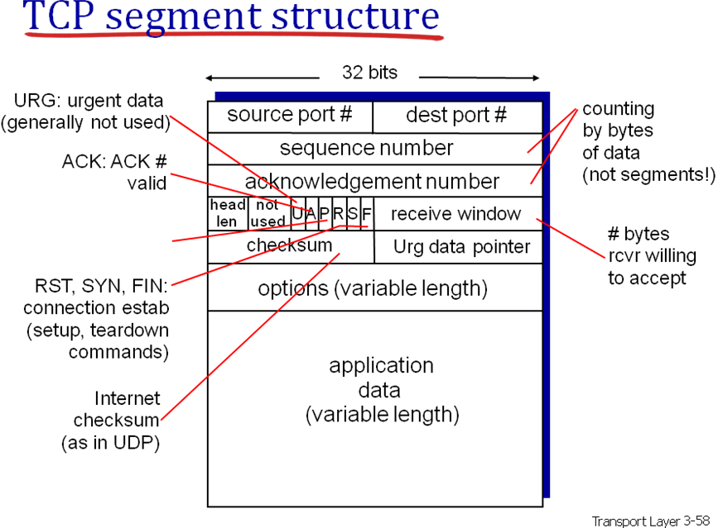

Transport layer 3- 70, 3-104

