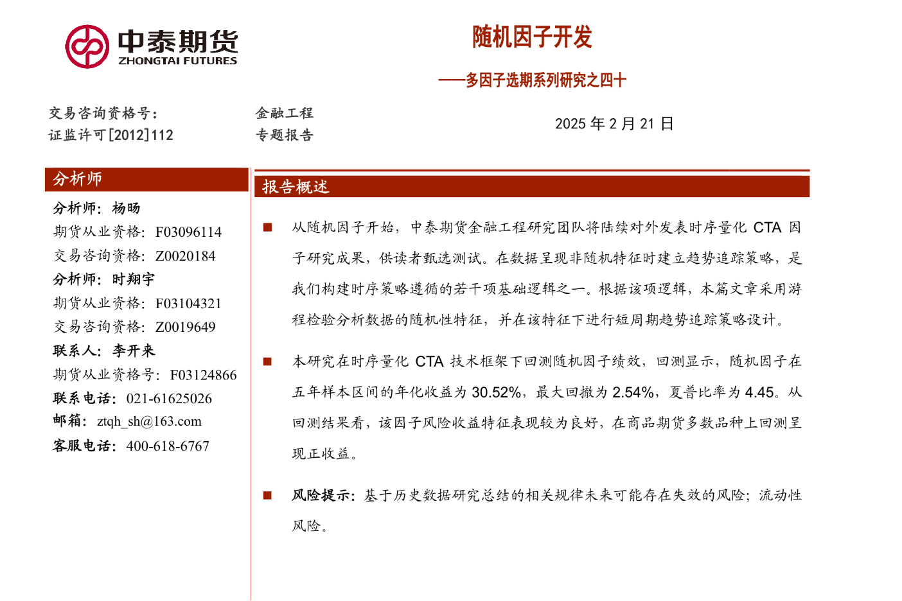
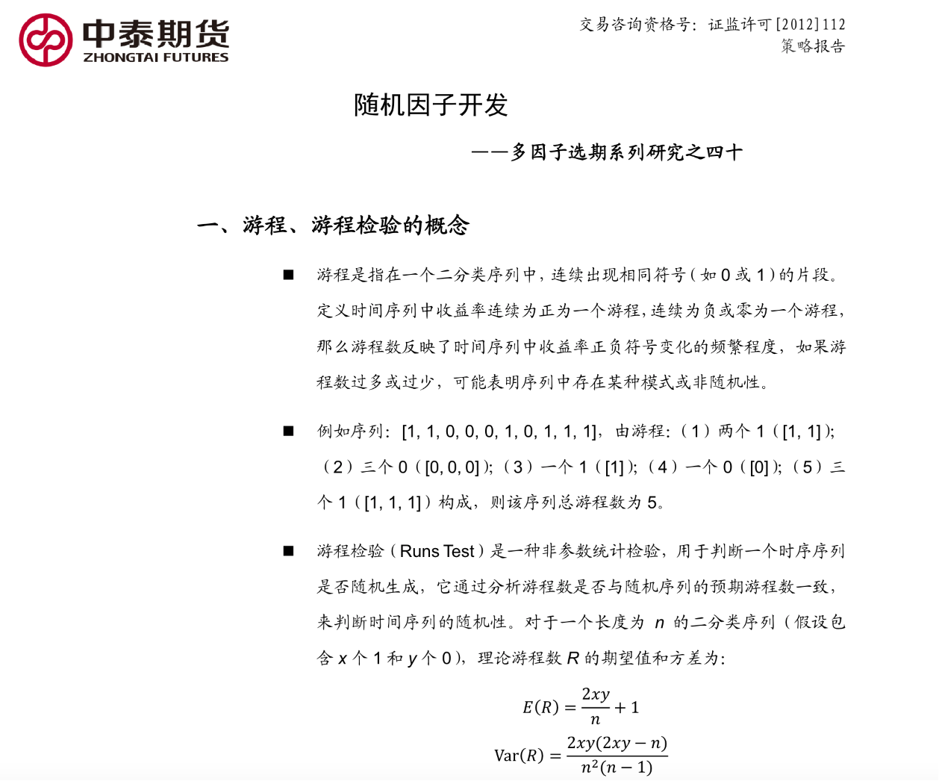

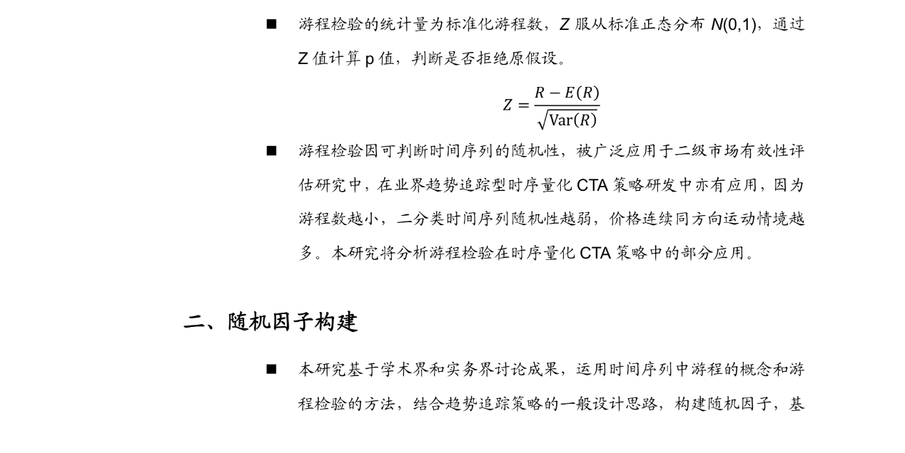
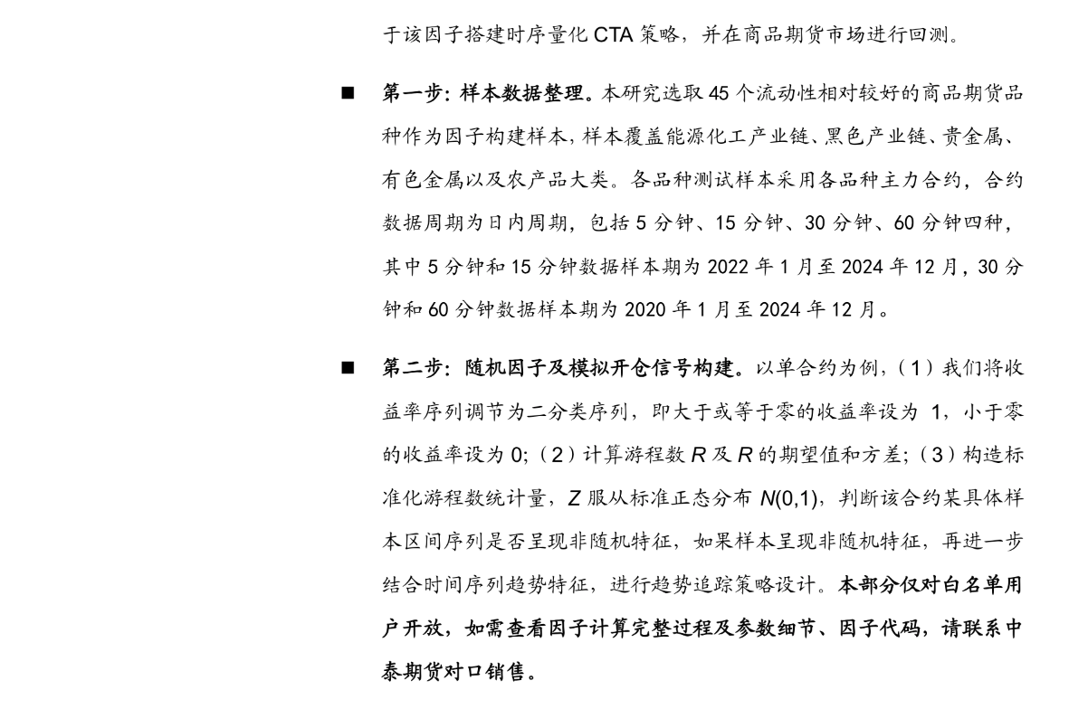
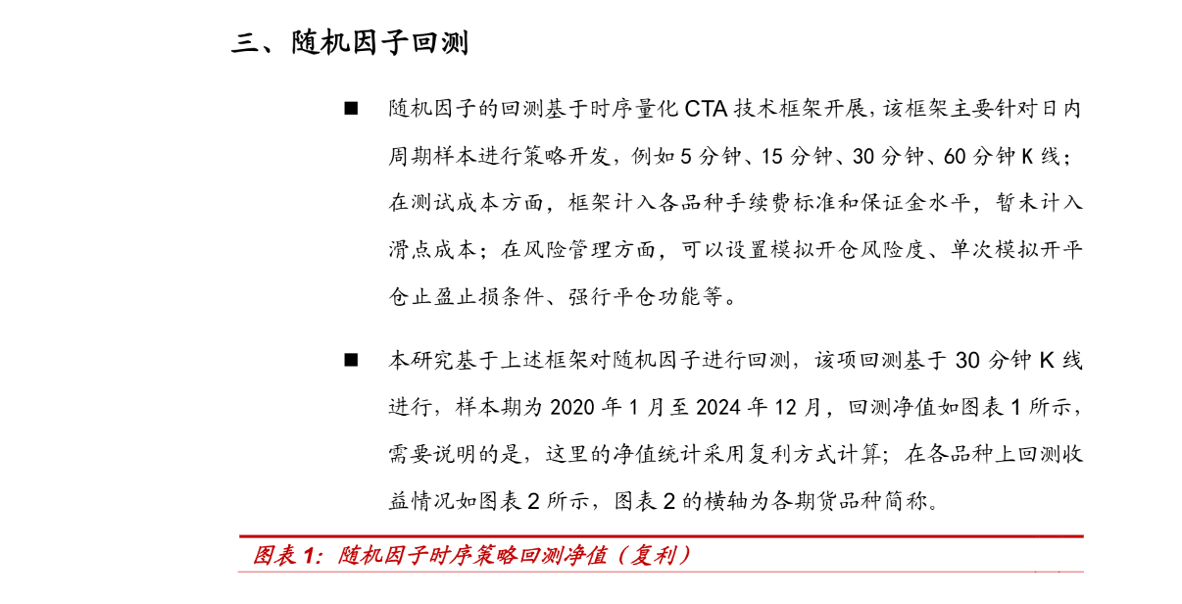
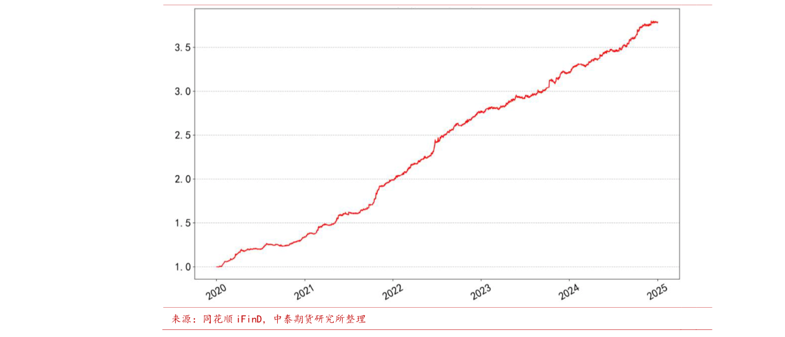
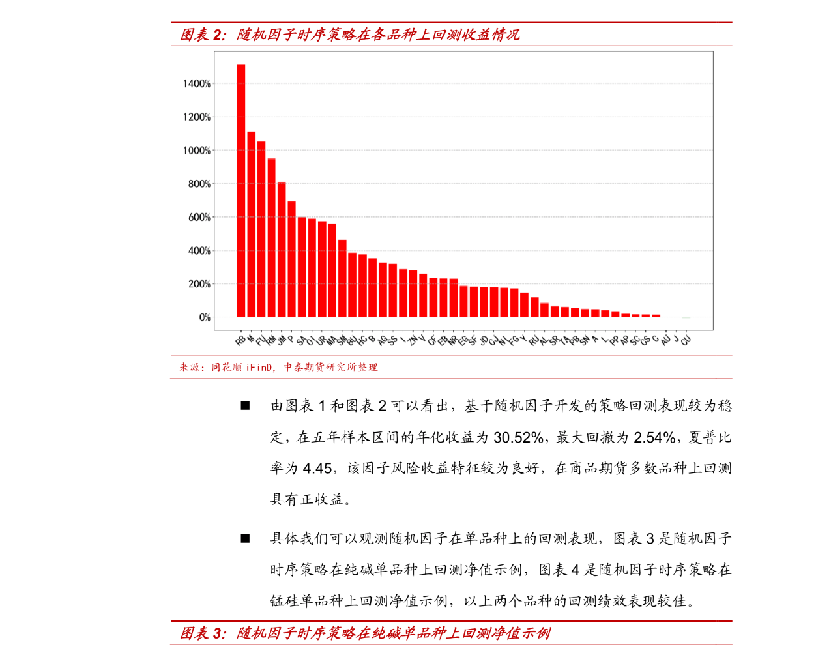
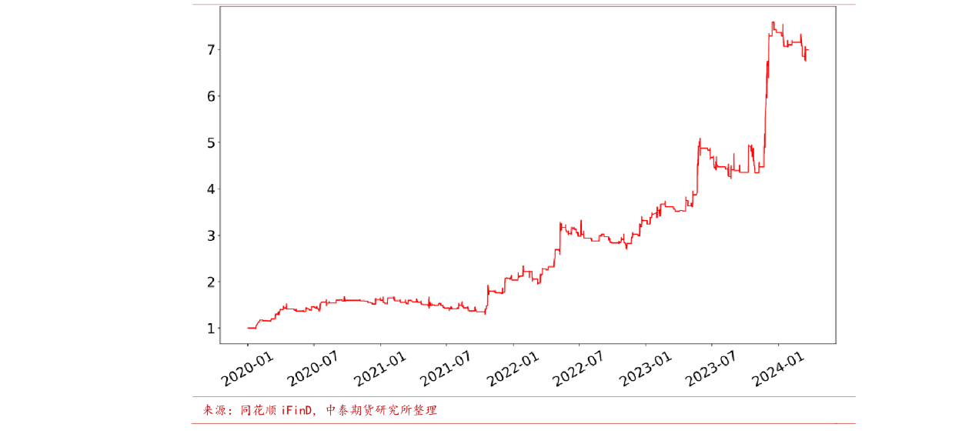
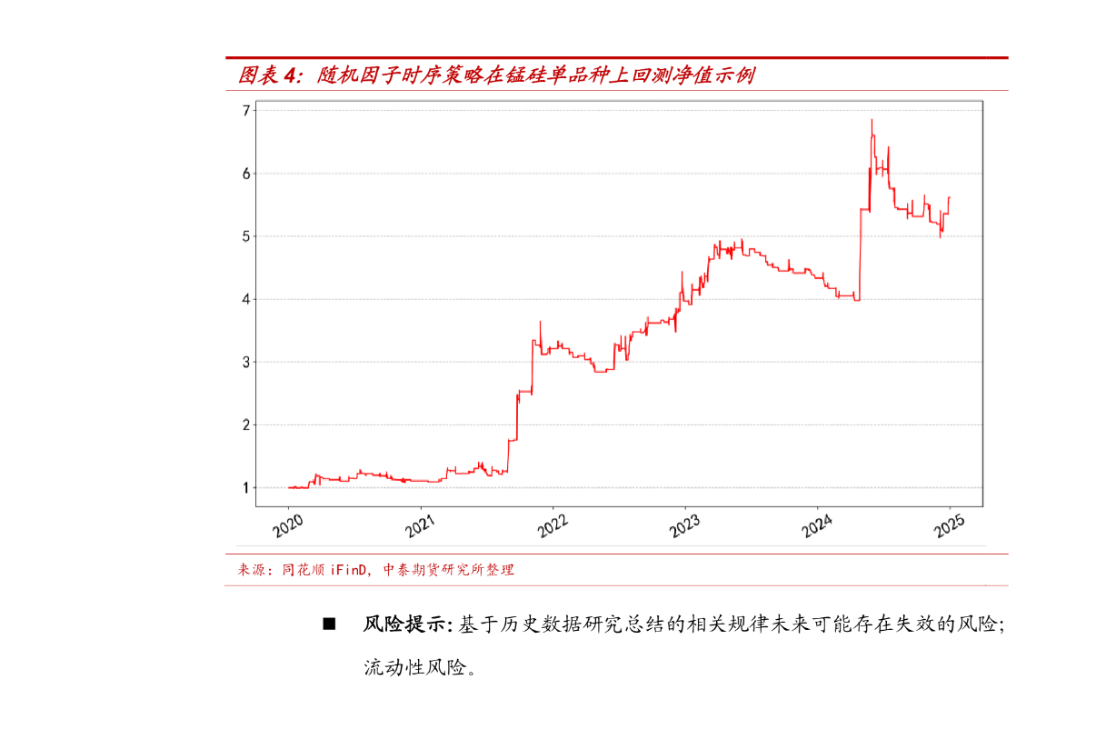
'''
timing_strategy_backtest_engine为中泰期货研究所开发的时序量化CTA回测引擎，在这个框架中，
"sj_strategy"类是从"timing_strategy_backtest"类派生出来的意味着它继承了"timing_strategy_backtest"类的特性与功能。
因子算法逻辑供各位研究员参考，具体使用请结合自身回测框架调整。

计算因子值所用数据为各期货品种合约的OHLC等,因子计算结果以RB2405合约为例见附件alpha_sj.csv。
'''

import pandas as pd
import numpy as np
from timing_strategy_backtest_engine import timing_strategy_backtest
import matplotlib.pyplot as plt
plt.rcParams['font.sans-serif']=['Simhei'] #用来正常显示中文标签
plt.rcParams['axes.unicode_minus']=False #用来正常显示负号
from scipy.stats import norm

def runs_test(sequence):
n = len(sequence)
n1 = np.sum(sequence) # 1的个数
n2 = n-n1 # 0的个数
runs = np.sum(np.diff(sequence)!= 0)+1
expected_runs = (2*n1*n2)/n+1
std_runs = np.sqrt((2*n1*n2*(2*n1*n2-n))/(n**2*(n-1)))
z_score = (runs-expected_runs)/std_runs
p_value = 2*(1-norm.cdf(abs(z_score)))
bilv = n1 / n2
return p_value

class sj_strategy(timing_strategy_backtest):

def set_conditions(self,df):
# 开平仓条件
#################################### 修改此处 ######################################################
df['returns'] = df.close.pct_change()
df['binary_returns'] = np.where(df.returns >= 0, 1, 0)
df['p_value'] = df.binary_returns.rolling(10).apply(runs_test)
short_vol = df.close.pct_change().rolling(20).std()
long_vol = df.close.pct_change().rolling(50).std()

ma = df.close.rolling(60).mean()
long_condition = (df.p_value < 0.05) & ( ma > ma.shift())
short_condition = (df.p_value < 0.05) & ( ma < ma.shift())

close_long_condition = False
close_short_condition = False

df['signal_open'] = np.where(long_condition,1,np.where(short_condition,-1,np.nan))
df['signal_close'] = np.where(close_long_condition,-1,np.where(close_short_condition,1,np.nan))

#####################################################################################################

df['signal_open'] = df['signal_open'].shift()
df['signal_close'] = df['signal_close'].shift()

return df

