Here is part of the concord_holdings_20160711.xls file.

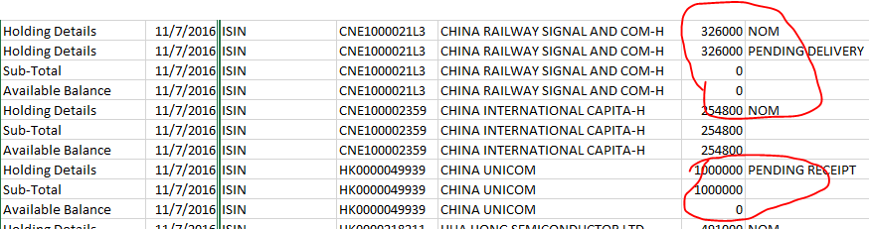

Structure:

Each position consists of:

* Holding Details: 1..N, each <Holding Details> item has one of the following status:
  + NOM: 0..1, seems to mean in-hand or settled units. If it is missing, meaning the #units = 0.
  + PENDING DELIVERY: 0..N, unsettled sell trades
  + PENDING RECEIPT: 0..N, unsettled buy trades
* Sub-Total: 1, the trade position. It should satisfy the following:
  + sub-total = settled_units + pending_receipt – pending_delivery
* Available Balance: 1, a conservative number, see above figure,
  + When a new position is just established, but pending receipt (China Unicomm), it is 0.
  + When there are units on hand, but sold out and pending delivery (China Railway), it is still 0.
  + It should satisfy: available_balance = settled_units – pending_delivery

Cash

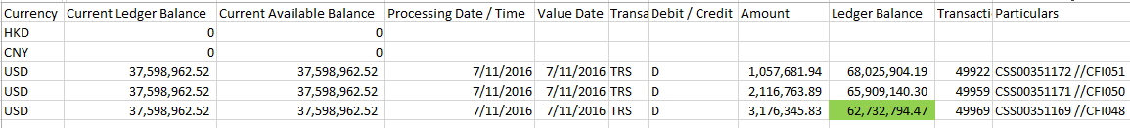

The above comes from “sample_cash1.xls”, the final cash in hand see the “Ledge Balance column”,

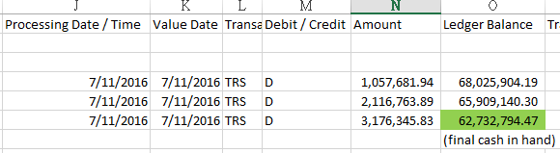

There are three buy transactions settled on that day, so we see three rows,

* Row1: debit 1,057,681.94, the resulting balance is 68,025,904.19
* Row2: debit 2,116,763.89, the resulting balance is 65,909,140.30, because 68,025,904.19 – 65,909,140.30 = 2,116,763.90
* Row3: similar, the final balance is 62,732,794.47.

The “available balance” is the amount that we can use, it is smaller than the “ledger balance” because the bank has frozen part of the ledger balance due to pending buy trades waiting to be settled. However, when there are pending sale trades to be settled, the available balance won’t be higher than the ledger balance, because the bank is conservative. Similar to the case of available balance in equity positions.

Sometimes, there is no transaction and ledger balance is zero, but the available balance is there, in this case, we simply use the available balance as the cash in hand. E.g., sample_cash2.xls

