Tsingtao Zhang’s Games 101 assignments

These are the assignments of GAMES101 https://sites.cs.ucsb.edu/~lingqi/teaching/games101.html

I filled in the crucial parts within the framework provided by TA.

Assignment 1: Model-View-Projection. Draw a rectangle using lines, the rectangle is in a 3D space, and its image is captured by a virtual camera. the assignment is to transform the triangle into screen space. By pressing A and D, I can rotate the triangle.

Assignment 2: Based on assignment 1, fill the pixels inside the triangles and there are two triangles in the camera view, I also need to consider the occlusion by their depths.

I also finished the bonus assignment: using super-sampling to generate the image with anti-aliasing.

文字图案

Assignment 3: Provided with mesh and textures, I need to draw the image of the mesh by filling each triangle of the mesh.

Showing the right normal color of the mesh.

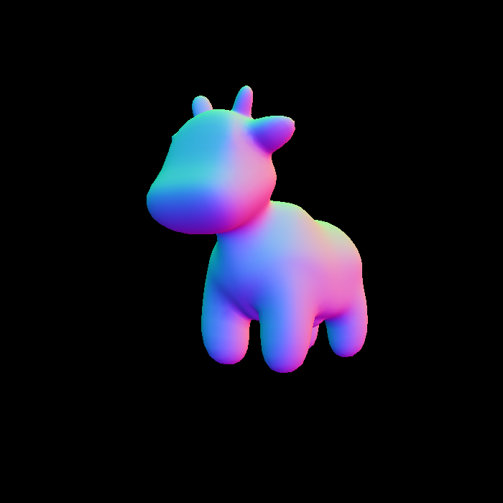

Using Blinn-Phong model to get the mesh with ambient light, diffuse and specular.

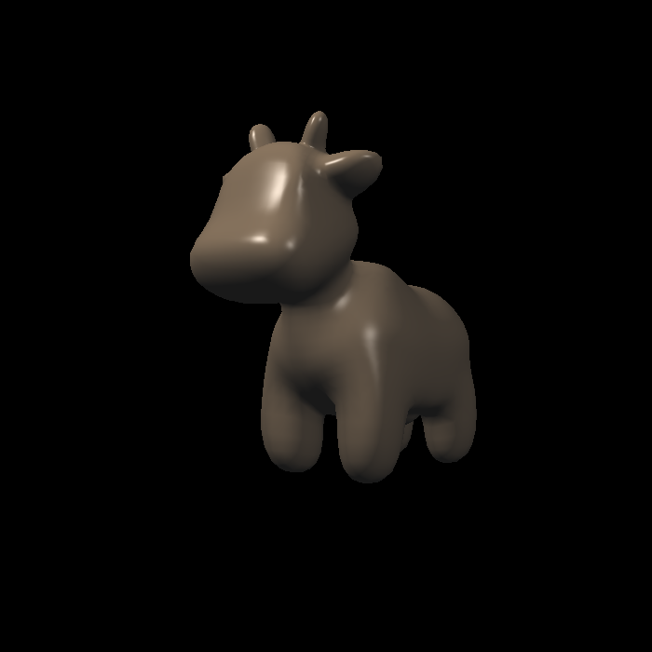

Applying the texture color with ambient light, diffuse and specular.

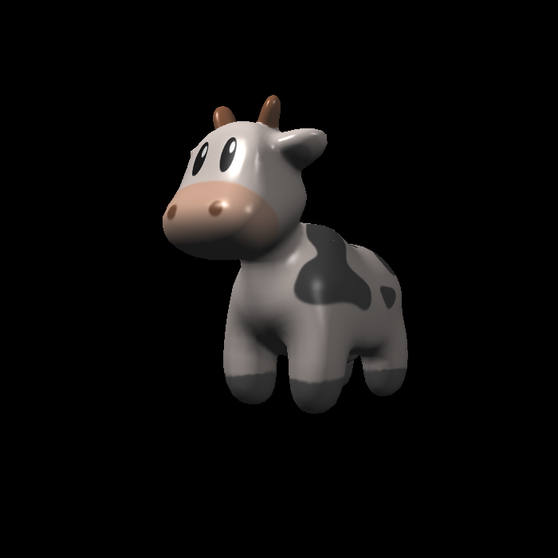

Applying the bump mapping

Applying the displacement mapping.

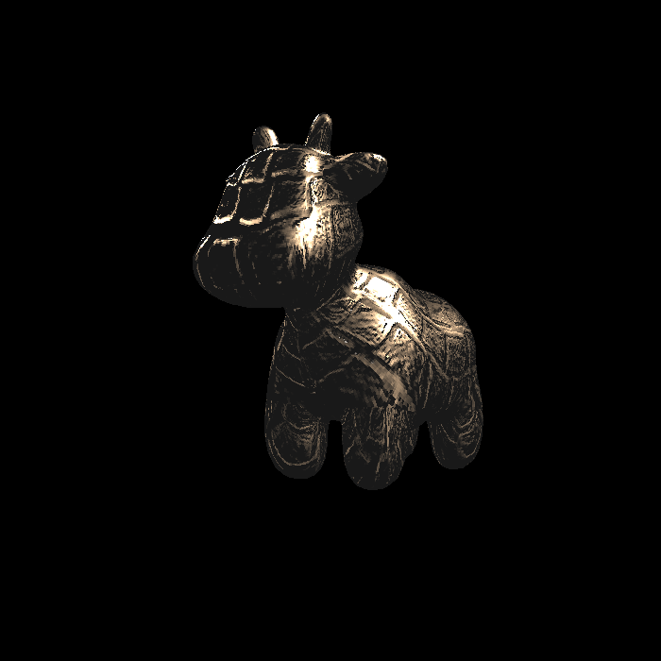

Bonus: Using Bilinear to get a higher definition texture with a lower resolution texture image.

卡通人物

