Hyper-Q Example
Thomas Bradley

Document Change History
Version | Date | Responsible | Reason for Change
1.0 | August, 2012 | Thomas Bradley | Initial release
1.1 | February, 2013 | Thomas Bradley | Updated example output

Abstract

Hyper‐Q enables multiple CPU threads or processes to launch work on a single GPU simultaneously, thereby dramatically increasing GPU utilization and significantly reducing CPU idle times. Applications that previously encountered false serialization across tasks, thereby limiting achieved GPU utilization, can see up to dramatic performance increase without changing any existing code.
This simple example demonstrates how false dependencies can arise even within a single CPU thread when Hyper-Q is not available, and shows how Hyper-Q eliminates the false dependencies to improve utilization of the GPU.

Background
Hyper-Q enables multiple CPU threads or processes to launch work on a single GPU simultaneously, thereby dramatically increasing GPU utilization and slashing CPU idle times. This feature increases the total number of “connections” between the host and GPU by allowing 32 simultaneous, hardware-managed connections, compared to the single connection available with GPUs without Hyper-Q (e.g. Fermi GPUs).
Hyper-Q is a flexible solution that allows connections for both CUDA streams and Message Passing Interface (MPI) processes, or even threads from within a process. Existing applications that were previously limited by false dependencies can see a dramatic performance increase without changing any existing code.

False Dependencies before Kepler
On Fermi, when a CPU thread dispatched work into a CUDA stream, the work was joined into a single pipeline to the Work Distributor. The Work Distributor takes work from the front of the pipeline, checks all dependencies are satisfied, and farms the work to the available SMs.
Stream Queue Management
C
B
A
C
B
A
C
B
A
SM
SM
SM
SM
Work Distributor
(16 active grids)
Consider three CUDA streams, each containing a sequence of kernels A, B, C as shown in the adjacent figure.
for (int i = 0 ; i < 3 ; i++)
{
A<<<gdim,bdim,smem,streams[i]>>>();
B<<<gdim,bdim,smem,streams[i]>>>();
C<<<gdim,bdim,smem,streams[i]>>>();
}

Using CUDA streams, we have declared the dependency chains A₀-B₀-C₀ and A₁-B₁-C₁ and A₂-B₂-C₂. Each of these chains is independent and therefore they could be executed at the same time (i.e. concurrently). With Fermi’s single pipeline, however, this depth-first launch sequence will result in false dependencies:
A₀
B₀
C₀
streams[0]
A₁
B₁
C₁
streams[1]
A₂
B₂
C₂
streams[2]
Hardware Work Queue
A₀
B₀
C₀
A₁
B₁
C₁
A₂
B₂
C₂
As a result the hardware is only able to determine that it can execute the shaded pairs concurrently.

Grid Management Unit
Stream Queue Management
C
B
A
C
B
A
C
B
A
SMX
SMX
SMX
SMX
Work Distributor
(16 active grids)
Grid Management Unit
(1000s of pending grids)
Kepler GK110 introduces the Grid Management Unit, which creates multiple hardware work queues to reduce or eliminate false dependencies. With the GMU, streams can be kept as individual pipelines of work.
Also shown on the diagram is the feedback path from the SMXs to the Work Distributor, and the work creation path from the SMXs to the GMU. These components provide dynamic parallelism (see the CUDA Programming Guide for more information on dynamic parallelism).

Simple Example
This sample code uses a depth-first launch as described above to demonstrate how Hyper_Q allows the independent kernels to be executed concurrently, regardless of the launch order.
After initializing and checking the device properties, the code creates a number of streams and launches a pair of kernels into each stream as follows:
for (int i = 0 ; i < nstreams ; ++i)
{
kernel_A<<<1,1,0,streams[i]>>>(&d_a[2*i], time_clocks);
total_clocks += time_clocks;
kernel_B<<<1,1,0,streams[i]>>>(&d_a[2*i+1], time_clocks);
total_clocks += time_clocks;
}

Each kernel is launched as a single thread, which simply executes a loop for a defined amount of time (10ms by default) and saves the total number of clock cycles to memory (as a simple sanity check).
Having launched the pairs into the streams, the code does a sum-reduction to add up all the clock cycle counts, and checks that the total number of clock cycles is as expected.

Running without Hyper-Q
On a device without Hyper-Q, the single work pipeline in hardware means that we can only see concurrency between pairs of kernel_B from stream N and kernel_A from stream N+1. This can be seen clearly when viewing the timeline with the NVIDIA Visual Profiler.

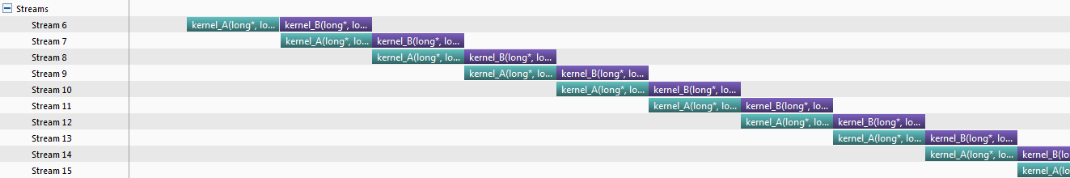

Running with Hyper-Q
On a device with Hyper-Q, the false dependencies are eliminated and all the kernel_As can execute concurrently (as can all the kernel_Bs). Again, the NVIDIA Visual Profiler can be used to visualize the timeline and clearly shows the benefit.
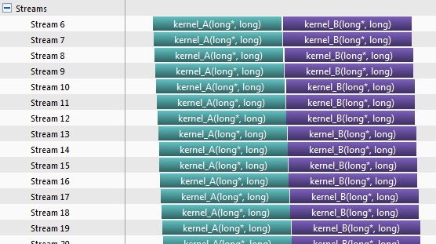

Appendix

Default Behavior
Typical output from the program on a device without Hyper-Q is:
starting hyperQ...
GPU Device 0: "GeForce GTX 680" with compute capability 3.0

> GPU does not support HyperQ
CUDA kernel runs will have limited concurrency
> Detected Compute SM 3.0 hardware with 8 multi-processors
Expected time for serial execution of 32 sets of kernels is between approx. 0.330s and 0.640s
Expected time for fully concurrent execution of 32 sets of kernels is approx. 0.020s
Measured time for sample = 0.346s

Typical output from the program on a device with Hyper-Q is:
starting hyperQ...
GPU Device 0: "Tesla K20X" with compute capability 3.5

> Detected Compute SM 3.5 hardware with 14 multi-processors
Expected time for serial execution of 32 sets of kernels is between approx. 0.330s and 0.640s
Expected time for fully concurrent execution of 32 sets of kernels is approx. 0.020s
Measured time for sample = 0.021s

An exit status of 0 indicates that the total clock count from all kernels matches (or exceeds) the sum of the target count multiplied by the number of launches.

Command Line Flags
Flag | Description | Default value
nstreams | Number of streams to use | 32
noprompt | Disable the pause before terminating

Example: $ hyperq --nstreams=8

Notice
ALL NVIDIA DESIGN SPECIFICATIONS, REFERENCE BOARDS, FILES, DRAWINGS, DIAGNOSTICS, LISTS, AND OTHER DOCUMENTS (TOGETHER AND SEPARATELY, “MATERIALS”) ARE BEING PROVIDED “AS IS.” NVIDIA MAKES NO WARRANTIES, EXPRESSED, IMPLIED, STATUTORY, OR OTHERWISE WITH RESPECT TO THE MATERIALS, AND EXPRESSLY DISCLAIMS ALL IMPLIED WARRANTIES OF NONINFRINGEMENT, MERCHANTABILITY, AND FITNESS FOR A PARTICULAR PURPOSE.
Information furnished is believed to be accurate and reliable. However, NVIDIA Corporation assumes no responsibility for the consequences of use of such information or for any infringement of patents or other rights of third parties that may result from its use. No license is granted by implication or otherwise under any patent or patent rights of NVIDIA Corporation. Specifications mentioned in this publication are subject to change without notice. This publication supersedes and replaces all information previously supplied. NVIDIA Corporation products are not authorized for use as critical components in life support devices or systems without express written approval of NVIDIA Corporation.

Trademarks
NVIDIA, the NVIDIA logo, GeForce, NVIDIA Quadro, and NVIDIA CUDA are trademarks or registered trademarks of NVIDIA Corporation in the United States and other countries. Other company and product names may be trademarks of the respective companies with which they are associated.

Copyright
© 2007-2013 NVIDIA Corporation. All rights reserved.

