【第一节】
Exercise: Write a Hello GPU Kernel
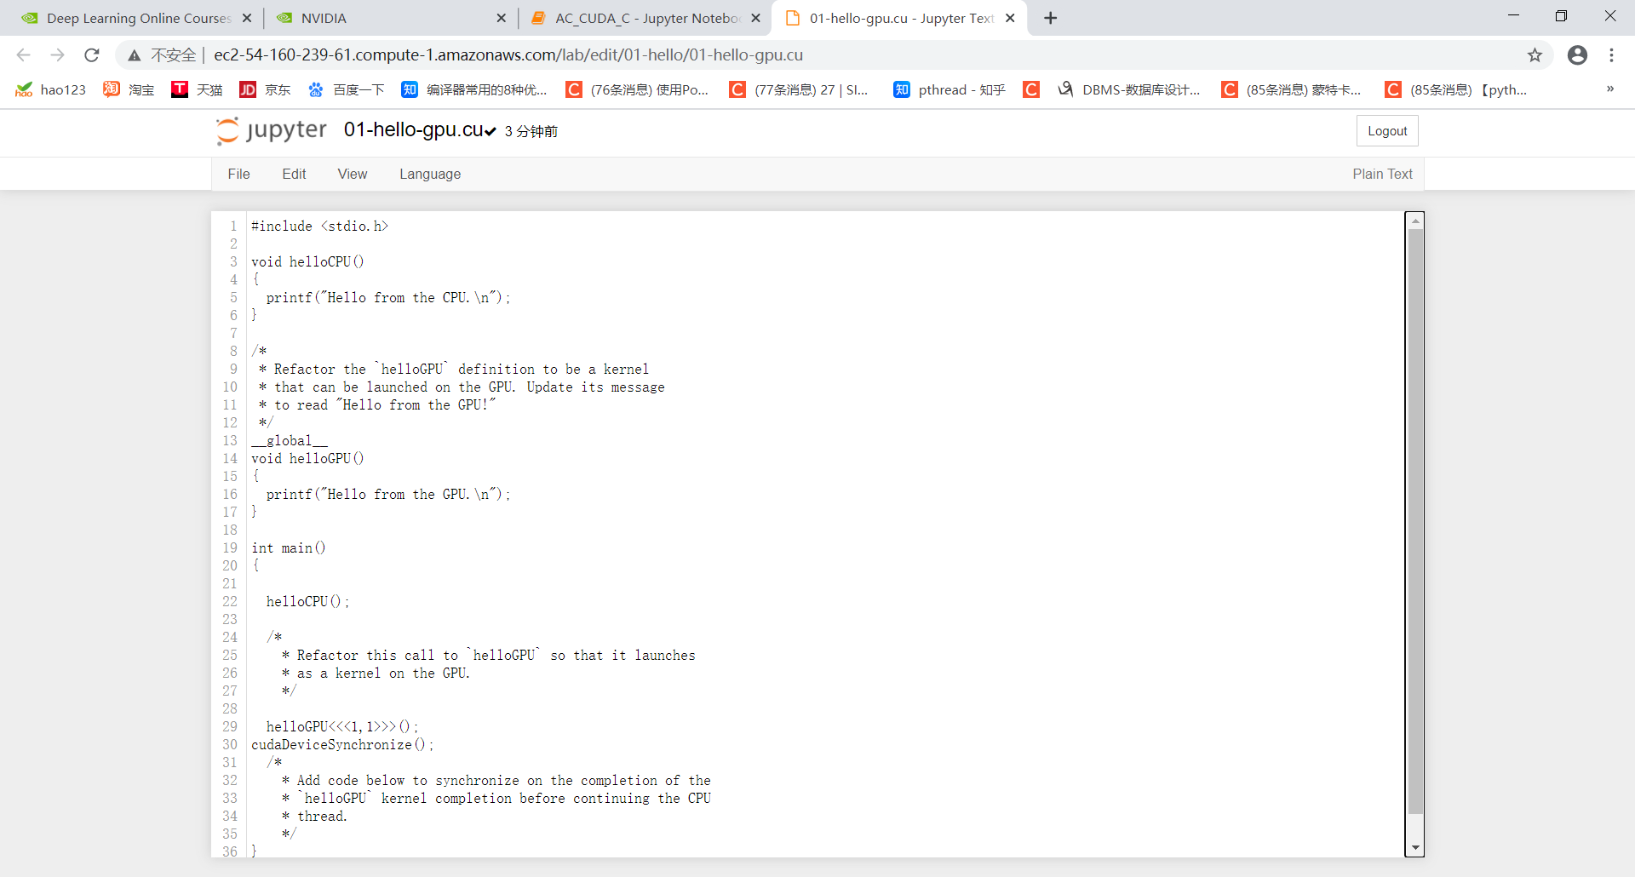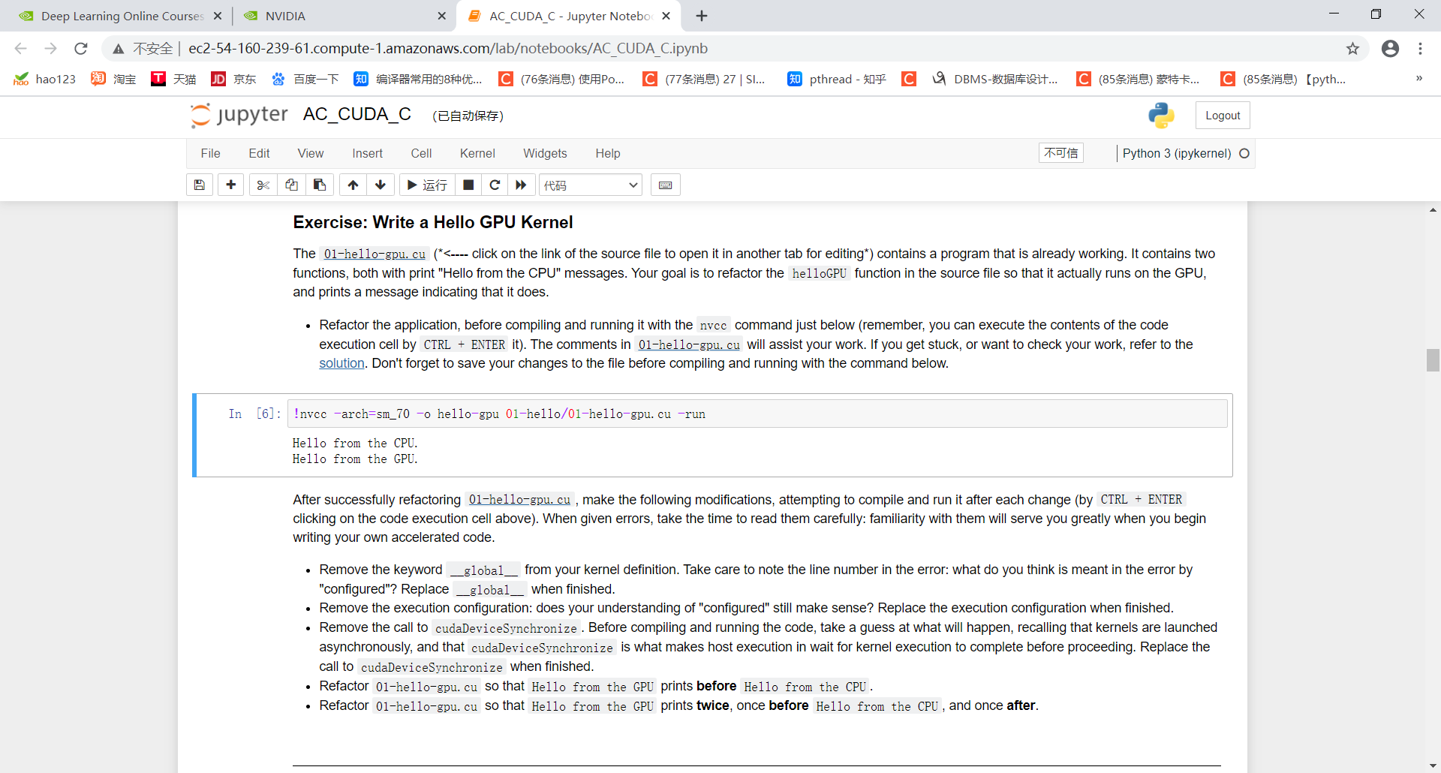
- Remove the keyword __global__ from your kernel definition. Take care to note the line number in the error: what do you think is meant in the error by "configured"? Replace __global__ when finished.
这一行出错：
- Remove the execution configuration: does your understanding of "configured" still make sense? Replace the execution configuration when finished.
- Remove the call to cudaDeviceSynchronize. Before compiling and running the code, take a guess at what will happen, recalling that kernels are launched asynchronously, and that cudaDeviceSynchronize is what makes host execution in wait for kernel execution to complete before proceeding. Replace the call to cudaDeviceSynchronize when finished.
- Refactor 01-hello-gpu.cu so that Hello from the GPU prints before Hello from the CPU.
- Refactor 01-hello-gpu.cu so that Hello from the GPU prints twice, once before Hello from the CPU, and once after.

Exercise: Launch Parallel Kernels
- Refactor the firstParallel function to launch as a CUDA kernel on the GPU. You should still be able to see the output of the function after compiling and running 01-first-parallel.cu with the nvcc command just below.
- Refactor the firstParallel kernel to execute in parallel on 5 threads, all executing in a single thread block. You should see the output message printed 5 times after compiling and running the code.
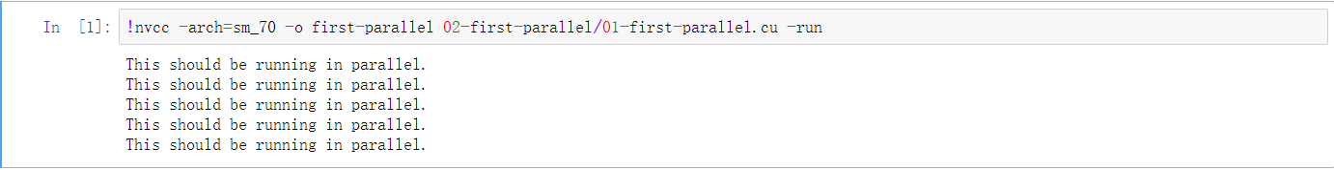
- Refactor the firstParallel kernel again, this time to execute in parallel inside 5 thread blocks, each containing 5 threads. You should see the output message printed 25 times now after compiling and running.
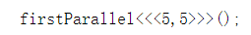
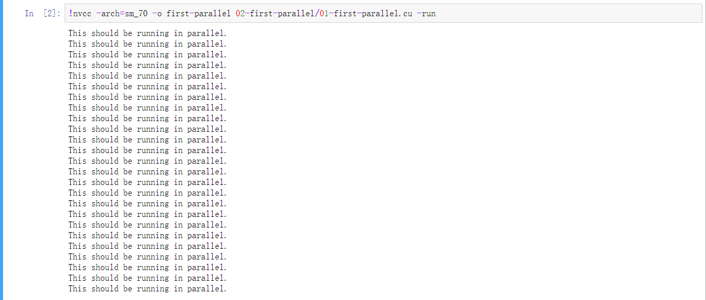

Exercise: Use Specific Thread and Block Indices

Exercise: Accelerating a For Loop with a Single Block of Threads

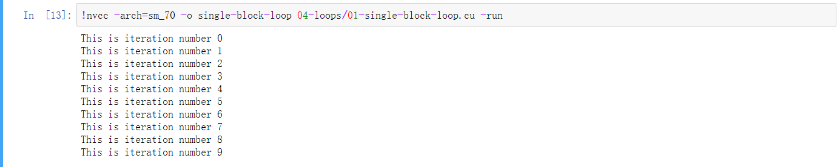

Exercise: Accelerating a For Loop with Multiple Blocks of Threads
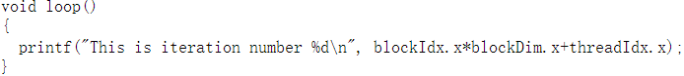
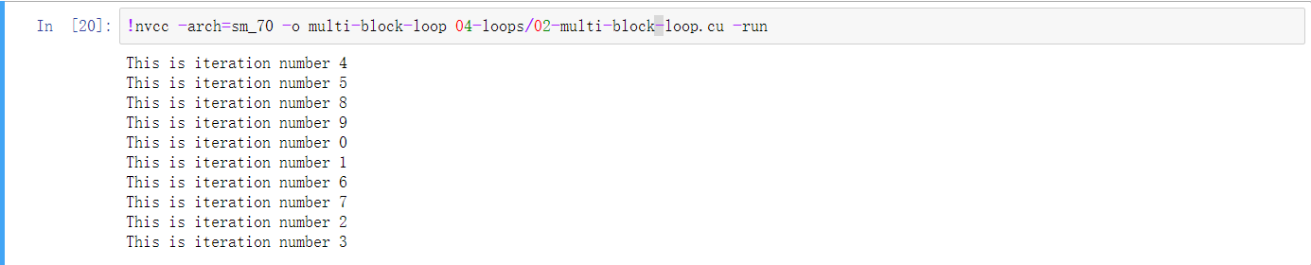

Exercise: Array Manipulation on both the Host and Device

Exercise: Accelerating a For Loop with a Mismatched Execution Configuration

Exercise: Use a Grid-Stride Loop to Manipulate an Array Larger than the Grid
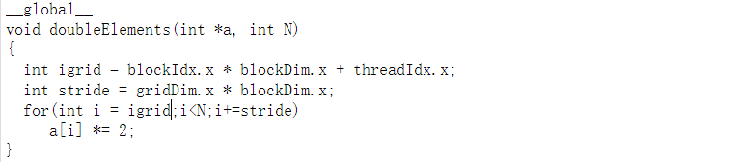

Exercise: Add Error Handling

Final Exercise: Accelerate Vector Addition Application
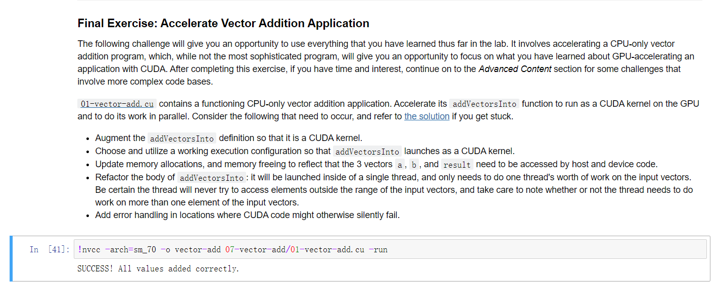

Exercise: Accelerate 2D Matrix Multiply Application

Exercise: Accelerate A Thermal Conductivity Application

【第二节】

Exercise: Profile an Application with nsys
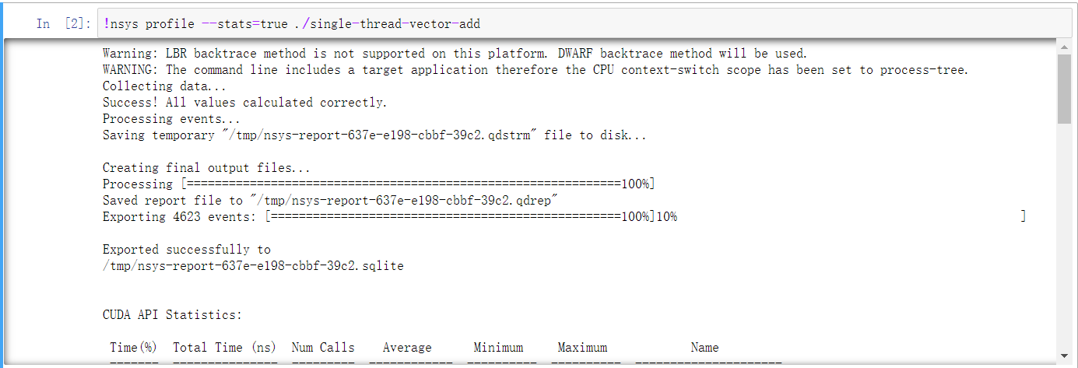
- What was the name of the only CUDA kernel called in this application?
addVectorsInto(float*, float*, float*, int)
- How many times did this kernel run?
1
- How long did it take this kernel to run? Record this time somewhere: you will be optimizing this application and will want to know how much faster you can make it.
2286869563ns

Exercise: Optimize and Profile
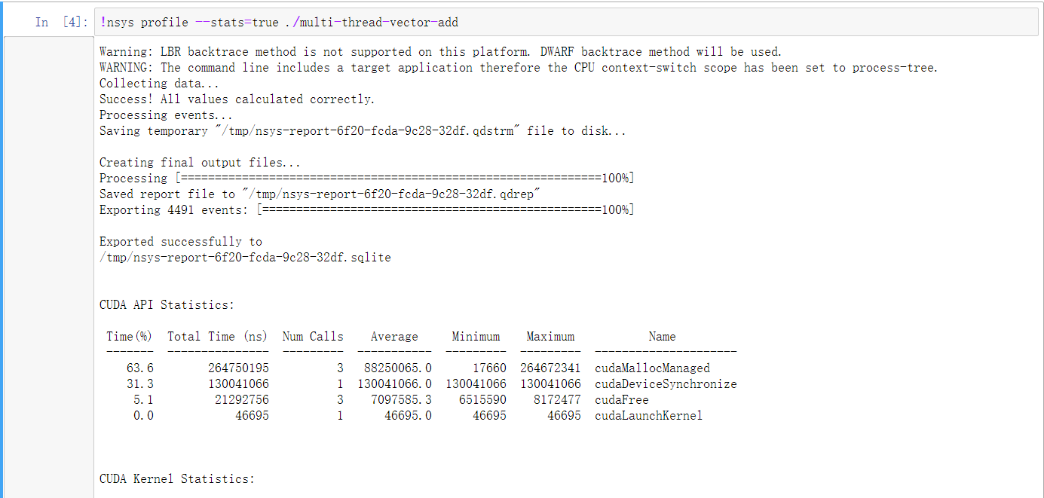
130030880ns
Ratio：17.59

Exercise: Optimize Iteratively

291289976ns 1 - 32
122003187ns 32 - 1024

Exercise: Query the Device
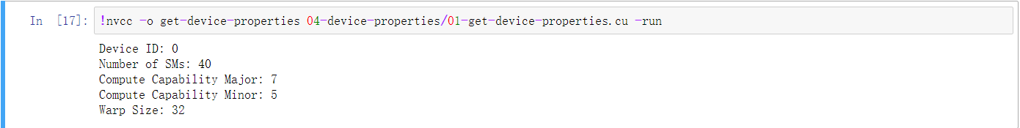

Exercise: Optimize Vector Add with Grids Sized to Number of SMs
111687983 ns
1000-1024
124120734 ns
1024-1024
123207304ns
40-1024
125928135ns
32-1024

Exercise: Explore UM Migration and Page Faulting
- Is there evidence of memory migration and/or page faulting when unified memory is accessed only by the CPU? (solution)
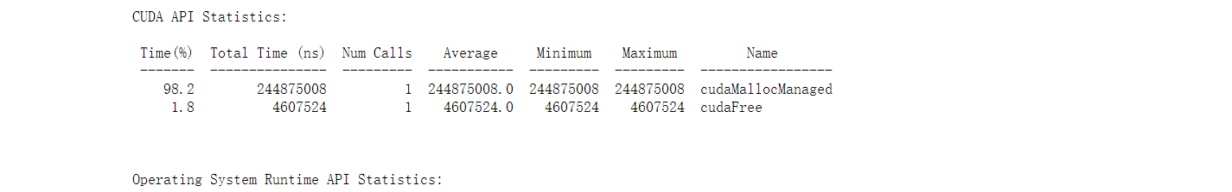
- Is there evidence of memory migration and/or page faulting when unified memory is accessed only by the GPU? (solution)
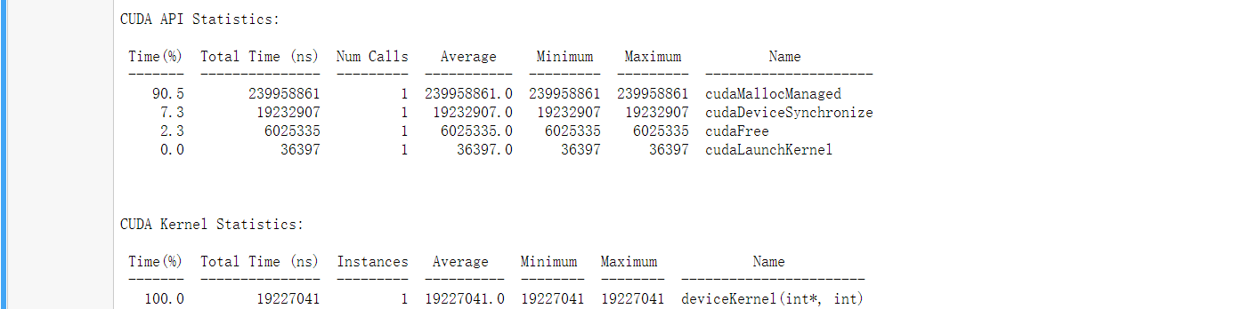
- Is there evidence of memory migration and/or page faulting when unified memory is accessed first by the CPU then the GPU? (solution)
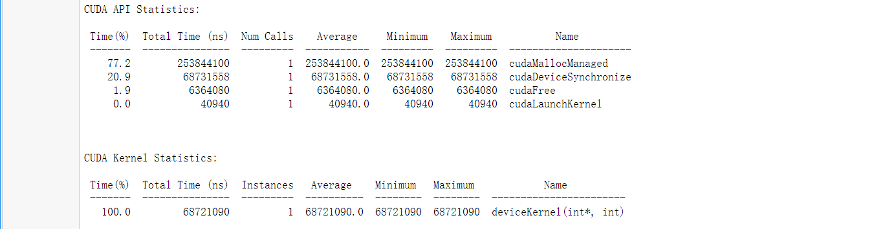
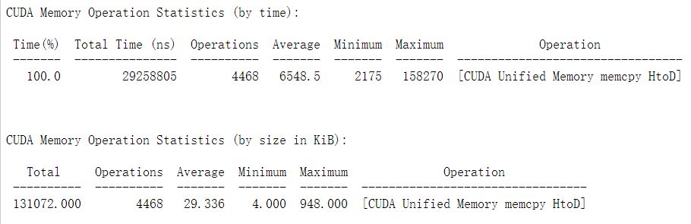
- Is there evidence of memory migration and/or page faulting when unified memory is accessed first by the GPU then the CPU? (solution)
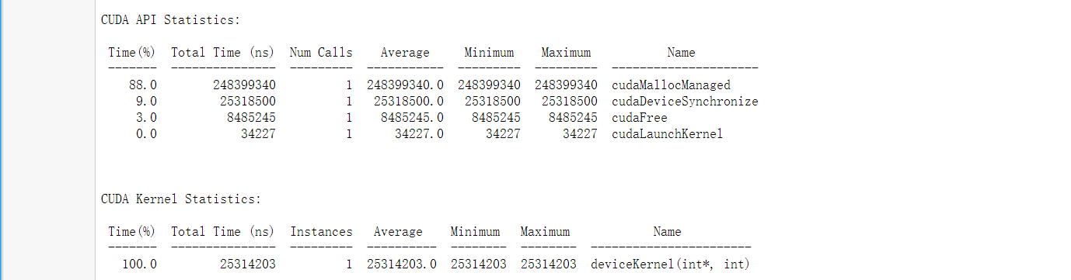
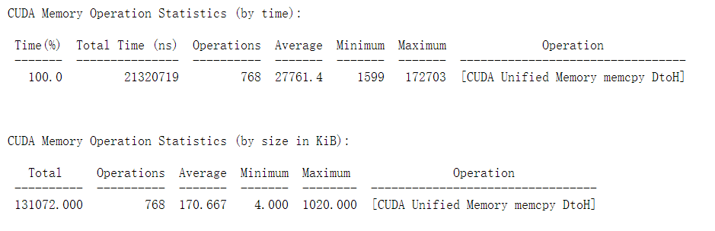

Exercise: Revisit UM Behavior for Vector Add Program
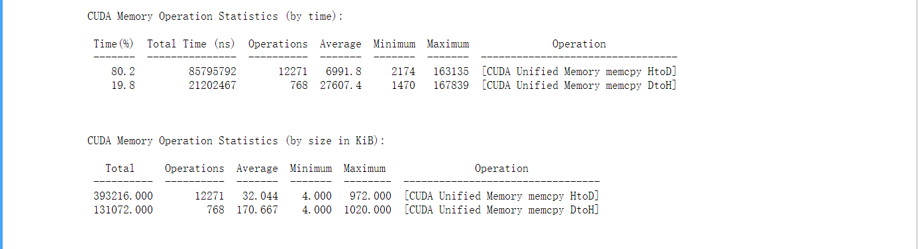

Exercise: Initialize Vector in Kernel
HOST初始化：
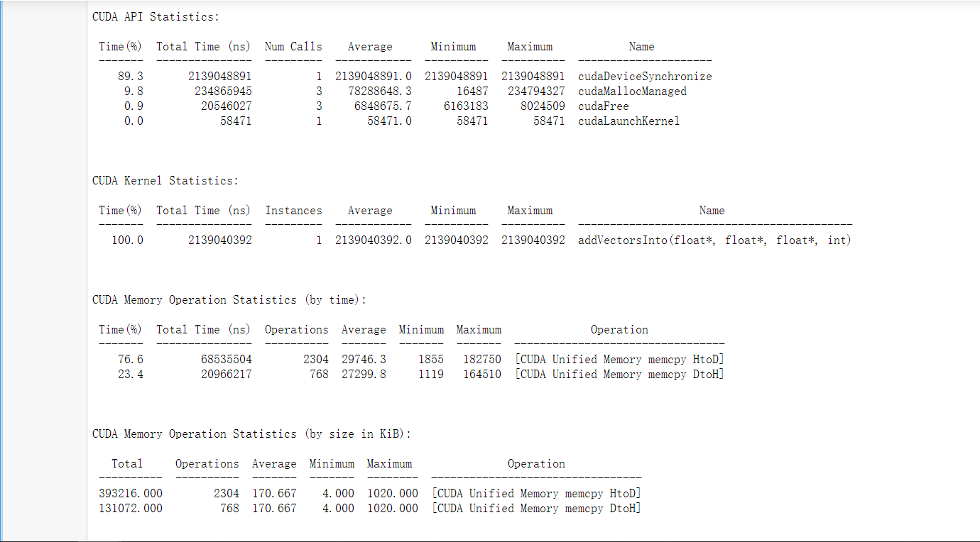
Device初始化：
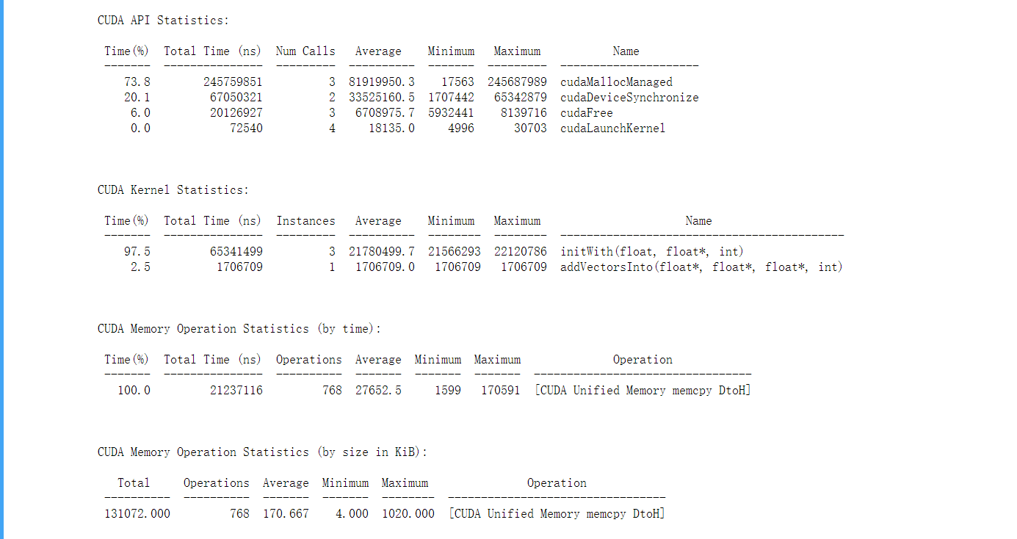

Exercise: Prefetch Memory
没有预取：
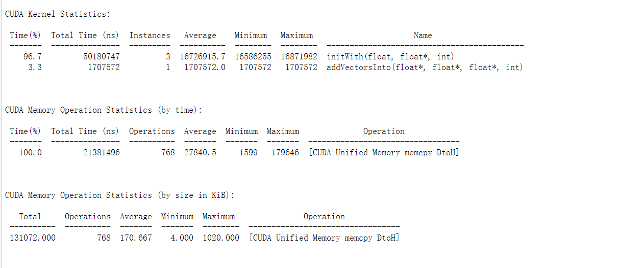
预取：
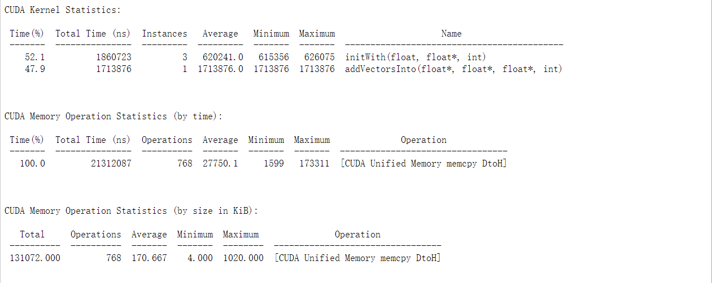

Exercise: Prefetch Memory Back to the CPU
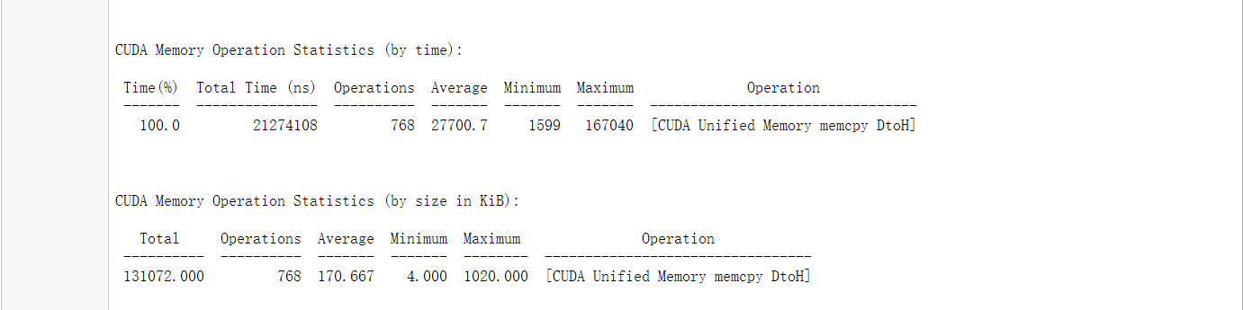
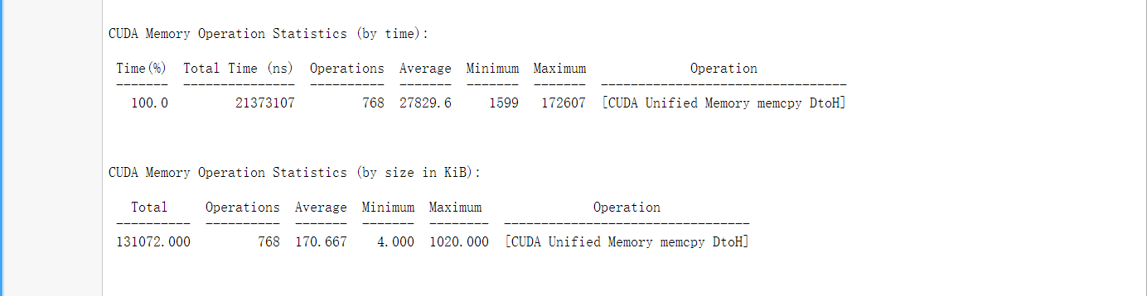

Final Exercise: Iteratively Optimize an Accelerated SAXPY Application

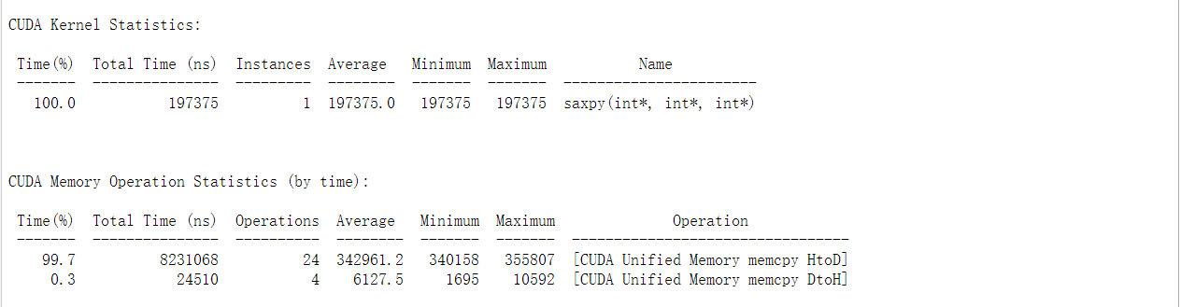
【第三节】

Exercise: Compare the Timelines of Prefetching vs. Non-Prefetching
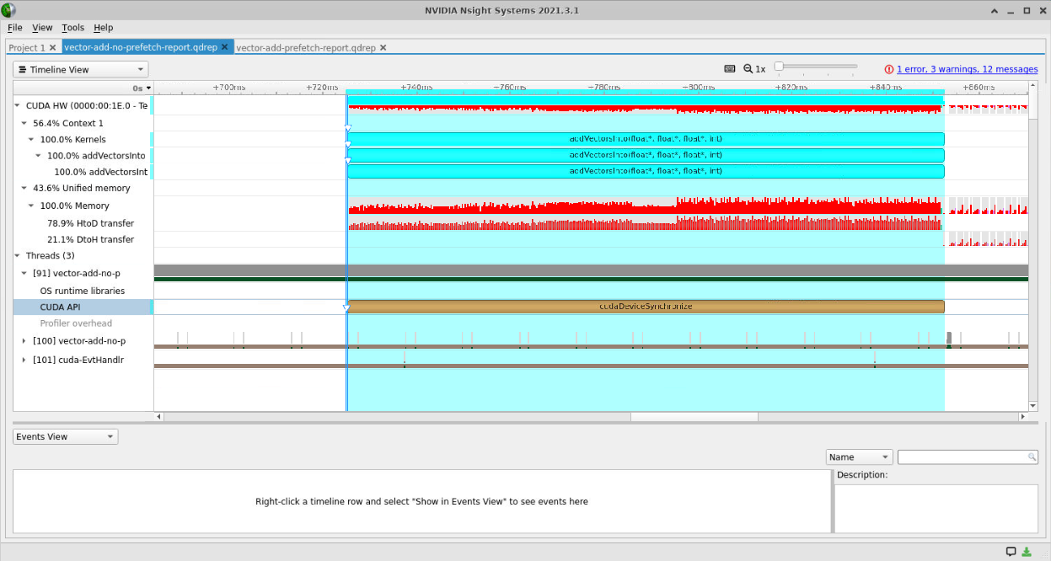
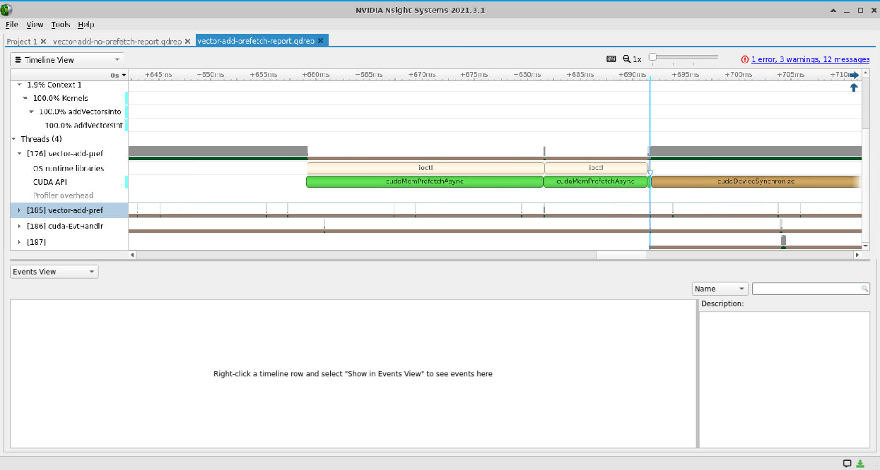

Exercise: Profile Refactor with Launch Init in Kernel
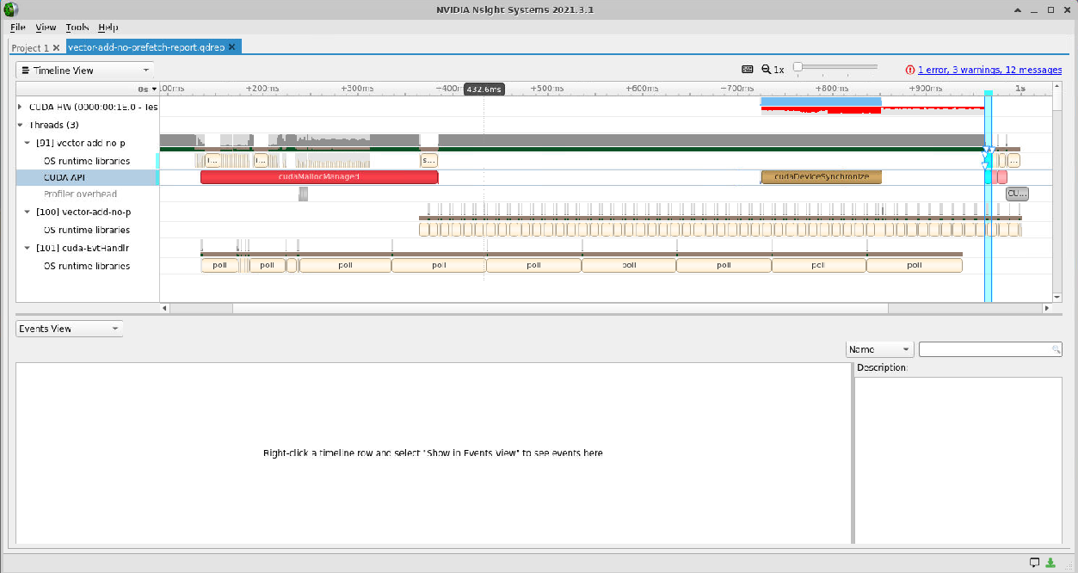

Exercise: Profile Refactor with Asynchronous Prefetch Back to the Host
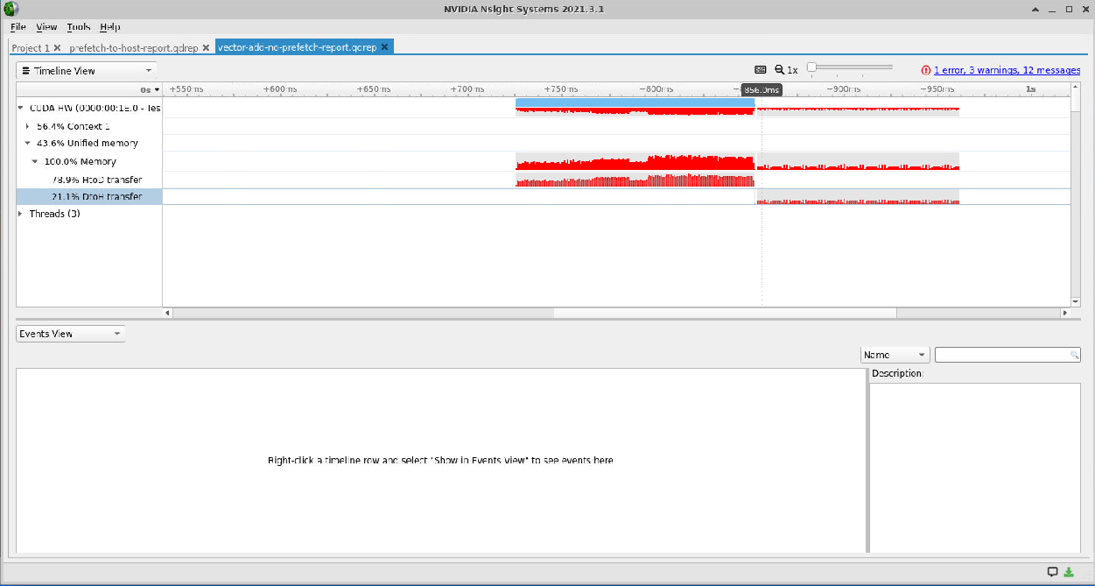
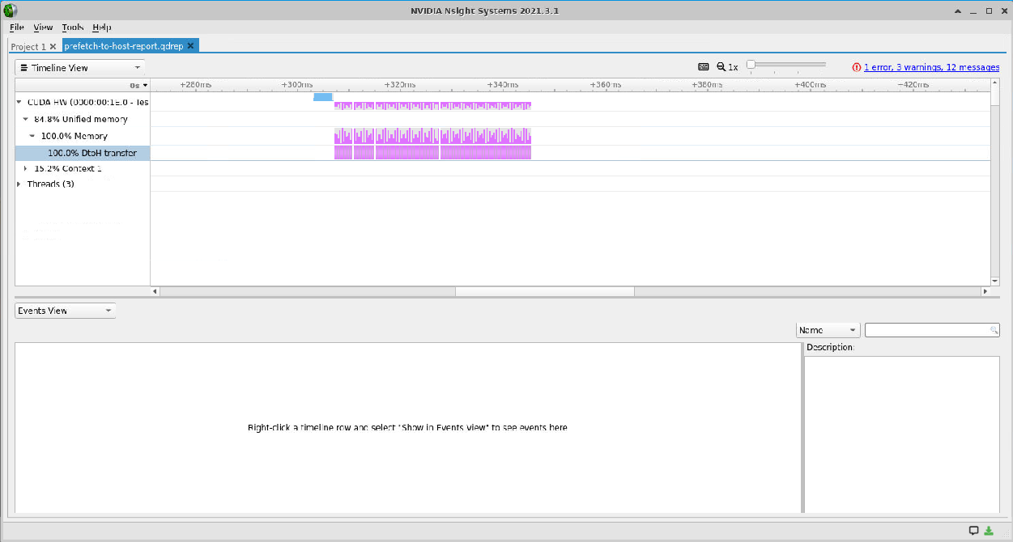

Exercise: Predict Default Stream Behavior

Exercise: Implement Concurrent CUDA Streams
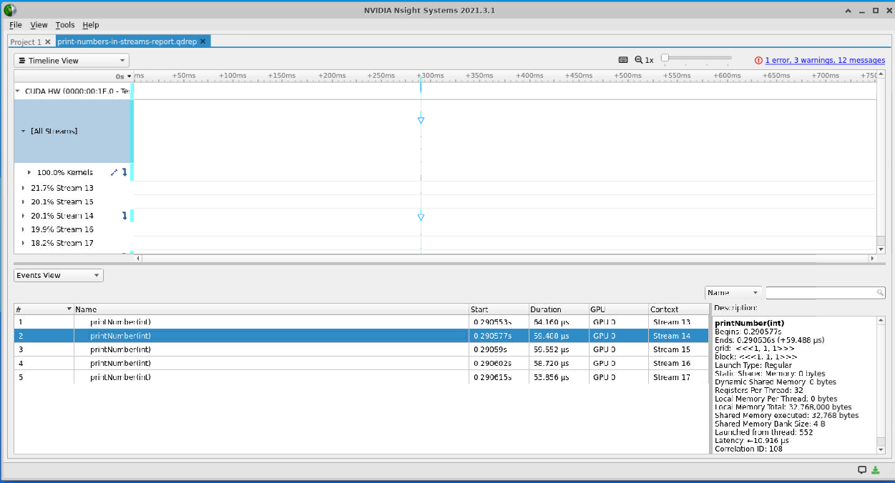

Exercise: Use Streams for Concurrent Data Initialization Kernels
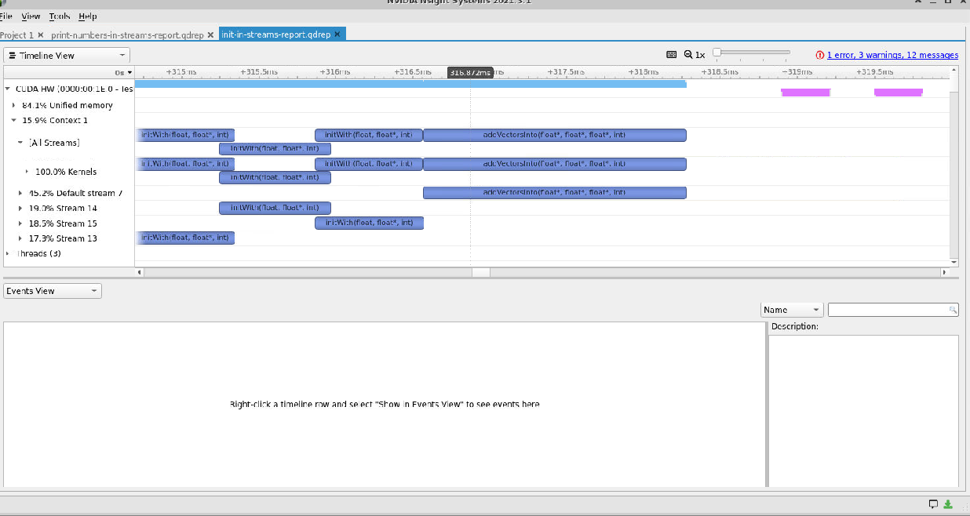

Final Exercise: Accelerate and Optimize an N-Body Simulator
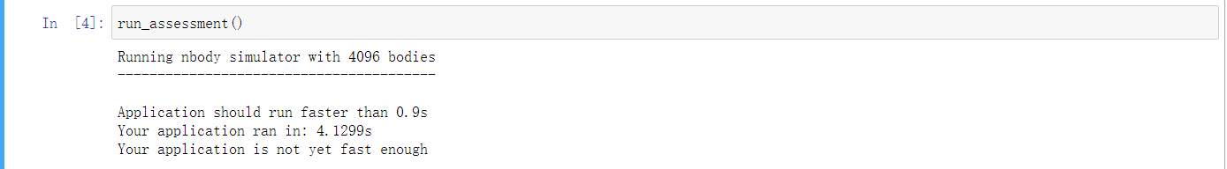
Original
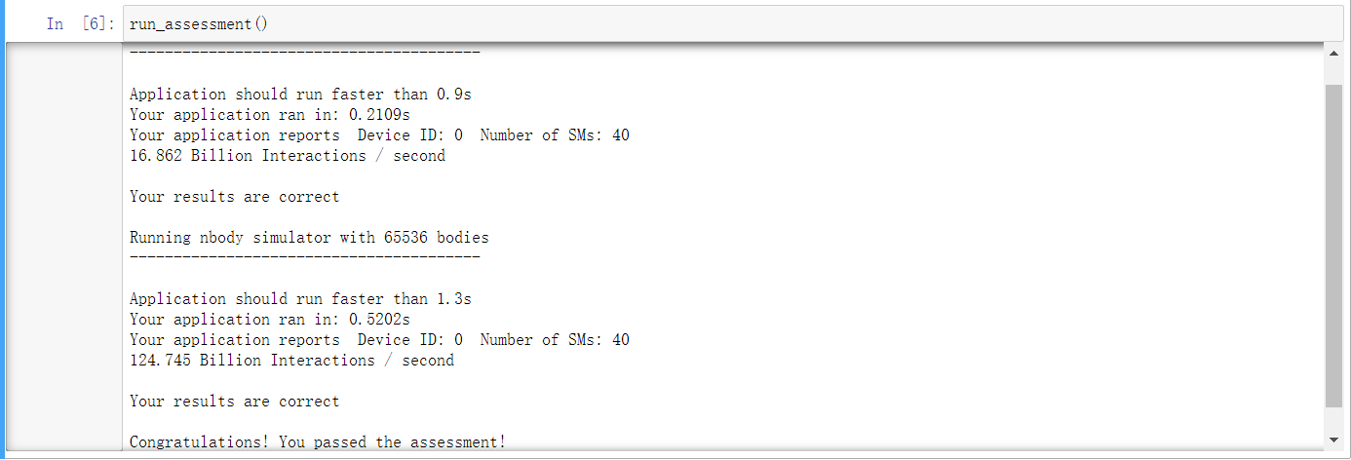
128-32*SMs
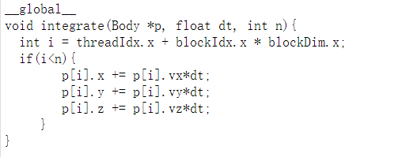
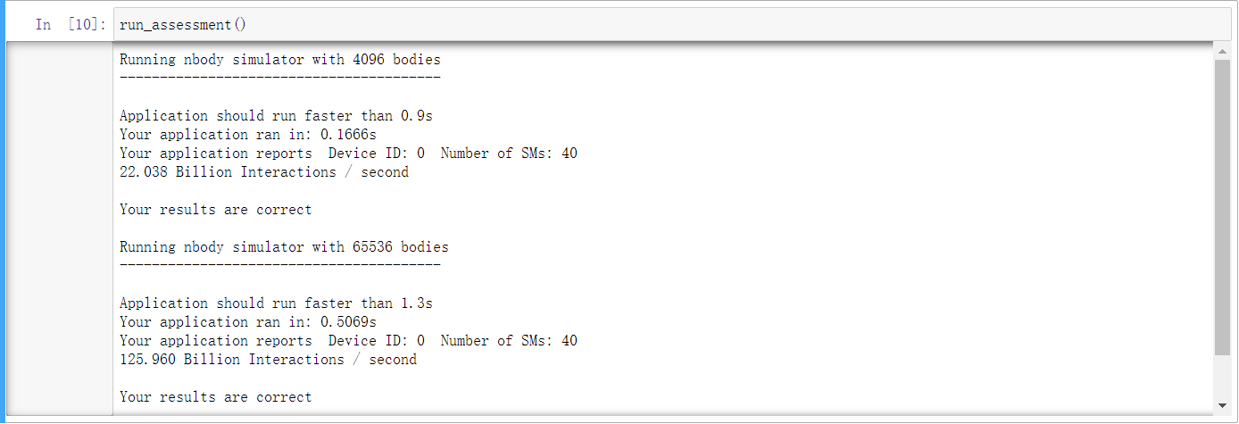
128-32*SMs integrate
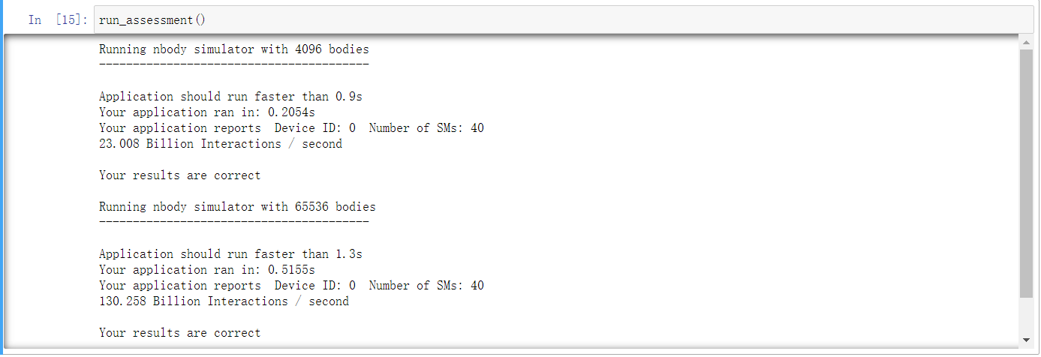
128-32*SMs integrate pre-fetch to Device
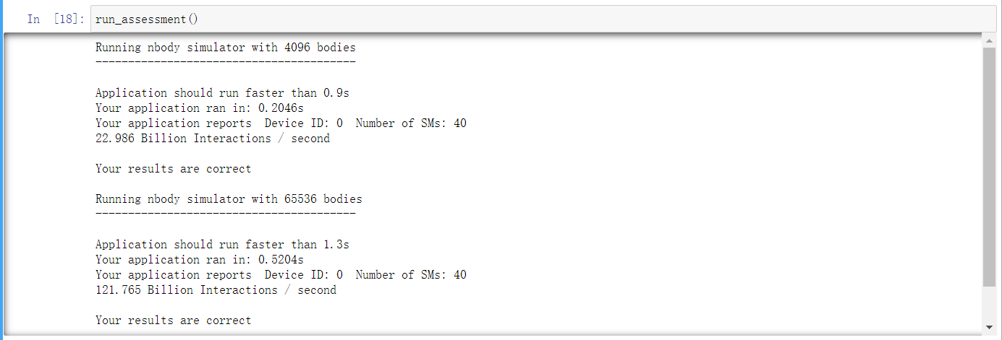
128-32*SMs integrate pre-fetch*2
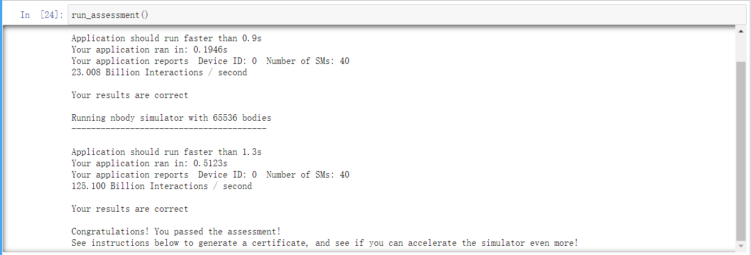
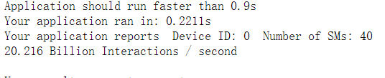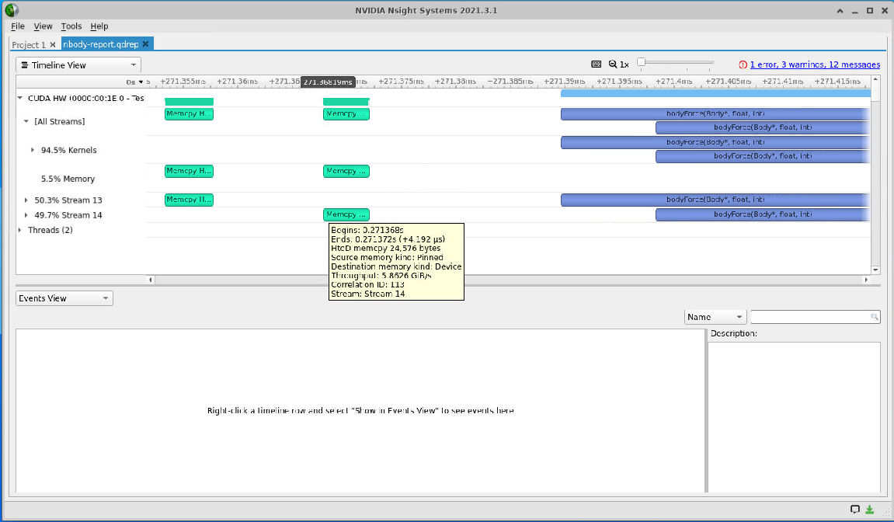
没有达到预期的重叠效果，经过可视化profiling，这是因为memcpy时间太短了。
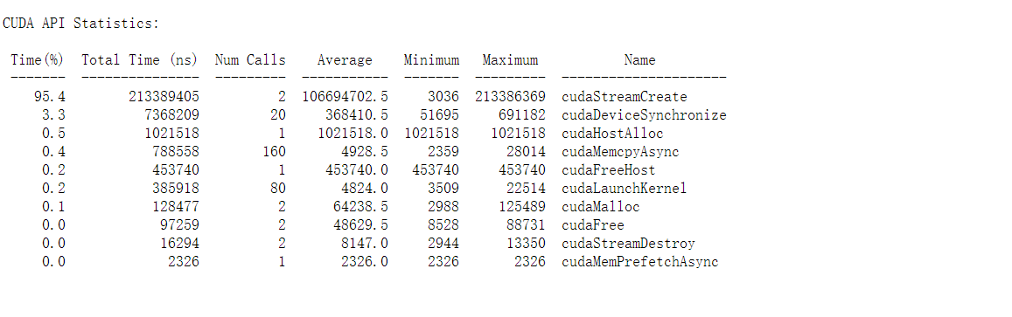而且cudaStreamCreate的时间开销远大于cudaMemcpyAsync。
像向量加法，如果在init里使用多流效果会很好，因为数据迁移和向量加法都是On复杂度。但在nBody问题里，On2复杂度的bodyForce是性能瓶颈，企望通过memcpy和计算并行(一个特别快，一个特别慢)来加速算法是不可取的，相反地，一些stream创建和管理开销还会降低加速效果。没有stream：
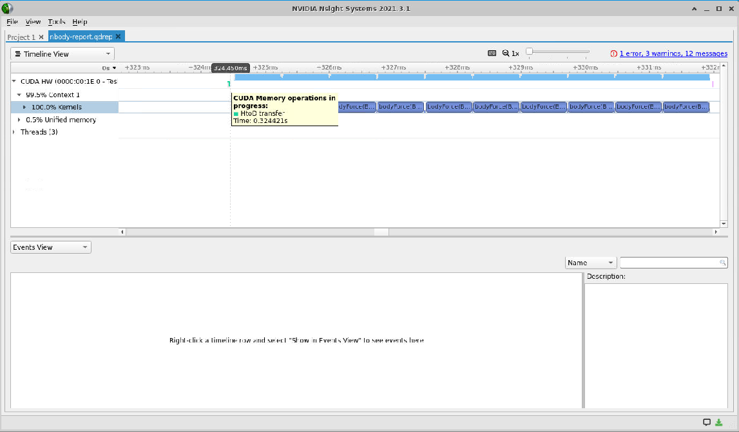
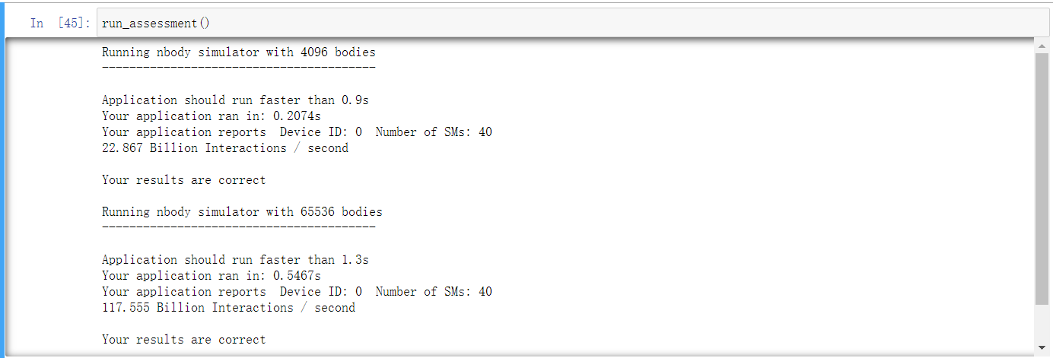
128-31*SMs
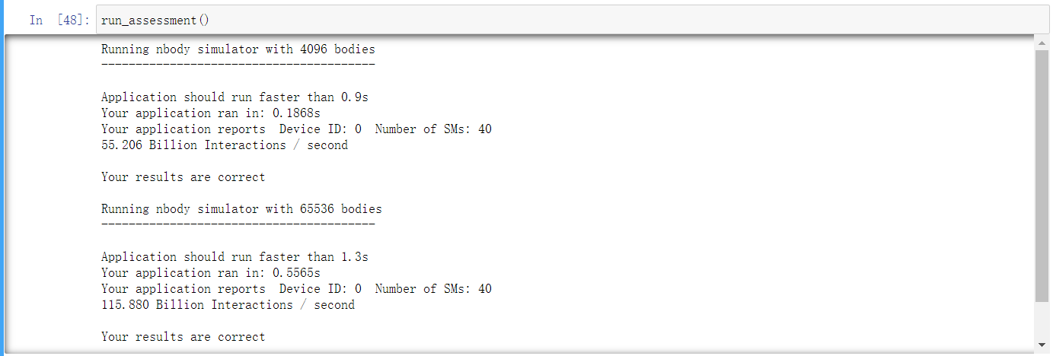
128-33*SMs

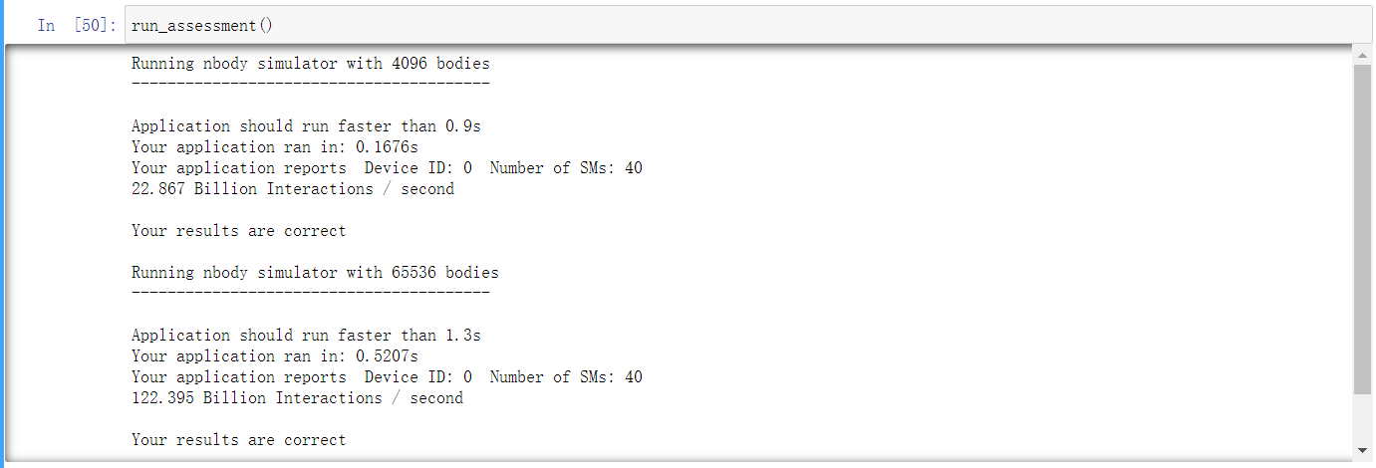
128-32*SMs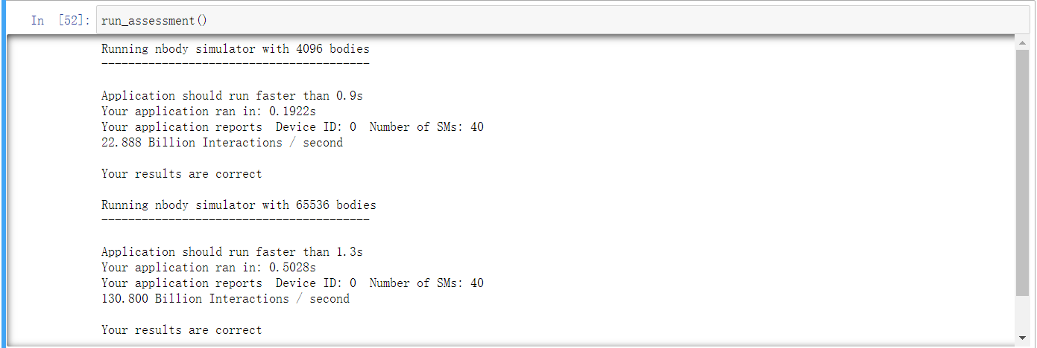
128-16*SMs
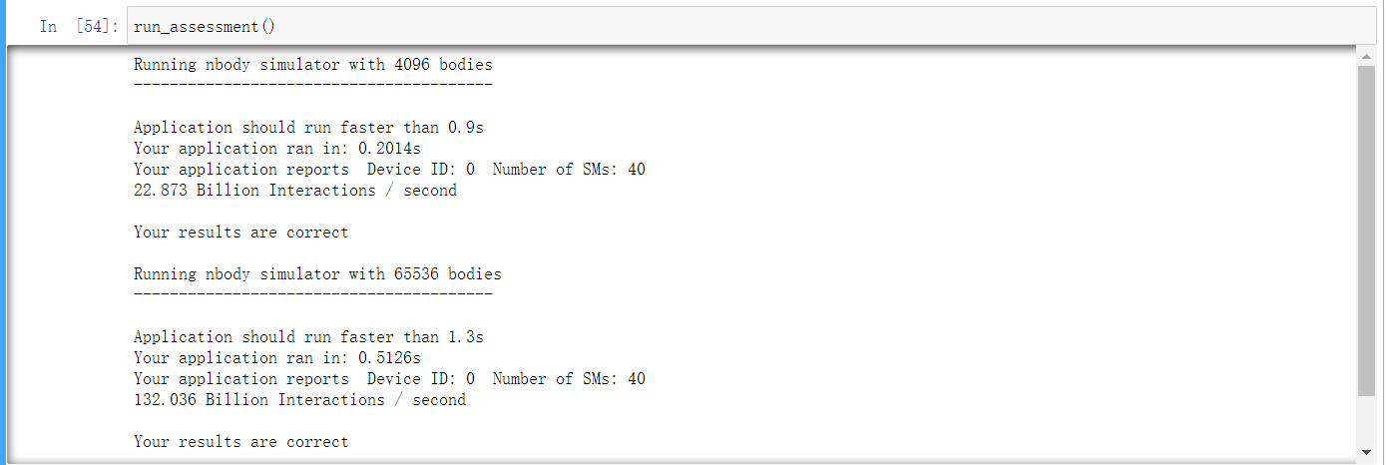
128-15*SMs
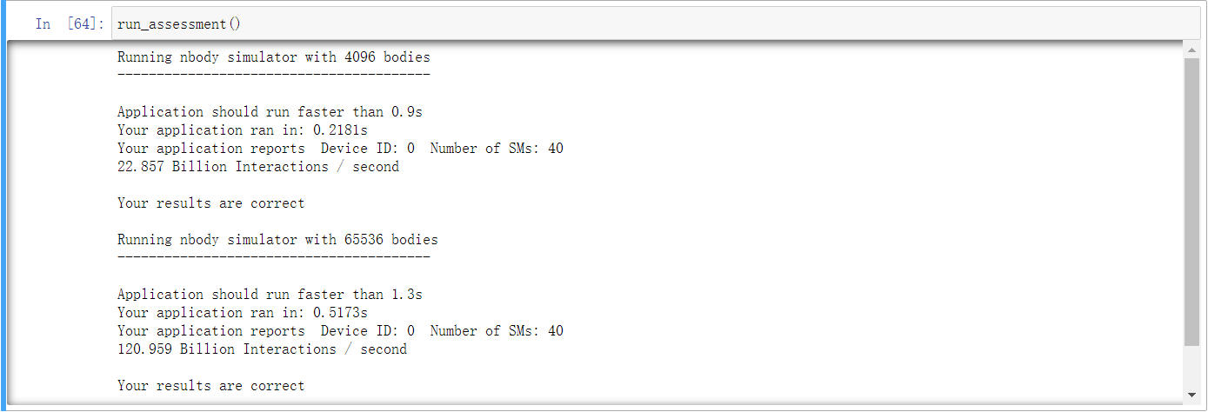
128-1281
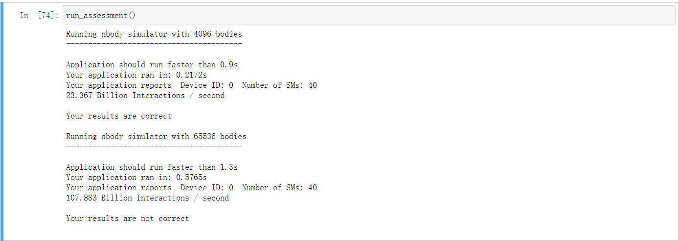
40-32*SMs
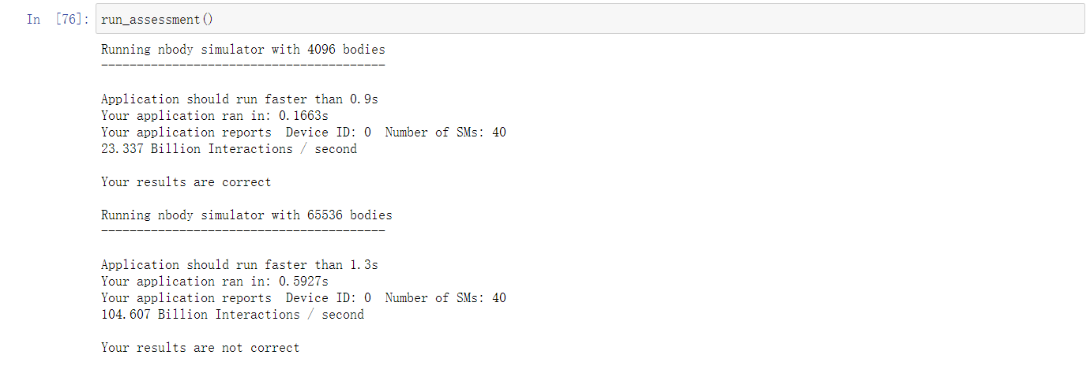
39-32*SMs

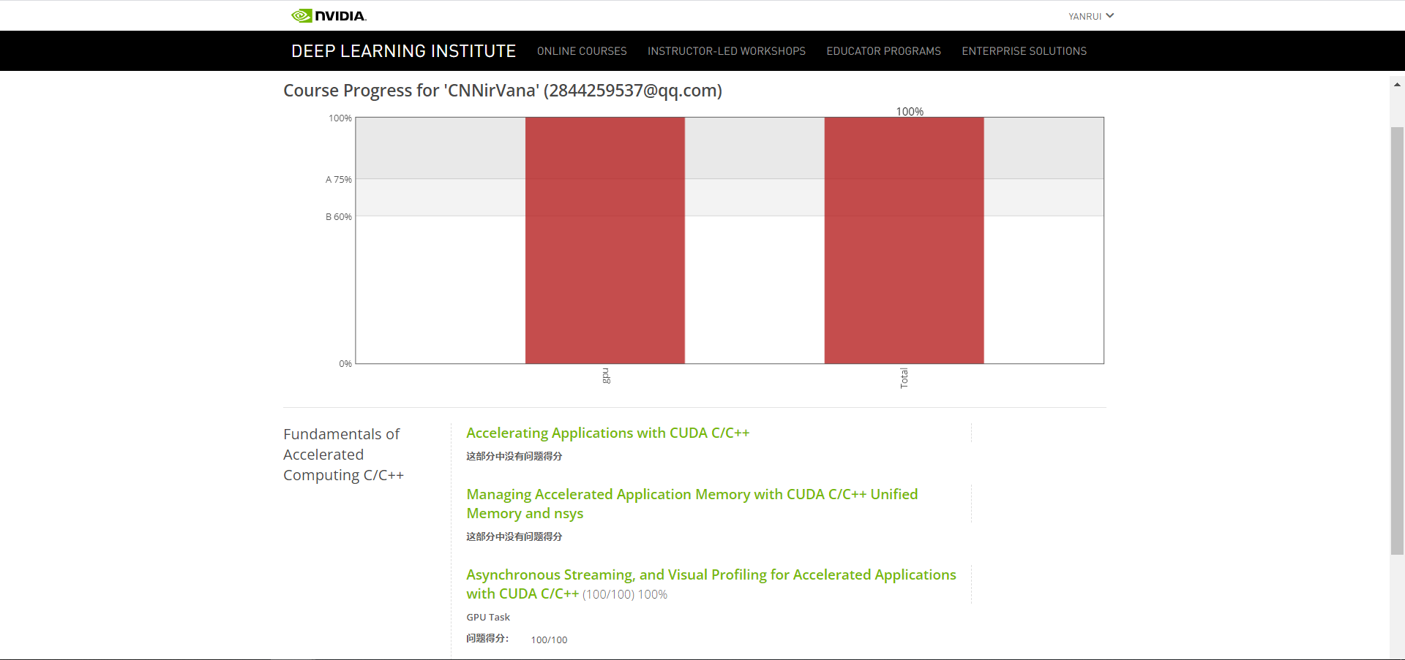
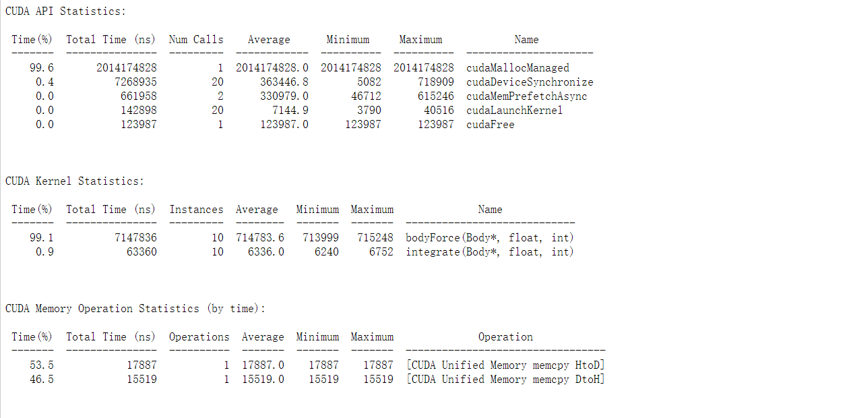2
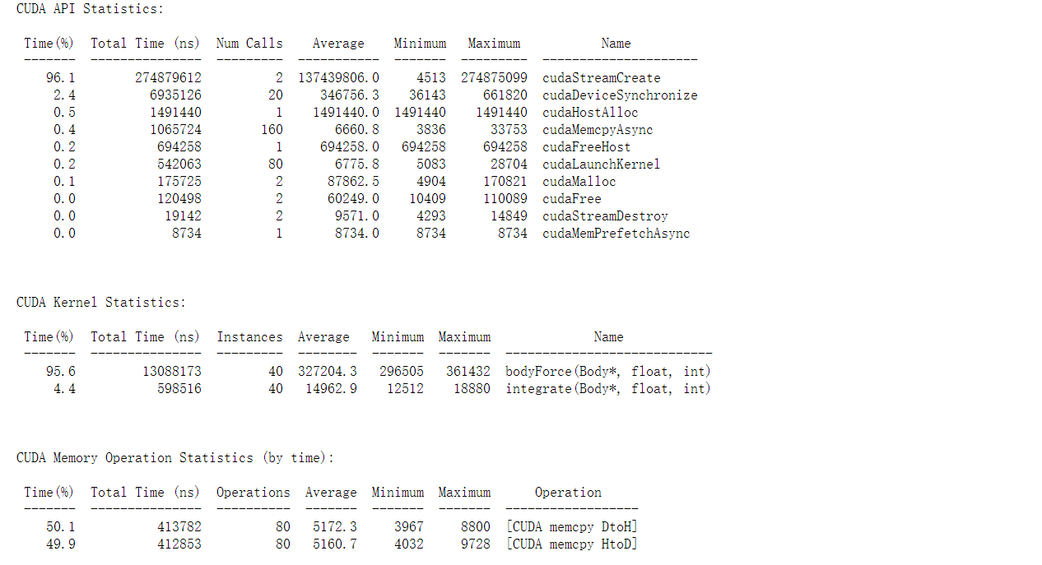3
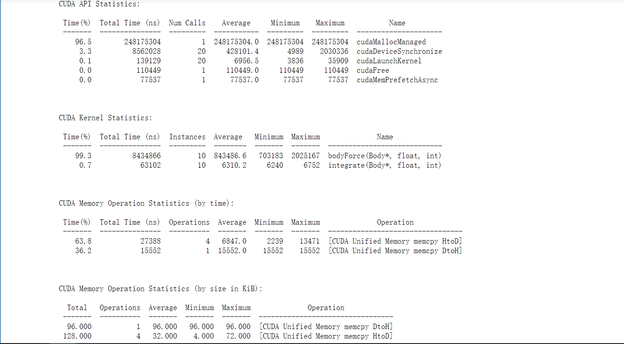no-fetch-4次HtoD

