题目：实验五：分治法

时间：2020年12月3日星期四

运行结果及截图：

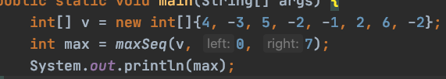



代码：

package exp05;

/\*\*

\* @author zhenwen

\* @date 2020/12/3

\*/

public class TestTwo {

public static void main(String[] args) {

int[] v = new int[]{4, -3, 5, -2, -1, 2, 6, -2};

int max = maxSeq(v, 0, 7);

System.out.println(max);

}

private static int max3(int x, int y, int z) {

if (x < y) {

x = y;

}

if (x < z) {

x = z;

}

return x;

}

private static int maxSeq(int[] v, int left, int right) {

if (left > right) {

return 0;

}

int mid = (left + right) / 2;

int leftMax = maxSeq(v, left, mid - 1);

int rightMax = maxSeq(v, mid + 1, right);

int max1 = v[mid];

int sum = v[mid];

for (int i = mid + 1; i <= right; i++) {

sum += v[i];

if (max1 < sum) {

max1 = sum;

}

}

int max2 = v[mid];

sum = v[mid];

for (int i = mid - 1; i >= left; i--) {

sum += v[mid];

if (max2 < sum) {

max2 = sum;

}

}

int midMax = max1 + max2 - v[mid];

return max3(leftMax, midMax, rightMax);

}

}