# 实验一 基于Servlet的CRUD

一、实验目的：

熟悉并掌握运用Servlet开发模式 (HTML+JSP+JavaBean+Servlet)即MVC模式实现数据库CRUD基本编程。

二、实验内容：

在MyEclipse环境下运用HTML+JSP+JavaBean+Servlet以及JDBC技术完成相应的数据库CRUD功能，调试运行程序。

三、实验要求：

1. 熟悉并掌握运用MVC技术开发功能模块的基本步骤；

2. 运用相关技术（HTML+JSP+JavaBean+Servlet以及JDBC）完成规定功能；

3. 写出实验报告。

1. 实验步骤：

1设计数据库表结构。

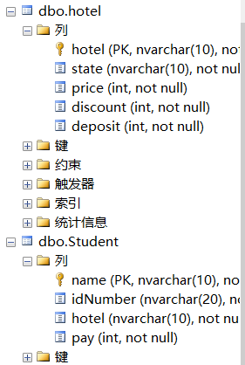

2采用MVC技术完成数据库的CRUD

**总目录结构：**

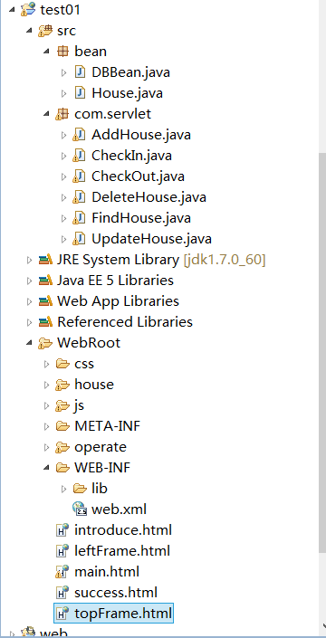

3程序运行截图。

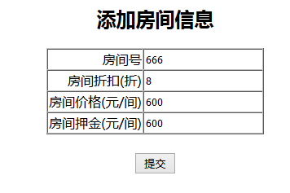

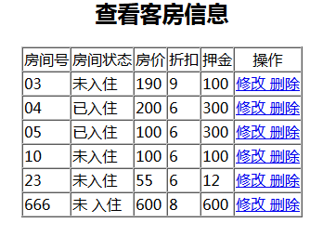

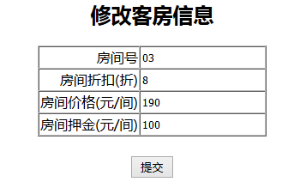

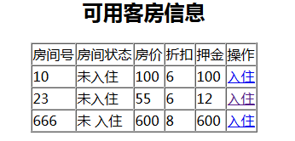

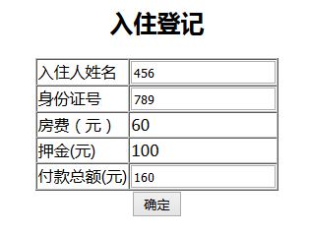

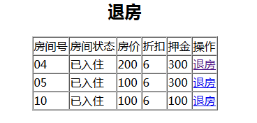

4关键源码

**house/findHouse.jsp**

|  |
| --- |
| <%@ page language=*"java"* import=*"java.util.*"* import=*"bean.House"* pageEncoding=*"utf-8"*%>  <%  String path = request.getContextPath();  String basePath = request.getScheme()+"://"+request.getServerName()+":"+request.getServerPort()+path+"/";  %>  <!DOCTYPE HTML PUBLIC "-//W3C//DTD HTML 4.01 Transitional//EN">  <html>  <head>  <base href=*"*<%=basePath%>*"*>    <title>My JSP 'findHouse.jsp' starting page</title>    <meta http-equiv=*"pragma"* content=*"no-cache"*>  <meta http-equiv=*"cache-control"* content=*"no-cache"*>  <meta http-equiv=*"expires"* content=*"0"*>  <meta http-equiv=*"keywords"* content=*"keyword1,keyword2,keyword3"*>  <meta http-equiv=*"description"* content=*"This is my page"*>  <!--  <link rel="stylesheet" type="text/css" href="styles.css">  -->  </head>  <body>  <h2 align=*"center"*>查看客房信息</h2>  <%  List<House> list=(List<House>)request.getAttribute("list");  System.out.println("123:"+list);  %>  <table border=*"1"* cellspacing=*"0"* align=*"center"*>  <tr>  <td>房间号</td><td>房间状态</td><td>房价</td><td>折扣</td><td>押金</td><td align=*"center"*>操作</td>  </tr>  <%  **for**(House house : list)  {  %>  <tr>  <td><%=house.getHouseId() %></td><td><%=house.getHouseState() %></td>  <td><%=house.getHousePrice() %></td><td><%=house.getHouseDiscount() %></td>  <td><%=house.getHouseDeposit() %></td><td><a href=*"house/updateHouse.jsp?houseId=*<%=house.getHouseId() %>  *&housePrice=*<%=house.getHousePrice() %>*&houseDiscount=*<%=house.getHouseDiscount()%>  *&houseDeposit=*<%=house.getHouseDeposit() %>*"*>修改 </a><a href=*"deleteHouseServlet?houseId=*<%=house.getHouseId() %>*"*>删除</a></td>  </tr>  <%  }  %>  </table>  </body>  </html> |

**house/updateHouse.jsp**

|  |
| --- |
| <%@ page language=*"java"* import=*"java.util.*"* pageEncoding=*"utf-8"*%>  <%  String path = request.getContextPath();  String basePath = request.getScheme()+"://"+request.getServerName()+":"+request.getServerPort()+path+"/";  %>  <!DOCTYPE HTML PUBLIC "-//W3C//DTD HTML 4.01 Transitional//EN">  <html>  <head>  <base href=*"*<%=basePath%>*"*>    <title>My JSP 'update.jsp' starting page</title>    <meta http-equiv=*"pragma"* content=*"no-cache"*>  <meta http-equiv=*"cache-control"* content=*"no-cache"*>  <meta http-equiv=*"expires"* content=*"0"*>  <meta http-equiv=*"keywords"* content=*"keyword1,keyword2,keyword3"*>  <meta http-equiv=*"description"* content=*"This is my page"*>  <!--  <link rel="stylesheet" type="text/css" href="styles.css">  -->  </head>    <body>  <%  String houseId=(String)request.getParameter("houseId").trim();  **int** housePrice=Integer.parseInt((String)request.getParameter("housePrice").trim());  **int** houseDiscount=Integer.parseInt((String)request.getParameter("houseDiscount").trim());  **int** houseDeposit=Integer.parseInt((String)request.getParameter("houseDeposit").trim());  %>  <h2 align=*"center"*>修改客房信息</h2>  <form action=*"updateHouseServlet"* method=*"post"*>  <table border=*"1"* align=*"center"* cellspacing=*"0"*>  <tr>  <td align=*"right"*>房间号</td><td><input type=*"text"* size=*"20"* name=*"id"* style="border:*none*" value=*"*<%=houseId %>*"* readonly=*"readonly"*></td>  </tr>  <tr>  <td align=*"right"*>房间折扣(折)</td><td><input type=*"text"* size=*"20"* name=*"discount"* style="border:*none*" value=*"*<%=houseDiscount %>*"*></td>  </tr>  <tr>  <td align=*"right"*>房间价格(元/间)</td><td><input type=*"text"* size=*"20"* name=*"price"* style="border:*none*" value=*"*<%=housePrice %>*"*></td>  </tr>  <tr>  <td align=*"right"*>房间押金(元/间)</td><td><input type=*"text"* size=*"20"* name=*"deposit"* style="border:*none*"value=*"*<%=houseDeposit %>*"*></td>  </tr>  </table>  <br>  <div align=*"center"*><input type=*"submit"* value=*"提交"*></div>  </form>  </body>  </html> |

**operate/checkIn.jsp**

|  |
| --- |
| <%@ page language=*"java"* import=*"java.util.*"* import=*"bean.House"* pageEncoding=*"utf-8"*%>  <%  String path = request.getContextPath();  String basePath = request.getScheme()+"://"+request.getServerName()+":"+request.getServerPort()+path+"/";  %>  <!DOCTYPE HTML PUBLIC "-//W3C//DTD HTML 4.01 Transitional//EN">  <html>  <head>  <base href=*"*<%=basePath%>*"*>    <title>My JSP 'readyCheckIn.jsp' starting page</title>    <meta http-equiv=*"pragma"* content=*"no-cache"*>  <meta http-equiv=*"cache-control"* content=*"no-cache"*>  <meta http-equiv=*"expires"* content=*"0"*>  <meta http-equiv=*"keywords"* content=*"keyword1,keyword2,keyword3"*>  <meta http-equiv=*"description"* content=*"This is my page"*>  <!--  <link rel="stylesheet" type="text/css" href="styles.css">  -->  </head>    <body>  <h2 align=*"center"*>可用客房信息</h2>  <%  List<House> list=(List<House>)request.getAttribute("list");  %>  <table border=*"1"* cellspacing=*"0"* align=*"center"*>  <tr>  <td>房间号</td><td>房间状态</td><td>房价</td><td>折扣</td><td>押金</td><td align=*"center"*>操作</td>  </tr>  <%  **for**(House house : list)  {  System.out.println(house.getHouseState().replaceAll(" ", ""));  **if**(house.getHouseState().replaceAll(" ", "").equals("未入住"))  {  %>  <tr>  <td><%=house.getHouseId() %></td><td><%=house.getHouseState() %></td>  <td><%=house.getHousePrice() %></td><td><%=house.getHouseDiscount() %></td>  <td><%=house.getHouseDeposit() %></td><td><a href=*"operate/checkInDel.jsp?houseId=*<%=house.getHouseId() %>  *&housePrice=*<%=house.getHousePrice() %>*&houseDiscount=*<%=house.getHouseDiscount()%>  *&houseDeposit=*<%=house.getHouseDeposit() %>*"*>入住 </a></td>  </tr>  <% }  }  %>  </table>  </body>  </html> |

**com.servlet.FindHouse.java**

**package com.servlet;**

**import java.io.IOException;**

**import java.io.PrintWriter;**

**import java.sql.ResultSet;**

**import java.util.ArrayList;**

**import java.util.List;**

**import javax.servlet.ServletException;**

**import javax.servlet.http.HttpServlet;**

**import javax.servlet.http.HttpServletRequest;**

**import javax.servlet.http.HttpServletResponse;**

**import com.sun.corba.se.spi.orbutil.fsm.Guard.Result;**

**import bean.DBBean;**

**import bean.House;**

**public class FindHouse extends HttpServlet {**

**protected void processRequest(HttpServletRequest request,HttpServletResponse response)**

**throws ServletException,IOException**

**{**

**response.setContentType("text/html;charset=utf-8");**

**String type=request.getParameter("type");**

**String sql="select * from hotel";**

**DBBean db=new DBBean();**

**PrintWriter out=response.getWriter();**

**try**

**{**

**List<House> list=new ArrayList<House>();**

**ResultSet rs=db.executeQuery(sql);**

**while(rs.next())**

**{**

**House house=new House();**

**house.setHouseId(rs.getString(1));**

**house.setHouseState(rs.getString(2));**

**house.setHousePrice(rs.getInt(3));**

**house.setHouseDiscount(rs.getInt(4));**

**house.setHouseDeposit(rs.getInt(5));**

**list.add(house);**

**}**

**db.close();**

**System.out.println(list);**

**request.setAttribute("list", list);**

**if(type.equals("Student"))**

**{**

**request.getRequestDispatcher("operate/checkIn.jsp").forward(request, response);**

**}**

**else if(type.equals("checkOut"))**

**{**

**request.getRequestDispatcher("operate/checkOut.jsp").forward(request, response);**

**}**

**else**

**{**

**request.getRequestDispatcher("house/findHouse.jsp").forward(request, response);**

**}**

**} catch (Exception e) {**

**// TODO: handle exception**

**out.println("<script language='javaScript'> alert('查询失败!');</script>");**

**out.close();**

**System.out.println("1+"+e);**

**}**

**}**

**protected void doGet(HttpServletRequest request,HttpServletResponse response)**

**throws ServletException,IOException**

**{**

**processRequest(request, response);**

**}**

**protected void doPost(HttpServletRequest request,HttpServletResponse response)**

**throws ServletException,IOException**

**{**

**processRequest(request, response);**

**}**

**}**

五、心得体会：

通过本次实验，对于利用servlet进行编程更加得心应手，之前都是有了解，但怕自己不会不敢在项目中使用。