**USER instruction (EF3.0 to EF3.1 data set converter)**

**Last Update 22/07/2022 – Version 1.0 beta**

**The EF3.0 to EF3.1 converter released is currently under the testing phase. The complete casuistry is expected to be covered by the converter once all the tendered EF3.0 datasets are delivered.**

The jar application has two main functions, the first converts **processes** data sets from EF3.0 to EF3.1, and the second function converts **lifecyclemodel** data sets from EF3.0 to EF3.1. In the case that a data stock contains both types of datasets, the two actions must be run in sequence (i.e., the first step run the procedure to convert process data sets, and after run the procedure to convert lifecyclemodel data sets).

1. **Procedure to convert process data sets**

Unzip the EF reference (zip) package,

Open the “Other” Folder

Launch the converter JAR application (it works with the updated version of JAVA, with Versions older than 8.190 the tool doesn’t work properly)

Run the Action “Start process data conversion”

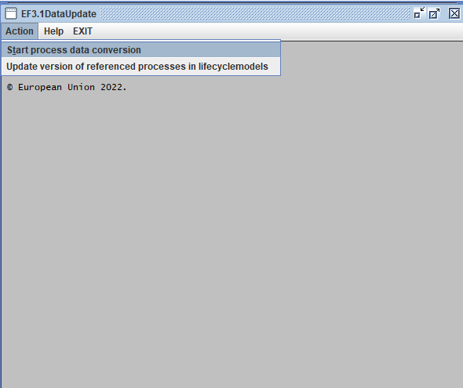

Choose the reference package (I.E. THE UNZIPPED REFERENCE PACKAGE MAIN FOLDER (DON’T SELECT SUB-FOLDERS WITHIN THE PACKAGE)

Click OPEN

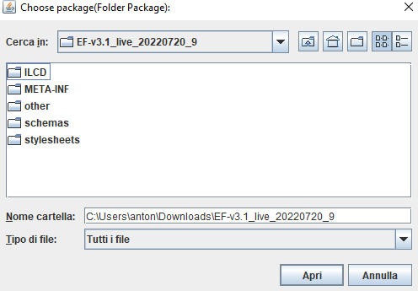

Choose the folder where the XML files of the processes to be converted are stored

Launch the tool by clicking OPEN.

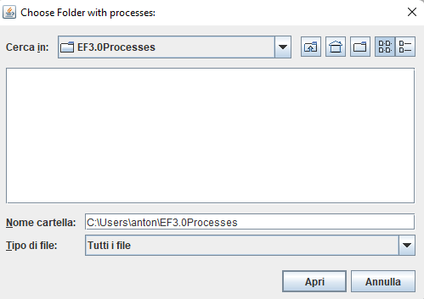

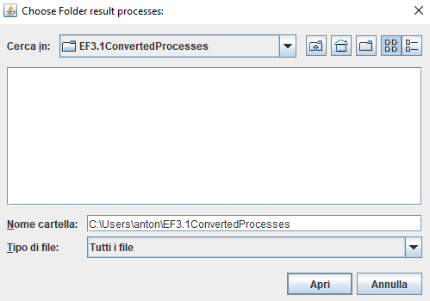

Select the folder where to store the converted (EF3.1) process data sets.

The processes will be converted in the original folder, and an app log (reporting errors, if any, and which processes have been updated or not) is generated in the folder where the results are stored (it can be moved to a different folder if needed).

1. **Procedure to convert lifecyclemodel data sets**

**(Note: before running the procedure for converting lifecyclemodel data sets, the procedure to convert process data sets (Section 1) has to be carried out.**

Run the Action “Update version of referenced processes in lifecyclemodels”



Choose the reference package (I.E. THE UNZIPPED REFERENCE PACKAGE MAIN FOLDER (DON’T SELECT SUB-FOLDERS WITHIN THE PACKAGE)

Click OPEN



Choose the folder where the XML files of the lifecyclemodel data sets to be converted are stored

Launch the tool by clicking OPEN.

Choose the folder where the XML files of the lifecyclemodels to be converted are stored

Launch the tool by clicking OPEN.

**Functions of the converter:**

* Update the version of the process and lifecyclemodel data sets
* Update the references of the linked process data sets to their new versions
* Update the references of the linked lciamethod data sets to their UUIDs
* Update the LCIA results for the impact categories of Climate Change, Ecotoxicity freshwater, Acidification, Photochemical Ozone Formation, Human Toxicity Cancer, and Human Toxicity Non-cancer.
* Update the declaration of the compliance system in line with the post-converted processes
* Addition of the following notice in the field “General description”:

“*Notice: this data set supersedes the EF3.0-compliant version (see link under "preceding data set version" below calculated with the EF3.0). The life cycle inventory is not changed from the original EF3.0 data set. The LCIA results are calculated based on the EF3.1 methods which provide updated characterisation factors in the following impact categories: Climate Change, Ecotoxicity freshwater, Photochemical Ozone Formation, Acidification, Human Toxicity non-cancer, and Human Toxicity cancer. The review report and the data quality ratings refer to the original results. The data set has been updated by the European Commission on the basis of the original EF3.0 data set delivered by the data provider*.”