**Installation and User Guide**

**1 Installation**

You can install the virtual environment by executing the following instructions：

**conda create -n CETA python==3.9.0**

**conda activate CETA**

**pip install diffusers==0.22.1**

**pip install git+https://github.com/tencent-ailab/IP-Adapter.git**

**cd CETA/Catvton**

**pip install -r requirements.txt**

Then you can download the required models and put them into CETA/models:

* CLIP-ViT-H-14: <https://huggingface.co/laion/CLIP-ViT-H-14-laion2B-s32B-b79K>
* Fahion-sd-2.1: <https://huggingface.co/Zhangwq76/fashion-adapter/tree/main/fashion-sd-2.1>
* Catvton: <https://huggingface.co/zhengchong/CatVTON>
* stable-diffusion-inpainting: <https://huggingface.co/booksforcharlie/stable-diffusion-inpainting>

Now you can start the robot by running:

**cd CETA/TelegramBotTest**

**python botTest.py**

##需要补充怎么打开机器人

**2 User Guide:**

Now you open the telegram robot, you can talk to it now !

You will see the screen like this：  
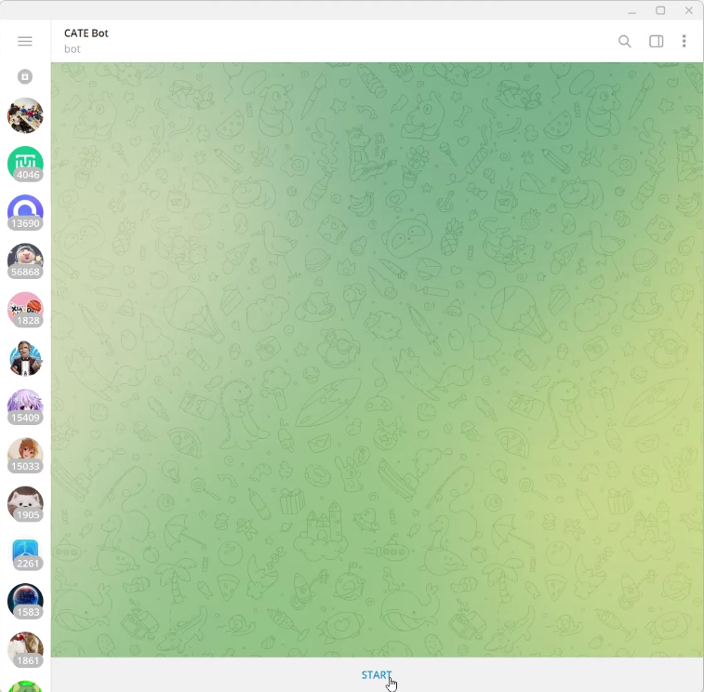

By pressing the start bottom，the robot will automatically send a guideline to you

You can simply ask for advice：

Or you have already had ideas about today’s outfits, you can ask it to search for you by using “/search” command  
电脑萤幕画面

If you are unsatisfied about your garment or the garment it provided, you can use command “/generate” to edit the clothes. You can either use image condition or text condition to edit it. While using text condition, the robot will search the corresponding components in database to replace the text condition into an image one, so that the generation model will always receive image conditions.

Fashion Adapter will generate 8 pictures in one time, you can pick your favorite one and use command “tryon” to specify a model to try on and do a virtual try on.

图形用户界面

**3 Reference**

[**IP-adapter**](https://github.com/tencent-ailab/IP-Adapter)

[**CatVTON**](https://github.com/Zheng-Chong/CatVTON?tab=readme-ov-file)

**4 Data Source**

**ARMANI: Part-level Garment-Text Alignment for Unified Cross-Modal Fashion Design:** [**2208.05621 (arxiv.org)**](https://arxiv.org/pdf/2208.05621)