**Data Driven Businesses with SQL & Tableau**

Understand the schema

Let’s take a moment to look at the schema of the database and understand how data goes from real customers purchasing products to the rows of these tables.

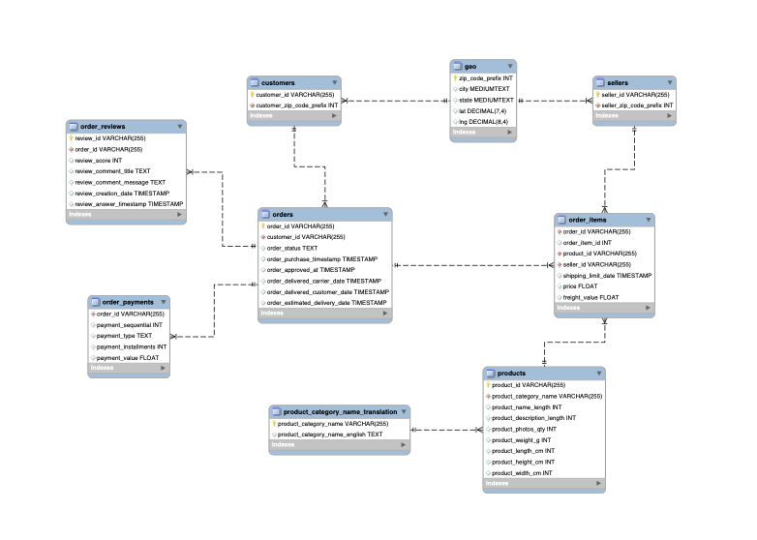

Let’s focus first of all on some tables that are just collections of items, independent of any transaction:

* **products.**contains a row for each product available for sale.
* **product_category_name_translation.**contains a relation of product categories in its original language, Portuguese, and English.
* **sellers.**contains a row for each one of the sellers registered in Magist’s marketplace.
* **customers.**contains a row for each customer that has made a purchase.
* **geo.**contains a relation between zip codes, coordinates and states, to obtain more precise information about sellers and customers.

Unless a new customer makes a purchase, a new product is released, or a new seller is registered, these tables remain unchanged during a transaction. The following tables are the ones responsible for capturing a purchase:

* **orders.**every time that an order is placed, a row is inserted in this table. Even if the order contains multiple products, here it will be reflected as a single row with an order_id that uniquely identifies it.
* **order_items.**this table contains one row for each *distinct* product of an order.

The relationship between orders and order_items can be better understood with an example. Imagine a customer purchases a Macbook Pro, two dongles, and a keyboard. The following rows would be added to each table:

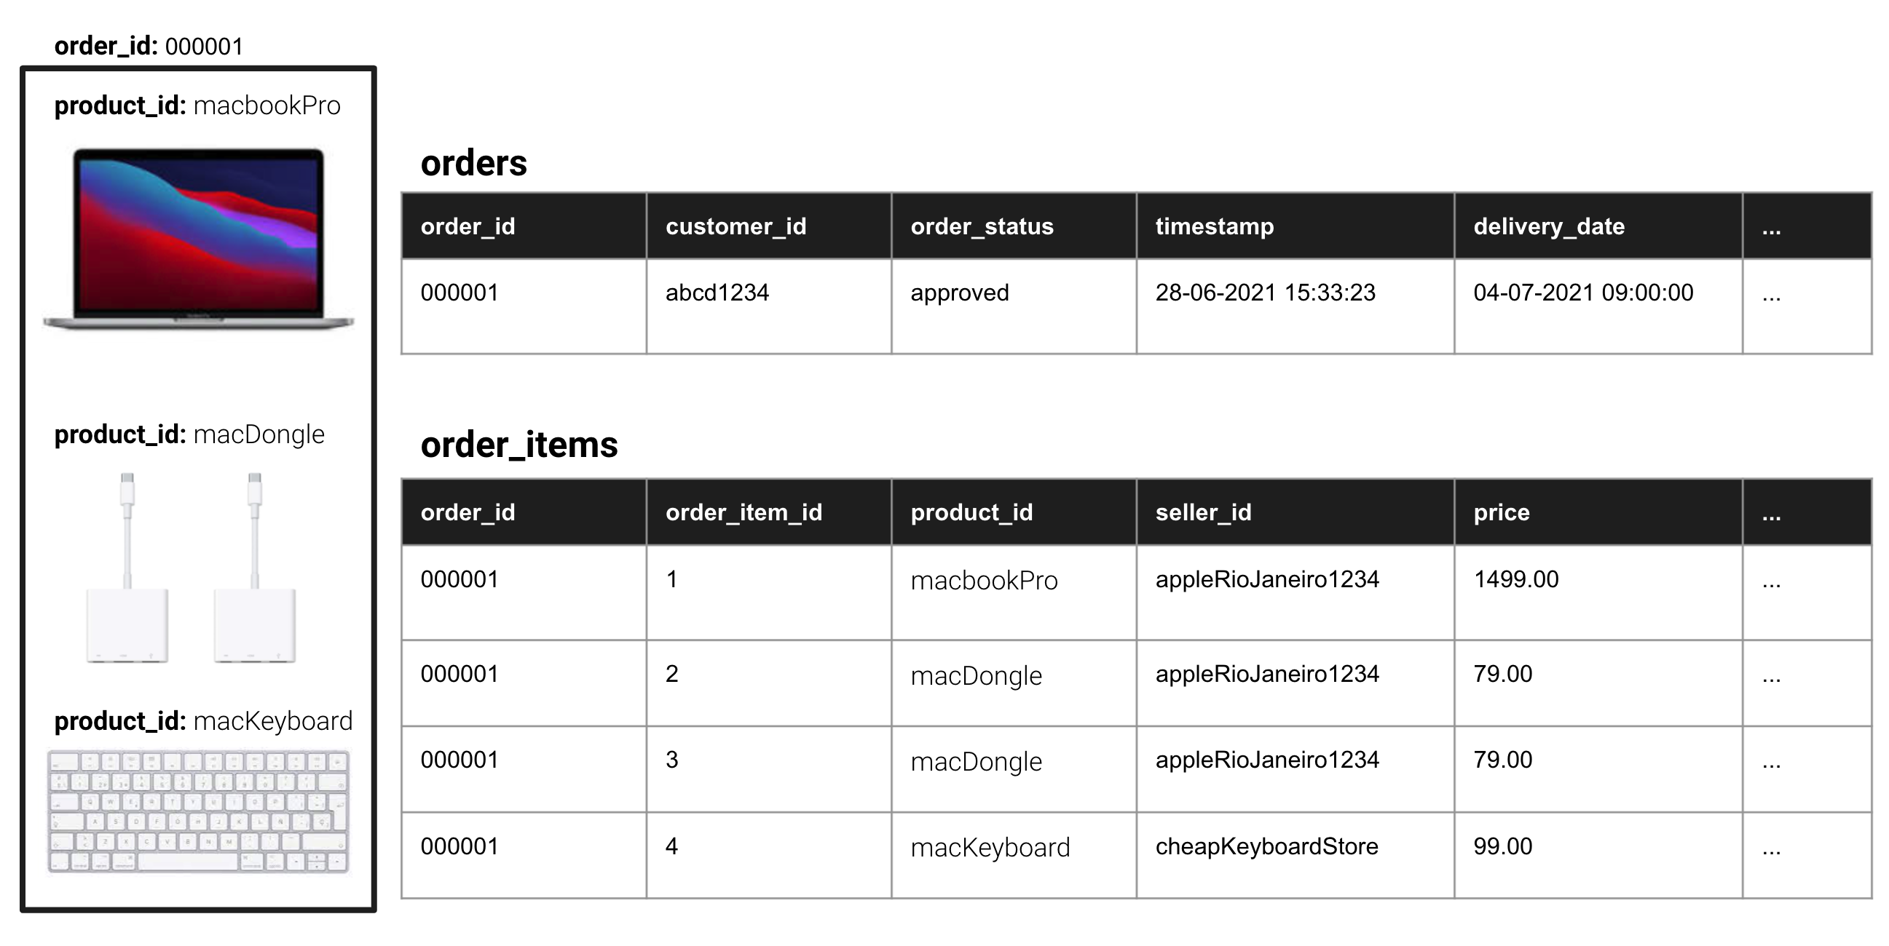

As you can see, the orders table contains only one row per order, in which information for the whole order like its status and delivery date is stored. But, as each order can contain multiple products, which can come from a different seller, have a different price, etc., the order_items table stores this information.

Both tables can be linked together by the order_id column: a unique identifier for each order. This will be specially relevant when we start doing JOINing multiple tables.

After an order is placed, a customer still needs to pay for it, and afterwards they can write a review. This information is stored in the corresponding tables:

* **order_payments.**customers can pay an order with different methods of payment.  Every time a payment is made, a row is inserted here. An order can be paid in by instalments, which means that a single order can have many separate payments.
* **order_reviews.**customers can leave multiple reviews corresponding to the order they placed.

You should now be ready for the next lesson, where we will start exploring the data!