**Homework Assignment 6: PCA and Face Recognition**

1. PCA Analysis
   1. Training images

C:\Users\Zhanneta\AppData\Local\Microsoft\Windows\INetCache\Content.Word\ps6-1-a.png

* 1. Average face

**Average face looks like a very blurry face that has rough shading for where ears, mouth, nose, and eyes are. It is hard to tell if it is a woman’s or a man’s face.**

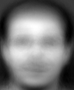

* 1. PCA analysis

**Eigen-faces look similar to an average face but with more unique features. You can tell that some of them have glasses or can guess about their facial expression.**

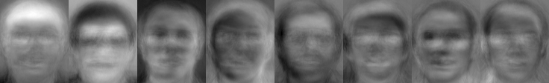

* 1. Capture 95% variance

**K =164**

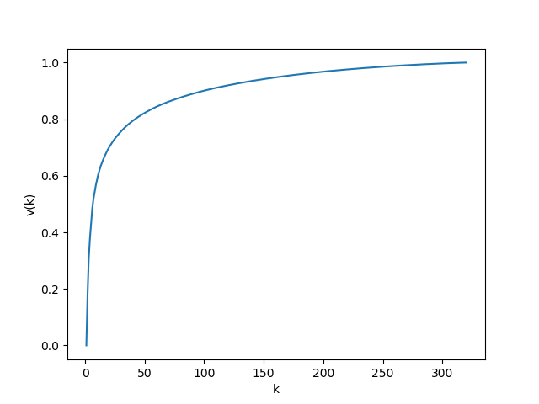

1. Feature Extraction for Face Recognition
   1. Feature extraction – training

**W training dimensions: (320, 164)**

* 1. Feature extraction – testing

**W testing dimensions: (80, 164)**

1. Face Recognition
   1. KNN

|  |  |
| --- | --- |
| **Number of Neighbors (k)** | **Accuracy** |
| 1 | 93.75 |
| 3 | 92.5 |
| 5 | 88.75 |
| 7 | 81.25 |
| 9 | 73.75 |
| 11 | 68.75 |

* 1. SVM

|  |  |
| --- | --- |
| **Kernel** | **Accuracy** |
| Linear | 96.25 |
| 3rd Degree Polynomial | 93.75 |
| Gaussian RBF | 97.5 |