TO: Andrew M. Cuomo, Governor of New York State

FROM: Zhanqiu Guo, a student from Cornell Summer School

SUBJECT: Saving the economy and controlling COVID-19 in New York state

DATE: 2020.8.2

**Executive Summary**

In 2020, COVID-19 broke out in the U.S. Among the states, New York state was hit the hardest in the past several months, leading to huge financial and economic loss. However, to better control the virus, you have to shut down the economy. Therefore, to balance these two objectives, I recommend implementing a case to case policy for each county in the New York state.

**Background**

In July.9th, according to Fig.1, we could see in the north of the state, the case rate is below 1000 in most of the counties, which shows that the virus has been successfully controlled in these counties. While, in the south of the state, which is the place with the most population (including Kings, Queens, New York, Suffolk, Bronx, which is the top 5 of the counties in population), has a higher case rate between 3000 to 4000. In short, the place with the most population suffered the most during this pandemic.

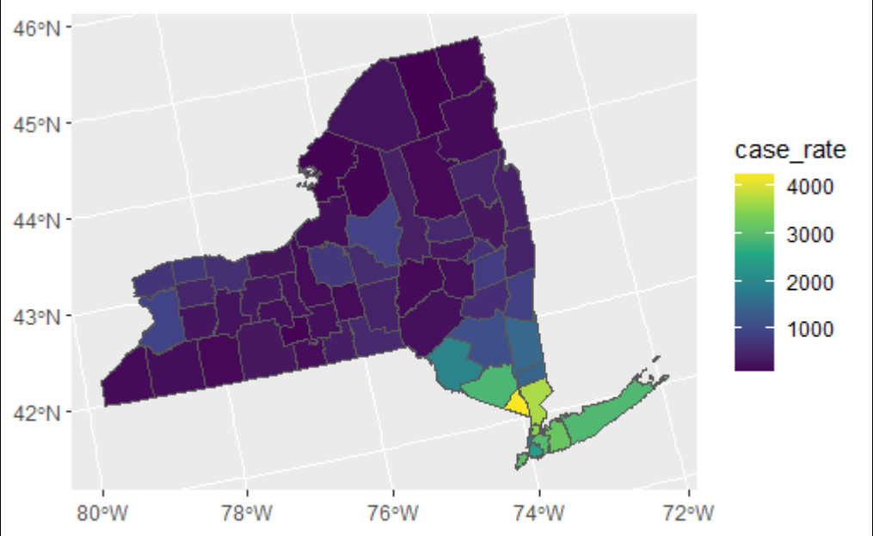

Fig.1 Case rate in New York state

Corresponding to the case rate, we see a various state for the spending in each county in New York state. In the south, the change in spending is in a relative low state, mostly negative. In the north, most of the state has a positive change in spending. However, there is still some counties in the north that has a relatively low change in spending. Among these counties in the south, Suffolk has a relative high spending change.

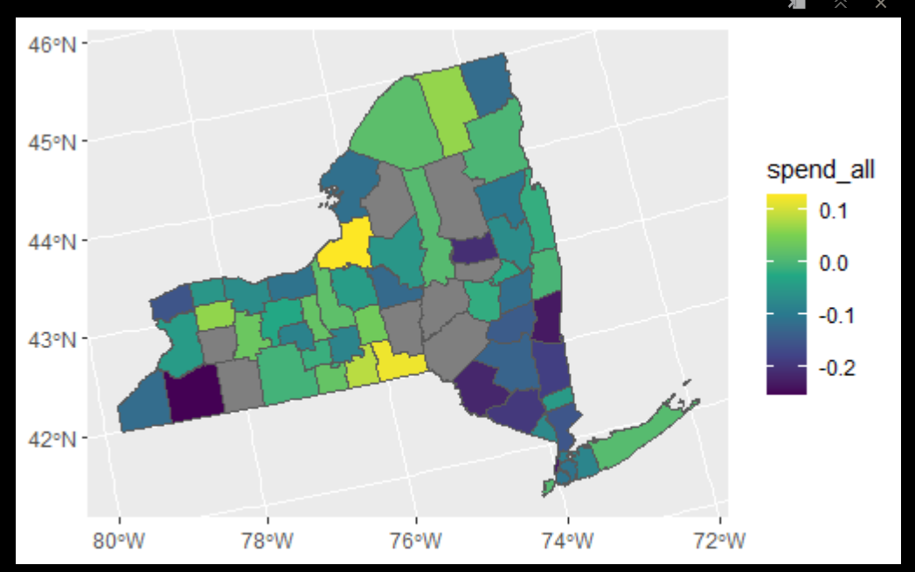

Fig.2 spending in New York state

However, if we see the number of confirmed new cased in the top 5 counties with the most population every day, which is shown in Fig.3, Suffolk has an increasing trend at the end of July. This is a sign that the county has not fully control the virus yet and the premature restart of the economy may lead to the deterioration of the pandemic. There is a significant negative relation between the change in spending and the new case rate from February to August. We then focus on the top 5 counties with the most population because the higher the population, the more spending it could take to the society. New York and Kings did the best job in controlling the virus, as the confirmed new case rate curve keeps at a low stage, while Bronx and Suffolk did the worst.

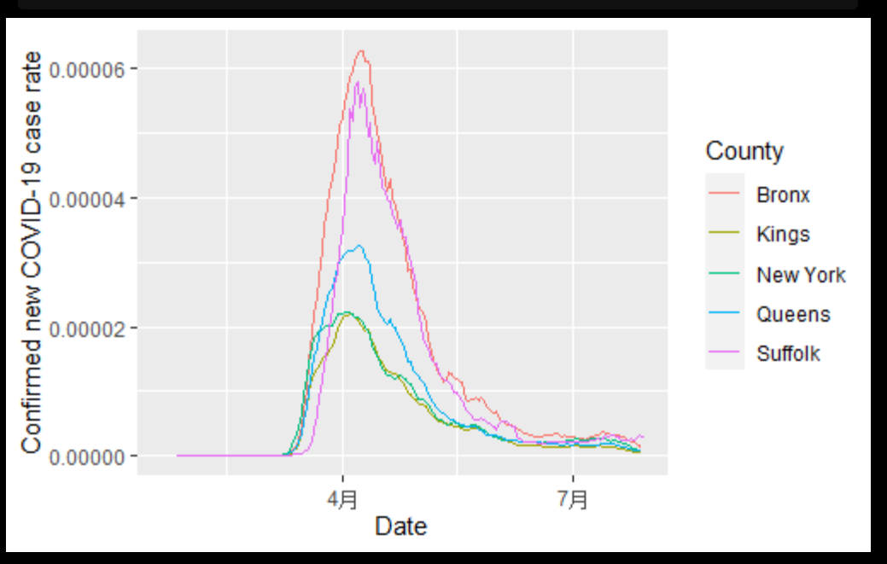

Fig 3. Confirmed case over time for the top 5 counties with highest population

For the spending in these counties, as shown in Fig 4., Suffolk has the smallest impact and New York the most. This shows that the shut down of economy is good for controlling the virus.

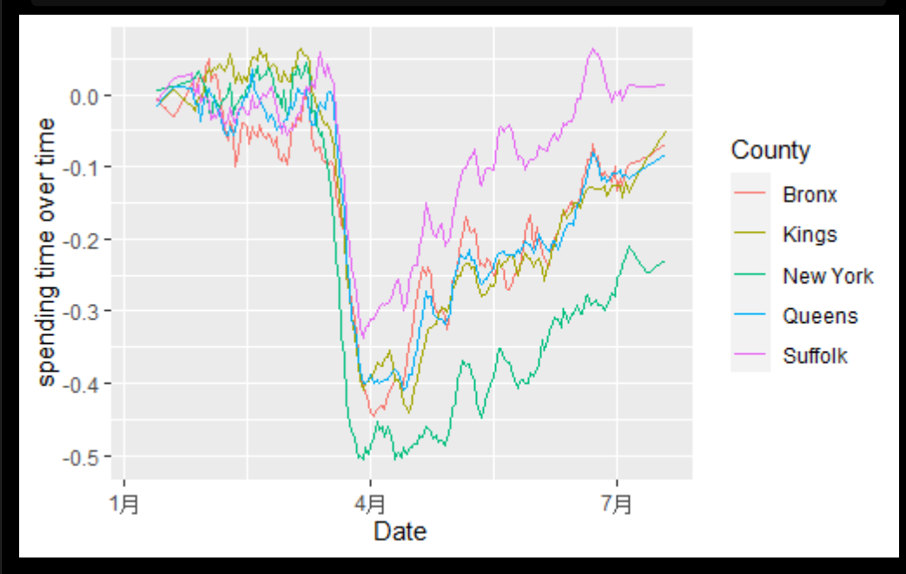

Fig 4. Spending change over time for the top 5 counties with highest population

**Option 1: restarting economy in the whole state**

Restart the economy for the whole state. Most of the counties have a low case rate and the counties with relative high case rate have also taken successful control of the virus now comparing with the data in April. The restart of the economy may not lead to a fast spreading of the virus in a short time period. Many counties with a low case rate have not restart their economy according to the spending data. There is a potential for restarting economy in these places.

Pros: the best for the economy in short run, easy to be implemented

Cons: risk of new outbreak in the future

**Options 2: case to case policy for each county in the New York state**

In the north of the state, although most counties have controlled the virus well, some of them still have a low spending level. For them, the government should encourage the work resumption in these counties. While in the south, the case rate keeps at a high level. The government should reinforce the control of the virus overall by shutting down the economy. For the 5 top counties, in specific, New York could speed up the work resumption while Suffolk should shut down the economy in order to better control the virus.

Pros: responding to the situation in every county, better targeting the problem

Cons:

1. only consider the relation between case rate and spending, which do not consider other factors such as the population mobility.
2. Hard to be implemented as different county should enact different policy.

**Recommendation:**

I recommend the second option, which is restarting economy in the north of the state and New York county while enforcing virus control in the south of the state especially in Suffolk county. This policy considers both the overall situation and the specific cases in each county. It also chooses the county that have the most population to study in-depth and focus on, making the policy easier to be put into act. The better targeting of the problem could help this policy to have a better effect, both saving the economy and controlling the pandemic.