**Task 1**

[**https://data.egov.kz/datasets/view?index=kadrlardy_dayarlau_bagyttary_b**](https://data.egov.kz/datasets/view?index=kadrlardy_dayarlau_bagyttary_b)

**I installed first 100 rows**

**Task 2**

**Json in MS SQL Serve:**

Declare @JSON varchar(max)

SELECT @JSON=BulkColumn

FROM OPENROWSET (BULK 'C:\Users\Lenovo\Desktop\DB2\assighment1\kadrlardy_dayarlau_bagyttary_b-v1.json', SINGLE_CLOB) import

SELECT * INTO db2

FROM OPENJSON (@JSON)

WITH

(

[faculties] varchar(300), [name] varchar(300), [region] varchar(300), [avg_state_cost] integer, [avg_commercial_cost] nvarchar(300)

)

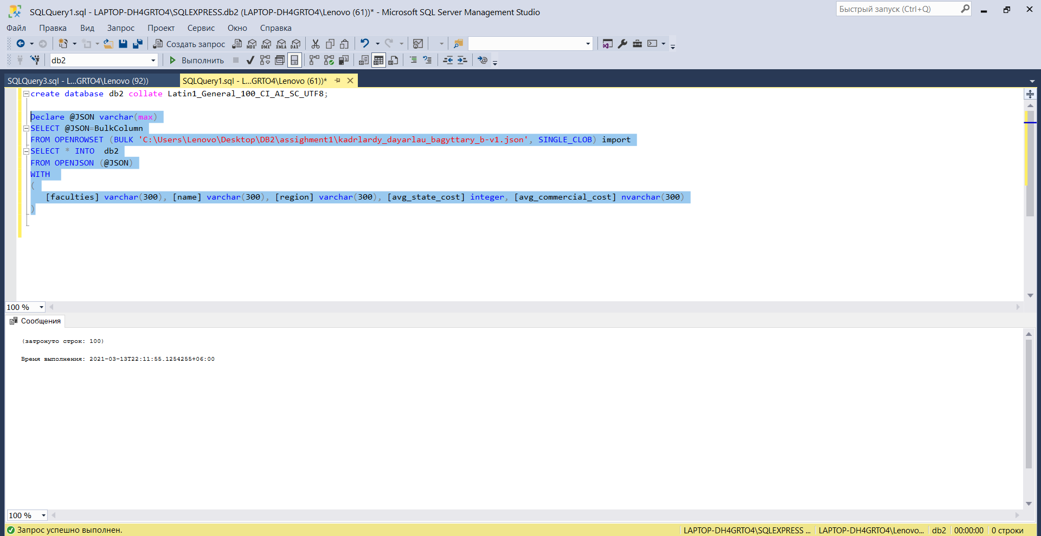

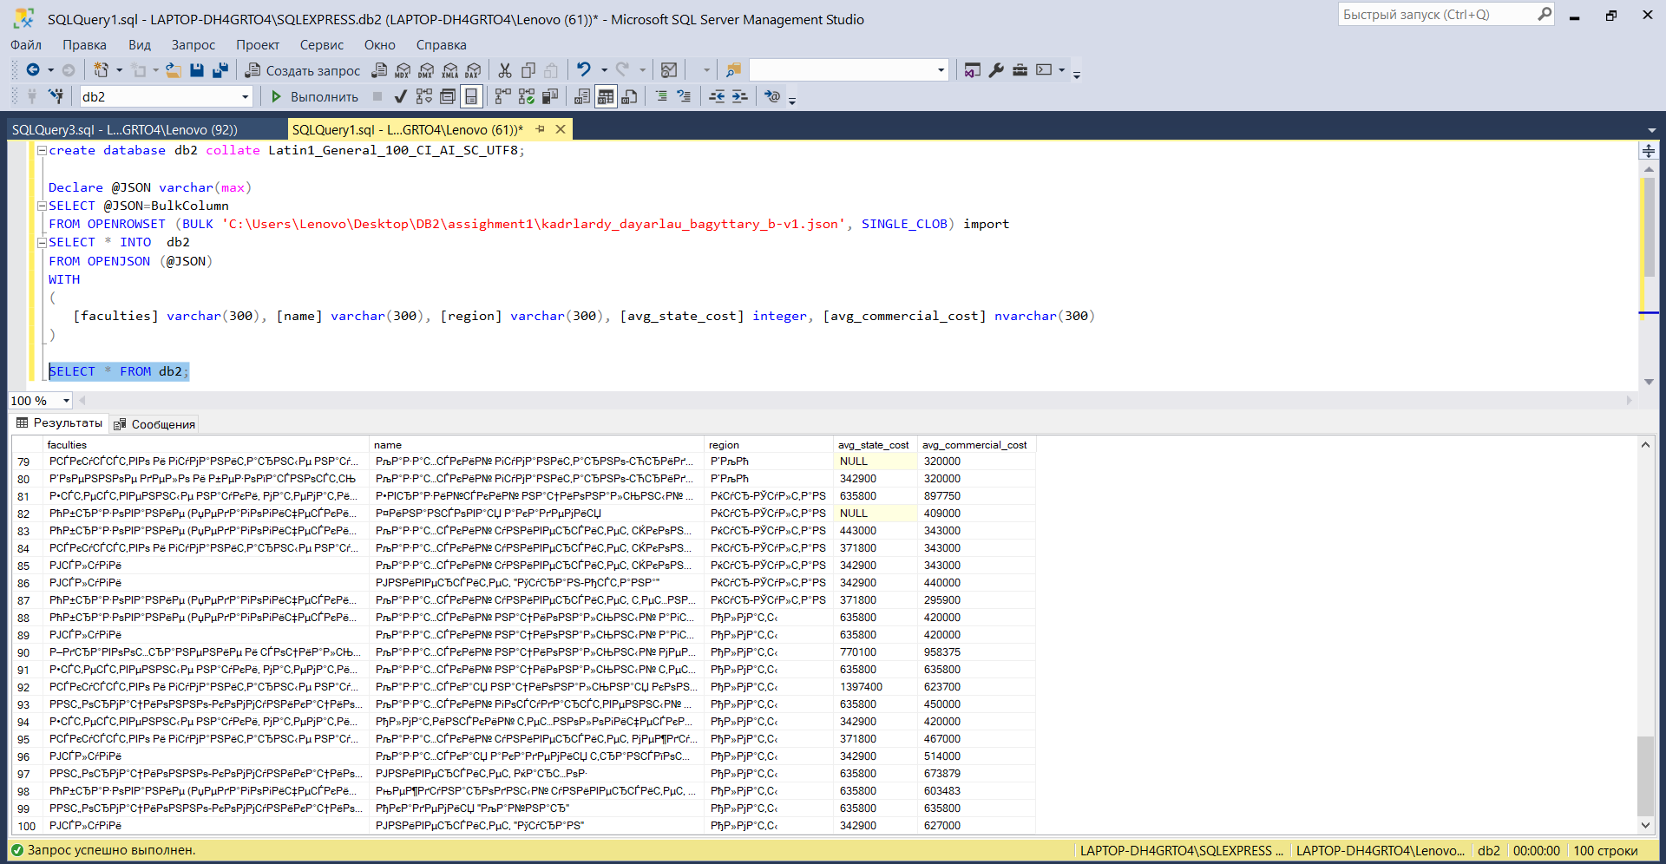

(Note: Even when I used collation table still didn’t encrypt utf8 but since instructor said it’s okay and the most important thing that json file is imported as table hope it won’t be a minus)

**CSV in Oracle, I used Oracle’s tools as it was suggested**

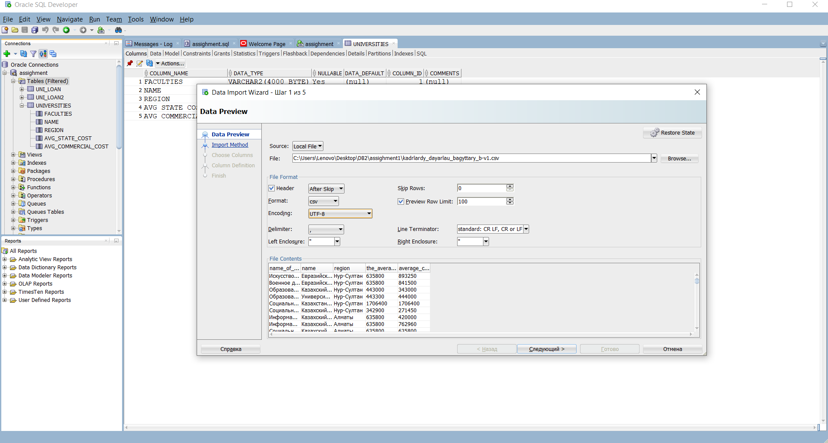

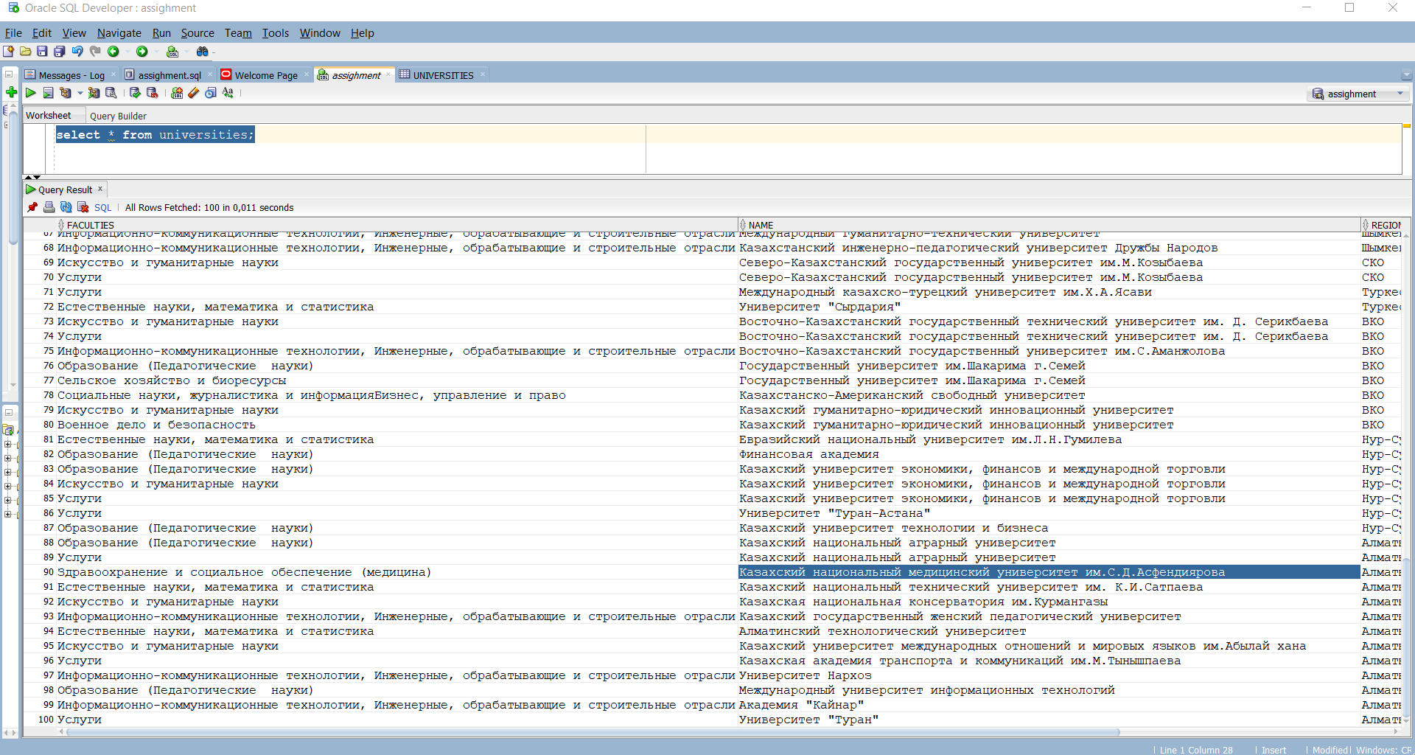

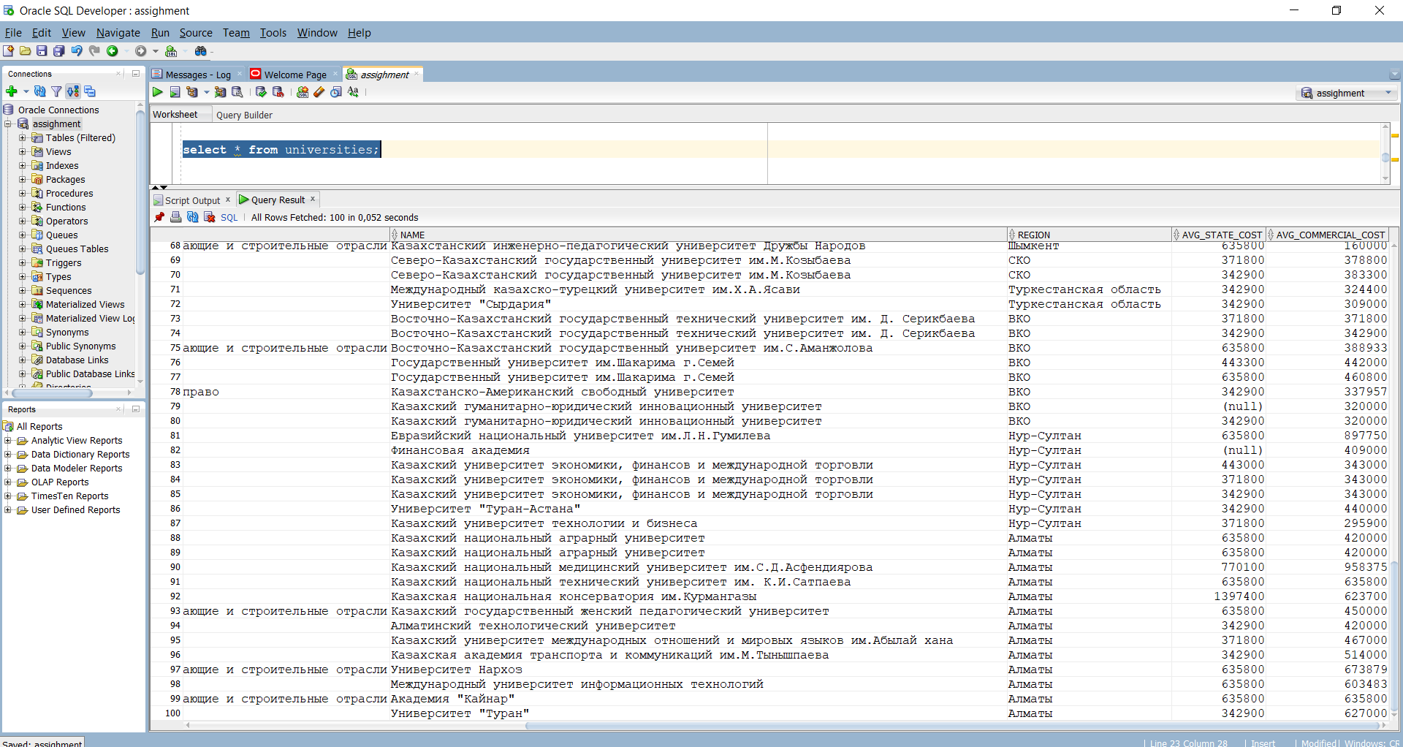

**Task 3**

DECLARE

CURSOR cur IS

SELECT

SUM(CASE WHEN faculties IS NULL THEN 1 ELSE 0 END) AS faculties,

SUM(CASE WHEN name IS NULL THEN 1 ELSE 0 END) AS name,

SUM(CASE WHEN region IS NULL THEN 1 ELSE 0 END) AS region,

SUM(CASE WHEN avg_state_cost IS NULL THEN 1 else 0 END) AS avg_state_cost,

SUM(CASE WHEN avg_commercial_cost IS NULL THEN 1 else 0 END) AS avg_commercial_cost

FROM UNI_LOAN;

cur_rec cur%ROWTYPE;

BEGIN

FOR cur_rec IN cur LOOP

DBMS_OUTPUT.PUT_LINE('Number of NULL values for each column');

DBMS_OUTPUT.PUT_LINE('Faculties: '|| cur_rec.faculties);

DBMS_OUTPUT.PUT_LINE('Name: ' || cur_rec.name);

DBMS_OUTPUT.PUT_LINE('Region: ' || cur_rec.region );

DBMS_OUTPUT.PUT_LINE('Avg_sate_cost: ' || cur_rec.avg_state_cost);

DBMS_OUTPUT.PUT_LINE('Avg_commercial_cost: ' || cur_rec.avg_commercial_cost);

END LOOP;

END;

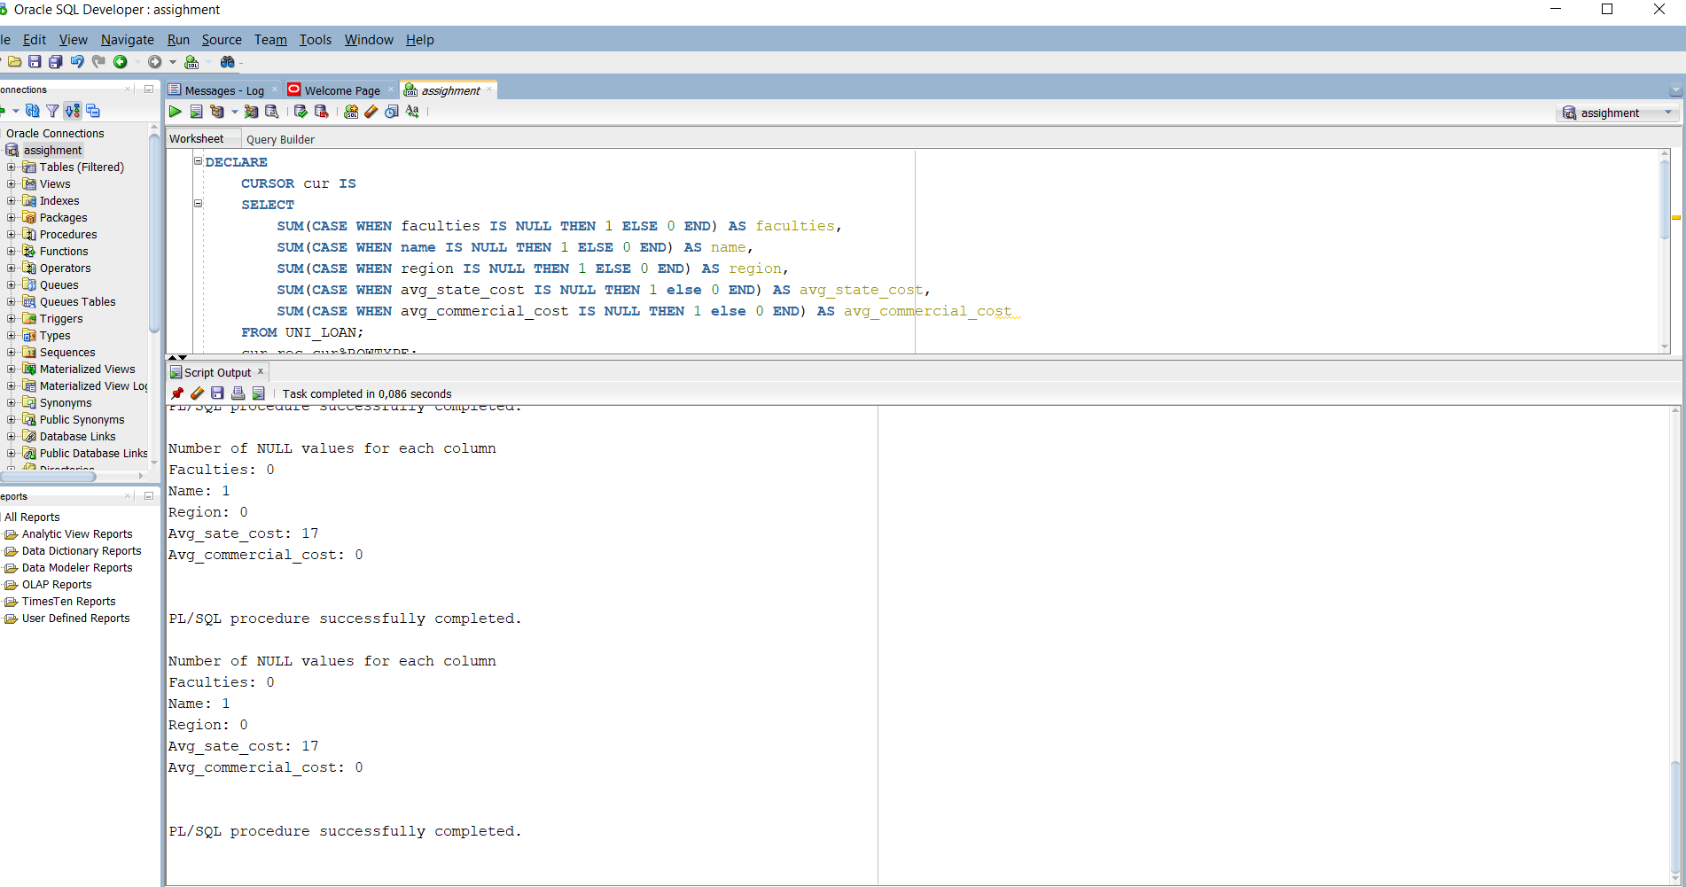

**Task 4**

1. **The cheapest region to study based on average comercial cost for region is in West Kazakhstan average cost for region is – 251078,75tg while the most expensive is Akmola region – 593025 tg**
2. **Atyrau region has the smallest number of universities, that is 1. While Almaty has the biggest number of universities which is 31**
3. **The most expensive university is “Казахстанский филиал МГУ им.М.В. Ломоносова” located at Nursultan based on average commercial cost of all faculties of this university. The average commercial cost is 1706400 tg**

**SQL code:**

**1)**

SELECT region, AVG(avg_commercial_cost)

FROM universities

GROUP BY region

ORDER BY 2 DESC;

**2)**

SELECT region, count(*) as num

FROM universities

GROUP BY region

ORDER BY num ;

**3) select * from universities where AVG_COMMERCIAL_COST = (select max(AVG_COMMERCIAL_COST) from universities);**

**Result:**

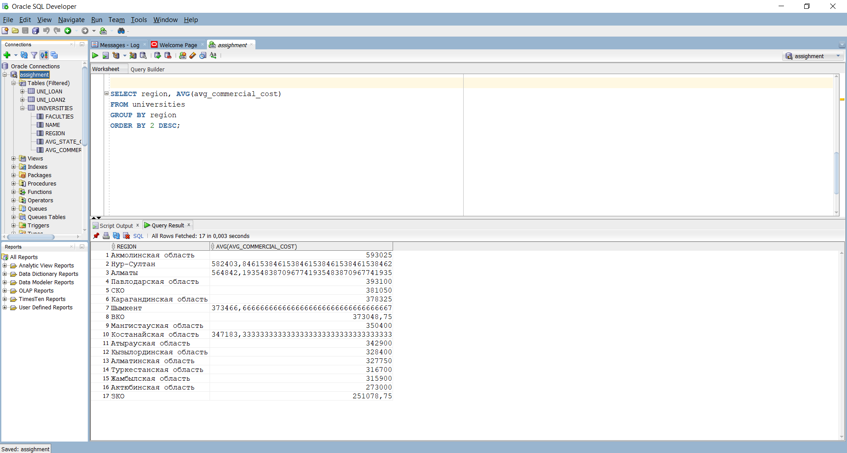

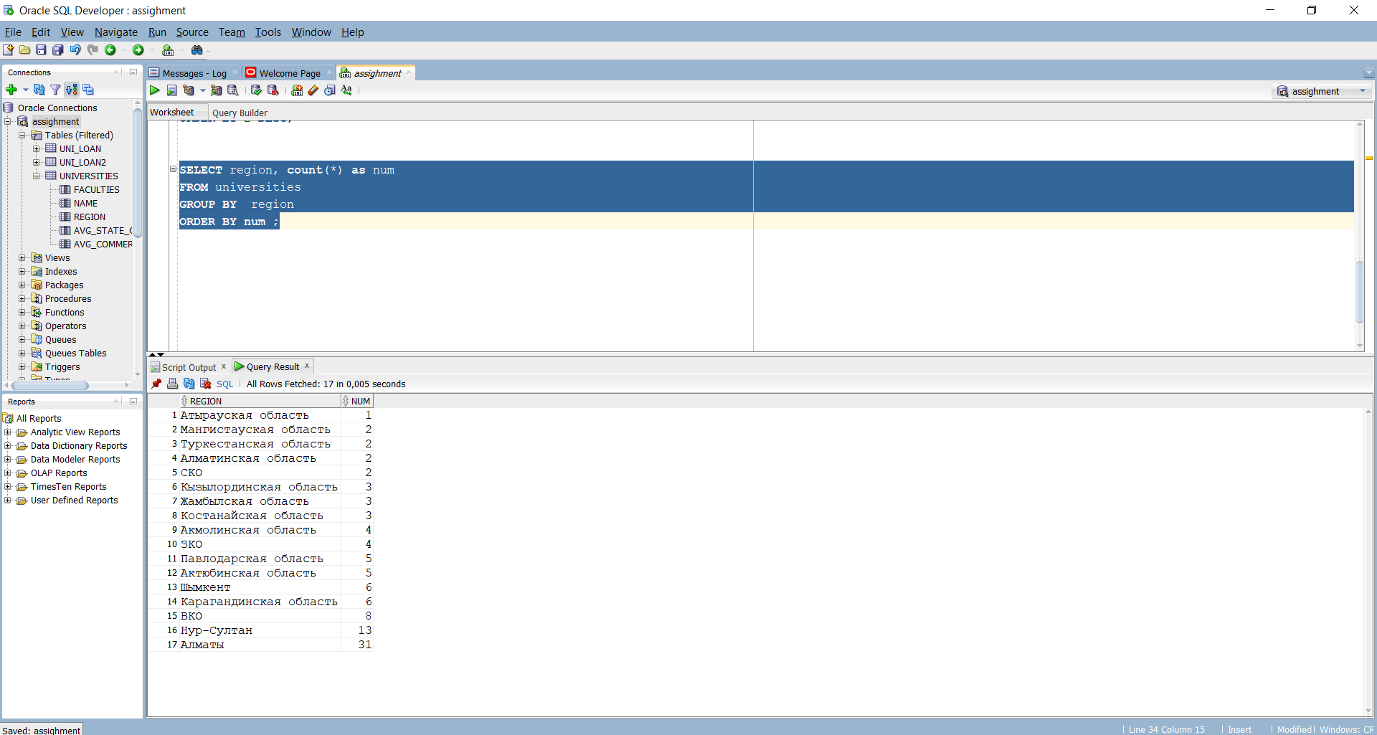

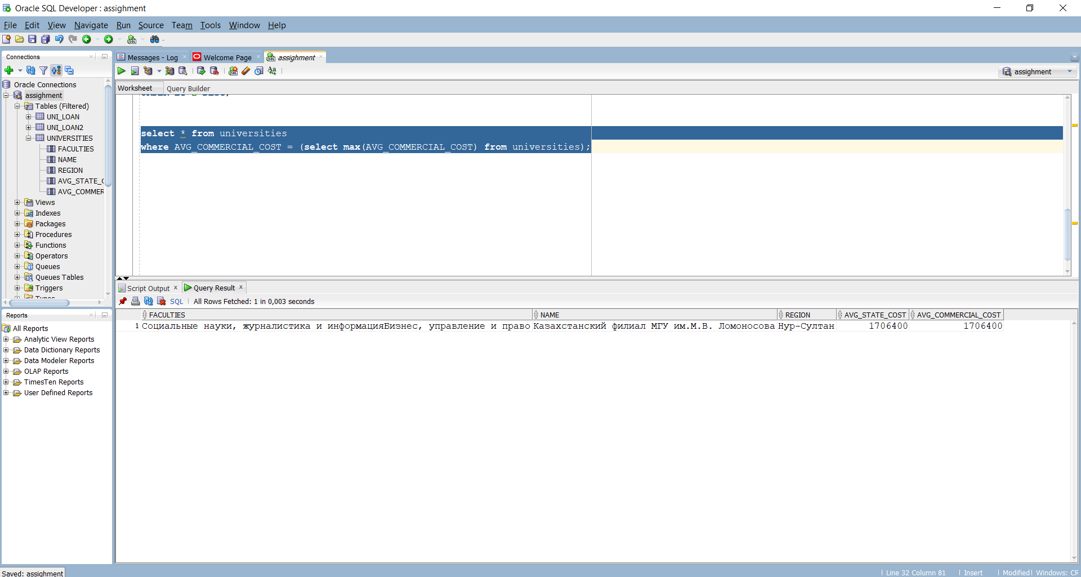

**Task 5**

