# CAN NM clock and BaudRate in EB

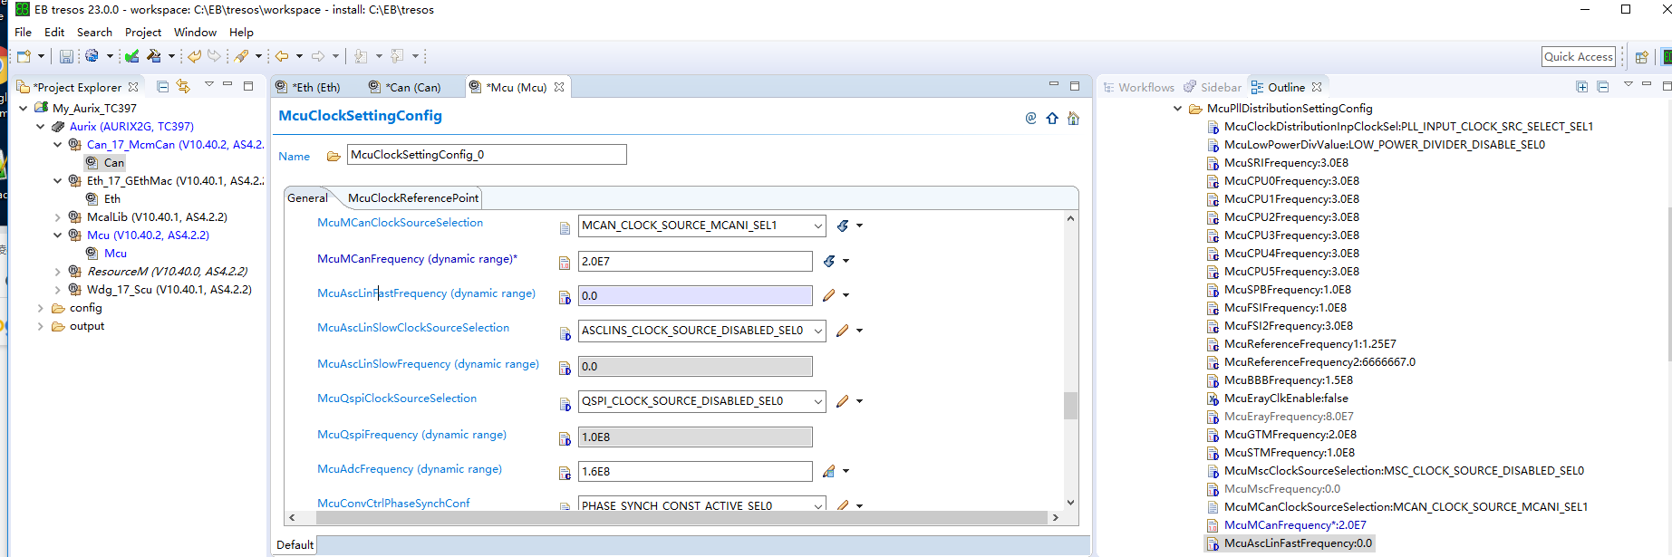

McuMCanFrequency / CanControllerBaudRate = CanControllerPropSeg + CanControllerSeg1 + CanControllerSeg2 + 1

CAN时钟频率/ CAN 波特率 = CanControllerPropSeg + CanControllerSeg1 + CanControllerSeg2 + 1

20M / 500K = 23 +8 +8 +1

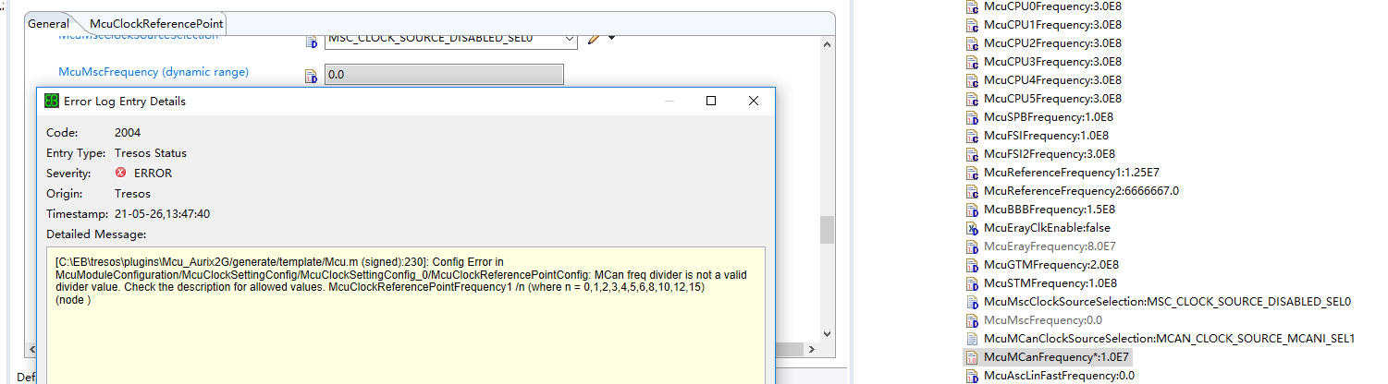

McuMCanFrequency 是从McuClockReferencePointFrequency1 分频而来

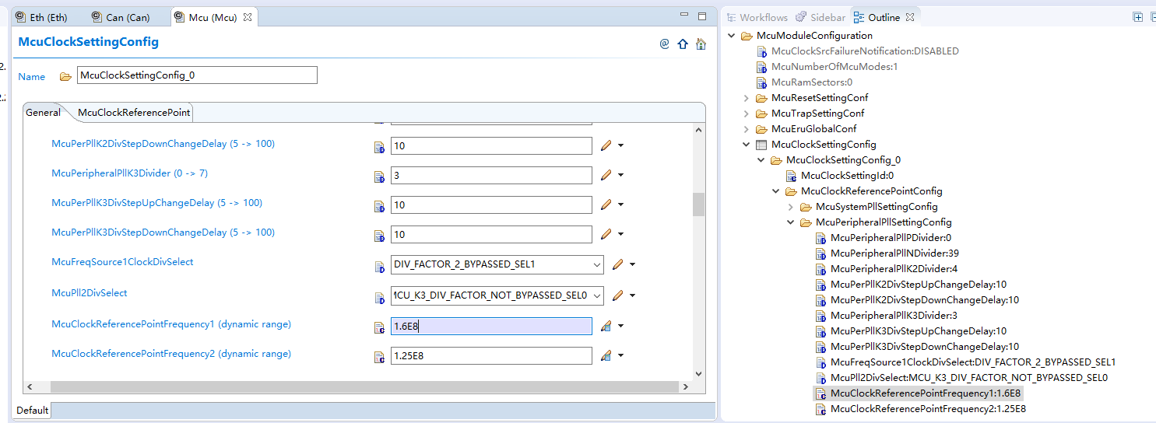

Fcan = 20M

FMcuClockReferencePointFrequency1 = 160M

FMcuClockReferencePointFrequency1 / Fcan = 8

MCan freq divider is not a valid divider value. Check the description for allowed values. McuClockReferencePointFrequency1 /n (where n = 0,1,2,3,4,5,6,8,10,12,15)