Gtm_lAtomComplexConfig()

Gtm_ConfigRoot[]

Gtm_kAtomChannelConfig0[]

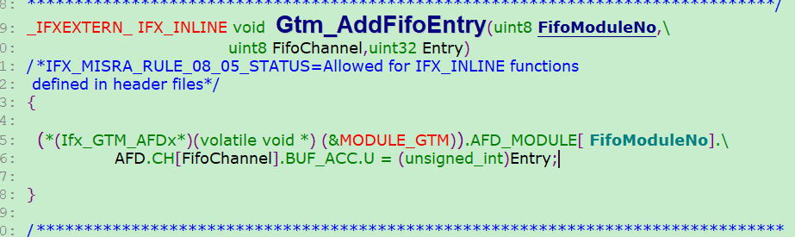

US_PwmDutyUpdata

FIFO -> F2A -> ARU -> ATOM

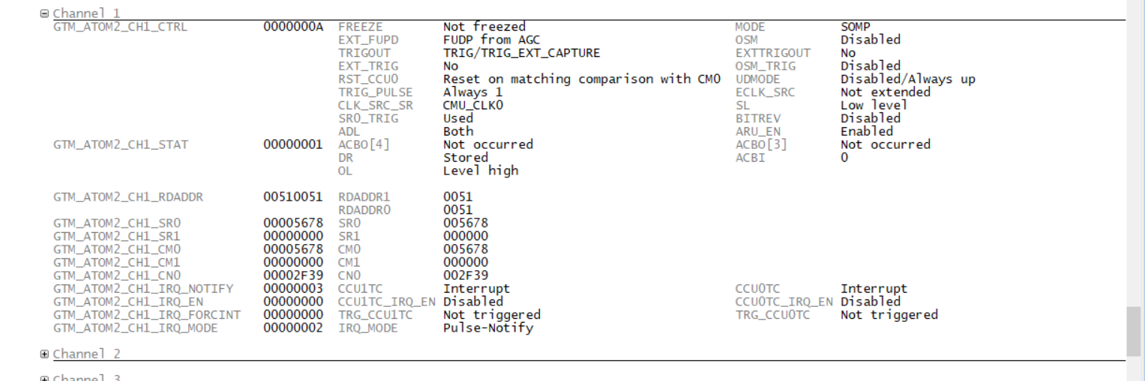

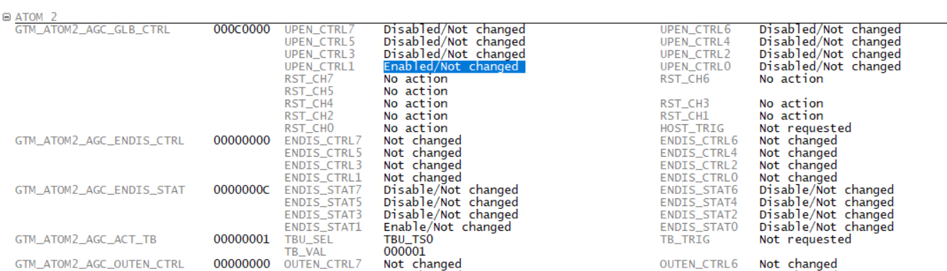

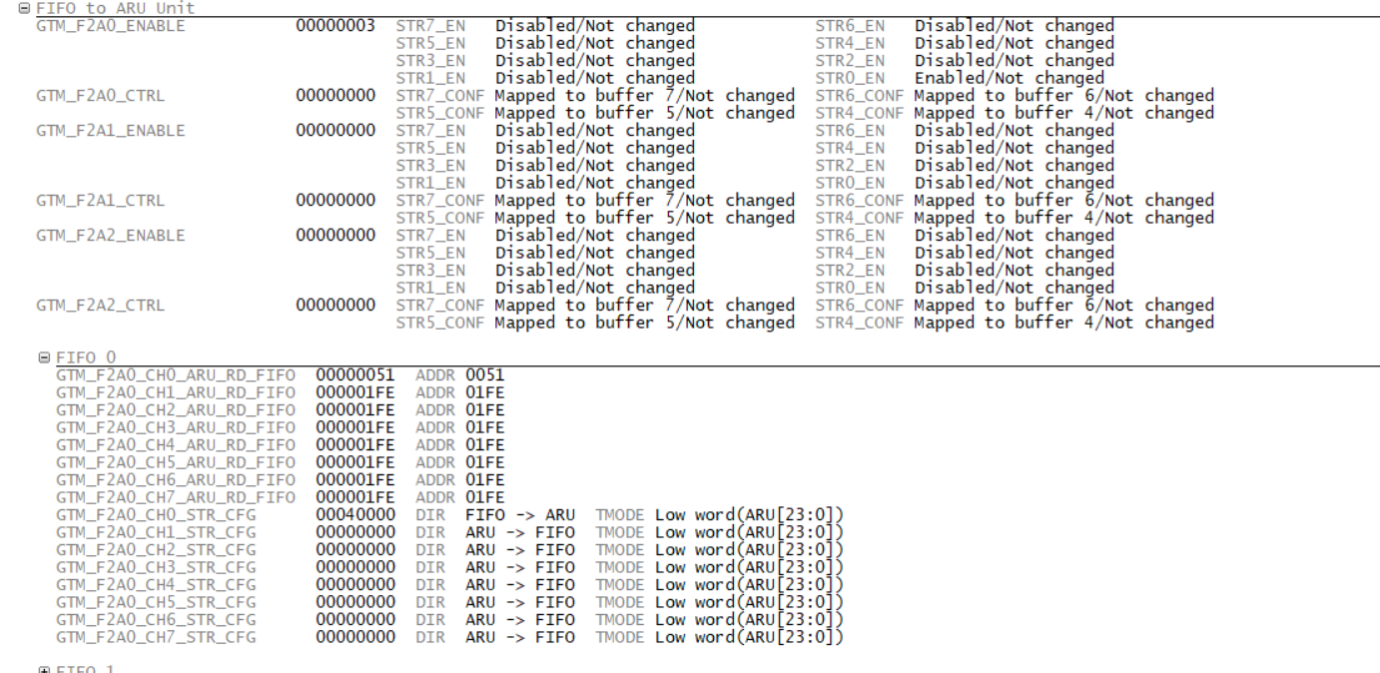

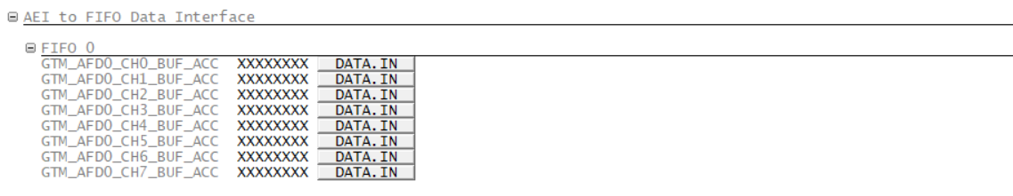

ATOM2_CH1_CTRL in 21H2

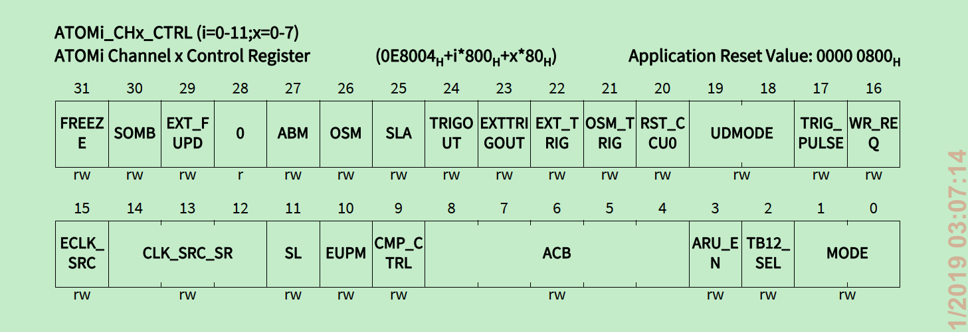

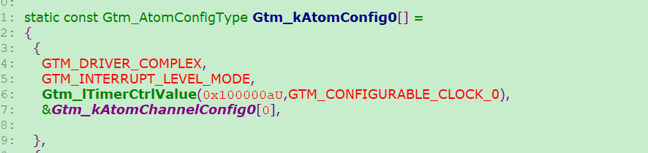

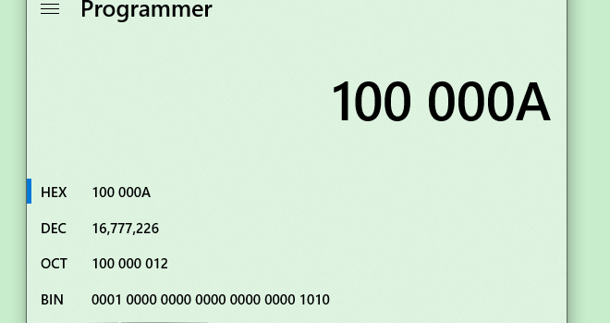

SR0 and SR1 can be changed by 

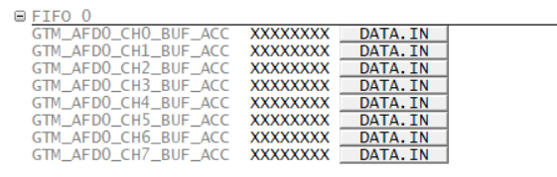

Both words in GTM_F2A0_CH0_STR_CFG

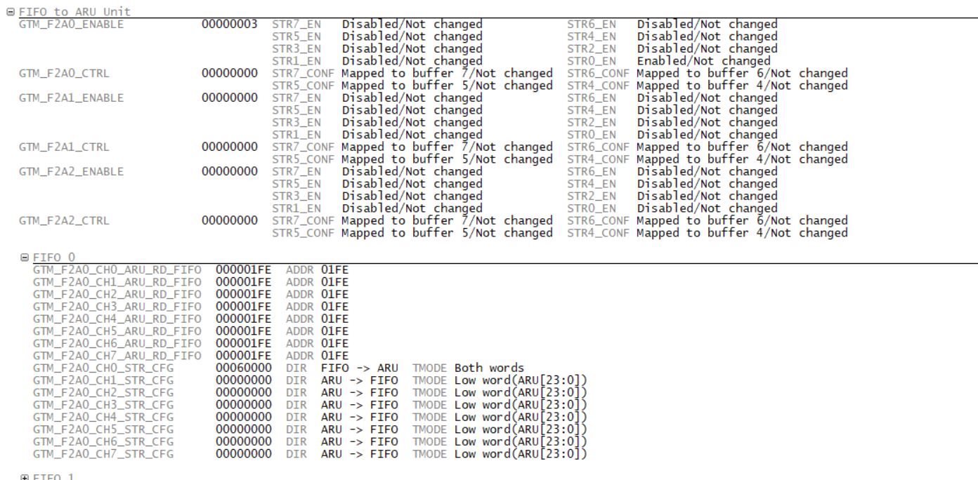

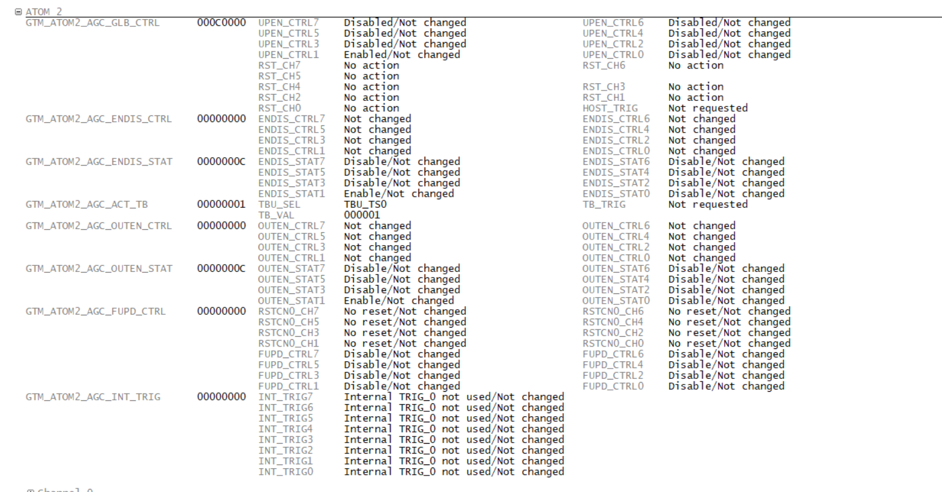

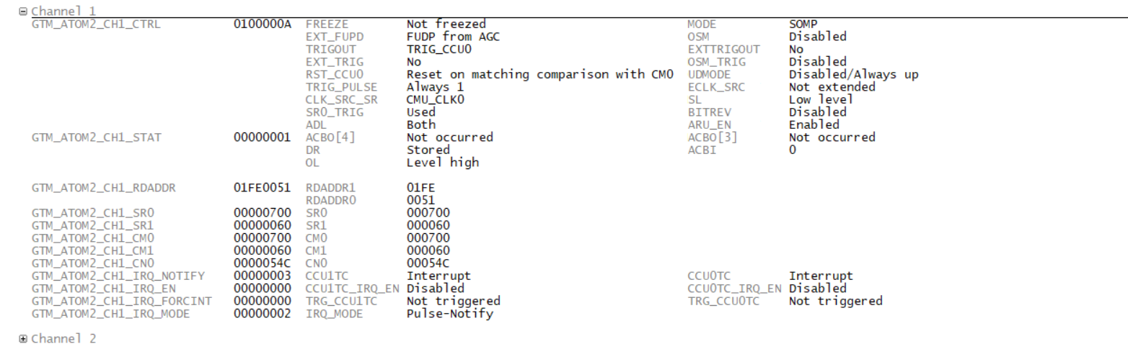

在

输入两次值，第一次是SR0，第二次是SR1

Code implement

GTM_ATOM2_CH1_CTRL.U = 0x100000A;

GTM_ATOM2_AGC_ENDIS_STAT.U = 0x04;

GTM_ATOM2_CH1_RDADDR.U = 0x1FE0051;

GTM_ATOM2_AGC_ENDIS_STAT.U = 0x08;

GTM_F2A0_ENABLE.U = 0x01;

GTM_F2A0_CH0_STR_CFG.U = 0x60000;

GTM_F2A0_ENABLE.U = 0x02;

/*************************************************/

/* Add Test code to connect Atom2-1 to port 14.10 should be reomved after test ok*/

GTM_TOUTSEL11.U = 0x800;

P14_IOCR8.U = 0x10889000;

/**************************************************/

uint32 GTM_SR0_Buff = 0x20;

uint32 GTM_SR1_Buff = 0x10;

uint32 GTM_FiFo_trg = 0 ;

**if**(GTM_FiFo_trg != 0)

{

GTM_FiFo_trg = 0;

GTM_FIFO0_CH0_CTRL.U |= 0x04;

GTM_AFD0_CH0_BUF_ACC.U =1000;

GTM_AFD0_CH0_BUF_ACC.U =500;

GTM_AFD0_CH0_BUF_ACC.U =200;

GTM_AFD0_CH0_BUF_ACC.U =100;

GTM_AFD0_CH0_BUF_ACC.U =50;

GTM_AFD0_CH0_BUF_ACC.U =25;

GTM_AFD0_CH0_BUF_ACC.U =50;

GTM_AFD0_CH0_BUF_ACC.U =0;

}

TIM0_7 configuration in 21H2

TOM0_CH7_CTRL

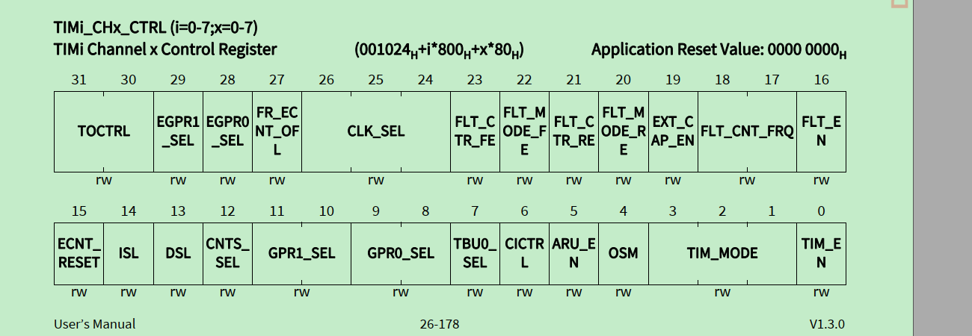

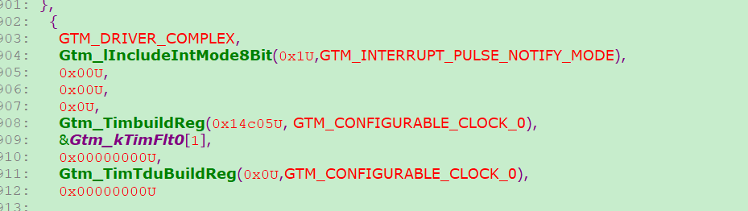

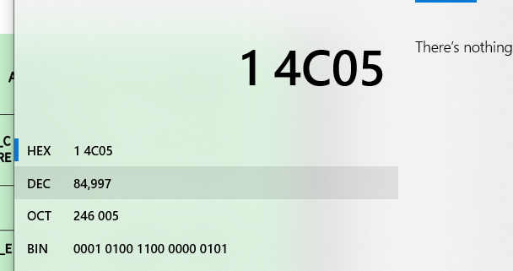

ATOM时钟 in 21H2

