**Model Pipeline**

Pipeline is a tool that simplifies and automates the process of building a machine learning workflow.

* It allows for the **sequential execution of multiple steps**, combining **data preprocessing** and the **final model training or prediction** into a single and streamlined process.
* Sequential chain of **transformers** (e.g., preprocessors like scaling, encoding, or feature extraction) followed by an **estimator** (e.g., a classifier or regressor) 🡺 ensures that the entire workflow is applied consistently and efficiently.
* Each step in the pipeline performs its transformation and passes the output to the next step.
  + **Transformers**:
    - Apply ***.fit_transform()*** during **training** and ***.transform()*** during **testing**.
  + **Estimator**:
    - Applies ***.fit()*** during **training** and ***.predict()*** during **testing**.
* **Workflow**

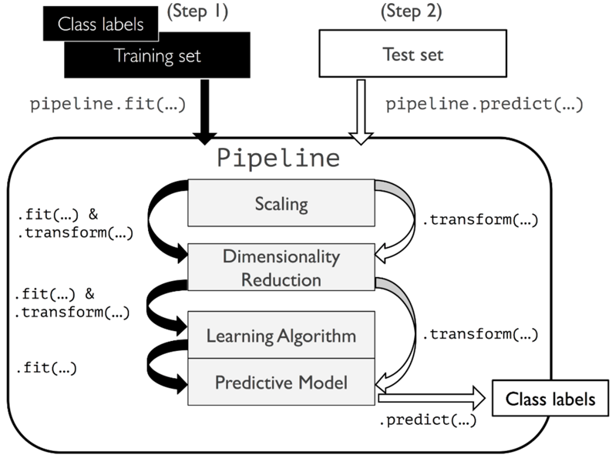

Binary classification with numeric features

* The goal is to predict the binary classification with building the pipeline.

**Components of a pipeline**

1. **Steps**:

* Each step is a tuple of a name and an object (transformer or estimator) 🡺 ('scaler', StandardScaler()).

1. **Preprocessing**:

* Steps like scaling, encoding, or imputing missing values.
* Must implement ***.fit()*** and ***.transform()*** methods.

1. **Estimator**:

* The final step of the pipeline is the machine learning model.
* Must implement ***.fit()*** and ***.predict()*** methods.

1. Hyperparameter tuning with pipeline

* Use “_ _” for each specific model for the hyperparameter tuning.
* Apply pipeline with dictionary of the hyperparameters using ***.fit(X_train, y_train)***

**Workflow of pipeline in binary task using *Pipeline([ ])***

* **'scale'**: Applies StandardScaler to standardize the features by removing the mean and scaling to unit variance.
* **'pca'**: Uses PCAto reduce the dimensionality of the dataset to 15 components.
* **'lr'**: Fits a LogisticRegression model as the final estimator.
* Using ***.fit(train, test)*** to get the sense of the model prediction by log reg.

* Use log reg model performance from pipeline (pipe1) to extract the PCs coefficients

* Use PCA model from pipeline (pipe1) to get each PCs

**Hyperparameter tuning via Pipeline**

* We need to specify the hyperparameter’s name with its corresponding model names with **“_ _”**
* Fit the pipeline (pipe1) with the specified hyperparameters to fit the X_train and y_train.
* Apply ***.score(X_train, y_train)*** to get the result.

**Pipeline display**

* By fitting the training data from the pipeline construction, we can visualize how each parameter inside the pipeline’s content and the workflow
* Order of each of the parameter inside the pipeline matters.

* Display the best estimator of each model inside the pipeline using ***.best_estimator_***

**Column Transformer**

It allows you to apply different transformations to different subsets of columns, which is particularly useful when dealing with datasets that have mixed data types, such as categorical and numerical features.

Column Transformer components

* Selective Transformation:
  + Apply specific preprocessing steps to **specific columns**.
* Integration with Pipelines:
  + Can be **used as part of a scikit-learn pipeline**.
* Support for Mixed Data Types:
  + Handle **numeric and categorical** data differently.

Workflow of column transformer with pipeline

1. Apply data column with **numerical features** processing with specific columns

* + Fill the missing value for columns age and fare with median with ‘imputer’
  + Standardize both columns with standard scaler with ‘scaler’

1. Apply another different column with **categorical features** with different processing method

* + Use simple imputing and one-hot encoding to process specified columns with ‘imputer’ and ‘onehot’

1. Combine both processing column transformer pipeline as preprocessor.

* + Combine the preprocessing with ColumTransformer

1. Set the final pipeline with the model training

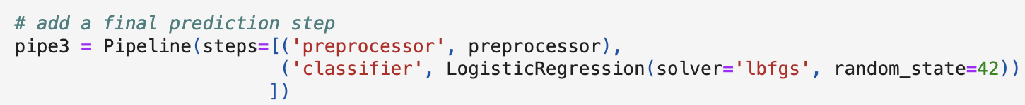

1. Visualization of pipeline

1. Apply the data splitting for model performance

* + We can use ‘survived’ as the binary target and all other features as the IVs
  + Apply train_test_split to split the data with X and y for model training

1. Connect with previous column transformation pipeline with split data using ***pipeline.fit (X, y)***

* + With pipe3, we conducted all the column transformation with numerical and categorical feature transformation and apply to the splitted train and test dataset.

1. Hyperparameter tuning with pipeline

* + We integrated the defined parameter for imputer and hyperparameter for classifier.
  + Use Grid Search to incorporate pipeline and set of hyperparameter with 3-fold CV.
  + After we impute the data by column transformation and hyperparameter tuning, we fit the training data with the integrated pipeline and obtain the best score for test set with 75.2%

1. Visualize the holistic pipeline structure

NLP

The corpus