流程图：

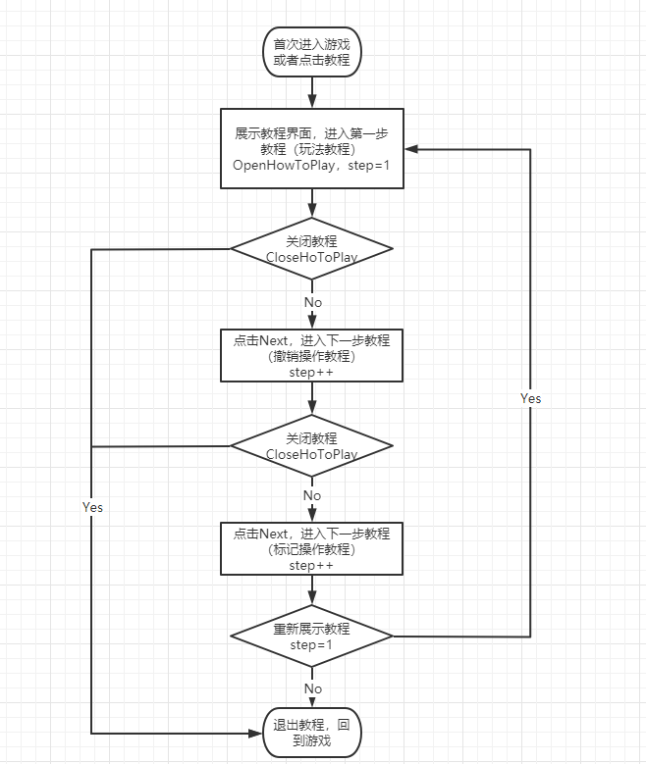

伪代码：

int step = 0;

void ShowHowToPlay()

{

ShowHoToPlayUI(step);

}

void ClickNext()

{

step++;

ShowHoToPlayUI(step);

}

void ShowHoToPlayUI (int i)

{

switch (i)

{

case 0:

{

ShowPlayGame();

}

break;

case 1:

{

ShowBackStep();

}

break;

case 2:

{

ShowMarkValue();

}

break;

case 3:

{

CloseHowToPlay();

}

break;

default:

break;

}

}

void CloseHowToPlay()

{

}