HW#4 Tianpu Zhao

  - (1)
The Verilog files are attached in the canvas submission. Here is a copy-paste version. The .sdc file is not included in the submission (submission type only allows .v)

The module file: Q1_ALU.v
//============================================================
// 8-bit ALU (unsigned inputs), F[2:0] selects operation
// F=000: Q=a+b (Cout = carry-out)
// F=001: Q=a-b (Cout = borrow ; 1 if a<b, else 0)
// F=010: Q=a OR b
// F=011: Q=a AND b
// F=100: Q=a XOR b
// F=101: Q=NOT a
// F=110: Q=arithmetic left shift a by 1 (<<1; LSB=0)
// F=111: Q=arithmetic right shift a by 1 (>>1; MSB holds sign bit a[7])
//============================================================
`timescale 1ns/1ps
module alu8 (
input wire [7:0] a,
input wire [7:0] b,
input wire [2:0] F,
output reg [7:0] Q,
output reg Cout // carry-out for add, borrow for sub
);
// Internal 9-bit adders for proper carry/borrow handling
wire [8:0] add9 = {1'b0, a} + {1'b0, b};
wire [8:0] sub9 = {1'b0, a} + {1'b0, ~b} + 9'b000000001;

always @* begin
Q = 8'h00;
Cout = 1'b0;

case (F)
3'b000: begin // a + b
Q = add9[7:0];
Cout = add9[8]; // true carry-out
end
3'b001: begin // a - b
Q = sub9[7:0];
Cout = ~sub9[8]; // borrow = NOT(carry-out of a + ~b + 1)
end
3'b010: begin // a OR b
Q = a | b;
Cout = 1'b0;
end
3'b011: begin // a AND b
Q = a & b;
Cout = 1'b0;
end
3'b100: begin // a XOR b
Q = a ^ b;
Cout = 1'b0;
end
3'b101: begin // NOT a
Q = ~a;
Cout = 1'b0;
end
3'b110: begin // arithmetic left shift by 1 (same as logical for 2's comp)
Q = {a[6:0], 1'b0};
Cout = 1'b0;
end
3'b111: begin // arithmetic right shift by 1 (preserve sign bit)
Q = {a[7], a[7:1]};
Cout = 1'b0;
end
default: begin
Q = 8'h00;
Cout = 1'b0;
end
endcase
end
endmodule

The testbench: Q1_tb_ALU.v

`timescale 1ns/1ps

module tb_alu8;
reg [7:0] a, b;
reg [2:0] F;
wire [7:0] Q;
wire Cout;

alu8 dut(.a(a), .b(b), .F(F), .Q(Q), .Cout(Cout));

// Reference model for checks
function [8:0] add9(input [7:0] x, input [7:0] y);
add9 = {1'b0,x} + {1'b0,y};
endfunction
function [8:0] sub9(input [7:0] x, input [7:0] y);
sub9 = {1'b0,x} + {1'b0,~y} + 9'd1; // x - y
endfunction

task check(input [7:0] ta, input [7:0] tb, input [2:0] tF);
reg [7:0] expected_Q;
reg expected_C;
reg [8:0] tmp;
begin
a = ta; b = tb; F = tF;
#1;

case (tF)
3'b000: begin
tmp = add9(ta,tb);
expected_Q = tmp[7:0];
expected_C = tmp[8];
end
3'b001: begin
tmp = sub9(ta,tb);
expected_Q = tmp[7:0];
expected_C = ~tmp[8];
end
3'b010: begin
expected_Q = ta | tb;
expected_C = 1'b0;
end
3'b011: begin
expected_Q = ta & tb;
expected_C = 1'b0;
end
3'b100: begin
expected_Q = ta ^ tb;
expected_C = 1'b0;
end
3'b101: begin
expected_Q = ~ta;
expected_C = 1'b0;
end
3'b110: begin
expected_Q = {ta[6:0],1'b0};
expected_C = 1'b0;
end
3'b111: begin
expected_Q = {ta[7], ta[7:1]};
expected_C = 1'b0;
end
endcase

if (Q!==expected_Q || Cout!==expected_C) begin
$display("FAIL F=%03b a=%0d (%08b) b=%0d (%08b) -> Q=%0d (%08b) Cout=%0b expected_Q=%0d (%08b) expected_C=%0b",
tF, ta, ta, tb, tb, Q, Q, Cout, expected_Q, expected_Q, expected_C);
end else begin
$display("PASS F=%03b a=%0d (%08b) b=%0d (%08b) -> Q=%0d (%08b) Cout=%0b",
tF, ta, ta, tb, tb, Q, Q, Cout);
end
end
endtask

initial begin
$display("---- 8-bit ALU Test ----");
// ADD tests (including 250+5 & 250+6)
check(8'd12, 8'd34, 3'b000);
check(8'd250, 8'd5, 3'b000); // expect Cout=0
check(8'd250, 8'd6, 3'b000); // expect Cout=1

// SUB tests (7-3 -> borrow 0; 3-7 -> borrow 1)
check(8'd7, 8'd3, 3'b001);
check(8'd3, 8'd7, 3'b001);

// Logic ops
check(8'b00101110, 8'b00011010, 3'b010); // OR
check(8'b00101110, 8'b00011010, 3'b011); // AND
check(8'b00101110, 8'b00011010, 3'b100); // XOR
check(8'b00101110, 8'b00011010, 3'b101); // NOT

// Shifts (show arithmetic right keeps MSB)
check(8'b10110100, 8'b01010101, 3'b110); // <<1
check(8'b10110100, 8'b01010101, 3'b111); // >>>1 (MSB stays 1)

$display("All tests done.");
#5 $finish;
end
endmodule

The sdc file (one-liner)
set_max_delay 1.0 -from [all_inputs] -to [all_outputs]

  - (2)
Waveforms:

Included are examples of F = 000 (summation):
Case 1: a = 12, b = 34, Cout = 0, Q = 46
Case 2: a = 250, b = 5, Cout = 0, Q = 255
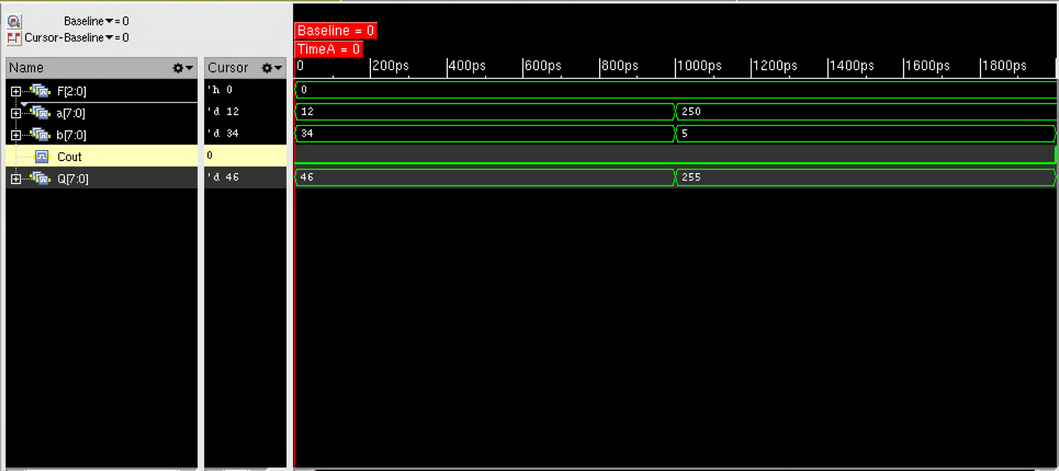

Case 3 (in the middle): a = 250, b = 6, Cout = 1, Q = 0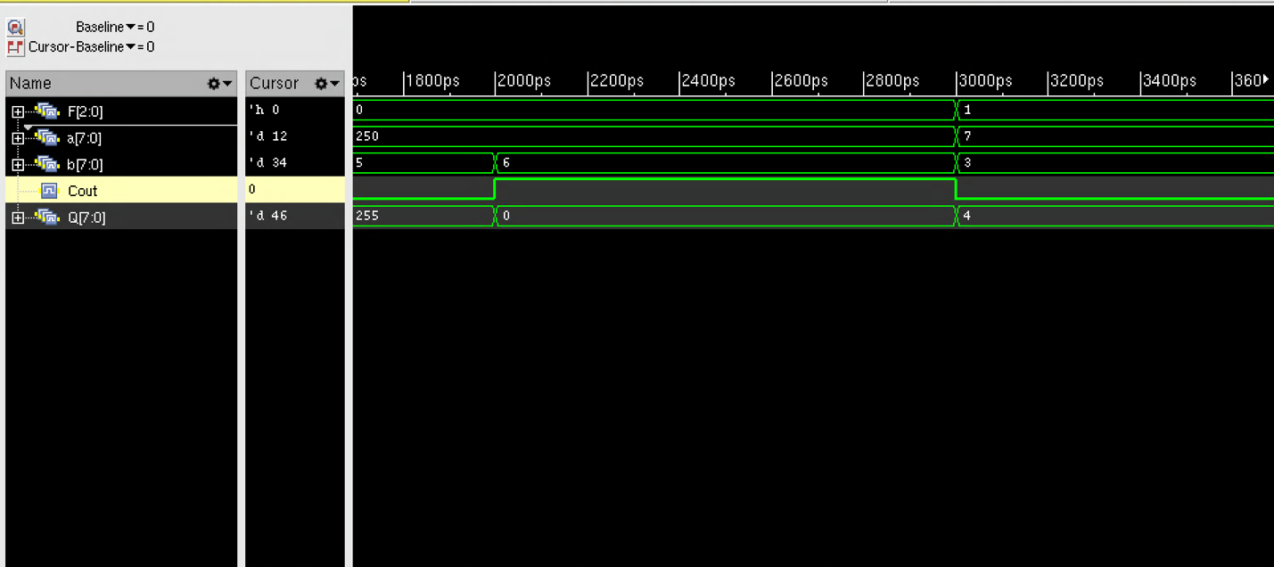

F = 001 (difference):
Left: a = 7, b = 3, Cout = 0, Q = 4
Right: a = 3, b = 7, Cout = 1, Q = 252
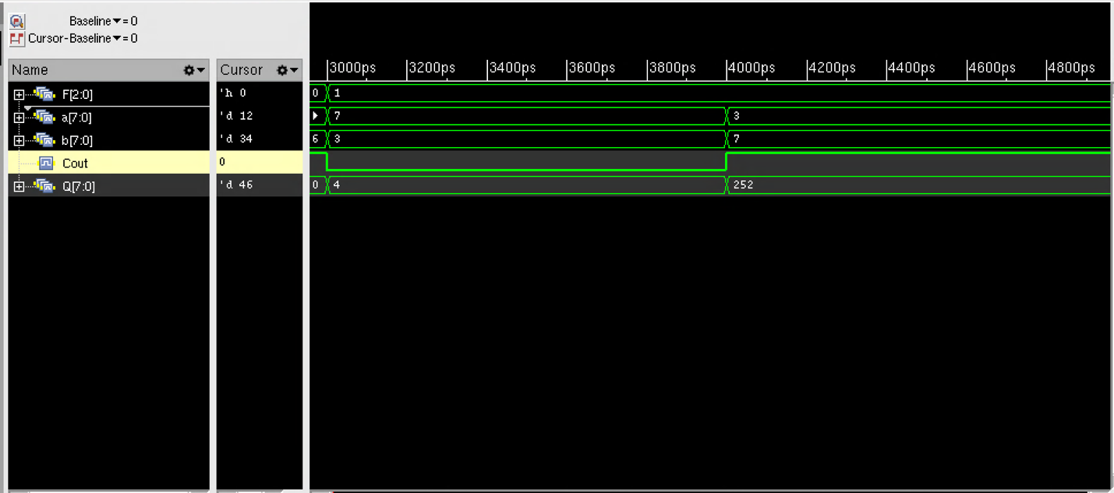

Left: F = 010 (a or b)
a=00101110, b=00011010
Q=0011110
Right: F = 011 (a and b)
Same set of a, b
Q = 00001010
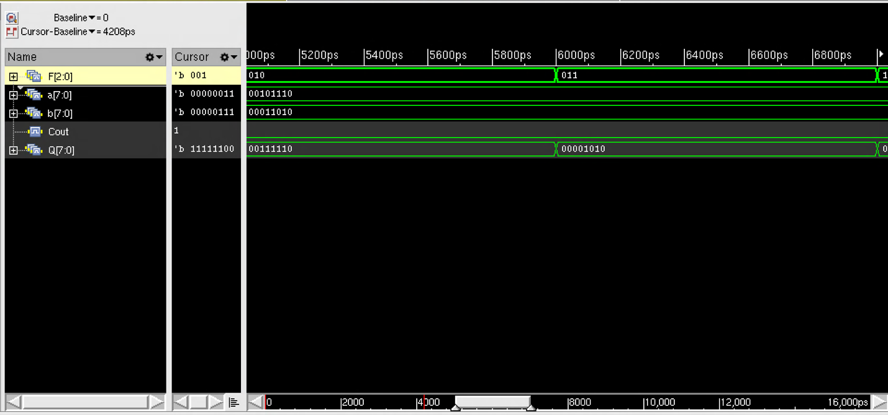

Left: F=110 (arithmetic left shift)
a=10110100 -> Q=01101000
Right: F=111 (arithmetic right shift)
a=10110100 -> Q=11011010
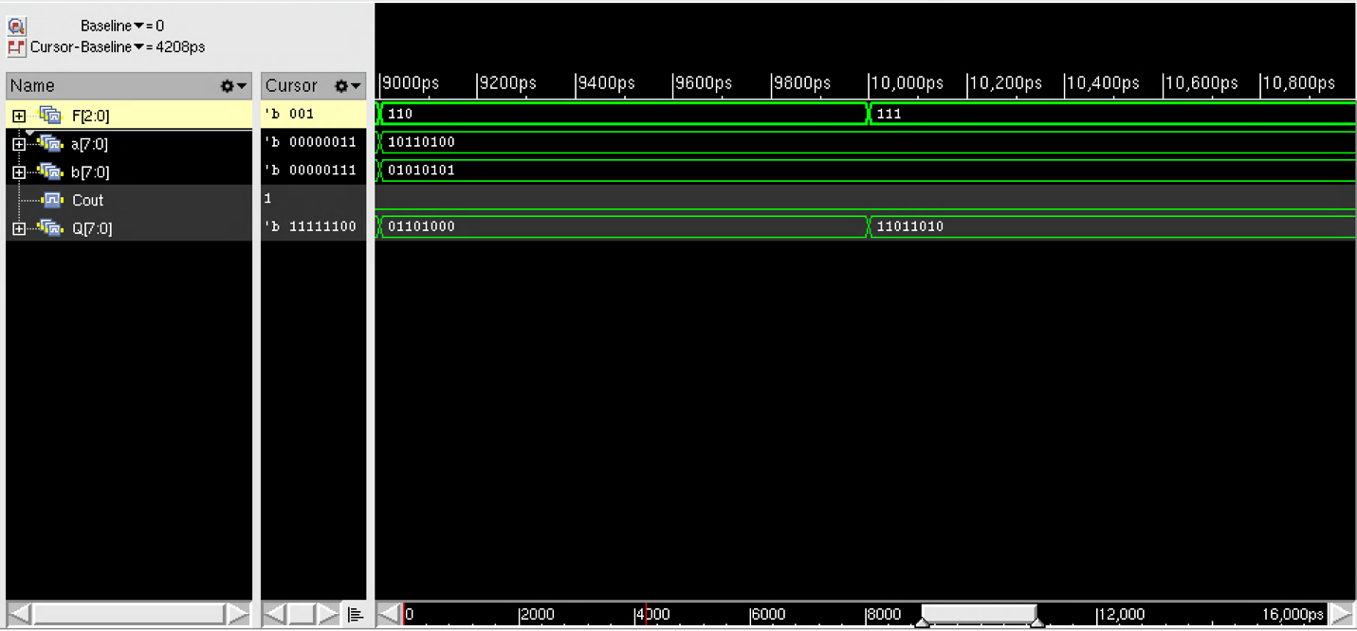
Left: F=100 a xor b
a=00101110, b=00011010 -> Q=00110100
Right: F=101 not a
a=00101110 -> 11010001
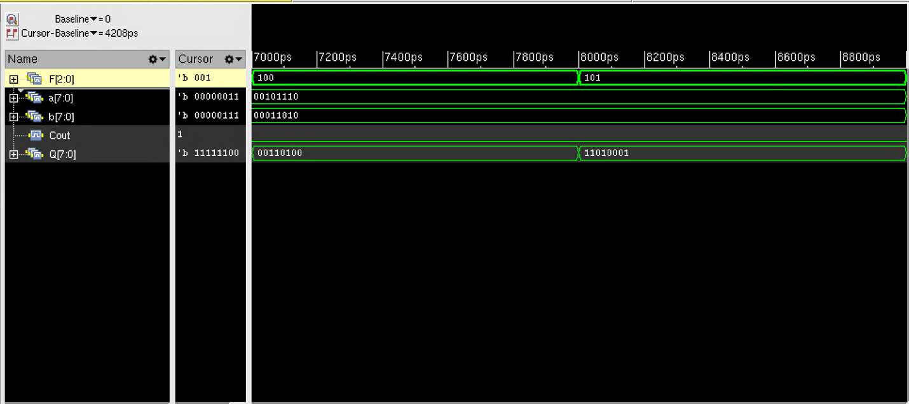
  - (3)
Total area = 396.673, cell count 160
Slack = 556ps

The area report area.rpt
============================================================
Generated by: Genus(TM) Synthesis Solution 18.14-s037_1
Generated on: Oct 30 2025 02:31:05 pm
Module: alu8
Operating conditions: typical
Interconnect mode: global
Area mode: physical library
============================================================

Instance Module Cell Count Cell Area Net Area Total Area
--------------------------------------------------------------
alu8 160 161.728 234.945 396.673

Timing report timing.rpt
============================================================
Generated by: Genus(TM) Synthesis Solution 18.14-s037_1
Generated on: Oct 30 2025 02:30:39 pm
Module: alu8
Operating conditions: typical
Interconnect mode: global
Area mode: physical library
============================================================

Path 1: MET (556 ps) Path Delay Check
Startpoint: (F) b[1]
Endpoint: (F) Q[7]

Capture Launch
Path Delay:+ 1000 -
Drv Adjust:+ 0 0
Arrival:= 1000

Required Time:= 1000
Data Path:- 444
Slack:= 556

Exceptions/Constraints:
max_delay 1000 constraints.sdc_line_1

#----------------------------------------------------------------------------------------
# Timing Point Flags Arc Edge Cell Fanout Load Trans Delay Arrival Instance
# (fF) (ps) (ps) (ps) Location
#----------------------------------------------------------------------------------------
b[1] - - F (arrival) 4 6.4 0 0 0 (-,-)
g5672__3772/ZN - A2->ZN R NOR2_X1 2 3.1 22 32 32 (-,-)
g5633__1840/ZN - A1->ZN R OR2_X1 1 1.2 6 26 57 (-,-)
g5614__2391/ZN - A1->ZN R AND2_X1 3 5.8 17 40 98 (-,-)
g5599__1857/ZN - B1->ZN F OAI21_X1 3 4.5 16 23 120 (-,-)
g5589__5266/ZN - B1->ZN R AOI21_X1 3 5.7 40 49 169 (-,-)
g5586/ZN - A->ZN F INV_X1 2 2.8 12 13 183 (-,-)
g5581__9682/ZN - B1->ZN R AOI21_X1 1 2.0 23 28 211 (-,-)
g5578/ZN - A->ZN F INV_X1 1 1.7 7 9 220 (-,-)
g5569__7344/ZN - B1->ZN R AOI21_X1 2 3.8 31 36 257 (-,-)
g5568/ZN - A->ZN F INV_X1 2 2.8 10 13 269 (-,-)
g5560__5953/ZN - B1->ZN R AOI21_X1 2 3.8 31 37 306 (-,-)
g5557/ZN - A->ZN F INV_X1 2 2.9 10 13 319 (-,-)
g5556__1309/ZN - A1->ZN F AND3_X1 1 1.8 7 31 350 (-,-)
g5551__1474/ZN - B->ZN R AOI211_X1 1 2.0 39 65 415 (-,-)
g5540__8780/ZN - B1->ZN F OAI221_X1 1 0.3 16 29 444 (-,-)
Q[7] <<< - F (port) - - - 0 444 (-,-)
#----------------------------------------------------------------------------------------

  - (4)
Gate-level netlist file – see Q1_ALU_syn.v submitted
The waveform (all the results are shown in one figure)
