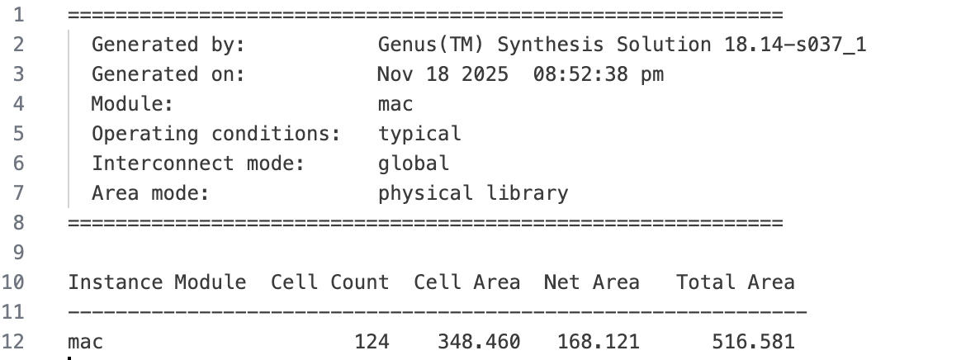
Area report

Timing report
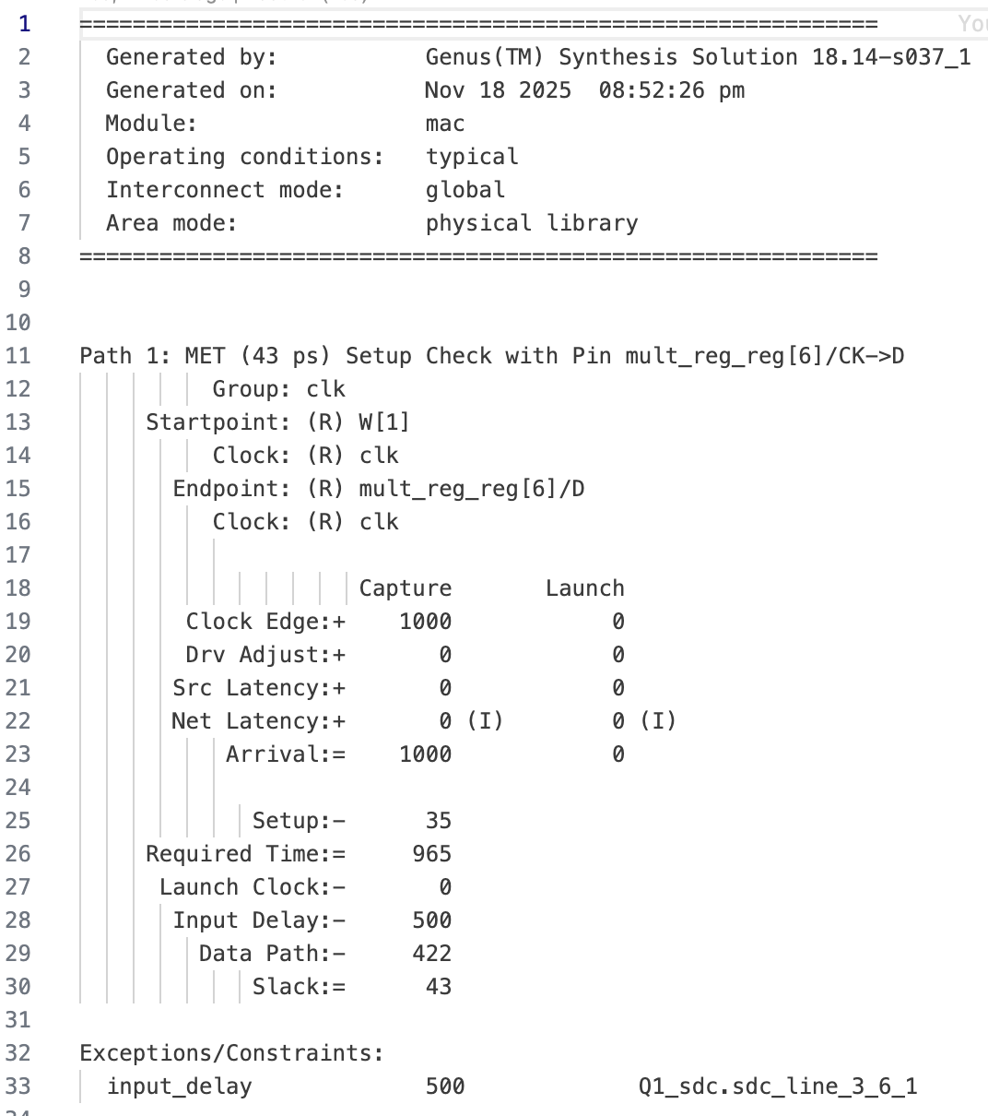

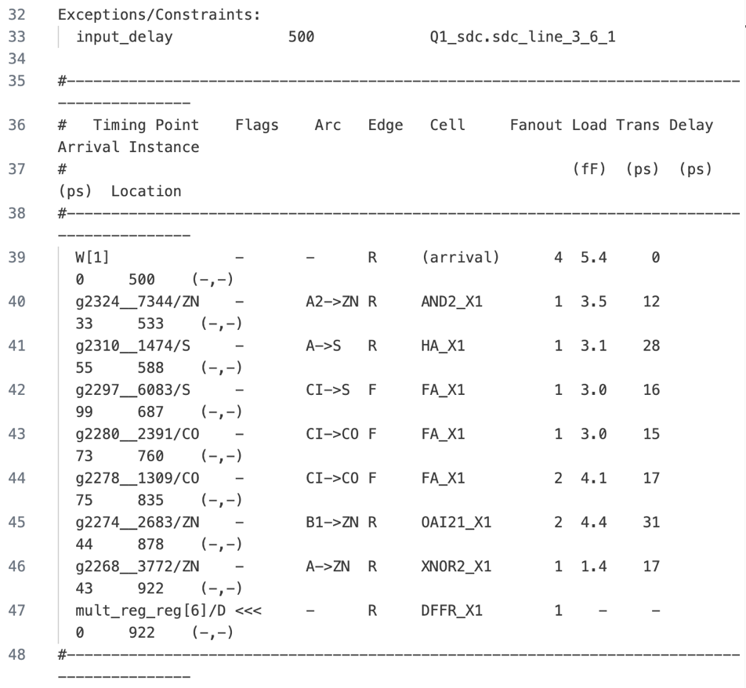

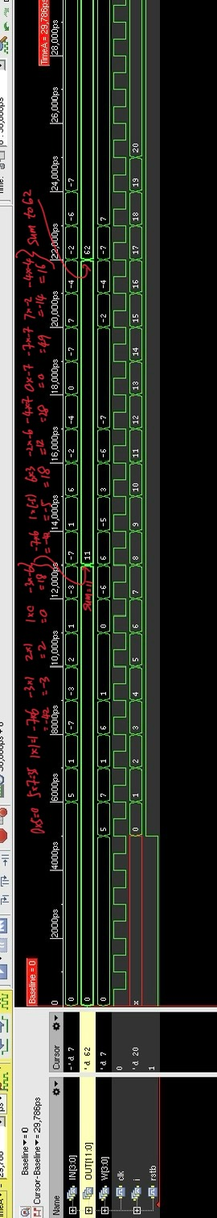
waveform (RTL):

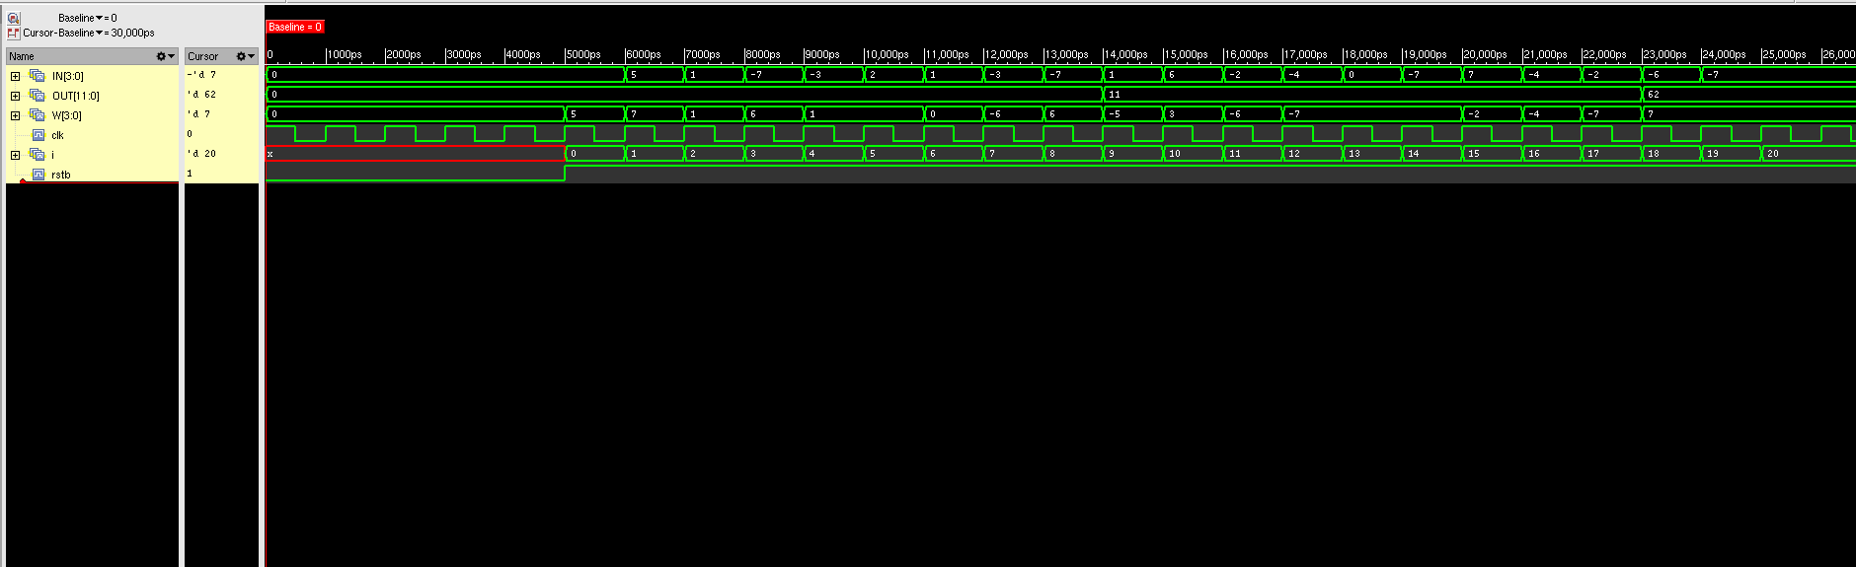
waveform (synthesized):

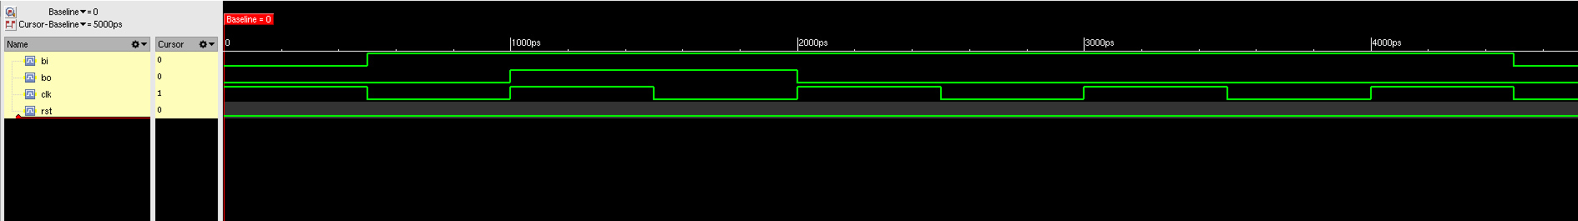
Waveform. Notice that the clock time is 1ns

