# FISH 552 Homework 1

Open a new script in R and put the following information at the top using comments:

# Name: First Last

# Homework 1

Complete the tasks below and be sure to label each question with comments

#==Question 1a

R Code . . .

#==Question 1b

R Code . . .

## Part 1 – Commit Log

While working on this assignment, please record a commit message at the end of each work session. Here is a reminder of what components to include:

New files created in this work session:

Existing files edited in this work session:

Brief summary of activity/changes completed in this work session (<=10 words):

Description of activity/changes completed in this work session (bullet points or 2 sentences):

Note to self for next time (what should you start on the next time you open this assignment?):

When your script is complete, save it as LastName_Homework1.R, then clear your workspace (Workspace/Clear all) and run through your script again to make sure you don’t have any ‘object not found’ errors. Then go to the course website to submit your R script.

## Part 2 – Programming Assignment

### Question 1

Create vectors of data with the following characteristics, using rep() and seq() when possible.

a) 100 regularly spaced values from -1 to 1. Call this vector x.

b) The function y = exp(x/2), evaluated for all the values in vector x created in (a). Call this vector y.

c) How many values in y created in (b) are above 1?

d) 5 entries each of “Small”, “Medium”, “Large”, encoded as a factor. Call this vector size.

e) Take the results of (d) and append 2 entries of “Unknown”. Call this vector observedSize.

### Question 2

For this question we will use counts of salmon and other fish from dams in the Columbia River Basin. Download the file “fishPassage.csv” and save it in the same directory as your r code.

a) Read the data into R as an object named fishPassage.

b) Calculate the maximum and minimum number of wild steelhead to pass Bonneville Dam (BON) and specify in which year each occurred.

c) Calculate the total number of fish counted at Bonneville Dam (BON) in 2007.

d) Create a new data frame called fishPassage1995BON that contains only observations from Bonneville Dam (BON) from 1995 onwards.

e) Create a matrix with 3 columns from the data fishPassage1995BON that contains counts of Coho adults, Coho jacks and the ratio of Coho jacks to adults. Name this matrix cohoPassage.

f) Compute the mean of each of the variables in cohoPassage.

g) Round the output in f) to two decimal places. You may need to search the help files.

h) Display all the observations associated with the largest Chinook adult count from the

fishPassage data.

## Part 3 – Checking for Understanding

Let’s step out of RStudio and build a visual model! We have encountered new data types and structures during the first two weeks of class. Using everyday objects, please construct visual representations of the following terms:

* an element
* a vector
* a data frame
* a matrix
* a list

Please include at least one of each data type (numeric, character, logical, integer) while constructing those terms. Take a picture of your physical models, add them to a Power Point slide, and label the different components. If digital media be your preference, feel free to use clipart or the equivalent to address this question. Please upload this slide with your R script.

Here are some examples of physical models:

Chemistry:

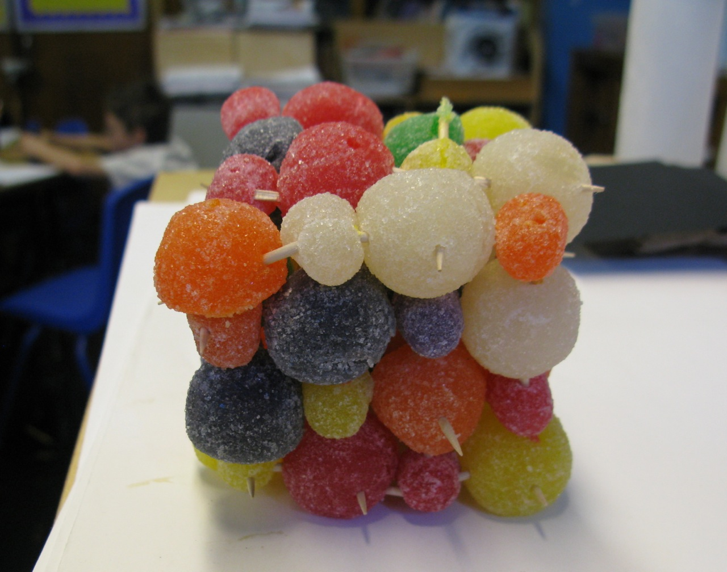

Biology:

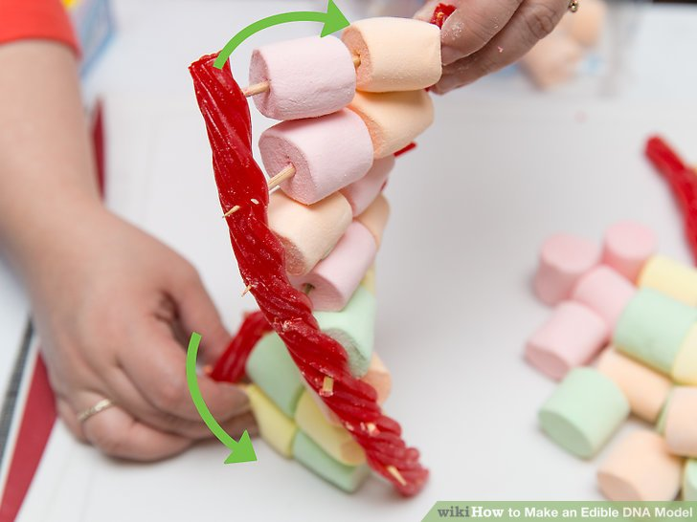

*Food is not a required medium for this question!

## Reminder of what to upload to Canvas:

1. Homework 1 Commit Log
2. Homework 1 R Script
3. R Visual Model Power Point Slide