# FISH 552 Homework 2

Open a new script in R and put the following information at the top using comments:

# Name: First Last

# Homework 2

Complete the tasks below and be sure to label each question with comments as before

#==Question 1a

R Code . . .

#==Question 1b

R Code . . .

When your script is complete, save it as LastName_Homework2.R, then clear your workspace (Workspace/Clear all) and run through your script again to make sure you don’t have any ‘object not found’ errors. Then go to the course website to submit your R script.

## Question 1

This question will use the dataset beaver1, which is built into R. Run the command head(beaver1) to get a sense of what is in the dataset, and go to the help file ?beaver1 to learn more about this data set. Using this dataset:

a) Use one function to compute the mean temperature for inside and outside the retreat. (5 points)

b) Recreate the following plot. Note the x-axis, and the green points mark activity outside the retreat. (25 points)

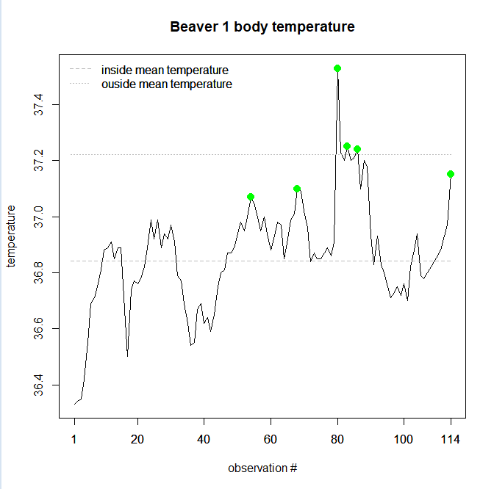

c) Note that the observation at 22:20 is missing. Create a new data frame that includes an additional observation with a temperature of 37.3 and activity outside the retreat at this time. (5 points)

d) How much did the mean temperature during periods of activity outside the retreat change? (i.e. compare beaver1 and your new data frame) (5 points)

## Question 2

This question will use the dataset crabs, which is built into R. Type the following command to get access to the dataset (we’ll cover what a library is later):

library(MASS)

head(crabs)

Now use the dataset crabs to complete the following:

a) Use one function to compute the mean of frontal lobe size for blue and orange purple rock crabs. Now compute the standard deviation of frontal lobe size for blue and orange purple rock crabs. (5 points)

b) Run this line of code

crabs$sp:crabs$sex

Explain what’s going on here by adding comments to your code above this line of code. Call this new factor spsex. (5 points)

c) Change the levels of spsex so that they are more informative. So B:F might be called "Blue Female" and so on. (5 points)

d) Use one function to compute the mean of frontal lobe size for each sex and color combination of purple rock crab. (5 points)

e) Use one function with the vector spsex to compute the total number of each sex and color combination of purple rock crab. Call this vector crab.counts. Hint: ?table. (5 points)

f) Create an informative plot using the crabs data with appropriate labeling. You may plot part of the data or all of the data. Be creative. (5 points)