《数据库技术》课程第四周练习题
创建一个员工管理系统，包含以下三个表：
-- 创建部门表
CREATE TABLE Departments (
dept_id INT IDENTITY(1,1) PRIMARY KEY,
dept_name NVARCHAR(50) NOT NULL,
location NVARCHAR(100)
);
-- 创建员工表
CREATE TABLE Employees (
emp_id INT IDENTITY(1,1) PRIMARY KEY,
emp_name NVARCHAR(50) NOT NULL,
position NVARCHAR(50),
salary DECIMAL(10,2),
dept_id INT,
hire_date DATE,
CONSTRAINT FK_emp_dept FOREIGN KEY (dept_id) REFERENCES Departments(dept_id)
);

-- 创建项目表
CREATE TABLE Projects (
project_id INT IDENTITY(1,1) PRIMARY KEY,
project_name NVARCHAR(100) NOT NULL,
budget DECIMAL(15,2),
start_date DATE,
end_date DATE,
manager_id INT,
CONSTRAINT FK_project_manager FOREIGN KEY (manager_id) REFERENCES Employees(emp_id)
);

并插入如下示例数据：

-- 插入部门数据
INSERT INTO Departments (dept_name, location) VALUES
('技术部', '北京总部'),
('市场部', '上海分部'),
('财务部', '北京总部'),
('人力资源部', '广州分部'),
('研发部', '深圳分部');

-- 插入员工数据
INSERT INTO Employees (emp_name, position, salary, dept_id, hire_date) VALUES
('张三', '高级工程师', 25000.00, 1, '2020-03-15'),
('李四', '市场经理', 18000.00, 2, '2019-07-22'),
('王五', '财务分析师', 22000.00, 3, '2021-01-10'),
('赵六', 'HR专员', 12000.00, 4, '2022-05-30'),
('钱七', '研发主管', 30000.00, 5, '2018-11-05'),
('孙八', '前端开发', 15000.00, 1, '2021-08-12'),
('周九', '市场专员', 10000.00, 2, '2022-02-18'),
('吴十', '会计', 14000.00, 3, '2020-09-03'),
('郑十一', '招聘经理', 20000.00, 4, '2019-04-25'),
('王芳', '后端开发', 16000.00, 5, '2021-06-15'),
('李伟', 'UI设计师', 13000.00, 1, '2022-07-20'),
('张敏', '销售主管', 24000.00, 2, '2018-12-01'),
('刘洋', '财务经理', 28000.00, 3, '2017-10-08'),
('陈静', '培训专员', 11000.00, 4, '2021-03-14'),
('杨光', '测试工程师', 14500.00, 5, '2020-11-30'),
('黄磊', 'CTO', 45000.00, 1, '2016-05-10'),
('周涛', '销售代表', 9000.00, 2, '2022-09-05'),
('吴京', '出纳', 9500.00, 3, '2021-12-12'),
('郑凯', '薪酬专员', 12500.00, 4, '2020-07-19'),
('王宝强', 'DevOps工程师', 23000.00, 5, '2019-08-25');

-- 插入项目数据
INSERT INTO Projects (project_name, budget, start_date, end_date, manager_id) VALUES
('企业门户网站', 150000.00, '2023-01-10', '2023-06-30', 1),
('移动应用开发', 250000.00, '2023-02-15', '2023-09-30', 5),
('市场推广活动', 80000.00, '2023-03-01', '2023-05-31', 2),
('财务系统升级', 120000.00, '2023-04-05', '2023-08-15', 3),
('员工培训平台', 60000.00, '2023-05-20', '2023-07-31', 4),
('AI智能助手', 350000.00, '2023-06-01', '2024-01-31', 16),
('客户关系系统', 180000.00, '2023-07-10', '2023-12-15', 12),
('云迁移项目', 200000.00, '2023-08-01', '2024-02-29', 20);

写出完成以下查询任务的SQL语句，并截图展示代码运行结果：
- 查询所有员工及其部门信息。
select * from Employees e left join Departments d on e.dept_id=d.dept_id;
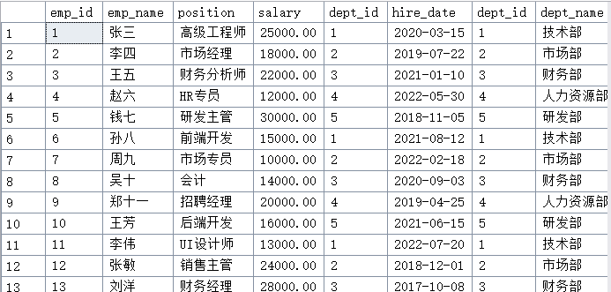
- 查询所有部门及其员工信息（包括没有员工的部门）。
select * from Departments d left join Employees e on e.dept_id=d.dept_id ;
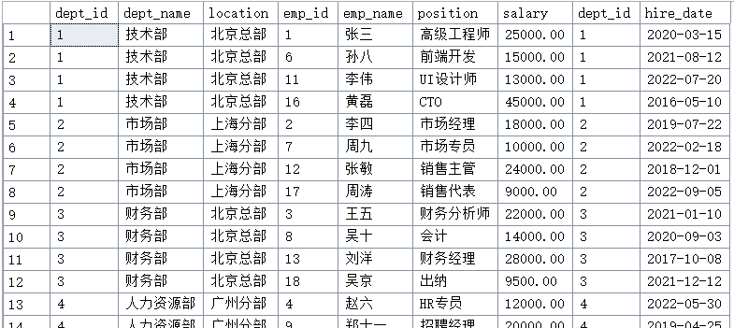
- 查询所有项目及其负责人和部门信息。
select * from Projects p left join Employees e on p.manager_id=e.emp_id left join Departments d on e.dept_id=d.dept_id;
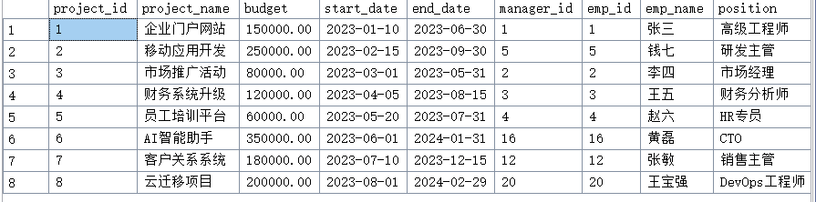
- 按照公司分部统计员工总数及负责项目的总数。
select d.location,count(distinct e.emp_id) as person_num,COUNT(p.project_id) as project_num from Departments d left join Employees e on e.dept_id=d.dept_id left join Projects p on e.emp_id=p.manager_id group by d.location
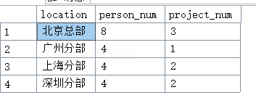
- 查询既是部门经理（职位名称中包括“经理”或者“主管”）又是项目负责人的员工。
select e.emp_id,e.emp_name from Employees e left join Projects p on e.emp_id=p.manager_id where e.position like '%经理' or e.position like '%主管';
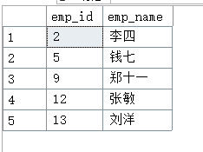
- 查询工资低于部门平均工资的员工。
select e.dept_id,e.emp_id,e.emp_name,e.salary from Employees e where e.salary< (select avg(salary) from Employees) group by e.emp_id,e.emp_name,e.salary,e.dept_id order by e.dept_id;
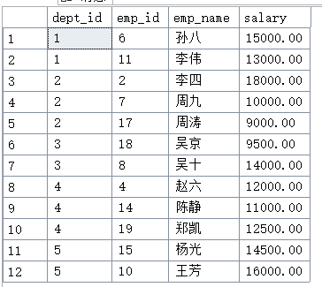
- 查询每个部门的员工数量和平均工资。
select d.dept_id,d.dept_name,count(e.emp_id) as NOP,avg(e.salary) as SOS from Departments d left join Employees e on d.dept_id=e.dept_id group by d.dept_id,d.dept_name
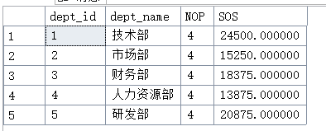
- 为所有在深圳总部工作的员工加薪5%。
update Employees set salary=salary*1.05 where emp_id ='5'
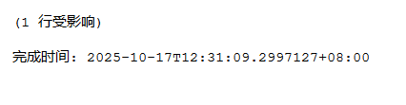
- 将工资低于部门平均工资的员工工资提高到部门平均工资。
with DeptAvgSalary as (
select
dept_id,
AVG(salary) as avg_dept_salary
from Employees group by dept_id
)
update E set E.salary = DAS.avg_dept_salary from Employees e join DeptAvgSalary DAS on E.salary = DAS.avg_dept_salary where E.salary<DAS.avg_dept_salary
- 查询负责预算最高项目的员工信息。
select * from Employees e right join Projects p on e.emp_id=p.manager_id where budget = (select max(budget) from Projects)
- 查询每个部门工资最高的员工（要求使用CTE）。
WITH DeptMaxSalary AS (
SELECT
dept_id,
MAX(salary) AS max_salary
FROM
Employees
GROUP BY
dept_id
)
SELECT
e.emp_id,
e.emp_name,
e.dept_id,
e.salary
FROM
Employees e
JOIN
DeptMaxSalary dms ON e.dept_id = dms.dept_id AND e.salary = dms.max_salary;
