A Model of Leaves’ Classification and Weight Evaluation

Abstract
In biology perspective, shapes of a tree’s leaves are a response to both own genetic factor and ecosystem’s limiting factor; all these two factors will be revealed on tree’s feature attribute. This article focuses on the view of leaf’s diversity, mainly from tree’s general feature perspective (tree’s rest energy, distribution of leaves and branches, tree’s profile). By using Wood’s SunScan canopy analysis equations and reverse calculation of beer’s law, on the basis of Campbell’s study, we obtain the quantitative relation between the leaves’ shape and the tree’s optimization structure factor. Then we fit the obtained data matrixes by using Gaussian Fitting method. According to the graph theory analysis, shapes are divided into three categories. Furthermore, we valid the model results by fitting the representative 48 kinds samples through Smooth spline function .
For a tree’s total leaves weight calculation, on the basis of previous research, we derive and publish a quantitative relation formula between leaf’s weight and several control factors (crown’s DBH, height, profile etc.). Then through sensitive analyzing of the result with the data collected from practical situation, the possibility of this model is proved.
1 Introduction

1.1 Background

1.1.1 A tree
Trees, the most beautiful and useful products of the nature on earth are mostly defined as a woody plant that has many secondary branches supported clear of the ground on a single main stem or trunk with clear apical dominance^{[1]}. “Trees come in various shapes and sizes but all have the same basic structure ^{[2]}.” A tree consists of five main components: roots, trunk, branches, leaves and reproductive parts (flowers and fruits or cones) (figure. 1). For the portion of the tree above the ground, trunk, branches and leaves contribute most part. Trees are an extremely important component of the natural landscape and play a decisive role in producing oxygen and reducing carbon dioxide in the atmosphere. Some of the descriptive characteristic variables are shown as below (figure.2)
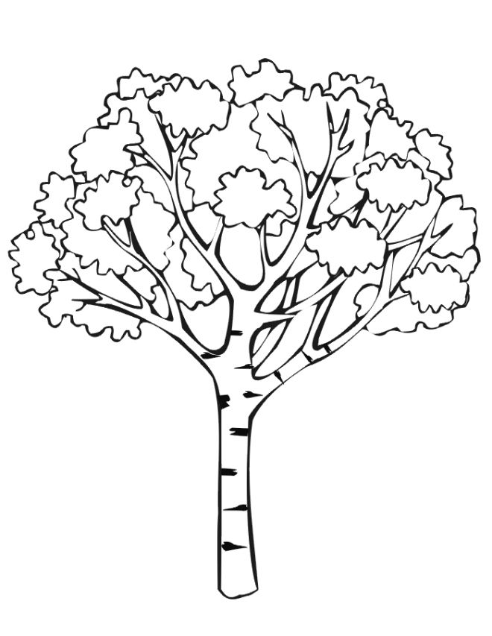
Fig.1 Tree diagram

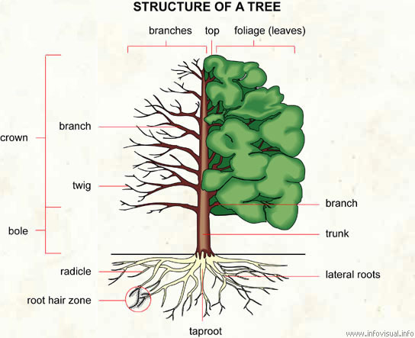
Fig.2 Structure of tree

1.1.2 Leaf of a tree
“Typically a leaf is a thin, flattened organ borne above ground and specialized for photosynthesis ^{[3]}”, shown as picture below (figure.3)
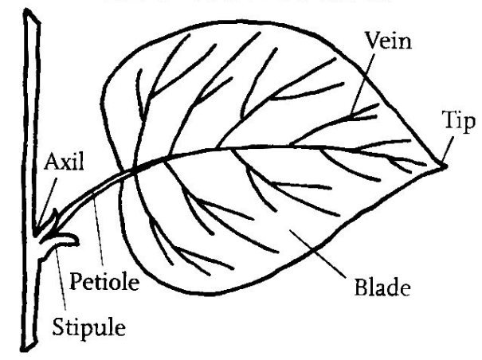
Fig.3 leaf part names
Leaves that located on crown of the tree, which is commonly above the ground, are the most important part of the plant. It consists of several crucial major functions for the tree:
- Manufacture food- Photosynthesis
- Air Exchange-Respiration
- Water transport-Transpiration
Photosynthesis is the process which plants use the energy from sunlight to produce glucose or sugar.
Respiration is the release of the energy, which is stored by photosynthesis. It occurs in the living cells all through plant’s living time. There are 2 different kinds of respiration: Aerobic respiration and anaerobic respiration. The Aerobic respiration occurs only in the presence of oxygen. However, anaerobic respiration occurs only if the oxygen is in absence.

1.2 Problem Restatement
The shapes of a tree’s leaves are a response to quite a few different factors; one is its genetic control of gene expression. Referring to the article published by Tomotsugu Koyama on ‘The Plant Cell’ November 2010^{[4]}, he and his research team carry out an idea that TCP Transcription Factors Regulate the Activities of ASYMMETRIC LEAVES1 and miR164, as Well as the Auxin Response, during Differentiation of Leaves in Arabidopsis. The other is the ecosystem’s limiting factors such as local temperature, humidity, sunlight, landscape, etc.
Both the two factors above will bring huge impacts on leaves, which will be revealed on tree’s feature attribute.
In this paper, we will focus on the relationship between the shape of leaves and the tree’s feature attribute, and then carry out a mathematical model to provide a solution for categorization of leaves’ shape. On that basis, we provide realistic formulas of weight calculation separately for leaves. We also do sensitivity, feasibility and accuracy analysis to this method in this paper.

2 Notations and Assumptions
2.1 Basic Terms and Variables
Firstly, we would explain some basic terms of the trees and leaves which will be discussed below (figure.4).
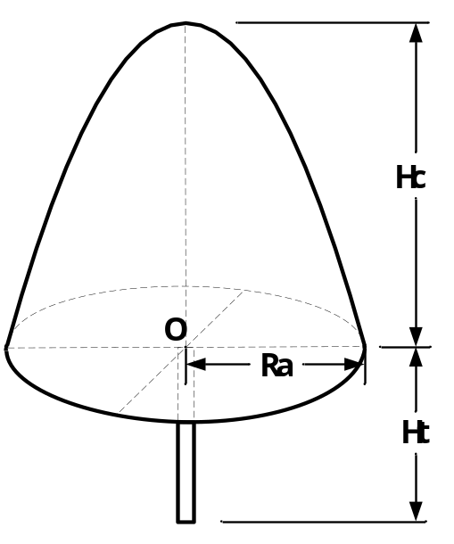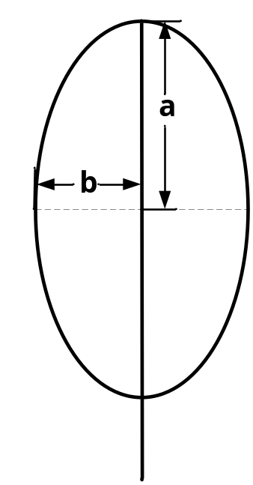
Fig.4 Model schemes for tree Fig.5 Model schemes for leaf
Secondly we’d like to explain some variables which we’ll use for the model and the following part defines important variables which are widely used in this paper while some additional parameters only confined to particular sections may be defined later.
Table 1: The parameter
Symbol Definition
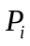 the total amount of organics production per unit time for leaf I
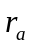 the radius of crown’s bottom
the organics production by photosynthesis per unit time per unit area
 the organics consumption by Aerobic respiration per unit time per unit area
the organics consumption by Anaerobic respiration per unit time per unit area
 the total amount of leaves on the tree;
the ratio of leaf that locates outside crown.
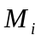 the sunlight capture ratio for leaf I outside the crown.
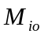 the sunlight capture ratio for leaf I inside the crown.
the scale factor
x length-width ratio of the leaf
L Optimization factor about trees

2.2 Model Assumptions
Since we consider leaves’ shape from trees’ feature attribute perspective, a reasonable and acceptable assumption need to be made for the tree itself and its local environment to simplify our model. The following part lists all the main assumptions we made for our mathematical model.
- For leaves’ shape categorization model, we only consider trees that are healthy and mature at the end of summer and neglect all the unexpected situations which means that trees in model are all classical and healthy grown; also needles or leaves on the tree don’t grow or drop during our study period^{[5]}.
- Divide leaves into three categories: small-size, medium-size and large size; all three type leaves’ quantity and area are normally distributed.
- As for photosynthesis and respiration of leaves, influences from the irradiation angle of the light received and the concentration of CO₂ in the air are not considered.
- Ignore the effect caused by weather condition for weight calculation.
3 The Model
3.1 The study of leaves’ shape and tree’s feature attribute
3.1.1 Study of leaves’ shape variety
●According to the research carried out by Ben Brand, a PhD student from University of Arizona, three factors take responsibility of controlling leaf’s shape. “There are basically three things at play in the workings of a leaf: the amount of carbon required making it, how long the leaf lives and how fast or slow it processes sunlight -- or its rate of photosynthesis.”
●These factors combine in different ways in different plants in different environments to create an incredible diversity of leaf shapes and structures ^{[6]}.
Along with ourselves case study and data analysis; we prefer to describe the differences among the leaves’ shapes as a result of evolutionary history of the plants.
The shape of the leaves is a response to the long-term ecological and evolutionary history of tree species, and limiting factors in the ecosystem may be involved in the decision of the final shape too. The limiting factor in the ecosystem of foliage shapes: enough sunlight and carbon dioxide for photosynthesis, but not too much associated heat absorption or water loss. That is, “the balancing factors are in fact environmental factors”. For example, tropical plants have a strong capacity for photosynthetic and have thick leaves, and thus most of the leaves of tropical trees are more rounded, smooth (non-serrated) and thicker than those from temperate regions ^{[7]}.
3.1.2 Study of the largest recipient area of illumination
Simplification and simple assumption of leaf shape
To study the controlling factors on the shape of leaves and carry on shape classification, and to facilitate our analysis, we appropriately simplify the shape of the leaves.
Through preliminary observation and analysis, we simplify the shape of leaves in order to gain better descriptions. (Figure.6)
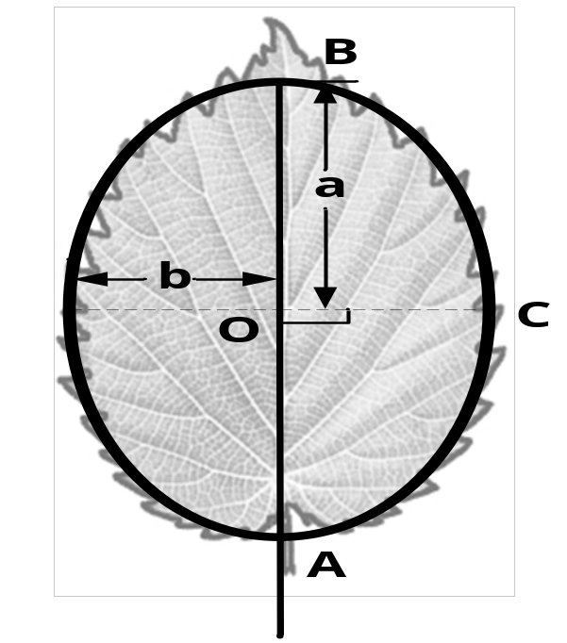
Fig.6 the Simplified leaf shape
As shown in the figure, the most similar ellipse is used to fit leaf’s profile. The length of AB is the distance from base to apex on leaf’s main vein. O is the mid-point of AB, equals AB/2, b is the distance between point O and point C, and OC is perpendicular to AB.
In order to quantitatively depict the relationship between different shapes of leaves and controlling factors, we firstly roughly divide the shapes into two categories: I and II (Figure.7), and assume remains the same in the analysis process, and foliage shape changes only through the change of .
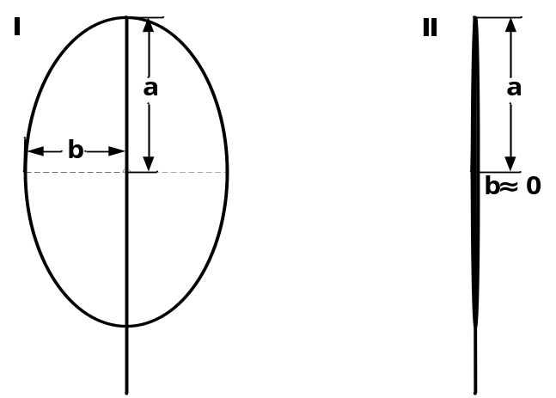
Fig.7 the picture for different leaf shapes
In order to simplify our mathematical model, a couple of basic assumptions will be made in our study:
Firstly, Leaf’s structure system has already reached its best performance after such a
long historical geology time period.
Secondly, we assume that the type of light and energy are certain.
Golley (1969) summarized previous studies and came to this conclusion ^{[8]}: the total energy of trees depends on the caloric values of foliage. And so we define the final residual energy of the leaves as:
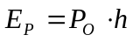 (1)
Where, 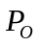is the caloric values are leaves store and is the transpiration coefficient.
Trees with needle-like leaves and a cone-shaped body, and belonging to high-latitude species, require a relatively high calorific value, as an effort to adapt to the alpine ecological environment. And what’s more, as their transpiration is very weak in such an environment, we mainly consider the changes of 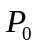 in terms of 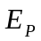. We assume  as the amount of organic matter net photosynthesis produces per unit time, and then there is a positive correlation between and. And so in order to make reach the maximum value, we only need to make the largest ^{[9]}.
Let’s suppose the amount of organic matter photosynthesis manufactures per unit time and per unit area of leaves is , the amount of organic matter foliage respiration consumes per unit time and per unit area of leaves is with illumination and without illumination, and what’s more, the area of leaves receiving sunshine is 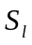 and 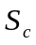 failing to receive sunshine (the overlapping areas between leaves), and finally, the total area of the leaves is S. To sum up, we can get S= +, and the maximum extent to receive sunshine = / S. Then there is:
(2)
Or, we can get:
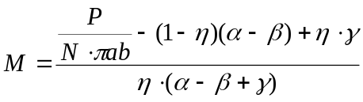 (3)
Of which,, , can be approximately regarded as constant coefficients, and is the total number of leaves, whilestands for proportion of leaves that spread out of the crown.
From (3), we know when 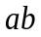reaches the minimum, or when the leaves are thin and long, their overlapping areas get the smallest and thus the areas receiving sunshine the largest.
As for trees with oval-shaped leaves, they belong to low-latitude species and live in an environment with a relatively higher temperature, so they don’t ask for much of their own store of calorific value. And as an effort to emit heat these trees own a strong capacity to transpire, and thus we put more emphasis on in terms of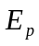.
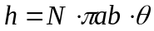 (4)
Where, is the coefficient for organic reduce by transpiration unit area.
It can be seen from the equation above that the size of also has something to do with, that is, the greater is, the greater is. Or, when leaves are wide, trees make more effective use of energy, and the smaller the overlapping area between leaves is, the larger the areas that receive sunlight.
So we can conclude that it is true the leaf shapes “minimize” overlapping individual shadows so as to maximize exposure.
3.1.3 Study on the relationship between Leaves’ shape & leaf and branches distribution.
a. Simplify the distribution of leaves and branches to that of leaves in the overall crown
In order to facilitate our quantitative analysis about the relationship of the distributions of leaves and their shape, we divide the distribution of leaves in the crown into two categories: outside and within.
Let’s suppose the total number of leaves of a tree is and the proportion that’s located outside the canopy is, and then we know the number of leaves in total is 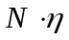 outside and 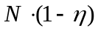 inside. As assumed before, the numbers of leaves of large, middle and small size follow a normal distribution, that is, their proportions are 2.27%, 95.45% and 2.27% respectively.
b. Leaf’s shape & leaves and branches distribution
In order to carry out a numerical relationship between these two components, we need to make a couple of assumed other factors, which may affect leaf’s shape, stay the same. For example, we suppose the profile of tree doesn’t change and treat the tree’s crown as a perfect hemisphere (cone).
Since the medium-size leaf will take the majority of leaves, all the leaves will be considered as medium-size. Suppose is the same for all leaves, leaves’ size as shown in the samples above will be considered. (Figure.7)
Suppose ray of light is perpendicular to the surface of crown and can be transmitted for only one time. As light transmitted into the crown, it’s all absorbed by inner crown. Also suppose the M value is the same for crown inside and crown outside of the same species and same size of leaf.
Let’s suppose two types of leaves, I and II, of whose crown periphery extent to receive sunshine is 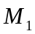 and 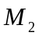 respectively. Then in terms of the crown contours in cone, the amount of organic matter produced by photosynthesis per unit time for the two types of leaves is:
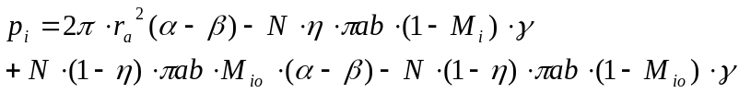 (5)

Table 2: The definition of symbols in formula 5
Symbol Definition
the total amount of organics production per unit time for leaf I
the radius of crown’s bottom
the organics production by photosynthesis per unit time per unit area
the organics consumption by Aerobic respiration per unit time per unit area
the organics consumption by Anaerobic respiration per unit time per unit area
the total amount of leaves on the tree;
the ratio of leaf that locates outside crown.
the sunlight capture ratio for leaf I outside the crown.
the sunlight capture ratio for leaf I inside the crown.

According to our research, is larger while is smaller, and they have the relationship:
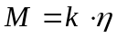 (6)
is the scale factor. We reduce formula 5 as:
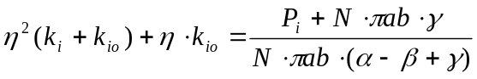 (7)
,,,,,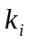,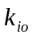are invariant and constant coefficients. is an optimal amount. When the distribution of leaves changes, that is, when the proportion of the number of leaves in the crown periphery gets larger, “” and “” should be minimized to ensure that is the largest. According to the assumption that “” remains unchanged, “” should be minimized or the shape of the leaves should become thin and long.
So the shape of leaves is relevant to the distribution of leaves and branches. From the above analysis, in terms of trees with a crown of conical outline, when the amount of leaves outside the canopy gets greater, the leaves will get thinner and longer accordingly.
3.1.4 Leaf’s shape and tree’s profile/branch structure
Tree’s branch structure is the most important factor for tree’s profile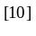, in other words, these two have a certain inter relationship. Therefore, only relationship between leaf’s shape and tree’s profile will be considered.
Referring to Jiang youguo’s study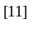, we use a couple of different proper standard geometry shapes to make them best fit our tree profile. Finally, several basic types of tree’s profile are carried out and shown as below (figure.8):
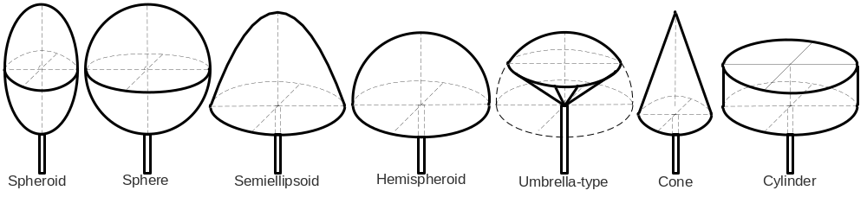Fig.8 the basic types of tree’s profiles
For the purpose of using quantitative method; also since ellipsoid and sphere are relatively similar, hemisphere is similar to umbellate. We can further summarize and simplify our model and fall into four categories as shown below (figure.9):
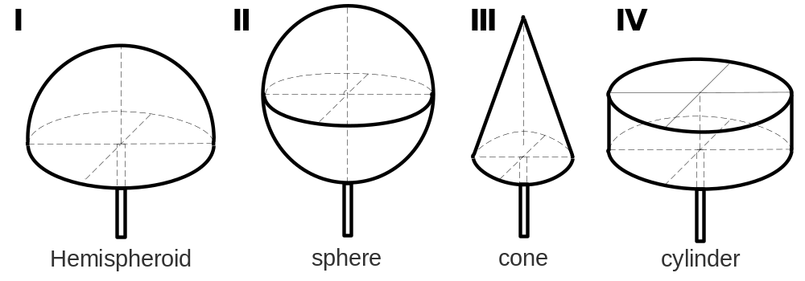Fig.9 the simplified model
Likewise, in order to analyze the relationship between leaf’s shape and tree’s profile, we need to set all the other factors that will affect our conclusion all the same.
Assume the total amount of leaf and leaf’s distribution are all the same; 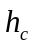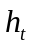and are the same; of every kind of leaves are the equal and also sunlight is the same. We only consider the vertical incident angle.
For the I leaf’s shape:
On the basis of the assumption above, we know =, and then,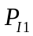=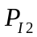>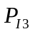>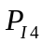
A conclusion can be drawn from above calculation: Since we assume  already reaches its maximum value, which means that the most proper trees’ profile is type I, or II.
From analysis above, we can know that the outline of trees has something to do with the shape of leaves. When trees have a certain outline, leaves tend to change their shape as an effort to acquire the maximum amount of organic matter.
3.2 Classification of leaf shape:
Through the study of the preceding research, both the distribution of branches and the outline of leaves will influence “” and “”, which describe the shapes of leaves. As a result, we consider classify leaf shape in terms of the relationship of “” and “”.
We introduce a variable “”, defined as 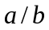, of which is the semi-major axis of similarity elliptic fitting and b is the semi-minor axis of similarity elliptic fitting.
According to Nilson’s study which is On the basis of Wood’s Canopy analysis equation, through the inverse in bill law, we get equation ^{[12, 13,14]} .
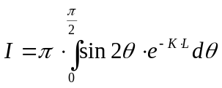 (8)
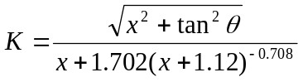 (9)
Where x is length-width ratio of the leaf after fitting, L is the Optimization factor about trees, through a simplifying calculation, and then we achieve the relationship between L and x, shown as the figure.10:
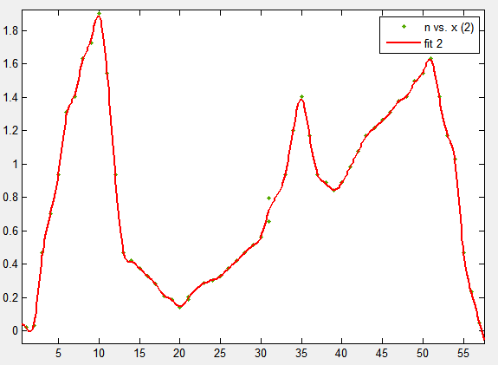
L
x
Fig.10 the relationship between and
After all, we find that “x” is always relatively concentrated around a few specific ranges of values. (figure.10) Therefore, we classify the shapes into three categories (table 2).
We pick some values during the area near every summit, calculate the average value respectively, then we get the basic characteristics of the three classify.
Table 3: The classification of leaves
x | Ⅰ(0,20) | Ⅱ[20,40] | Ⅲ(40,+∞]
E | 10 | 33 | 50
 | 0.6208 | 0.3766 | 0.4233
Afterwards, through measuring and counting 48 different tree species with various shape of leaves(as table 3 shows),we use the smooth Spline fitting method to best fit the data by Matlab., the fitted figure is presented as figure.11.
Table 4: The statistical chart of 48 different kinds of trees
Varieties of trees | Saliz matsudana | Pendula schneid | Pinus koraiensis | Elm
x | 6 | 7 | 55 | 2
V  arieties of trees | Wild apricot | Rhus typhina | Ulmus laevis | Picea wilsonii
x | 1.3 | 11 | 1.5 | 28
Varieties of trees | Pinus bungeana | Celtis bungeana | Picea koraiensis | Magnolia Sieboldii
x | 39 | 1.8 | 35 | 2
Varieties of t  rees | Prunus tomentosa | Picea meyeri | Prunus padus | Sabina vulgaris
x | 1.6 | 30 | 2 | 30
Varieties of trees | Ailanthus altissima | Steamed bread liu | Gleditsia japonica | Lyonia ovalifolia
x | 3 | 9 | 2.5 | 8
Varieties of trees | Sophora japonica | Pinus armandi | Catalpa ovata | Salix babylonica
x | 1.6 | 60 | 1 | 12
Varieties of trees | Short yew | Prunus davidiana | Sabina chinensis | Malus baccata
x | 44 | 2.5 | 53 | 1.8
Varieties of trees | Sabina davurica | Lonicera | S.salicifolia | Magnolia obovata
x | 40 | 8 | 8 | 2.5
Varieties of trees | Syringa oblata | Vitex negundo var | Spiraea japonica | Koelreuteria
x | 0.9 | 9 | 7 | 10
Varieties of trees | Lithocarpus | Lepidodendron | Masson pine | Picea asperata
x | 10 | 25 | 66 | 30
Varieties of trees | Ginkgo biloba | Pinus tabulaeformi | Cycas revolute | Podocarpus fleuryi
x | 0.62 | 50 | 11 | 11
Varieties of trees | Phellodendron | Korea's giant | Abies | Gold leaf You
x | 6 | 28 | 40 | 8

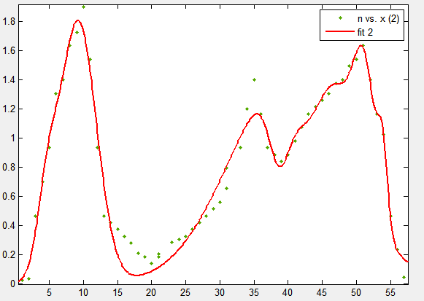
L
x

Fig.11 Statisticalfit chart of sample
We find out that the two have some similarity. Through fitting analysis about the characteristics of statics from 2 figures, we now classify the shape of leaves into three types: I, II and III with reasonable accuracy.
3.3 Estimation of the weight of leaves of a tree
Through the study above, we can get the area of a single leaf by fitting the shape of leaves, and then multiplied by the thickness of the leaves, we can get the volume. And when the volume is multiplied by monolithic density, we get the monolithic weight of the leaves, and then multiplied by the total number of tree leaves, and we can also get the weight all of the tree leaves. After that, with fitting coefficients connecting the fitting and the actual situation, we can get the weight of the leaves of a tree in the actual situation.
a. The total number of leaves on a tree
By dividing the height of the crown into 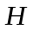 layers equally, and counting the number of leaves in unit volume randomly selected as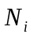, we get an one-dimensional matrix :
U = [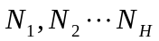] (10)
We assume that the data in the matrix satisfy the normal distribution relationship, and then there is  = =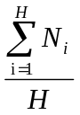.
Then we can serialize the discretemagnitude.（figure.12）
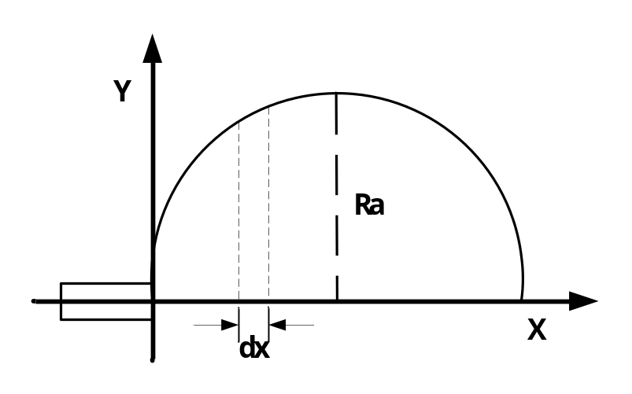
Fig.12 The coordinate graphs of the leaf weight calculation
Let G be the functional relation between the number of leaves in a unit volume from the bottom to the top of the crown and the height of the crown, then we assume
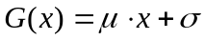 (11)
Corresponding to the circular crown, then the outline of trees can show as:
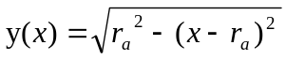
Then we yield out:
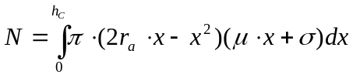 (12)
b. The total weight of leaves on a tree
From the study above, we can get
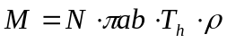 (13)
●When 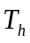 is roughly same, we randomly select 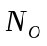samples as well, and get an one-dimensional matrix:
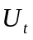 = [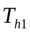,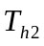, ... 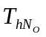] (14)
And thus there is
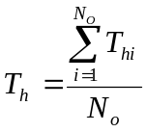 (15)
●As for, since the basic structure of leaves changes little, we can take p as a constant that’s 0.67g/cm3 approximately.
(http://www.thenakedscientists.com/forum/index.php?topic=8277.0)
Since we use the most similar oval to fit the actual shape of leaves, and taking into account that the actual oval cannot make a perfect fit, we define a degree of fitting. When the fitting is good, = 1, and =0 otherwise.
So in reality, the weight of leaves of a tree is:
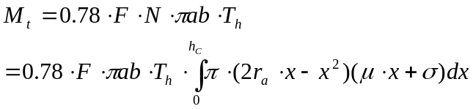 (16)
4 Validation of the model
We collected data from a padauk with a rounded crown in a lumber mill nearby.
From measuring, we know=2m, =10m, and for the majority of the leaves, =4cm, =2cm, =0.2cm, =6, 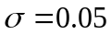=0.9 and the total weight of leaves is 0.081 ton.
When we put the data into our model calculation, the result is 0.076 ton. And in comparison to the actual weight which is 0.081 ton, we get the relative error 6.17%. So our model is rather effective.

5 Discussion of the Model Result

5.1 Sensitivity Analysis
Through the formula above, we can get the correlation diagrams of 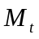 , ,and, which are shown in figures.11, figure.12 and figure 13:
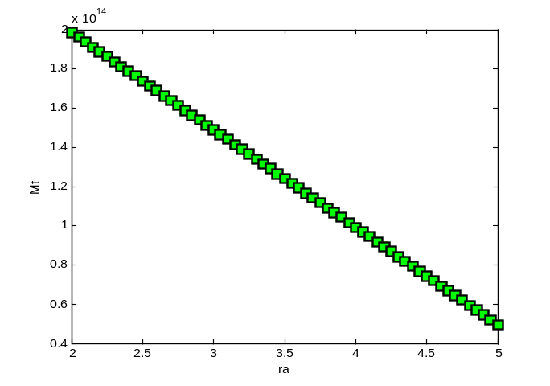
Fig.13 The relationship between and

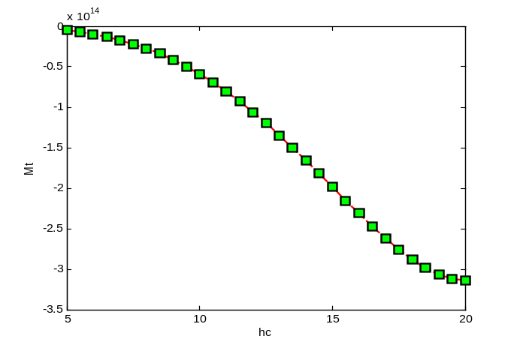

Fig.13 The relationship between and 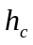

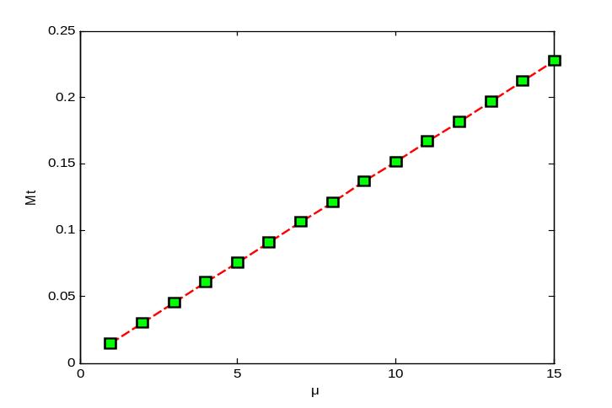

Fig.13 The relationship between and 
According to the above figures, we see has relationship with the volume and quality of tree, has something with the quality of the tree,is also related with ,,.
Through the analysis above, we know that there is a positive correlation between the weight of leaves and the size the tree (height, mass and volume).
5.2 The advantages and disadvantages of the model
Advantages: Through reasonable simplification of actual leaves, our model makes it easier to classify the shapes of leaves. And meanwhile, we take the degree of fitting into consideration to calculate the actual weight of leaves of a tree.
Disadvantages: we consume that the number of leaves of a tree per unit volume together with the height of the crown follows the normal distribution, however, in reality, they may not meet an exact relationship, and it may just be a correlation between them.
6 Conclusions
According to our analysis, the evolution of leaf shape indeed aims at decreasing the overlapping area between leaves, so that the utilization of energy is maximized. We classify the shape of leaves into three types according to their length and width, and the basic characteristics of them are:
x | Ⅰ(0,20) | Ⅱ[20,40] | Ⅲ(40,+∞]
E | 10 | 33 | 50
 | 0.6208 | 0.3766 | 0.4233
We try to validate the result through our model with actual data, and get an inaccuracy as 6.17%.
Through the model, we managed to calculate the actual weight of tree leaves, and the result was in line with the reality.

7 The letter to the science magazine
Dear editor:

We are very glad to have the privileges to introduce our research results about our group’s view in the classifying of the leaves and the calculation of the leaves’ mass.
According to the Preliminary analysis, we establish a model, define the energy 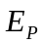 as the final residual energy of the leaves .
We set 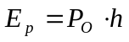, where, 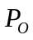 is the leaves' stored calorific value , while is the transpiration coefficient of leaves
On the basis of Wood’s Canopy analysis equation, through the inverse in beer law, we get equation
When all the feature attribute of trees changes, using the Gaussian high times fitting, we get the diagram shown the relationship between the tree shape and the Optimization factor L, it is shown by the below figure.1.(The figure will be attached below)
Through the analysis of the figure, we can classify the leaf shape into three categories, the characteristics of every category is respectively
We adopt the Smooth Spline Function fitting method to best fit the actual 48 groups representative tree data, achieve the consistent conclusion as the model abovementioned as the following figures2, 3, and 4.
We advocate a method of computing the leaves’ mass of a whole tree based on using the biggest similar ellipse to fit the leaf shape. The quantitative expression is
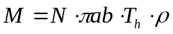
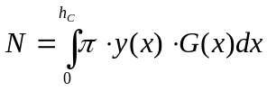
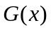-the distribution relationship between leaves number of tree's unit volume and crown height，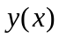 -the relationship between the tree outline and the crown structure，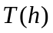 -the average thickness of leaves，-the average volume density of the tree.
Furthermore, we valid our model with the actual situation, the error is only 6.17%, confirmed the availability of our model.
We hope our study outcomes can provide you with a little valuable inspire.
Yours looking for the sky
L
x

Fig.1 the relationship between and Fig.2 The relationship between and

Fig.3The relationship between and Fig.4The relationship between and
8 References
[1]http://en.wikipedia.org/wiki/Tree
[2]http://forestry.about.com/od/treephysiology/ss/part_of_tree.htm [3]http://en.wikipedia.org/wiki/Leaf
[4]http://www.plantcell.org/content/22/11/3574.full)
[5]http://news.discovery.com/earth/leaf-shapes-mystery.html
[6]Bernatzky, A. Tree ecology and preservation[D]. China Architecture and Building Press，1987.
[7]Wei ming. why leaves have so many shapes? [J].2011, 04 issue.
[8] Qiaoxiujuan. Yunnan tropical, subtropical ridge part of the energy distribution pattern of the dominant species. The Chinese academy of sciences, xishuangbanna with botanical gardens, 2006.
. [9]Lincoln Taiz, Eduardo Zeiger. Plant Physiology, science press, Fourth Edition
[10]Zhang Guocai Yuan Yao( Northeast Forestry University),Yang Yanlan( Resource Bureau Of Xinglong Forest Bureau). Summarize Of Tree Branching Structure.
[11]J IANG Youxu, ZANG Renguo. A PRELIMINARY ANALYSIS ON ELEMENTARYARCHITECTURE OF TROPICAL TREES IN THE TROPICAL ARBORETUM OF JIANFENGLING, HAINAN ISLAND. Institute of Forest Ecology and Envi ronment , Chinese Academy of Forestry Sciences , Beijing 100091 , China
[12] Li Xiaowen, Wang Jindi. Measuring Leaf Angle Distribution and Leaf Area Index of Conifer Canopies Simultaneously on Wide-angle Image.Institute of Remote Sensing Application, Chinese Academy ofScience,Beijing100101, P.R.China .
[13] Nilson, T. A theoretical analysis of the frequency of gaps in plant stands. Agr. Meteorol., 1971,8: 25-38.
[14] Chen J. Optically-based methods for measuring seasonal variation of LAI in boreal forest stands, Ag. For. Met., in press, 1995.

9 Appendix
1.%The ra-Mt figure
function [a,b]=Mtra(a,b)
F=1;a=2;b=1;Th=0.1;u=5;rou=0.05;Hc=15;N=1000000;
%through numerical integration calaulating A, B
A=0.78*1000000*1*pi*2*1*0.1*quad(inline('20*x-8000*x.^3'),0,15);
B=0.78*1000000*1*pi*2*1*0.1*quad(inline('-10*x.^2+4000*x.^4'),0,15);
%Calculate Mt using variable values
ra=2:0.05:5;
Mt=A*ra+B;
2.% the hc-Mt figure
function [a,b]=Mthc(a,b)
F=1;a=2;b=1;Th=0.1;u=5;rou=0.05;N=1000000;
%using the circular program to calculate Mt
hc=5:0.5:20;
for k=1:31
Mt(k)=0.78*1000000*1*pi*2*1*0.1*quad(inline('20*x-8000*x.^3'),0,hc(k))*10+0.78*N*F*pi*a*b*Th*quad(inline('-10*x.^2+4000*x.^4'),0,hc(k));
end
%plot figure
plot(hc,Mt,'--rs','LineWidth',2,...
'MarkerEdgeColor','k',...
'MarkerFaceColor','g',...
'MarkerSize',10)
3.%fitting the relationship between plant amount and the shape parameter
x=[1 2 3 4 5 6 7 8 9 10 11 12 13 14 15 16 17 18 19 20 21 21 23 24 25 26 27 28 29 30 31 31 33 34 35 36 37 38 39 40 41 42 43 44 45 46 47 48 49 50 51 52 53 54 55 56 57 ];n =[0.0233 0.0327 0.4668 0.7002 0.9337 1.3071 1.4005 1.6339 1.7273 1.9001 1.5405 0.9337 0.4668 0.4201 0.3735 0.3268 0.2801 0.2101 0.1867 0.1400 0.1867 0.2054 0.2848 0.3034 0.3268 0.3735 0.4201 0.4668 0.5135 0.5602 0.6536 0.7936 0.9337 1.2011 1.4005 1.1671 0.9337 0.8870 0.8403 0.8870 0.9803 1.0737 1.1671 1.2137 1.2604 1.3071 1.3771 1.4005 1.4938 1.5405 1.6339 1.4005 1.1671 1.0270 0.4668 0.2334 0.0467]
cftool(x,n)

