**Overview**

A very simple Android app that implements Red light therapy with a few interesting twists.

**On Load**

When you run it it asks the user to select parameters as per below:  
  
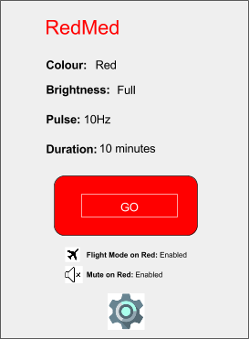

**1.Colour:**

The default is red but the user can choose another colour should they wish. Options are: Red, Blue, Cyan, Green, Magenta as per: <https://developer.android.com/reference/android/graphics/Color.html>

**2.Brightness:**

Default is full brightness (backlight must be 100%)

**3.Pulse:**

Default is 10 Hz (10 cycles a second) the user should be able to enter any integer from 0 (no pulse, static colour) to 25000 Hz

**4.Duration:**

This sets the duration of the app, how long does it do the colour at the brightness and pulse for. Options are to set in seconds, minutes or “until stopped”.

**Note:** It displays below the “Go” button the status (from the settings screen) if airplane mode and muting will enable when the Red screen (therapy) starts.

**Settings Screen:**

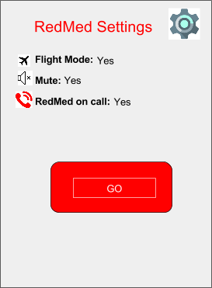

**1.Flight Mode**: Default is Yes, this determines if when the user starts the RedMed session the phone should switch on flight mode and at the end of the session switch it off. It should check which wireless devices are enabled, save this and restore the same state at the end of the session.

2.**Mute:** Default is Yes, this determines if the phone should mute when the session starts and put volume back at the end (once again it should save the audio volume level and restore it at the end of the session).

**3.RedMed on call:** Default is yes, when the user is in a call (phone call) should Red Med automatically start for the duration of the call and end at the end of the call.

**The RedMed Process**

When RedMed is activated it displays a red screen at the brightness set by the user with the pulse set by the user. To disable it the user should double tap the screen. If the user taps the screen once it should show a message for a few seconds: Tap again to disable Redmed. This should be shown in Maroon text. This is to avoid accidental disabling say the user is using it against the body. If they do nothing the message goes away if they tap twice quickly (double tap), RedMed goes back to the main screen.



**Reference:**

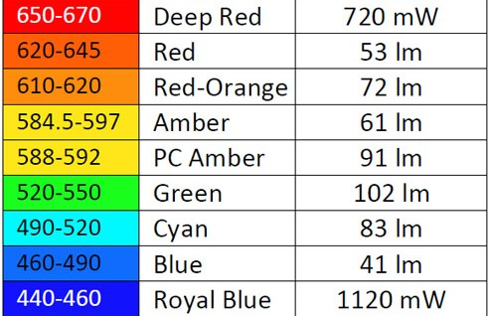  
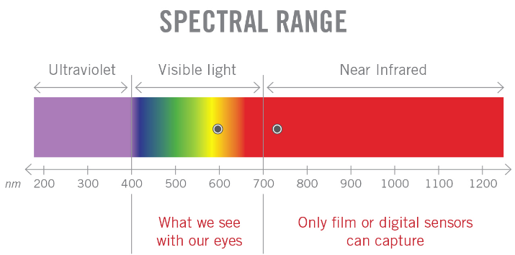

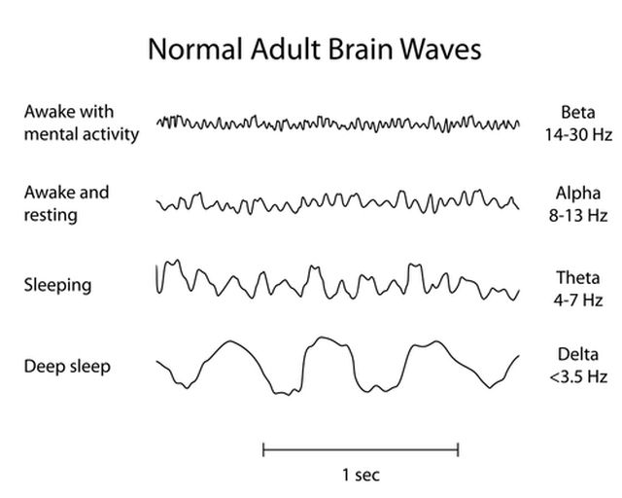

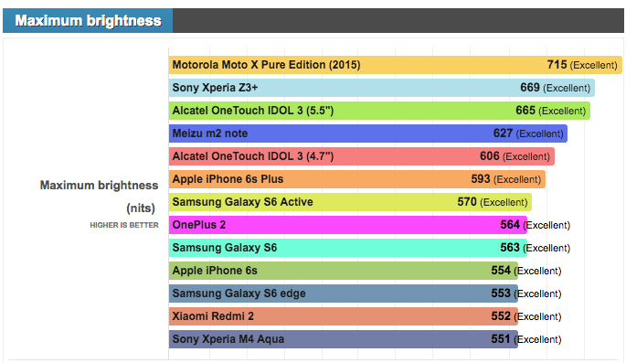

1.Enable flight mode

2.Maximum screen brightness

3.Mute device