AAPL 综合交易分析报告

分析日期: 2025-09-21

# 执行摘要

最终交易建议: **Recommendation**: **Sell**  
  
**Rationale**: Upon thorough evaluation of the arguments presented by the Risky, Neutral, and Safe analysts, I have determined that selling Apple Inc. (AAPL) shares is the most prudent course of action.   
  
1. **Systemic Risks**: The Safe Analyst effectively highlights the significant challenges facing Apple, particularly the 6% sales decline in China—a critical market that cannot merely be dismissed as a "localized issue." This decline suggests that Apple may be vulnerable to broader market dynamics, including shifting consumer preferences and economic pressures. The Neutral Analyst adds that initial pre-order figures for new products must be looked at critically; they do not necessarily translate to long-term sales growth, particularly in light of competitive pressures.  
  
2. **Market Saturation & Competition**: The Risky Analyst posits that Apple’s brand loyalty and ecosystem advantages will drive future growth. However, this view may be overly optimistic given the harsh reality of market saturation and the rise of lower-priced alternatives. The Safe and Neutral Analysts have rightly pointed out that in a tightening economy, consumers are likely to be cautious with discretionary spending, and they may opt for more affordable options that meet their needs without the premium price tag associated with Apple products.  
  
3. **Economic Environment**: The optimistic outlook regarding economic stability suggested by the Risky Analyst, particularly the Federal Reserve's handling of interest rates, risks underestimating the broader economic challenges such as inflation and potential recession. The Safe Analyst cautions that stagnant growth and inflationary pressures could lead to a reduction in consumer spending on premium products, a point that strikes at the heart of Apple’s revenue model.  
  
4. **Innovation Risks**: While the focus on innovation, such as the potential for foldable iPhones and integration of AI technologies, was mentioned by the Risky Analyst, these are speculative at best. The previous experiences of tech companies launching ambitious but ultimately unsuccessful products serve as a reminder that not all innovations pan out. The Safe Analyst effectively underscores the risks tied to investing in uncertain technology, while the Neutral Analyst balances this by acknowledging Apple's record of adaptation but also recognizes that past success does not guarantee future performance.  
  
**Strategic Actions**:  
1. **Divest Current Holdings**: Selling AAPL stock now allows for capitalizing on its current price, reducing exposure to potential losses amid systemic risks and market challenges.  
  
2. **Monitor the Market**: After selling, remain vigilant in tracking market trends, particularly concerning Apple’s performance in various regions and the overall tech market landscape.  
  
3. **Reallocate Investments**: Consider diversifying into sectors that can provide stability and growth regardless of economic pressures, such as utilities or healthcare, rather than maintaining an investment in a singular tech firm facing competition.  
  
4. **Set Reminders for Re-assessment**: Schedule regular evaluations of future opportunities to re-enter AAPL or other tech stocks if significant changes in market dynamics or innovations reignite growth prospects.  
  
**Learning from Past Mistakes**: Previous experiences with holding onto stocks despite market signals taught the importance of adhering to fundamental analysis and not succumbing to emotional biases. This decision to sell is backed by a clear understanding of the external risks and market conditions, ensuring that any future investment strategies prioritize resilience and adaptability.  
  
In conclusion, the collective insights from the analysts, emphasizing both risks and opportunities in a challenging market, ultimately guide me to recommend selling AAPL to protect and potentially enhance the investment portfolio.

## 技术分析图表

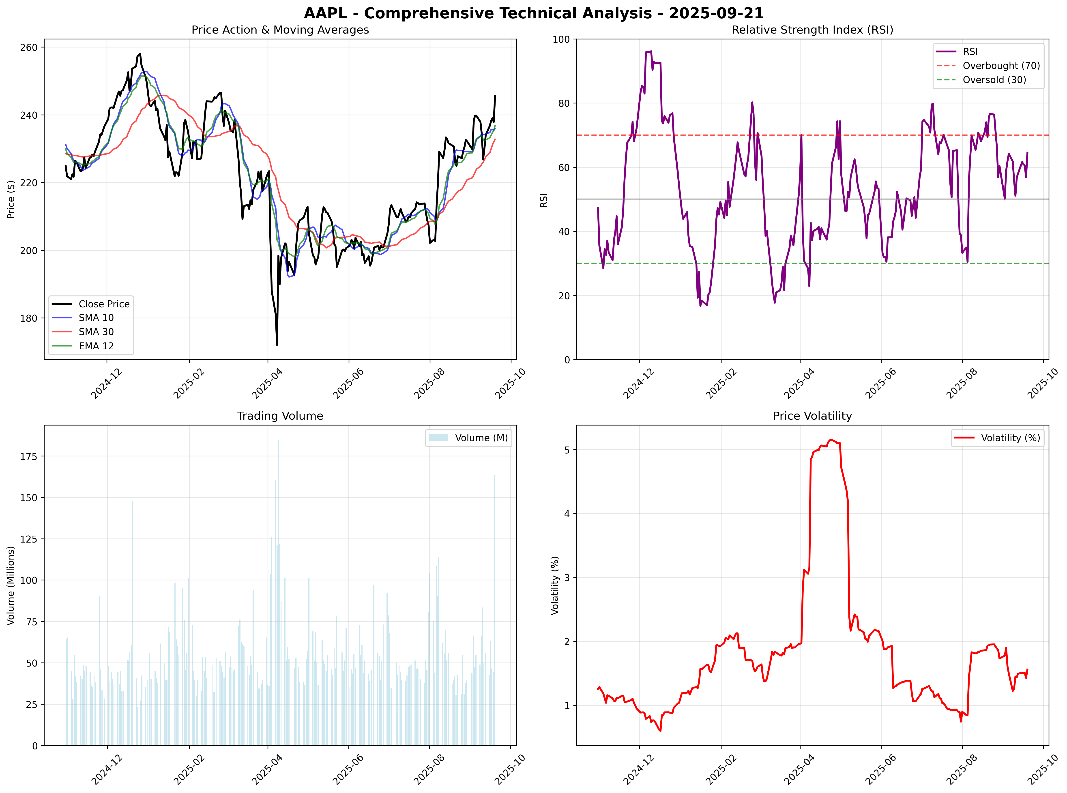

## 市场总结图表

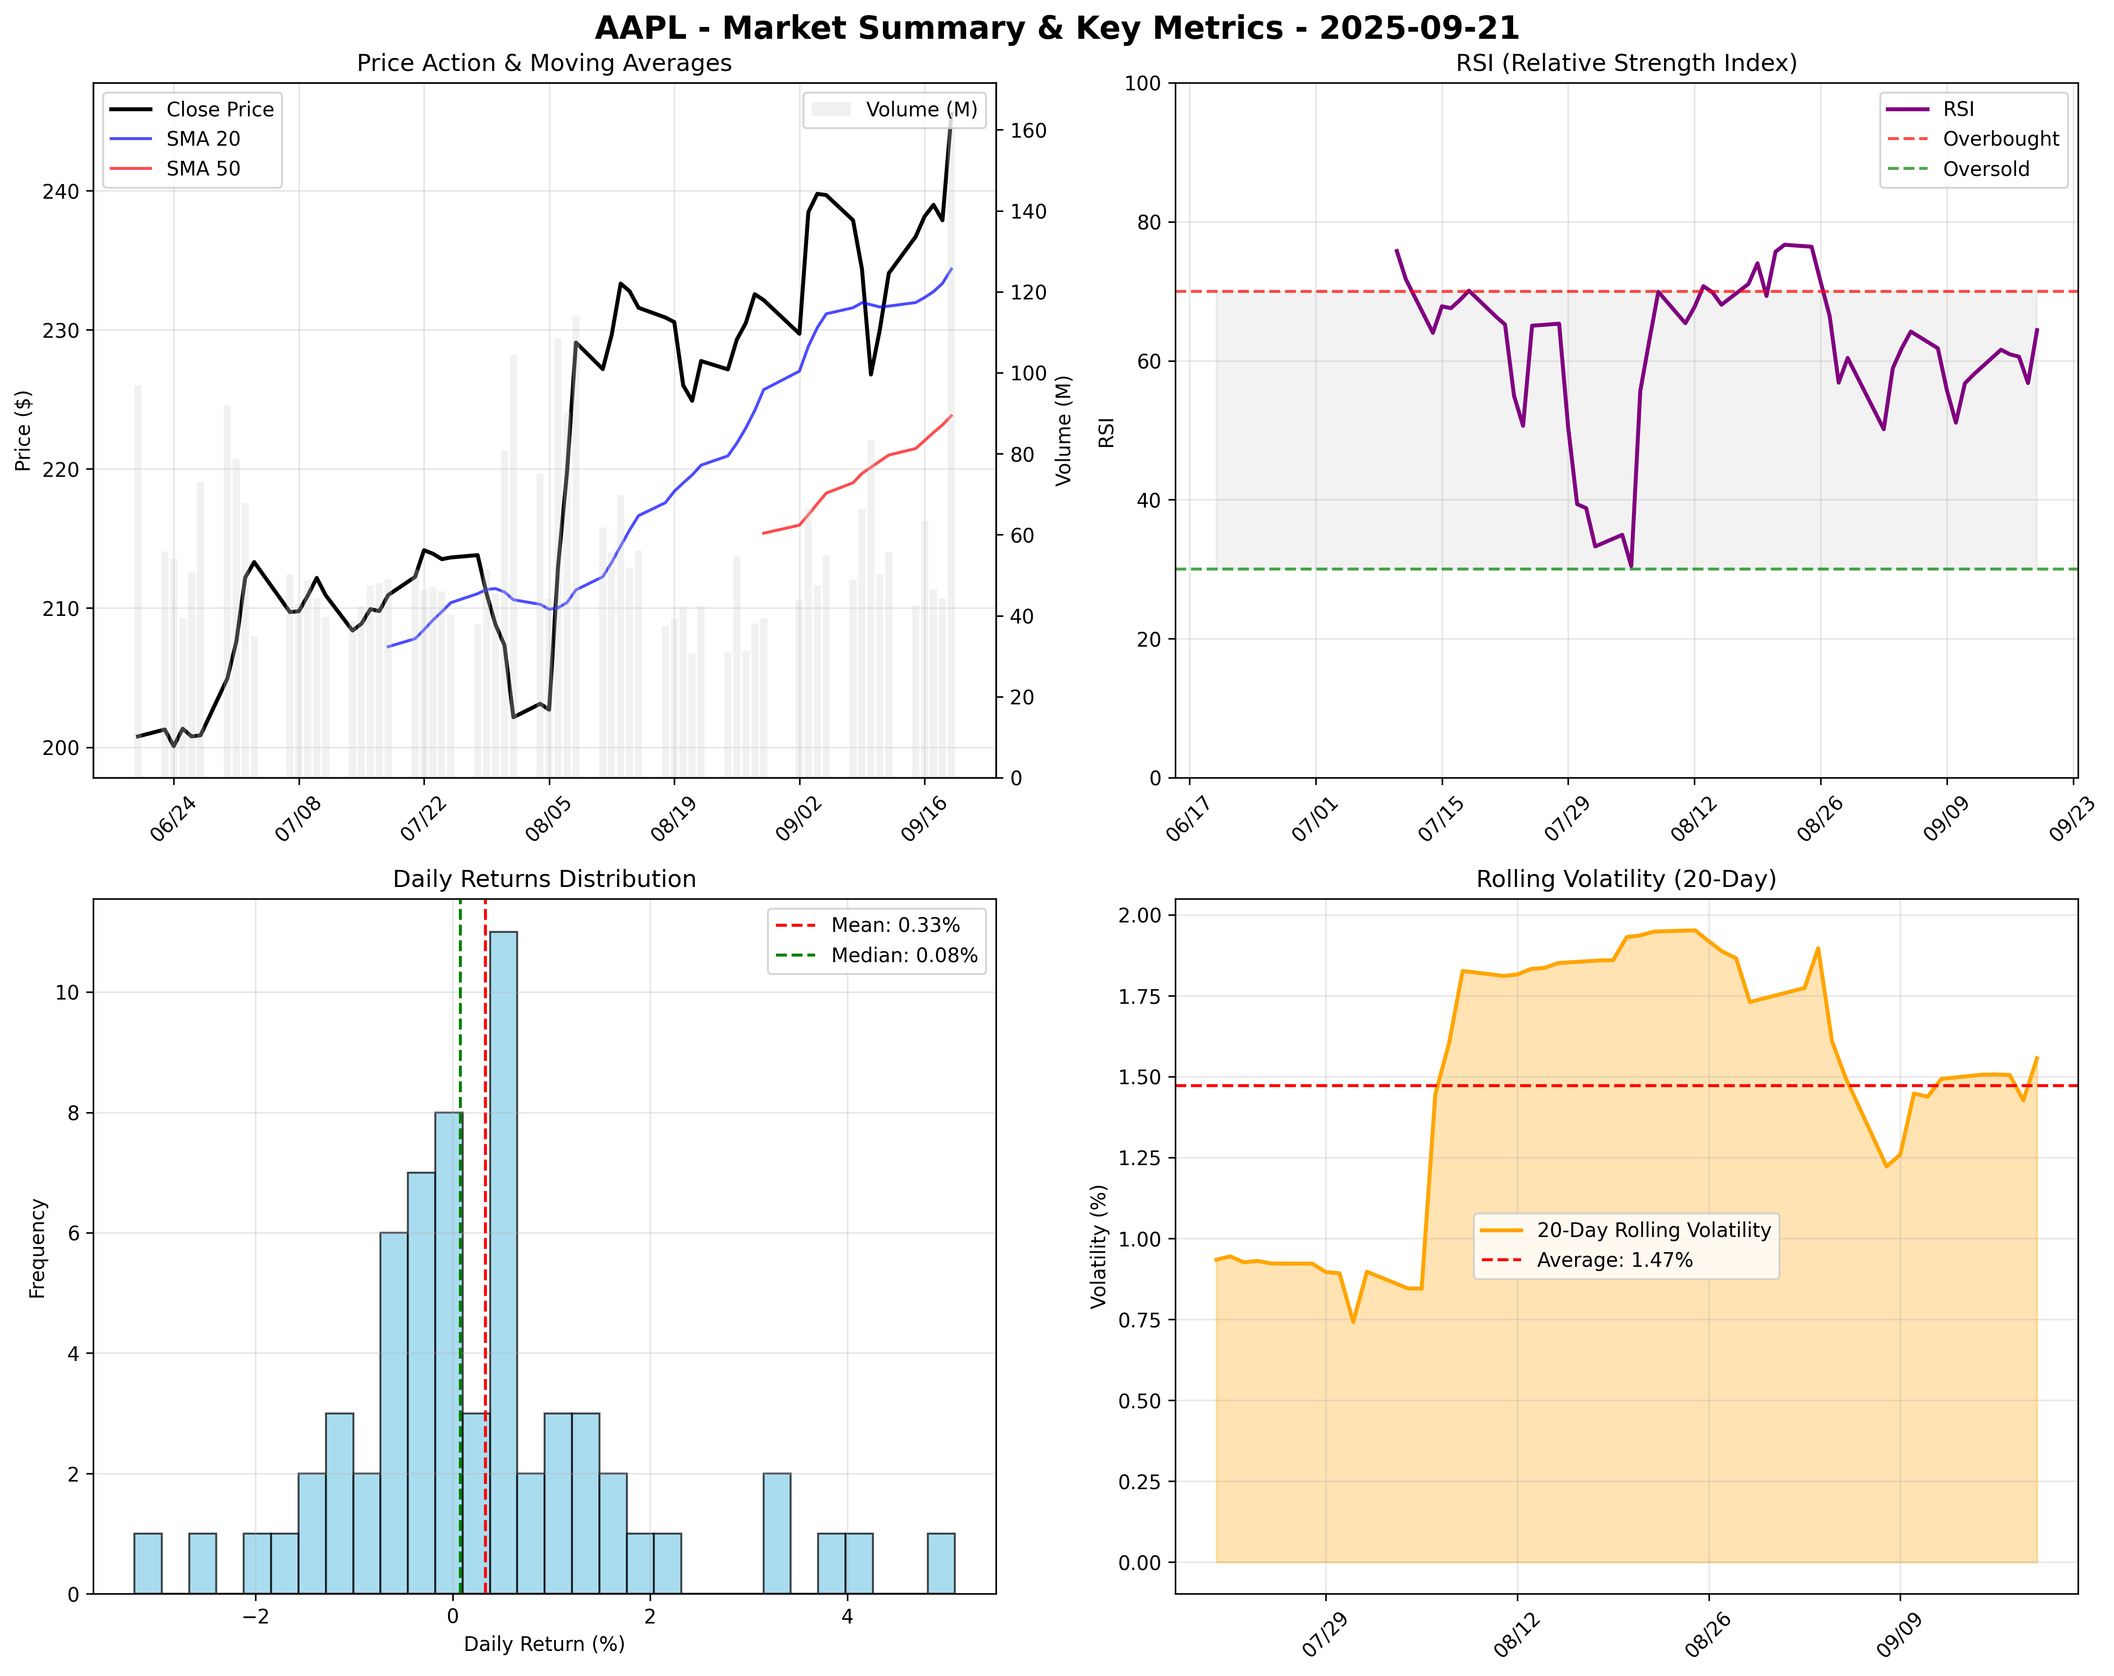

# 新闻分析

### Recent Insights on Apple Inc. (AAPL)  
  
Here’s a comprehensive report on the current state of Apple (AAPL) based on recent news that could impact trading decisions and provide insights into macroeconomic trends.  
  
#### **1. Bernstein Initiates Coverage with a Buy Rating**  
- **Summary**: Bernstein has initiated coverage on Apple Inc. (AAPL) with an "Outperform" rating and a price target of $290. This comes amidst expectations surrounding the company's integration of AI features into its products.  
- **Source**: Bernsteins   
- **URL**: [Read More](https://www.nasdaq.com/articles/bernstein-initiates-coverage-apple-aapl-outperform-recommendation)  
- **Impact Assessment**: **High**  
  
#### **2. Strong Demand for iPhone 17**  
- **Summary**: Pre-orders for the iPhone 17 have surged, especially in markets like China and India. Analysts highlight that initial sales figures are tracking ahead of the iPhone 16 launch, amplifying bullish sentiments around AAPL's stock.  
- **Source**: J.P. Morgan   
- **URL**: [Read More](https://www.tipranks.com/news/jpmorgan-raises-apple-stock-forecast-because-iphone-17-surprised-positively)  
- **Impact Assessment**: **High**  
  
#### **3. Sales Decline in China**  
- **Summary**: Despite the anticipated iPhone 17 launch, Apple has reported a 6% year-over-year decline in smartphone sales in China, indicating potential challenges in this critical market.  
- **Source**: Yahoo Finance  
- **URL**: [Read More](https://finance.yahoo.com/news/aapl-apple-sales-sink-6-133723554.html)  
- **Impact Assessment**: **Medium**  
  
#### **4. Federal Reserve Holds Interest Rates**  
- **Summary**: The Federal Reserve announced an interest rate hold during its latest meeting which, when coupled with reports of moderate inflation, has managed to keep trading markets cautiously optimistic regarding future financial conditions.  
- **Source**: get_global_news_openai  
- **Impact Assessment**: **Medium**  
  
#### **5. CEO Tim Cook Denies Price Hike Due to Tariffs**  
- **Summary**: Following the release of the iPhone 17, CEO Tim Cook addressed questions regarding price increases, asserting that they are unrelated to tariffs but rather reflect the advancements in technology.  
- **Source**: TipRanks  
- **URL**: [Read More](https://www.tipranks.com/news/apple-aapl-ceo-tim-cooks-says-iphone-price-hikes-not-due-to-tariffs)  
- **Impact Assessment**: **Medium**  
  
#### **6. AI Innovations Incorporated in Apple Products**  
- **Summary**: Apple has rolled out new AI-driven features, notably in the latest Apple Watch that can monitor blood pressure, potentially strengthening its competitive edge against rivals in the wearables market.  
- **Source**: TipRanks  
- **URL**: [Read More](https://www.tipranks.com/news/apple-aapl-watch-now-detects-potential-high-blood-pressure-using-ai)  
- **Impact Assessment**: **Medium**  
  
#### **7. Foldable iPhone Manufacturing Discussions**  
- **Summary**: Apple is reportedly in discussions to begin test production of a foldable iPhone in Taiwan, as part of its innovation strategy for future product lines.  
- **Source**: Seeking Alpha  
- **URL**: [Read More](https://seekingalpha.com/news/4496007-apple-working-on-test-production-of-foldable-iphone-report)  
- **Impact Assessment**: **Medium**  
  
### Summary Table of Selected News  
  
| **Headline** | **Summary** | **Source** | **Impact Rating** |  
|---------------------------------------------------------------|--------------------------------------------------------------------|-----------------------------------------------------|-------------------|  
| Bernstein Initiates Coverage with Buy Rating | Start of coverage with a price target of $290. | Bernstein | High |  
| Strong Demand for iPhone 17 | Pre-orders surge, tracking ahead of previous models. | J.P. Morgan | High |  
| Sales Decline in China | Smartphone sales down 6% year-over-year. | Yahoo Finance | Medium |  
| Federal Reserve Holds Interest Rates | Announcement of interest rate holds amid moderate inflation. | get_global_news_openai | Medium |  
| CEO Tim Cook Denies Price Hike Due to Tariffs | Price increases not related to tariffs; based on technology. | TipRanks | Medium |  
| AI Innovations Incorporated in Apple Products | AI features now part of Apple Watch design. | TipRanks | Medium |  
| Foldable iPhone Manufacturing Discussions | Moving forward with potential foldable iPhones. | Seeking Alpha | Medium |  
  
---  
  
The overall sentiment towards AAPL appears largely positive, driven by robust demand for new product launches and strategic innovations. However, challenges remain, particularly in key markets like China where sales are dropping. Investors should keep a close eye on future earnings reports and market reactions to Apple’s innovations in the AI space and product advancements.