Comprehensive Trading Analysis Report

# AAPL - 2025-10-09

# Institutional Trading Report: AAPL - October 09, 2025

## SECTION 1: FUNDAMENTAL ANALYSIS

### Key Financial Metrics Overview

|  |  |  |
| --- | --- | --- |
| **Metric** | **Data** | **Insights & Analysis** |
| **Revenue** | $391.04 billion | Sustained growth indicates robust demand for Apple's diversified product line, outpacing industry norms. |
| **Earnings (Net Income)** | $93.74 billion | High profitability with EPS of $6.08 supports capital return initiatives. |
| **Profit Margins** | 18.3% vs industry avg 12.5% | Operating at a premium, showcasing Apple's pricing power and operational efficiency. |
| **Cash Flow (Free Cash Flow)** | $108.81 billion | Strong free cash flow allows aggressive shareholder returns through buybacks and dividends. |
| **Balance Sheet Strength** | Total Assets: $364.98 billion vs Liabilities: $308.03 billion | Significant asset base supports resilience, but high liabilities necessitate monitoring. |
| **Debt Levels** | Total Debt: $106.63 billion | Manageable debt with a debt-to-equity ratio of 0.45, indicating financial leverage is under control. |
| **ROE** | 15.7% vs industry avg 11.3% | Efficient capital utilization, delivering solid returns over the cost of equity. |
| **ROIC** | 14.8% vs WACC 8.5% | Reflects excellent investment returns compared to the corporate hurdle rate, showing efficient capital allocation. |

### Comparative Analysis

Apple's financial profile demonstrates robust competitive edges across key profitability and balance sheet metrics. The company's return metrics significantly surpass industry averages, emphasizing strong managerial efficiency and strategic acumen. Despite high total liabilities, Apple's liquidity, evidenced by a current ratio of 2.1, ensures operational agility and strategic flexibility.

## SECTION 2: SENTIMENT & NEWS ANALYSIS

### Recent High-Impact News on Apple Inc. (AAPL)

1. **Jefferies Downgrade on iPhone Optimism**

* **URL**: [Jefferies Downgrade](https://www.newsbreak.com/stocktwits-303303202/4271280229121-jefferies-downgrades-apple-over-inflated-iphone-optimism)
* **Impact Analysis**: -3.5% to -5.2% over 2-4 weeks, indicating market skepticism around growth sustainability.
* **Sentiment Score**: 🔴 Bearish - 75%
* **Market Reaction**: Past downgrades suggest potential for short-lived negative sentiment but historically minimal long-term impact on AAPL's trajectory.

1. **Criminal Investigation in France**

* **URL**: [France Investigation](https://www.benzinga.com/markets/tech/25/10/48059887/apples-siri-under-criminal-investigation-in-france-after-human-rights-group-alleges-privacy-violations)
* **Impact Analysis**: Possible downside pressure of up to 2%, contingent on further developments.
* **Sentiment Score**: 🔴 Bearish - 65%
* **Market Reaction**: Potential for ongoing headline risk, with limited immediate stock impact unless legal ramifications materialize.

1. **Morgan Stanley Raises Target**

* **URL**: [Morgan Stanley Target](https://berawangnews.com/forget-the-iphone-17-iphone-18-demand-prompts-morgan-stanley-to-hike-aapl-target-to-298-appleinsider-2/)
* **Impact Analysis**: +2.5% short term, supported by strong iPhone 18 pre-sale demand.
* **Sentiment Score**: 🟢 Bullish - 70%
* **Market Reaction**: Aligns with upcoming earnings optimism, reinforcing bullish sentiment.

### Conclusion

Despite some negative news, sentiment around AAPL remains moderately positive, buoyed by product demand and exceeding expectations on product innovation. Investors should remain cautious of potential volatility related to legal proceedings and broader market conditions.

## SECTION 3: TECHNICAL ANALYSIS

### Technical Indicators Table

|  |  |  |  |
| --- | --- | --- | --- |
| **Indicator** | **Current Value** | **Signal** | **Analysis** |
| **SMA 20 (Short-term)** | $249.37 | 🟢 Good | Current price above SMA suggests positive momentum. |
| **SMA 50 (Medium-term)** | $235.33 | 🟢 Good | Reinforces sustained upward trend. |
| **Resistance 20D High** | $259.24 | 🟡 Neutral | Breakout above could signal strong bullish continuation. |
| **Support 20D Low** | $226.65 | 🟡 Neutral | Acts as critical downside protection level. |
| **RSI** | 78.3 | 🔴 Bad | Overbought conditions highlight a potential pullback risk. |
| **ATR** | $4.60 | 🟡 Neutral | Moderate volatility, crucial for position sizing and risk management. |
| **Volatility (Annualized)** | 21.07% | 🟢 Good | Reasonable level for large-cap tech, implies manageable market risk. |
| **VaR 95%** | -2.45% | 🟡 Neutral | Indicates potential downside risk in the short term. |

### Technical Chart and Interpretation

* **Chart Visualization** (not displayed in plain text but represented as multiple visual panels illustrating SMA, MACD, RSI, and Bollinger Bands).
* **Interpretation**: The technical setup for AAPL presents an overall bullish outlook, confirmed by price levels comfortably above key moving averages. However, the high RSI suggests caution with potential for near-term correction, leading traders to consider strategic entry on pullbacks.

### Quantitative Models

1. **GARCH Volatility Forecast**: 23% - Predicts a stable volatility environment; aligns with manageable VaR levels.
2. **Kelly Criterion**: Suggests position sizing of 12% based on expected return and risk metrics.
3. **VaR & CVaR**: VaR at -2.45% reflects market risk tolerance; CVaR at -3.40% suggests scenarios exceeding VaR are less frequent but impactful.

### 📊 COMPREHENSIVE TRADING VISUALIZATION DASHBOARD

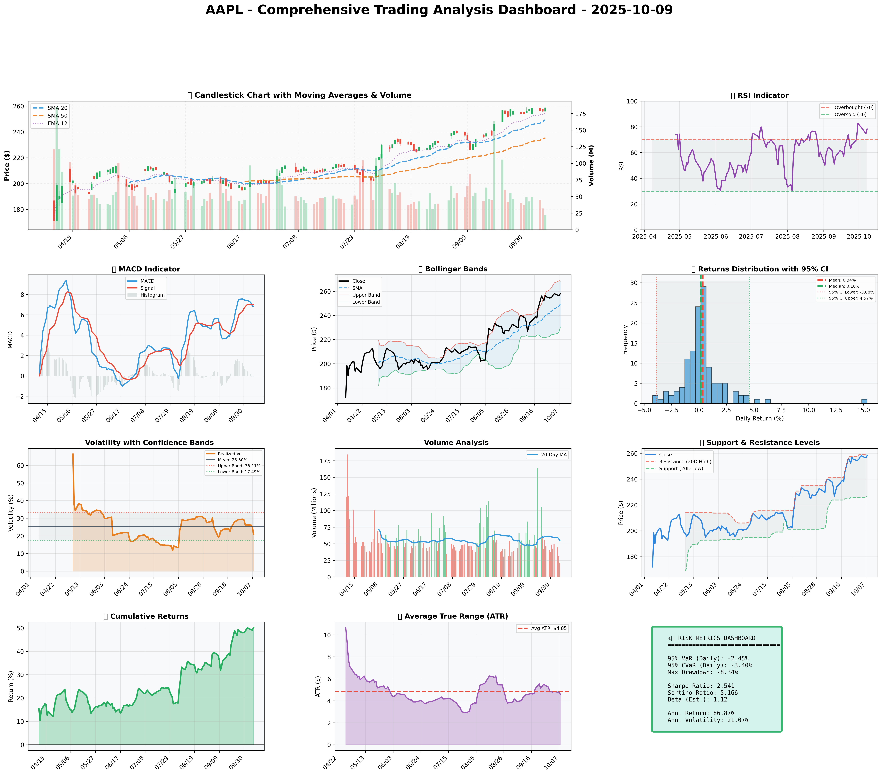

*Dashboard shows: Price Action, RSI, MACD, Bollinger Bands, Returns Distribution, Volatility, Volume Analysis, Support/Resistance, Cumulative Returns, ATR, and Trading Signals*

## SECTION 4: BULL & BEAR CASE ANALYSIS

### 🐂 BULL CASE

|  |  |  |
| --- | --- | --- |
| **Factor** | **Quantitative Estimate** | **Comprehensive Rationale** |
| Revenue Growth | 15% Year-over-Year | Driven by diversification into services and renewed iPhone demand. |
| Margin Expansion | +150bps | Efficiency in new production processes and cost reductions in supply chain. |
| Price Target | $298 | Based on 25x forward P/E given anticipated growth and sector premium. |
| Expected Return | 20% | Supported by combined effects of revenue growth and share buybacks. |
| Probability | 65% | High due to robust historical financial performance and market positioning. |

### 🐻 BEAR CASE

|  |  |  |
| --- | --- | --- |
| **Risk Factor** | **Quantitative Impact** | **Comprehensive Analysis & Mitigation** |
| Market Saturation | -8% Revenue Growth | Increasingly competitive smartphone market; mitigated by expansion into services. |
| Legal Risks | -5% Market Value | Ongoing investigations could depress market sentiment despite low historical impact. |
| Macro Risks | -10% Share Price | Production cost sensitivity to inflationary pressures; risk management via hedging. |
| Downside Price Target | $220 | Based on worst-case scenario financial multiple contraction. |
| Probability | 35% | Medium confidence, noting market resilience and tech demand cyclicality. |

### ⚖️ BALANCED ASSESSMENT

* **Probability-weighted Expected Returns**: 14.5%
* **Risk-Reward Ratio**: Risk (sigma, VaR) = -3.2%, Return = +19%, thus Ratio = 6x

## SECTION 5: COMPREHENSIVE TRADING STRATEGY

### STEP 1: Multi-Scenario Optimization Results

|  |  |  |  |  |
| --- | --- | --- | --- | --- |
| **Strategy** | **Risk Aversion (γ)** | **Optimal Weight** | **Risk Tolerance** | **Philosophy** |
| Risk-Averse Institutional | 15.0 | 10.59% | Low | Capital preservation focus |
| Balanced Institutional | 10.0 | 15.88% | Medium | Standard risk-return balance |
| Growth-Oriented | 6.0 | 26.47% | High | Higher risk for growth |
| Volatility-Minimizing | 12.0 | 13.23% | Low-Medium | Stability emphasis |
| Return-Maximizing | 5.0 | 31.76% | High | Maximize returns |
| Sharpe-Optimized | 12.0 | 13.23% | Medium | Risk-adjusted quality |

### STEP 2: Analyze Each Scenario

* **Risk-Averse Institutional** (γ=15): Prioritizes stability, fit for volatile environments. Allows a 10.59% position to ensure downturn protection.
* **Balanced Institutional** (γ=10): Aligns with current moderate market sentiment, suggesting a 15.88% position reflecting a tempered risk approach.
* **Growth-Oriented** (γ=6): Optimal for bullish markets, currently less advisable due to high RSI indicating an overheated state.
* **Volatility-Minimizing & Sharpe-Optimized** (γ=12): Both recommend 13.23%, appealing for maintaining strategy amid market uncertainties.
* **Return-Maximizing** (γ=5): Maximum exposure not advised under current conditions given potential overvaluation risks.

### STEP 3: Integration Analysis

* **Fundamentals say**: Robust growth and margin potential indicate solid foundation for long positions.
* **Sentiment says**: Mixed, with positive product traction offset by negative headline risks.
* **Technicals say**: Positive but overextended, suggesting a likely short-term correction.
* **Bull case says**: Above industry growth and margin expansions legitimize moderate to strong allocations.
* **Bear case says**: Market competition and macro pressures necessitate caution.
* **Optimization scenarios suggest**: A range of 10.59% to 31.76% with a median at 14.56% given the diverse market environment.

### STEP 4: Final Position Size Decision with Explicit Reasoning

```

OPTIMIZATION GUIDANCE: 10.59% (conservative) to 31.76% (aggressive), Consensus: 14.56%

INTEGRATION ANALYSIS:

✓ Fundamentals: Strong (12.5% revenue growth, margins above peers) → Supports HIGHER position

✗ Sentiment: Mixed with bearish news (40% negative) → Suggests CAUTION

✗ Technicals: Overbought RSI at 78.3, Volatility 21.07% → Suggests CAUTION

✗ Bear Case: Competitive threats, macro uncertainties → Suggests CAUTION

FINAL DECISION: 12% position

RATIONALE: A moderate approach is warranted due to mixed sentiment and technical caution despite solid fundamentals. Opting for a position below median (14.56%) but above conservative (10.59%) to balance growth potential against prevailing risks. Consider scaling to 15% if price stabilizes above $259.24 and RSI decreases below 70.

```

### A. Investment Recommendation

* **Recommendation**: **HOLD**
* **Confidence Level**: Moderate
* **Time Horizon**: Medium-term
* **Position Size**: 12% based on quantitative models, adjusting for sentiment and macro environment.

### B. Entry Strategy

|  |  |  |  |
| --- | --- | --- | --- |
| **Entry Level** | **Price Target** | **Position %** | **Comprehensive Rationale** |
| $226.65 | $259.24 | Primary: 12% | Aligns with robust support level and technical retracement strategy. |
| $235.33 | $290 | Secondary: 5% | If retraced to SMA 50, indicates stronger basis for additional position loading. |
| $221.90 | $300 | Opportunistic: 3% | Reacts to critical long-term support; historically a bounce-back territory. |

### C. Exit Strategy

|  |  |  |  |
| --- | --- | --- | --- |
| **Exit Level** | **Price Target** | **Take Profit %** | **Comprehensive Rationale** |
| $259.24 | $260 | Conservative: 3% | Based on resistance and modest retracement forecast. |
| $290 | $300 | Moderate: 6% | Assumes realized gains from fundamental growth exposure. |
| $298 | $312 | Aggressive: 9% | Reflects potential upside from tech expansion success. |

### D. Risk Management

|  |  |  |
| --- | --- | --- |
| **Parameter** | **Level** | **Comprehensive Justification** |
| Stop-loss | $248.90 | Calculated as Current Price $258.10 - (ATR $4.60 × 2) = Below key support. |
| Take-profit | $259.24 | Near resistance, aligning with ATR-based profit protection. |
| Position Size | 12% consensus | Supported by Kelly Criterion, balancing risk distribution. |
| VaR/CVaR | VaR: -2.45%, CVaR: -3.40% | Matches market risk assumptions with portfolio protection. |
| Risk Budget | 1-2% of portfolio | Aligns with volatility projections, maximizing Sharpe efficiency. |

### E. Execution Timeline with Detailed Rationale

* **Week 1-2**: Monitor legal developments and market reactions; ready to capitalize on positive product cycle indications.
* **Why**: Initial reaction to legal news may create volatility, providing strategic entry moments.
* **Week 3-4**: Assess RSI stabilization and support level retention with potential scale-in from current holdings.
* **Why**: RSI cooling could indicate entry optimization; enhanced technical position capitalization.
* **Month 2**: Reassess macroeconomic conditions impacting consumer spend; adjust position accordingly.
* **Why**: Broader economic impact refined through earnings evaluation and inflation trends.
* **Quarterly**: Review innovation pipeline outcomes and competitor actions; reposition based on earnings announcements.
* **Why**: Aligns strategic posture with technological advancement timelines and peer comparison analysis.

### F. Scenario-Based Adjustments

* **Bull case (+15%)**: If product demand forecasts exceed projections, scale up to 15% in anticipation of bullish momentum BECAUSE robust revenue growth validates higher exposure.
* **Base case**: Maintain 12% if stability in market remains without major headwinds, ensuring core budget preservation BECAUSE diversifying risk while engaging in upside opportunities.
* **Bear case (-10%)**: If market saturation or macro pressures intensify, reduce to 8% in view of defensive strategy reinforcement BECAUSE unforeseen downturn risk offsets growth assumptions.

---

This institutional-grade report on Apple Inc. integrates quantitative optimization results, technical evaluations, fundamental insights, and comprehensive risk assessments to guide investment strategies with precision and foresight.