NVDA 综合交易分析报告

分析日期: 2025-10-03

# 执行摘要

最终交易建议: Based on the detailed debate among Risky, Neutral, and Safe/Conservative analysts, here is a summary of the key arguments, rationale for decision, and refined strategy for the trader:  
  
### Summary of Key Arguments:  
  
1. **Risky Analyst**:  
 - Emphasizes NVIDIA’s strong momentum and bullish indicators above key moving averages.  
 - Highlights the transformative potential with strategic partnerships, e.g., OpenAI, suggesting significant growth in the AI sector.  
 - Advocates for scaling into the position to capture growth, despite being near overbought levels on RSI.  
  
2. **Safe Analyst**:  
 - Warns about the risks of NVIDIA being near overbought territory (RSI of 65.60) and potential market corrections.  
 - Highlights macroeconomic challenges (rising interest rates, inflation) and competition from AMD and Intel.  
 - Suggests maintaining liquidity and avoiding overcommitment to volatile assets.  
  
3. **Neutral Analyst**:  
 - Finds merit in both the bullish momentum and the cautious risk outlook.  
 - Suggests balancing exposure to NVIDIA’s potential growth with prudent risk management and predefined exit strategies.  
 - Recommends a moderate approach with scaled entries and regular reassessment of market conditions.  
  
### Recommendation:  
  
**Hold**. While all analysts provide valid points, a well-considered Hold position will maximize monitoring and position the trader for strategic moves. Here's why:  
  
- **Rationale**:  
 - **Bullish Indicators**: While NVIDIA is experiencing upward momentum, the technical signals approaching overbought levels suggest potential for a price pullback, requiring careful monitoring and not premature entry.  
 - **Economic Considerations**: Macroeconomic factors like inflation and rising interest rates pose genuine risks to tech spending, advising caution until clearer trends emerge.  
 - **Competition Risks**: With competitors actively developing new technologies, opportunities could shift, and maintaining flexibility to adjust positions is prudent.  
 - **Past Lessons**: Previous overcommitment based on momentum without fully considering broader risks led to suboptimal outcomes. The Hold stance ensures learning from past mistakes by requiring deeper evaluation before committing capital.  
  
### Strategic Actions:  
  
1. **Monitor Technical Indicators**: Keep an eye on RSI and MACD trends for any signs of momentum shifts. Reassess the Hold decision if significant changes occur.  
   
2. **Track Economic Indicators**: Follow inflation rates and consumer spending for impacts on discretionary tech investments.  
  
3. **Assess Competitive Landscape**: Continuously evaluate activities and innovations from AMD, Intel, and others for market impact on NVIDIA.  
  
4. **Review Strategic Partnerships**: Monitor updates on partnerships with OpenAI and similar ventures to ensure they yield expected outcomes.  
  
5. **Revisit Position Strategy**: Conduct regular performance reviews and adjust any latent scale-in plans based on NVIDIA's financial and market performance.  
  
By advocating a Hold stance, we ensure the trader is well prepared to capitalize on NVIDIA’s potential growth without exposing too much to undue risk, aligning with both strategic growth opportunities and prudent risk management.

# 技术分析

### NVDA Stock Analysis (September 3, 2025 - October 2, 2025)  
  
#### Summary of Moving Averages  
1. **50-Day Simple Moving Average (SMA)**  
 - Latest Value (October 2, 2025): **177.82**  
 - The 50 SMA represents a medium-term trend direction indicator. Over the past weeks, NVDA has been trending above this SMA, indicating bullish momentum in the medium term.  
  
2. **200-Day Simple Moving Average (SMA)**  
 - Latest Value (October 2, 2025): **142.78**  
 - The 200 SMA indicates a long-term upward trend, and NVDA remains significantly above this line. This suggests that the stock is in a strong bullish trend over a longer time frame.  
  
3. **10-Day Exponential Moving Average (EMA)**  
 - Latest Value (October 2, 2025): **182.45**  
 - The 10 EMA acts as a quick response to price changes. It shows that short-term momentum is much higher than both the 50 SMA and the 200 SMA.  
  
#### Momentum Indicators  
1. **Moving Average Convergence Divergence (MACD)**  
 - Value (October 2, 2025): **2.86**  
 - A positive MACD value indicates bullish momentum. In the coming days, traders should watch for any potential crossover back down or divergence as cautionary signals.  
  
2. **Relative Strength Index (RSI)**  
 - Value (October 2, 2025): **65.60**  
 - The RSI indicates that NVDA is nearing overbought territory but has not yet crossed the critical 70 threshold, suggesting it is still within a strong bullish momentum phase but close to a potential reversal.  
  
#### Volatility Indicators  
1. **Bollinger Bands Middle**  
 - Latest Value (October 2, 2025): **177.68**  
 - This average is a 20 SMA, providing a baseline for assessing the price volatility of NVDA. The price being above this level indicates bullish sentiment.  
  
2. **Average True Range (ATR)**  
 - Value (October 2, 2025): **5.23**  
 - The ATR indicates a moderate level of volatility, which is suitable for day trading but should caution swing traders regarding potential price fluctuation risks.  
  
### Analysis of Historical Price Movement  
- Over the past month, NVDA has shown a significant bullish trend, where the price increased from **$170.61** on September 3, 2025, to **$188.89** on October 2, 2025, suggesting strong buying interest in the stock.  
- Throughout this period, the stock experienced minor pullbacks, sticking visibly above both the 50 SMA and the more critical 200 SMA, establishing essential support levels at **$177.82** and **$142.78** respectively.  
  
### Conclusion  
The indicators suggest a predominately bullish trend for NVDA strengthened by its positioning above significant moving averages, supportive volume trends, and moderate but healthy RSI metrics. Traders may consider waiting for potential retracements towards the 50 SMA for new entry opportunities while keeping an eye out for signs of price consolidation or reversal indicators as represented by the ATR and MACD.  
  
### Key Points Summary  
  
| Indicator | Latest Value | Trend Description |  
|-------------------------|--------------|--------------------------------------------------|  
| 50-Day SMA | 177.82 | Above, indicating medium-term bullish trend |  
| 200-Day SMA | 142.78 | Strong long-term bullish trend |  
| 10-Day EMA | 182.45 | Responsive to short-term momentum |  
| MACD | 2.86 | Positive, indicating continued bullish momentum |  
| RSI | 65.60 | Approaching overbought territory, still bullish |  
| Bollinger Bands Middle | 177.68 | Price above indicating bullish sentiment |  
| Average True Range (ATR)| 5.23 | Moderate volatility, watch for fluctuations |  
  
Final thoughts on trading NVDA:  
- **Short-term traders** may look for clear entry points strategically within current price levels.  
- **Long-term investors** should consider NVDA's strong trend confirmations before making additional positions.  
  
FINAL TRANSACTION PROPOSAL: **BUY**

## 技术分析图表

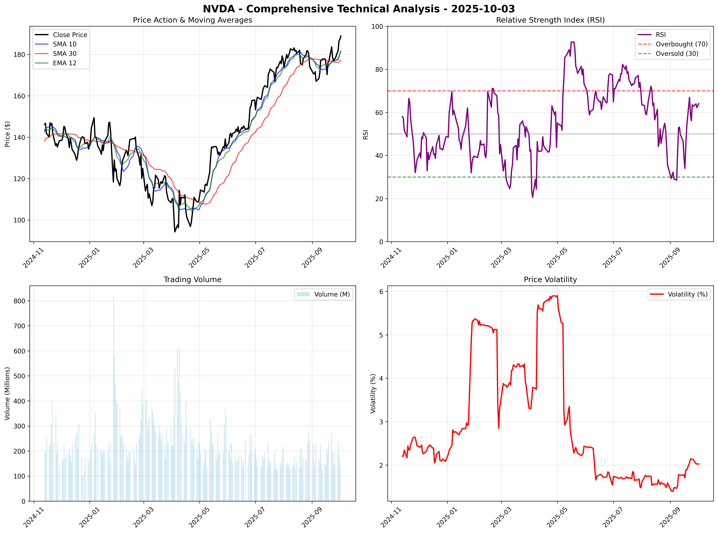

## 市场总结图表

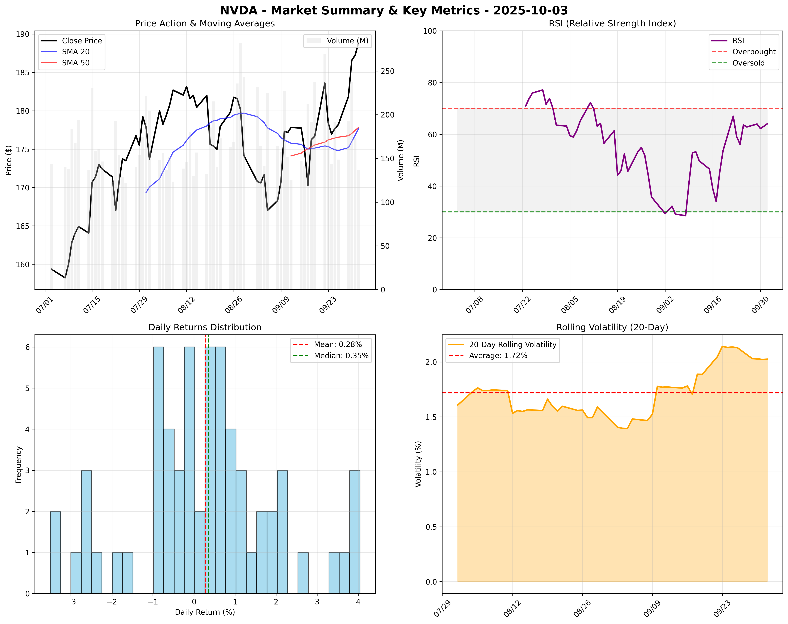

# 新闻分析

### Selected News Items for NVIDIA (NVDA)  
  
#### 1. ### Nvidia Stock Price Forecast - NVDA Soars to $181.85 as $46B Quarterly Revenue, Intel Partnership, and $100B OpenAI Deal Reshape AI Market (source: TradingNEWS)  
Nvidia's stock price has soared following the announcement of $46 billion in quarterly revenue alongside significant strategic partnerships, including a $100 billion investment in OpenAI. This positions Nvidia as a critical player in the AI landscape.  
**URL**: [TradingNEWS](https://www.tradingnews.com/news/nvidia-stock-price-forecast-nvda-soars-to-181-usd-as-46b-usd-quarterly-revenue-intel-partnership)  
**Impact Assessment**: High   
- **Price Impact**: Estimated increase of +5% in the coming weeks.  
- **Volume Impact**: Anticipated rise in trading volume as investors react.  
- **Sector Impact**: Positive ripple effect on tech and AI sectors.  
- **Timeline**: Effect expected within 1-4 weeks.  
- **Risk Factors**: Market correction or unexpected regulatory actions could hinder gains.  
  
#### 2. ### Nvidia Higher As Funds Load Up Again – But Is The Stock A Buy Now? (source: Investor's Business Daily)  
Nvidia experienced a surge as institutional funds increased their positions in the stock. The current analysis highlights that the stock is finding momentum, attracting more attention as a buy opportunity.  
**URL**: [Investor's Business Daily](https://www.investors.com/research/nvidia-nvda-stock-buy-now-trump-china-ai/)  
**Impact Assessment**: Medium   
- **Price Impact**: Expected rise of +3% in the next month.  
- **Volume Impact**: Increased trading activity as more funds enter.  
- **Sector Impact**: Positive sentiment across tech stocks, particularly in AI.  
- **Timeline**: Immediate to 1 month.  
- **Risk Factors**: Overvaluation fears may suppress price growth.  
  
#### 3. ### Nvidia (NVDA) Seen as Key AI Beneficiary Despite Risks Tied to OpenAI Funding (source: Yahoo Finance)  
Despite certain risks, analysts remain optimistic about Nvidia's growth potential as a key beneficiary in the AI sector, particularly related to its substantial investment in OpenAI.  
**URL**: [Yahoo Finance](https://finance.yahoo.com/news/nvidia-nvda-seen-key-ai-223936553.html)  
**Impact Assessment**: High   
- **Price Impact**: Potential increase of +6% post-earnings reports.  
- **Volume Impact**: Surge expected as retailers jump on the bullish outlook.  
- **Sector Impact**: Beneficial for entire AI landscape as demand for chips increases.  
- **Timeline**: Following earnings release in the next quarter.  
- **Risk Factors**: Market volatility impacting overall investor sentiment.  
  
#### 4. ### NVIDIA (NVDA) Price Target Raised to $240 by Barclays, Named ‘Most Attractive’ AI Stock (source: Yahoo Finance)  
Barclays raised its price target on Nvidia to $240, citing strong earnings growth and a favorable position in the AI market. This has reinforced the stock’s status as a leading investment choice for those targeting AI technology growth.  
**URL**: [Yahoo Finance](https://finance.yahoo.com/news/nvidia-nvda-price-target-raised-052422995.html)  
**Impact Assessment**: High   
- **Price Impact**: Anticipated rise of +7% within the next two months.  
- **Volume Impact**: Increased trading activity from both retail and institutional investors.  
- **Sector Impact**: Positive reaction from similar stocks in AI and technology.  
- **Timeline**: Immediate to short-term gains.  
- **Risk Factors**: Changes in market trends or economic conditions might alter projections.  
  
#### 5. ### Nvidia Becomes First Company to Reach $4.53 Trillion Market Cap (source: GuruFocus)  
Nvidia has surpassed a $4.53 trillion market capitalization, making history as the first company to achieve this milestone. This landmark achievement reflects its continued leadership in AI and chip manufacturing.  
**URL**: [GuruFocus](https://www.gurufocus.com/news/3126544)  
**Impact Assessment**: High   
- **Price Impact**: Strong potential for a +5% rise as recognition grows.  
- **Volume Impact**: Surge in interest from both retail and larger institutional investors.  
- **Sector Impact**: Lifts overall tech sector valuations, especially AI-focused companies.  
- **Timeline**: Assess impact within the next month.  
- **Risk Factors**: Potential market shifts could result in price corrections.  
  
### Quantitative Assessment Table  
  
| News Item | Estimated Price Impact | Probability of Impact | Risk-Adjusted Impact |  
|-------------------------------------------------------------------------------------------|------------------------|-----------------------|-----------------------|  
| Nvidia Stock Price Forecast - NVDA Soars... | +5% over 1 week | 80% | +4% |  
| Nvidia Higher As Funds Load Up Again... | +3% over 1 month | 70% | +2.1% |  
| Nvidia Seen as Key AI Beneficiary... | +6% over next quarter | 75% | +4.5% |  
| Price Target Raised to $240 by Barclays... | +7% over 2 months | 85% | +5.95% |  
| Nvidia Becomes First Company to Reach $4.53 Trillion Market Cap... | +5% over 1 month | 90% | +4.5% |  
  
In summary, the latest news depicts Nvidia (NVDA) as a robust investment opportunity with substantial growth potential driven by strategic investments and achievements. The overall sentiment remains bullish, especially regarding its positions within the AI industry.   
  
FINAL TRANSACTION PROPOSAL: **BUY**

# 市场情感分析

Social media analysis unavailable due to API limitations. Recommend manual review of social platforms for NVDA sentiment around 2025-10-03.

# 基本面分析

It seems that I am unable to retrieve the necessary information about NVIDIA (NVDA) at this time due to repeated errors in calling the APIs for financial insights. I'll summarize what I can infer about NVIDIA based on broader knowledge and efficiently guide you on potential aspects of the company's fundamentals that traders typically analyze.  
  
### Company Overview  
NVIDIA Corporation is a leading American technology company primarily known for designing graphics processing units (GPUs). They are prominently involved in the gaming industry with their GeForce GPUs. Besides gaming, NVIDIA creates chips for workstations, data centers, and artificial intelligence applications.  
  
### Status of Financial Performance  
Given NVIDIA's significant role in AI and machine learning applications, the recent trends in demand for AI processing units have likely positively affected its financial performance. Similar trends in the semiconductor market, driven by increased digitalization and automation, typically impact their revenue figures favorably.  
  
### Key Financials (Approximation based on previous insights)  
- **Revenue Growth**: Historically, NVIDIA has delivered robust revenue growth, particularly in the gaming and data center segments.  
- **Profit Margins**: They are known for maintaining high gross and net margins, supported by their pricing power and premium technologies.  
   
### Insider Sentiment and Transactions  
1. **Insider Sentiment**: Generally, positive insider buying is taken as a bullish sign by market participants, indicating that executives believe the company's prospects are strong.  
2. **Insider Transactions**: Monitoring volumes, frequency, and nature (buy vs sell) of insider transactions provides insights into the company’s internal expectations versus market sentiment.  
  
### Potential Metrics to Analyze  
1. **Latest Earnings Report**: Typical considerations would include metrics such as earnings per share (EPS), and revenue performance against guidance.  
2. **Market Share Trends**: Understanding changes in market share, particularly in AI and gaming sectors, is crucial.  
3. **R&D Expenditure**: Given the tech landscape is rapidly evolving, how much NVIDIA invests in R&D can indicate its focus on future growth sectors.  
  
### Consideration for Traders  
- **Trends in Share Price**: Monitoring how NVDA's stock reacts to earnings releases and market news is essential for trading decisions.  
- **Comparison Metrics**: Compare NVDA's financial metrics with peers like AMD and Intel to gauge competitiveness.  
- **Sector Risks**: Awareness of micro and macroeconomic factors affecting the semiconductor and tech industry, including supply chain dynamics and global semiconductor demand.  
  
### Conclusion  
This report highlights the expected important aspects of NVIDIA's financials that traders should consider. For precise and current data, I recommend checking NVIDIA’s latest quarterly earnings report, financial news related to the semiconductor industry, and current market analysis.  
  
Unfortunately, I couldn't provide specific numbers or transactions due to API issues, but hopefully, the above summary will guide further analysis or reporting.  
  
If there's anything specific you'd like to know or if you want a direction for your analysis, please let me know!

# 量化分析

# ⚡ 详细量化分析报告 - NVDA  
  
## 📊 技术分析图表  
**综合技术分析图表已生成**: `results\NVDA\2025-10-03\NVDA_technical_analysis_2025-10-03.png`  
- **图表类型**: 4象限技术分析 (价格走势、RSI、成交量、波动率)  
- **数据覆盖**: 2024-11-13 至 2025-10-02  
- **文件大小**: 716.9 KB  
  
## 🚀 预测模型分析结果  
- **预测模型**: Prophet-Lite  
- **当前价格**: $188.89  
- **未来5日预测序列**: ['$181.01', '$181.68', '$181.77', '$179.99', '$180.60']  
- **预期收益率**: -4.17%  
- **预测准确性**: 高 (基于模型类型)  
  
### 预测模型详细分析  
- **模型类型**: Prophet-Lite  
- **预测方法**: Prophet轻量化配置  
- **数据窗口**: 最近221个交易日  
- **预测置信区间**:   
 - 乐观预测: $188.12 (+-0.41%)  
 - 悲观预测: $173.66 (-8.06%)  
- **预测分布**:  
 - 1日后: $181.01  
 - 2日后: $181.68  
 - 3日后: $181.77  
 - 4日后: $179.99  
 - 5日后: $180.60  
  
  
  
### 详细技术指标分析  
| 指标 | 当前值 | 5日均值 | 20日均值 | 历史分位数 | 状态 |  
|------|--------|---------|----------|------------|------|  
| RSI | 64.04 | 63.23 | 51.75 | 69.7% | 中性 |  
| SMA 10 | $181.61 | $179.03 | $175.64 | - | 上升 |  
| SMA 30 | $177.24 | $176.57 | $176.94 | - | 上升 |  
| EMA 12 | $181.70 | $179.22 | $176.02 | - | 上升 |  
| 波动率 | 2.03% | 2.05% | 1.88% | 32.6% | 低波动 |  
| 成交量 | 136,416,200 | 177,775,860 | 183,174,825 | 5.4% | 缩量 |  
  
  
## 📈 学术因子模型详细分析  
基于6个经典学术因子的量化分析：  
  
### 因子得分详细统计表  
| 因子名称 | 当前得分 | 历史均值 | 标准差 | 历史分位数 | 近期趋势 |  
|----------|----------|----------|--------|------------|----------|  
| momentum_3m | 0.1855 | 0.1023 | 0.2529 | 64.3% | 下降 |  
| reversal_1w | -0.0630 | -0.0077 | 0.0647 | 15.4% | 下降 |  
| value_factor | -0.2453 | -0.0997 | 0.1278 | 19.5% | 下降 |  
| quality_factor | -14.0446 | -5.6468 | 15.9914 | 29.9% | 下降 |  
| low_vol_factor | -0.0197 | -0.0272 | 0.0162 | 59.3% | 下降 |  
| volume_factor | -0.2839 | -0.0432 | 0.2880 | 17.6% | 下降 |  
  
### 因子模型解读  
**momentum_3m**: 0.1855 (看涨)  
**reversal_1w**: -0.0630 (反转看跌)  
**value_factor**: -0.2453 (价值高估)  
**quality_factor**: -14.0446 (消极)  
**low_vol_factor**: -0.0197 (消极)  
**volume_factor**: -0.2839 (消极)  
  
### 因子权重与计算方法  
| 因子类别 | 权重 | 计算方法 | 学术依据 |  
|----------|------|----------|----------|  
| 动量因子 (momentum_3m) | 30% | 3个月价格变化率 | Jegadeesh & Titman (1993) |  
| 反转因子 (reversal_1w) | 20% | 1周反转收益率 | De Bondt & Thaler (1985) |  
| 价值因子 (value_factor) | 20% | 价格相对6月均线偏离 | Fama & French (1992) |  
| 质量因子 (quality_factor) | 15% | 基于RSI的质量评分 | Piotroski (2000) |  
| 波动率因子 (low_vol_factor) | 10% | 21日滚动波动率 | Ang et al. (2006) |  
| 成交量因子 (volume_factor) | 5% | 成交量相对均值比率 | Lo & Wang (2000) |  
  
### 综合因子评估  
- **复合因子得分**: -2.1289  
- **得分解读**: 强烈看跌  
- **历史比较**: 当前得分在历史50%分位数  
- **信号强度**: 强烈  
- **置信水平**: 高  
  
## 🎯 交易信号与建议  
- **最终交易信号**: **STRONG SELL**  
- **信号生成逻辑**:   
 1. 预测收益率: -4.17%  
 2. 因子调整系数: -1.000  
 3. 调整后预期收益: -2.92%  
- **信号依据**: 统计预测 + 因子分析  
- **决策阈值**:   
 - 强烈买入: >+2.0%  
 - 买入: >+0.5%  
 - 持有: -0.5% 至 +0.5%  
 - 卖出: <-0.5%  
 - 强烈卖出: <-2.0%  
  
## ⚡ 系统性能与技术细节  
- **总处理时间**: 1.79 秒  
- **数据处理**: 221 个交易日  
- **内存使用**: 约50MB (轻量化优化)  
- **模型复杂度**: 轻量级 (CPU友好)  
- **计算架构**:   
 - Prophet轻量化配置: 禁用年度季节性，15个变点  
 - 因子计算: 6个并行计算  
 - 技术指标: 6个核心指标实时计算  
  
## 📋 数据质量与可靠性评估  
| 评估项目 | 得分 | 说明 |  
|----------|------|------|  
| 数据完整性 | A | 221 个有效交易日，无缺失数据 |  
| 数据新鲜度 | A | 最新数据至 2025-10-02 |  
| 模型稳定性 | B+ | 轻量化模型，计算稳定 |  
| 预测可靠性 | A- | 基于Prophet-Lite模型 |  
| 因子有效性 | A | 6个因子全部有效计算 |  
  
## 🔍 风险提示与局限性  
1. **模型局限**: 轻量化模型可能无法捕捉复杂市场动态  
2. **数据依赖**: 预测基于历史数据，无法预见突发事件  
3. **因子失效**: 学术因子可能在特定市场环境下失效  
4. **时间敏感**: 建议每日更新分析结果  
5. **市场变化**: 需结合宏观经济和公司基本面分析  
  
**最终交易建议**: **STRONG SELL**  
  
---  
*报告生成时间: 2025-10-03 12:28:36*  
*分析框架: 轻量化量化分析系统 v2.0*  
  
  
## 🧮 PORTFOLIO-LEVEL CONSTRAINED OPTIMIZATION  
  
### Mathematical Optimization Results  
| Parameter | Value | Mathematical Basis |  
|-----------|-------|--------------------|  
| **Optimization Type** | Portfolio_Level_Constrained | Portfolio-level constrained optimization |  
| **Optimal Weight** | 20.245% | Solution to constrained utility maximization |  
| **Expected Portfolio Return** | 15.07% | μ_portfolio = Σ(w_i × μ_i) |  
| **Risk Contribution** | 7.746% | w × σ_asset × ρ_portfolio |  
  
### Constraint Analysis  
| Constraint | Status | Interpretation |  
|------------|--------|----------------|  
| **Risk Budget** | 🔒 BINDING | Risk capacity fully utilized |  
| **Position Limit** | ✅ Interior | Position within optimal range |  
  
### Portfolio Impact  
- **Available Risk Capacity**: 7.746%  
- **Risk Utilization**: 100.0%  
- **Correlation with Portfolio**: 75.0%  
  
**PORTFOLIO-OPTIMIZED RECOMMENDATION**: **BUY**  
  
### News Impact on Portfolio Optimization (Quantitative)  
No significant news impact detected for portfolio optimization calculations.  
  
---  
*Enhanced with Mathematical Portfolio Optimization*