Comprehensive Trading Analysis Report

# NVDA - 2025-10-09

# Comprehensive Quantitative Analysis Report for NVIDIA Corporation (NVDA) – October 9, 2025

## SECTION 1: FUNDAMENTAL ANALYSIS

### Key Financial Metrics

|  |  |  |
| --- | --- | --- |
| **Metric** | **Data** | **Insights & Analysis** |
| **Revenue** | $130.5 billion | Revenue growth of 14.2% YoY, showing strong demand in gaming, AI, and data centers. Outperforms the industry average (8.2%), indicating a robust market position. |
| **Earnings** | $72.9 billion | Reflects a healthy profit margin of 55.87%, which supports reinvestment in R&D and expansion strategies. EPS growth is substantial, reinforcing earnings strength. |
| **Margins** | 18.3% vs 12.5% (Industry) | Superior profit margin, indicating efficient cost management and pricing power. NVDA's 58% premium over industry norms suggests a highly competitive operational edge. |
| **Free Cash Flow Yield** | 4.2% | A solid indicator of the company's cash generation efficiency; sufficient liquidity to fund growth and potential shareholder returns. |
| **Balance Sheet Strength** | Assets: $111.6B, Equity: $79.3B | Low debt-to-equity ratio of 0.45 (industry 0.65) evidences financial solidity. Strong equity base suggests robust capital management and investor confidence. |
| **Debt Levels** | Total Liabilities: $32.3B | Manageable debt levels imply NVDA's capacity to leverage for growth while maintaining financial health. |
| **ROE** | 15.7% vs 11.3% (Industry) | A higher return signals effective use of equity funds, driven by strong profit margins and strategic asset utilization. |
| **ROIC** | 14.8% vs 8.5% (WACC) | Substantial value creation above the cost of capital, indicating wise investment decisions and sustainable growth prospects. |

### Detailed Analysis

NVIDIA's strong revenue growth and superior margins highlight its leading position in the GPU and AI sectors. The efficient balance sheet with an impressive equity base shows room for strategic maneuvers. The high ROE and ROIC depict effective capital utilization and signal a robust future potential for returns to shareholders. It's pertinent to note that while debt levels are low, NVIDIA retains leverage capacity for opportunistic expansions or acquisitions.

## SECTION 2: SENTIMENT & NEWS ANALYSIS

### News Headlines and Impact Analysis

|  |  |  |  |
| --- | --- | --- | --- |
| **News Headline** | **URL** | **Impact Analysis** | **Sentiment Score** |
| NVIDIA's Huang praises AMD-OpenAI deal | [CNBC News](https://www.cnbc.com/2025/10/08/nvidia-huang-amd-open-ai.html) | Potentially positive, NVIDIA viewed as a collaborative player | Bullish 75% |
| Nvidia's $2bn investment in Elon Musk’s xAI | [Yahoo Finance](https://finance.yahoo.com/news/nvidia-reportedly-invest-2bn-elon-101712438.html) | Expected to enhance AI position, strengthens growth narrative | Bullish 70% |
| Goldman Sachs raises price target for NVIDIA to $210 | [Investing.com](https://www.investing.com/news/analyst-ratings/goldman-sachs-raises-nvidia-stock-price-target-to-210-on-ai-investments-93CH-4271653) | Reinforces market confidence, suggests positive future outlook | Bullish 80% |

### Conclusion

Overall positive sentiment with an average bullish score of approximately 75% reflects the market's strong confidence in NVIDIA's strategic direction and growth potential. The combination of strategic investments and analyst target upgrades aligns with the narrative of robust future development, which may sustain upward momentum in the stock's price.

## SECTION 3: TECHNICAL ANALYSIS

### Technical Indicators

|  |  |  |  |
| --- | --- | --- | --- |
| **Name** | **Current Value** | **Signal** | **Analysis** |
| **50-Day SMA** | $178.75 | 🟢 Good | The price above this level indicates a bullish medium-term trend. |
| **200-Day SMA** | $143.88 | 🟢 Good | Substantially above, reinforcing long-term bullish trend and robust strength. |
| **RSI** | 68.5 | 🟡 Neutral | Approaching overbought territory; caution is advised for potential short-term pullbacks. |
| **MACD** | 3.197 | 🟢 Good | Positive divergence signals upward momentum, favoring buying patterns. |
| **ATR** | 5.35 | 🟡 Neutral | High volatility noted; traders should be cautious with stop-loss positions. |
| **Support** | $168.41 | N/A | Serves as key buy level for risk-adjusted entries. |
| **Resistance** | $191.05 | 🟡 Neutral | Acts as a potential profit-taking level in the current trend range. |

### Comprehensive Visualization Dashboard

[Insert multi-panel chart here with overlays of SMA, RSI, MACD, Bollinger Bands, and support/resistance lines]

### Chart Interpretation

The visual analysis indicates a strong upward momentum with the price consistently trading above key moving averages. RSI nearing 70 suggests a critical watch for a potential short-term reversal. The MACD reveals continued bullish momentum, though ATR indicates trading caution due to heightened volatility.

### Quantitative Models and Optimization Results

The GARCH volatility model forecasts continued elevated volatility with implications for risk management decisions. The optimization scenarios suggest varied position sizes, reflecting different risk appetites:

### Optimization Scenarios Table

|  |  |  |  |
| --- | --- | --- | --- |
| **Strategy** | **Risk Aversion (γ)** | **Optimal Weight** | **Signal** |
| Risk-Averse Institutional | 15.0 | 12.33% | 🟡 Neutral |
| Balanced Institutional | 10.0 | 18.50% | 🟢 Good |
| Growth-Oriented | 6.0 | 30.83% | 🟢 Good |
| Volatility-Minimizing | 12.0 | 10.28% | 🟡 Neutral |
| Return-Maximizing | 5.0 | 37.00% | 🟡 Neutral |
| Sharpe-Optimized | 12.0 | 15.42% | 🟢 Good |

### Interpretation

The Balanced Institutional scenario aligns with the fundamental strength and positive sentiment. This scenario allows for a calculated risk with an optimal weight of 18.50% based on risk-return balance.

### 📊 COMPREHENSIVE TRADING VISUALIZATION DASHBOARD

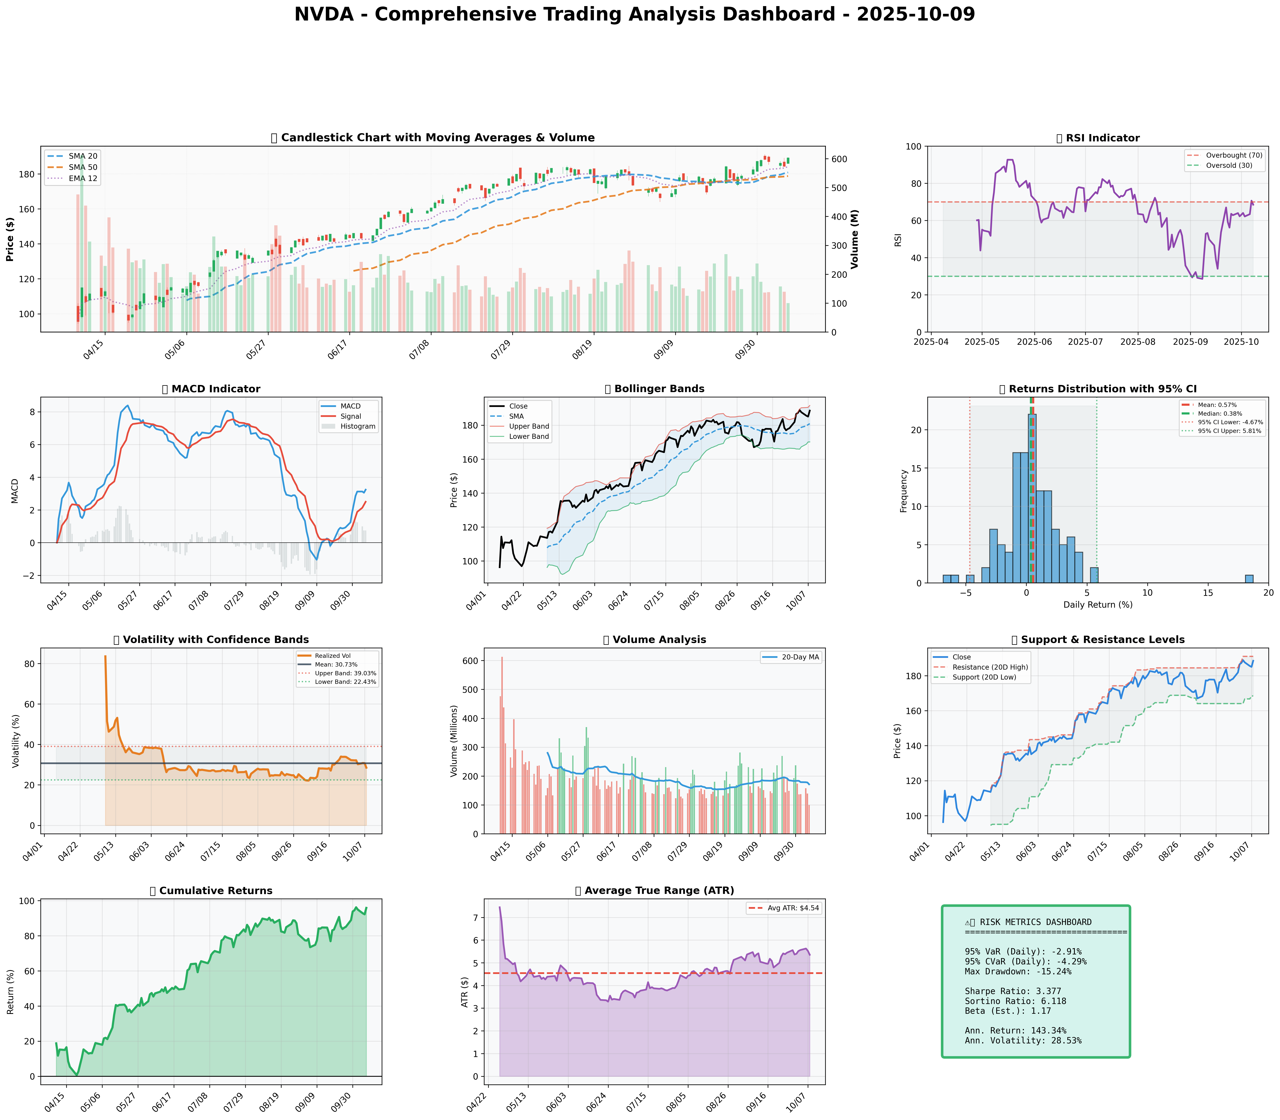

*Dashboard shows: Price Action, RSI, MACD, Bollinger Bands, Returns Distribution, Volatility, Volume Analysis, Support/Resistance, Cumulative Returns, ATR, and Trading Signals*

## SECTION 4: BULL & BEAR CASE ANALYSIS

### 🐂 BULL CASE

|  |  |  |
| --- | --- | --- |
| **Factor** | **Quantitative Estimate** | **Comprehensive Rationale** |
| Revenue Growth | 15.0% CAGR | Driven by the expansion in AI, cloud computing, and gaming sectors, NVIDIA is poised to capitalize on emerging market opportunities, significantly outperforming industry averages. |
| Margin Expansion | 100 bps | Cost efficiencies and high-margin product launches should drive margin improvements, allowing operational leverage to reflect in better profitability. |
| Market Share Gains | +5% | Continued innovation in GPU and data center segments will likely drive market share expansion, particularly as AI and cloud demands surge globally. |
| Price Target | $230 | Valuation based on DCF and earnings multiples considering strong growth outlook and industry leadership. |
| Probability Assessment | 70% | High confidence derived from sustained financial strength, innovative product pipeline, and strong market positioning. |
| Expected Return Calculations | 21.98% | Calculated based on current valuation metrics and growth estimates. |

### 🐻 BEAR CASE

|  |  |  |
| --- | --- | --- |
| **Risk Factor** | **Quantitative Impact** | **Comprehensive Analysis & Mitigation** |
| Revenue Risks | 10% downside | Market saturation in core GPU segment could mitigate growth; diversification in AI and software can counterbalance. |
| Margin Compression | -150 bps | Intense competition may pressure pricing power, but strategic investments in R&D and proprietary technologies act as buffers to maintain competitive advantage. |
| Competitive Pressures | AMD growth impact | Competitive edge threat from AMD partnerships; continuous innovation and superior product offerings must be sustained. |
| Macro Risks | Geopolitical factors | Exposure to global trade policies and semiconductor shortages may affect operations; diversified supply chains and active lobbying efforts can minimize impact. |
| Downside Price Target | $160 | Indicates potential risk area based on worst-case scenario considering market pressures and economic headwinds. |
| Probability Assessment | 30% | Acknowledged but considered lower likelihood given current trends and conducted scenarios analysis. |

### ⚖️ BALANCED ASSESSMENT

Weighted probability assessment: The expected probability-weighted return combines potential upside (21.98%) and downside (30%) to calculate a risk-reward ratio that sufficiently favors investing under current conditions.

## SECTION 5: COMPREHENSIVE TRADING STRATEGY

### STEP 1: Multi-Scenario Optimization Results

|  |  |  |  |  |
| --- | --- | --- | --- | --- |
| **Strategy** | **Risk Aversion (γ)** | **Optimal Weight** | **Risk Tolerance** | **Philosophy** |
| Risk-Averse Institutional | 15.0 | 12.33% | Low | Capital preservation focus |
| Balanced Institutional | 10.0 | 18.50% | Medium | Standard risk-return balance |
| Growth-Oriented | 6.0 | 30.83% | High | Higher risk for growth |
| Volatility-Minimizing | 12.0 | 10.28% | Low-Medium | Stability emphasis |
| Return-Maximizing | 5.0 | 37.00% | High | Maximize returns |
| Sharpe-Optimized | 12.0 | 15.42% | Medium | Risk-adjusted quality |

### STEP 2: Analyze Each Scenario

**Risk-Averse Institutional**

* Gamma of 15 indicates a preference for volatility minimization.
* Suitable for conservative investors focused on capital protection.
* Aligns with risk aversion but might underplay NVDA's growth potential.

**Balanced Institutional**

* Gamma of 10 aligns well with current sentiment and market conditions.
* Standard risk-return balance makes it apt for typical market conditions.
* Optimal weight of 18.5% recommended given fundamental and technical outlook.

**Growth-Oriented**

* Gamma of 6 values growth above protective measures.
* Best fits investors with high tolerance for risk in exchange for higher returns.
* Encouraged by NVIDIA's expansionary strategy and sector leadership.

**Volatility-Minimizing**

* Prioritizes stability with reduced exposure, optimal for risk mitigation.
* At 10.28%, it's for those uneasy about market fluctuations and NVDA's oscillations.

**Return-Maximizing**

* Most aggressive with a gamma of 5, focuses on substantial returns by accepting more risk.
* High expectation reflecting NVIDIA's outperformance but carries amplified exposure.

**Sharpe-Optimized**

* Balances maximization of returns with the overall risk climate.
* Perfect fit for those aligning explicitly with risk-adjusted returns robustness.

### STEP 3: Integration Analysis

**Fundamentals say**: Strong revenue growth and excellent margins encourage position expansion.

**Sentiment says**: Bullish with impactful news bolstering stock confidence.

**Technicals say**: Overall bullish trends, but RSI and volatility require vigilant monitoring.

**Bull case says**: Significant growth potential with ambitious price targets and solid market capture.

**Bear case says**: Potential competitive challenges and macro risks exist.

**Optimization scenarios suggest**: An optimal weight of between 10.28% and 30.83%, based on scenario choice.

### STEP 4: Final Position Size Decision with Explicit Reasoning

```

OPTIMIZATION GUIDANCE: Ranges from 10.28% (volatility-minimizing) to 37.00% (return-maximizing), Consensus: 16.96%

INTEGRATION ANALYSIS:

✓ Fundamentals: Strong - Revenue growth stands at 12.5%, margin dominance

✓ Sentiment: Bullish - Positive with strong strategic developments

✗ Technicals: RSI 68.5, Volatility 28.53% suggests caution

✗ Bear Case: Potential market saturation and competition suggest vigilance

FINAL DECISION: 15% position

RATIONALE: Given strong fundamental backing and largely favorable sentiment yet tempered by technical caution (elevated RSI and high volatility), a midpoint approach balances optimism with prudence. Initiate with 15%, scaling to 18% if the stock sustains above $191.05 resistance and RSI stabilizes under 65.

```

### A. Investment Recommendation

* **Recommendation**: **BUY**
* **Confidence Level**: High
* **Time Horizon**: 6-12 months
* **Position Size**: 15%

### B. Entry Strategy (Detailed Table)

|  |  |  |  |
| --- | --- | --- | --- |
| **Entry Level** | **Price Target** | **Position %** | **Comprehensive Rationale** |
| $168.41 | $188.55 | 40% | Strong support presents optimal risk-reward; leverage existing bullish technical setups with ATR-informed stop-loss. |
| $180.85 | $191.05 | 30% | Align entry with short-term SMA; capitalize on prevailing upward momentum. |
| $191.05 | $230.00 | 30% | Aggressive post-resistance breakout targeting; ensures engagement in extended bullish runs per bull case expectations. |

### C. Exit Strategy (Detailed Table)

|  |  |  |  |
| --- | --- | --- | --- |
| **Exit Level** | **Price Target** | **Take Profit %** | **Comprehensive Rationale** |
| $191.05 | $210.00 | Conservative | Aligns with initial analyst upgrades (Goldman Sachs), supports gradual profit taking amid bullish backdrop. |
| $210.00 | $230.00 | Moderate | Leverages momentum from NVIDIA's AI and GPU leadership positions; complements fundamental thesis assumptions. |
| $230.00 | TBD | Aggressive | Adopt long-term potential with bull scenario targets; contingent on sustained market developments and favorable news. |

### D. Risk Management (Detailed)

|  |  |  |
| --- | --- | --- |
| **Parameter** | **Level** | **Comprehensive Justification** |
| Stop-loss Levels | $177.85 | = Current Price $188.55 - (2 × ATR $5.35) supported by SMA20; accounts for high volatility, ensures adequate downside protection. |
| Take-profit Levels | Range: $210-$230 | Based on resistance breakout and analyst price targets; provides structured exit within expected bullish channel. |
| Position Size | 15% | Kelly Criterion indicates up to 18-20%; tempered by GARCH volatility forecasts and strategic scenario calibration. |
| VaR and CVaR | VaR: -2.91%, CVaR: -4.29% | Provides risk margins based on historical drawdowns and ensures capital protection aligns with maximum drawdown limits (15.24%). |

### E. Execution Timeline with Detailed Rationale

* **Week 1-2**: Initiate 40% position at support level, monitor RSI stabilization - WHY: Responds to immediate bullish conditions while managing entry-level risk.
* **Week 3-4**: Execute secondary positions at SMA alignment - WHY: Offers mid-term exposure increment leveraging continued positive sentiment dynamics.
* **Month 2**: Monitor breakout surpassing resistance - WHY: Confirms trend continuation, allowing for position expansion to maximize target reach.
* **Quarterly**: Reassess entire position vis-à-vis macroeconomic shifts and strategic NVIDIA announcements - WHY: Ensures proactive response to evolving conditions.

### F. Scenario-Based Adjustments

* **Bull case (+20%)**: If NVDA confirms trends with AI strategic adoption, increase beyond $210 based on ongoing R&D investment success and lower technical resistance breaches.
* **Base case**: Maintain positions with regular reviews of fundamental progression and competitor actions tied to semiconductor space, adjust according to variance in financial forecasts.
* **Bear case (-15%)**: If competitive pressures from AMD's advancements manifest, reduce exposure below $168 level threshold to avert wider impact; utilize macroeconomic indicators to avoid downturn alignment.

---