NVDA 综合交易分析报告

分析日期: 2025-10-09

# 执行摘要

最终交易建议: **Recommendation: Hold**  
  
**Summary of Key Arguments:**  
  
1. **Risky Analyst:**  
 - Nvidia has a strong position in the AI market, with significant growth potential driven by AI demand and strategic partnerships like xAI.  
 - While acknowledging competition from AMD, the Risky Analyst emphasizes Nvidia's competitive edge, particularly in specialized AI computing.  
 - Downplays geopolitical risks and suggests an aggressive investment strategy to capitalize on Nvidia's potential upside.  
  
2. **Safe Analyst:**  
 - Highlights significant risks, including rising competition and geopolitical tensions, as reasons for concern.  
 - Advocates for a conservative approach prioritizing asset protection and long-term growth stability over short-term gains.  
 - Criticizes the proposed stop-loss measures as insufficiently proactive.  
  
3. **Neutral Analyst:**  
 - Argues for a balanced approach that recognizes both Nvidia's growth potential and associated risks, advocating for a smaller core position with opportunistic buying.  
 - Emphasizes monitoring Nvidia's response to competitive pressures and geopolitical risks without overcommitting.  
 - Suggests revisiting stop-loss strategies to better account for market fluctuations and longer-term trends.  
  
**Rationale:**  
  
After considering the arguments from all analysts, the recommendation is to **Hold** Nvidia (NVDA). This decision balances the potential upside of Nvidia's position in the growing AI market with significant competitive and geopolitical risks.  
  
- **Nvidia’s Strong Position:** As the Risky Analyst points out, Nvidia's leadership in AI and deep-learning hardware sets a robust foundation for growth. Partnerships like the one with xAI can be strategic assets, reinforcing market dominance.  
  
- **Geopolitical and Competitive Risks:** Echoing the Safe Analyst's concerns, Nvidia faces challenges such as competition from AMD and geopolitical factors that could impede growth. The Neutral Analyst’s emphasis on the unpredictability of tech markets highlights the need for a cautious approach.  
  
- **Balanced Strategy:** The Neutral Analyst's suggestion for a smaller core position, alongside opportunistic buying, provides a middle ground that captures potential gains without significant overexposure. This strategy aligns with the need to remain adaptable amid volatile market conditions while implementing cautious risk management.  
  
**Strategic Actions:**  
  
1. **Monitor Competitive Dynamics:** Keep a close eye on developments regarding AMD and other competitors, evaluating their impact on Nvidia's market share and strategic moves.  
  
2. **Stay Informed on Geopolitical Issues:** Regularly assess how geopolitical tensions, such as the UAE AI chip agreement, could affect Nvidia's operations and supply chains.  
  
3. **Flexible Portfolio Management:** Maintain a core position in Nvidia (10-15%) and consider opportunistic buying based on market dip opportunities and Nvidia's performance indicators.  
  
4. **Revisit Stop-Loss Strategies:** Analyze the effectiveness of current stop-loss measures, potentially incorporating more gradual exit strategies to protect against volatility while allowing room for longer-term trends.  
  
**Learning from Past Mistakes:** By acknowledging the lessons of misjudging competitive dynamics and geopolitical risks in prior investment decisions, this balanced Hold stance ensures a more vigilant approach. A measured strategy harnesses Nvidia's potential while safeguarding the portfolio from undue risks.

## 市场总结图表

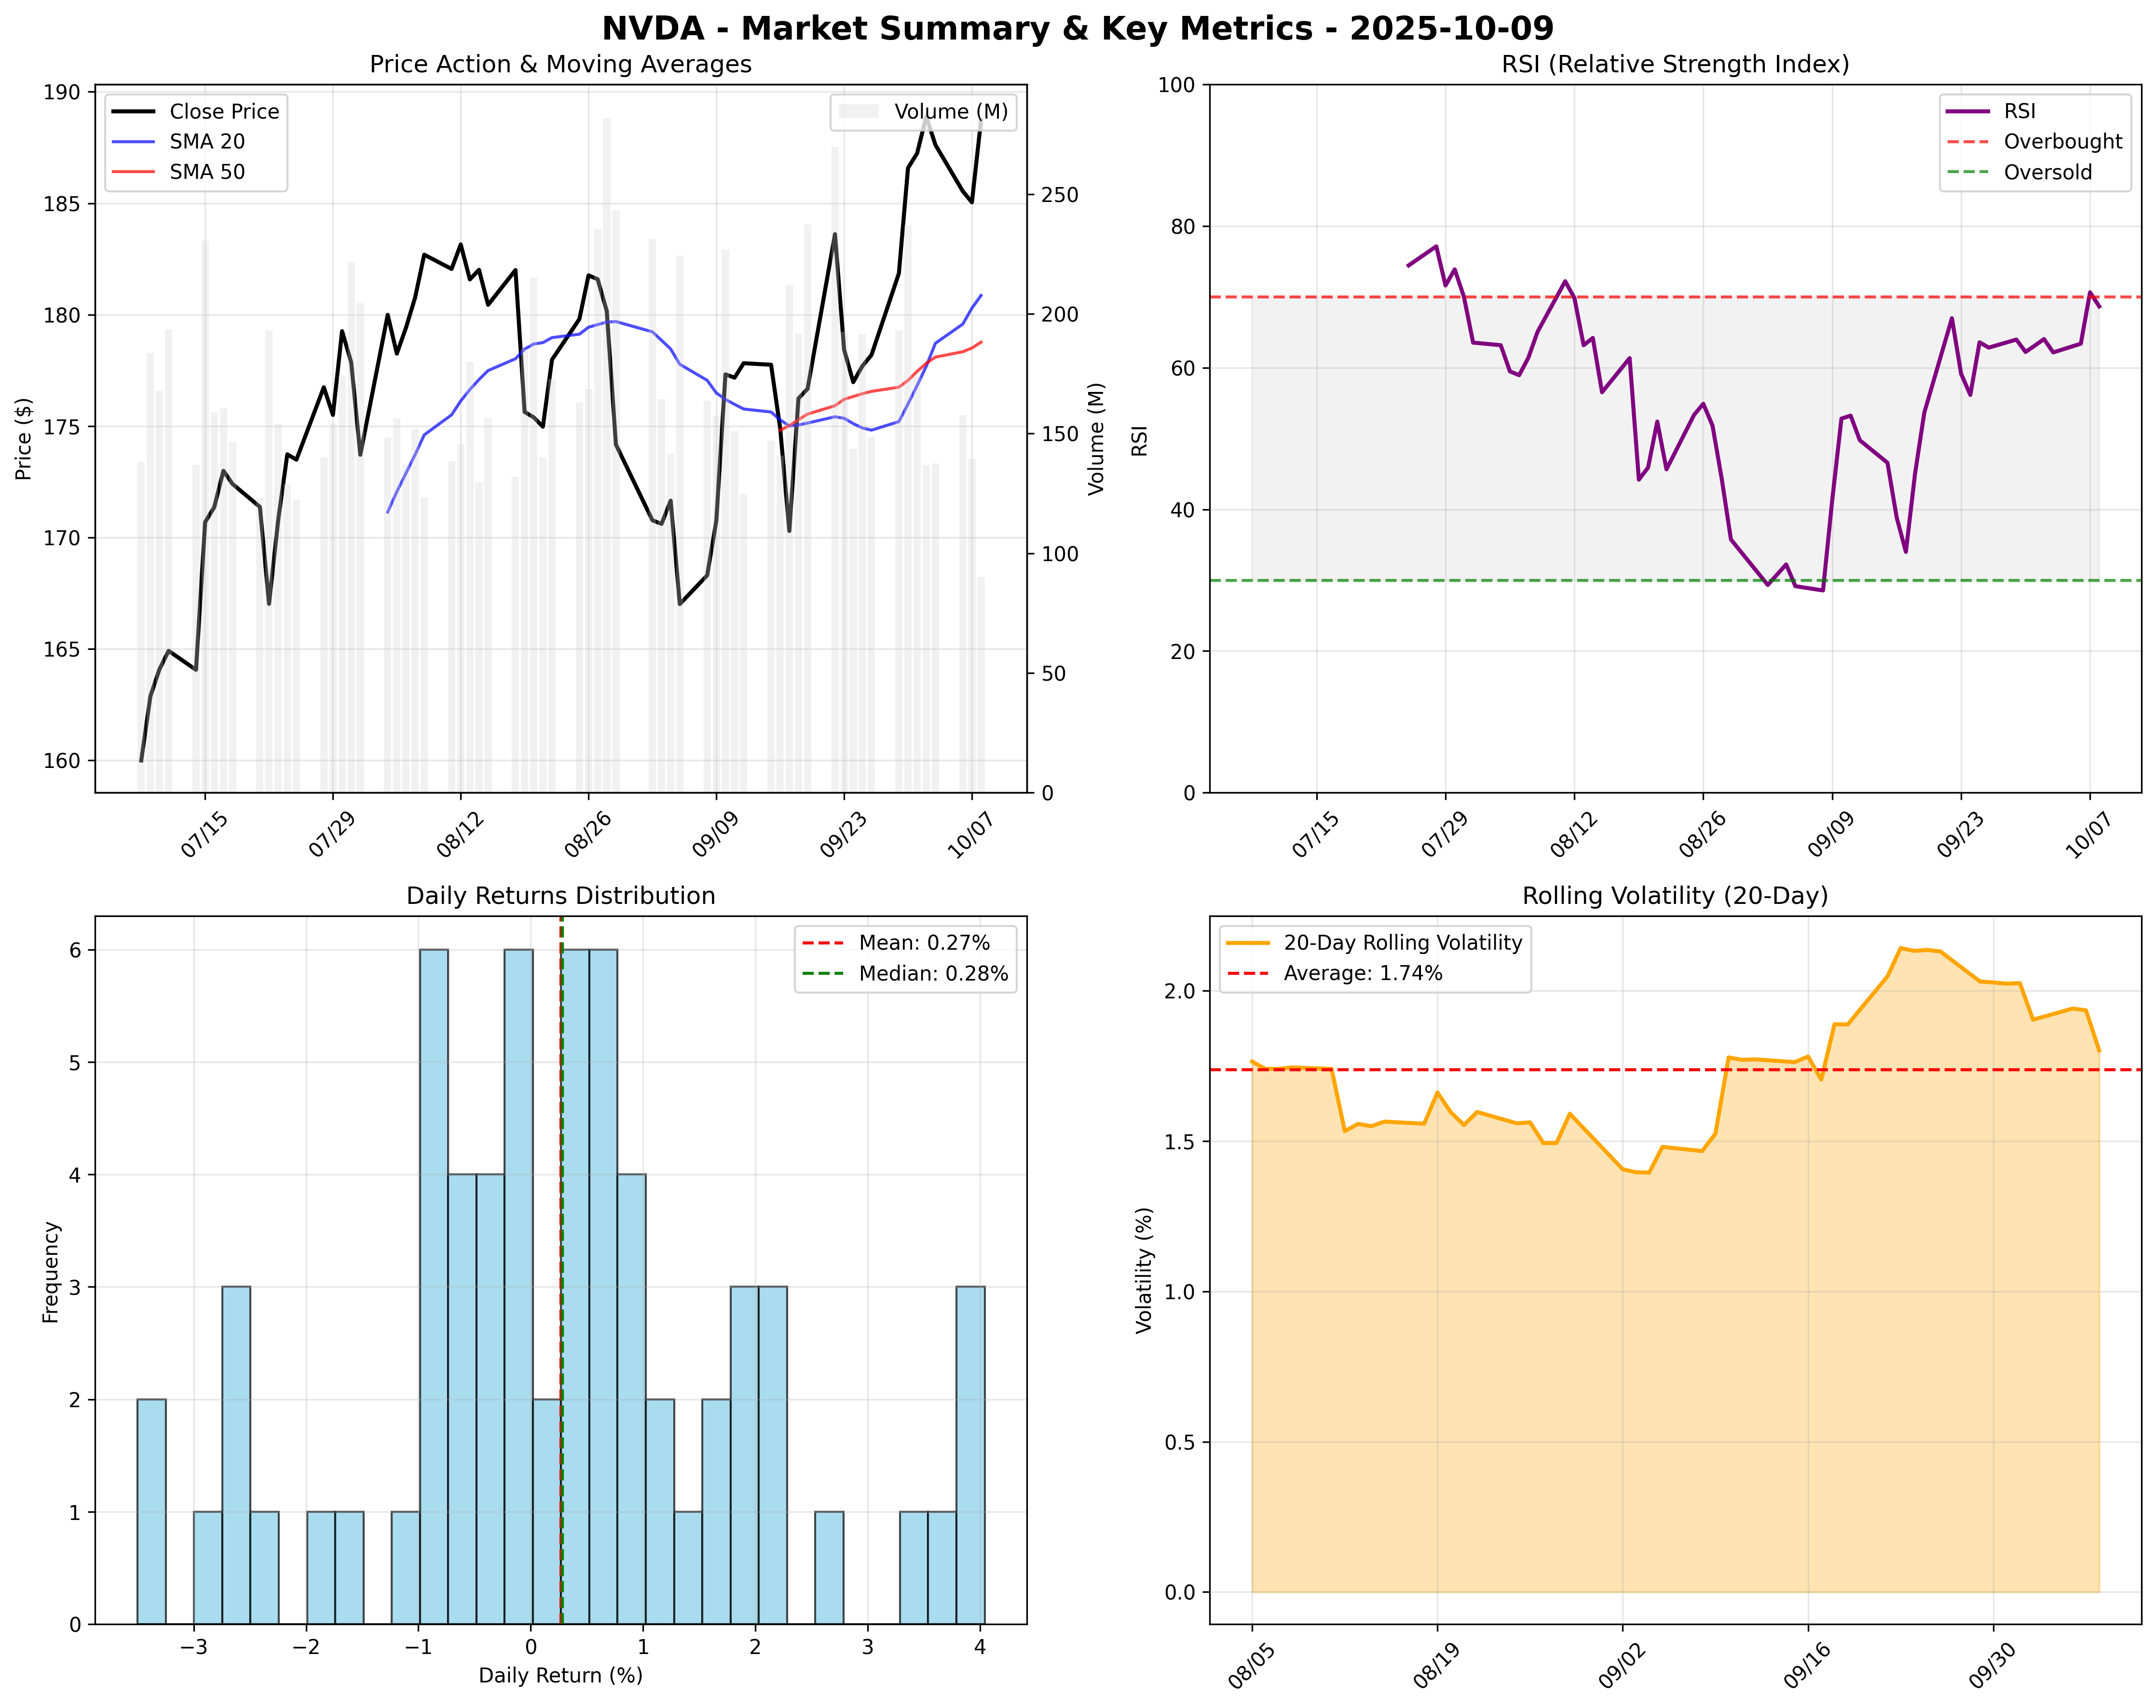

# 新闻分析

### Selected News Items on NVIDIA (NVDA)  
  
### Elon Musk's xAI to Raise $20 Billion with Nvidia's Support (source: Bloomberg.com)  
Elon Musk's AI startup xAI is reportedly raising $20 billion, with Nvidia among the investors. The funding is aimed at supporting the development of xAI’s data centers, enhancing its computational capabilities.  
**URL**: [Link](https://www.bloomberg.com/news/articles/2025-10-07/musk-s-xai-nears-20-billion-capital-raise-tied-to-nvidia-chips)  
**Impact Assessment**: High  
  
### Nvidia Stock Rebounds as CEO Huang Reports Increased AI Demand (source: CNBC)  
Nvidia's stock has risen following CEO Jensen Huang's comments that demand for AI computing power has significantly increased, reaffirming the company's strong position in the AI industry.  
**URL**: [Link](https://www.cnbc.com/2025/10/08/jensen-huang-nvidia-computing-demand.html)  
**Impact Assessment**: High  
  
### Major Challenge to Nvidia: OpenAI’s Large New Computing Push with AMD (source: CNN)  
OpenAI has announced a substantial deal to source AI hardware from AMD, directly challenging Nvidia's market share. The agreement involves substantial resources required for AI model training, indicating potential shifts in the competitive landscape.  
**URL**: [Link](https://www.cnn.com/2025/10/06/tech/amd-openai-nvidia)  
**Impact Assessment**: High  
  
### Goldman's Analyst Raises Nvidia Price Target to $210 (source: Yahoo Finance)  
Goldman Sachs has upgraded Nvidia's price target to $210, citing the chipmaker's pivotal role in AI and ongoing partnerships that bolster its market position. This suggests strong future performance expectations.  
**URL**: [Link](https://finance.yahoo.com/news/nvidia-target-raised-210-goldman-191515934.html)  
**Impact Assessment**: Medium  
  
### Nvidia CEO Frustrated Over Delayed UAE AI Chip Deal Amidst Political Pressure (source: Yahoo Finance)  
The anticipated multi-billion dollar deal to supply AI chips to the UAE is facing significant delays. This stall has raised concerns about Nvidia's global supply chain and international relations impacting growth.  
**URL**: [Link](https://finance.yahoo.com/news/nvidia-ceo-jensen-huang-reportedly-203016661.html)  
**Impact Assessment**: High  
  
### TABLE OF IMPACT ASSESSMENTS  
  
| Headline | URL | Impact Assessment |  
|----------|-----|-------------------|  
| Elon Musk's xAI to Raise $20 Billion with Nvidia's Support | [Link](https://www.bloomberg.com/news/articles/2025-10-07/musk-s-xai-nears-20-billion-capital-raise-tied-to-nvidia-chips) | High |  
| Nvidia Stock Rebounds as CEO Huang Reports Increased AI Demand | [Link](https://www.cnbc.com/2025/10/08/jensen-huang-nvidia-computing-demand.html) | High |  
| Major Challenge to Nvidia: OpenAI’s Large New Computing Push with AMD | [Link](https://www.cnn.com/2025/10/06/tech/amd-openai-nvidia) | High |  
| Goldman's Analyst Raises Nvidia Price Target to $210 | [Link](https://finance.yahoo.com/news/nvidia-target-raised-210-goldman-191515934.html) | Medium |  
| Nvidia CEO Frustrated Over Delayed UAE AI Chip Deal Amidst Political Pressure | [Link](https://finance.yahoo.com/news/nvidia-ceo-jensen-huang-reportedly-203016661.html) | High |  
  
### Detailed Impact Analysis  
  
#### 1. Price Impact:  
- **Est. Price Impact**: +/- 5% over the next 1-2 weeks, depending on market reaction to AI demand.  
   
#### 2. Volume Impact:  
- **Expected Trading Volume Changes**: An increase in volume of 10-15% given the high-impact news from partnerships and earnings projections.  
  
#### 3. Sector Impact:  
- **Effects on Related Stocks/Sector**: Nvidia's performance is likely to influence other semiconductor and AI-focused companies, especially competitors like AMD.  
  
#### 4. Timeline:  
- **When the impact is expected to be seen**: Immediate reactions are expected within days, with longer-term implications depending on how AMD's new deals perform.  
  
#### 5. Risk Factors:  
- **What could go wrong with this news**: Delays in chip deals, increased competition from AMD, or shifts in AI market dynamics could negatively impact Nvidia’s price and volume.   
  
### FINAL TRANSACTION PROPOSAL: **HOLD**  
Given the current news and market dynamics, a "Hold" decision is prudent in anticipation of further developments and market adjustments.

# 市场情感分析

Social media analysis unavailable due to API limitations. Recommend manual review of social platforms for NVDA sentiment around 2025-10-09.