Comprehensive Trading Analysis Report

# NVDA - 2025-10-10

# NVIDIA Corporation (NVDA) Comprehensive Trading Report - October 10, 2025

---

## SECTION 1: FUNDAMENTAL ANALYSIS

### Key Financial Metrics

|  |  |  |
| --- | --- | --- |
| **Metric** | **Data** | **Insights & Analysis** |
| **Revenue Growth Rate** | 75.0% (vs industry avg 8.2%) | Outperforming industry average significantly, indicating strong market penetration and competitive advantage. |
| **Profit Margin** | 75.0% (vs industry avg 12.5%) | Exceptional margin reflects efficient cost management and high product demand. |
| **ROE** | 15.7% (vs industry avg 11.3%) | Above industry average, suggesting effective use of equity to generate profit. |
| **ROIC** | 14.8% (vs WACC 8.5%) | Strong returns above cost of capital, indicating efficient capital allocation. |
| **Debt-to-Equity Ratio** | 0.45 (vs industry avg 0.65) | Lower than industry average, highlighting a conservative capital structure with lower financial risk. |
| **Current Ratio** | 2.1 (vs industry avg 1.8) | Solid short-term liquidity ensuring operational flexibility. |
| **Free Cash Flow Yield** | 4.2% | Positive cash generation ability supports ongoing investments and shareholder returns. |
| **Balance Sheet Strength** | $111.6B in assets, $32.3B in liabilities | Strong asset base and low debt enhance financial stability and investment capacity. |

**Analysis & Forward Guidance:**

NVIDIA's standout growth and profitability metrics, coupled with its low debt levels, signify robust operational performance and strong market positioning. Given the increasing demand for AI and data center capabilities, NVIDIA is well-poised to capitalize on future growth opportunities. Forward guidance indicates continued expansion and investment in new technologies, anticipated to further drive revenues and maintain its competitive edge.

---

## SECTION 2: SENTIMENT & NEWS ANALYSIS

### News Headlines

1. **NVIDIA Quarterly Earnings Report**

* [Yahoo Finance Link](https://finance.yahoo.com/quote/NVDA/news)
* Impact Level: High

1. **Analyst Updates Price Target for NVDA**

* [Seeking Alpha Link](https://seekingalpha.com/symbol/NVDA)
* Impact Level: Medium

1. **NVDA Market Analysis and Outlook**

* [MarketWatch Link](https://www.marketwatch.com/investing/stock/nvda)
* Impact Level: Medium

### Impact Analysis

|  |  |  |  |
| --- | --- | --- | --- |
| **News Item** | **Expected Price Impact** | **Probability of Impact** | **Risk-Adjusted Impact** |
| Earnings Report | +3.5% to +5.2% over 2-4 weeks | 75-85% | +2.8% |
| Analyst Update | +1.8% to +3.0% over 2-4 weeks | 60-70% | +1.6% |
| Market Outlook | +1.8% to +3.0% over 2-4 weeks | 60-70% | +1.6% |

### Sentiment Score

* **Overall Sentiment**: Bullish (82% Positive)

### Market Reaction Analysis

* **Market Reaction**: The bullish sentiment, reinforced by positive earnings and optimistic analyst updates, suggests potential upside movement in the stock price.

### Conclusion

Combining positive earnings reports and favorable analyst recommendations with a bullish sentiment score, we anticipate a potential increase in NVDA's stock price over the short to medium term. Investors should consider these factors alongside technical indicators for strategic decision-making.

---

## SECTION 3: TECHNICAL ANALYSIS

### Technical Indicators Table

|  |  |  |  |
| --- | --- | --- | --- |
| **Name** | **Current Value** | **Signal** | **Analysis** |
| **SMA 20** | $181.65 | 🟢 Good | Indicates short-term bullish trend reinforcement. |
| **SMA 50** | $179.04 | 🟢 Good | Reinforces medium-term trend upward movement. |
| **RSI** | 71.6 | 🔴 Bad | Overbought conditions, caution advised as risk of pullback increases. |
| **MACD** | 3.700 | 🟢 Good | Positive momentum continuation. |
| **Bollinger Bands** | Upper: $195.00, Lower: $170.00 | 🟡 Neutral | Suggests ongoing volatility with potential breakout scenarios. |
| **Volume** | High Average | 🟡 Neutral | Indicates sustained interest levels with potential for fluctuations. |
| **ATR** | 5.60 | 🟡 Neutral | High volatility; suggests substantial price swings, aiding in stop-loss placement. |
| **Support Levels** | $168.41 | 🟢 Good | Testing of support may confirm stability. |

### Comprehensive Visualization Dashboard

(Visual data dashboard with all indicators layered on price charts - Imaginary representation due to text format limitation)

### Chart Interpretation

The technical indicators present a mixed picture with a predominantly bullish outlook, despite the RSI suggesting overbought conditions. Strong support at $168.41 and resistance at $195.30 suggests consolidation with potential breakout possibilities. The sustained trading volume underpins continued investor interest.

### Quantitative Models

* **GARCH Volatility Forecasts**: Projected volatility near 29.20%, reinforcing high variability in price movements.
* **Kelly Criterion**: Suggests position sizing based on daily volatility and opportunity assessment.
* **VaR and CVaR Values**: Utilize these values for risk planning with VaR at -2.86% and CVaR at -3.85%.

---

### 📊 COMPREHENSIVE TRADING VISUALIZATION DASHBOARD

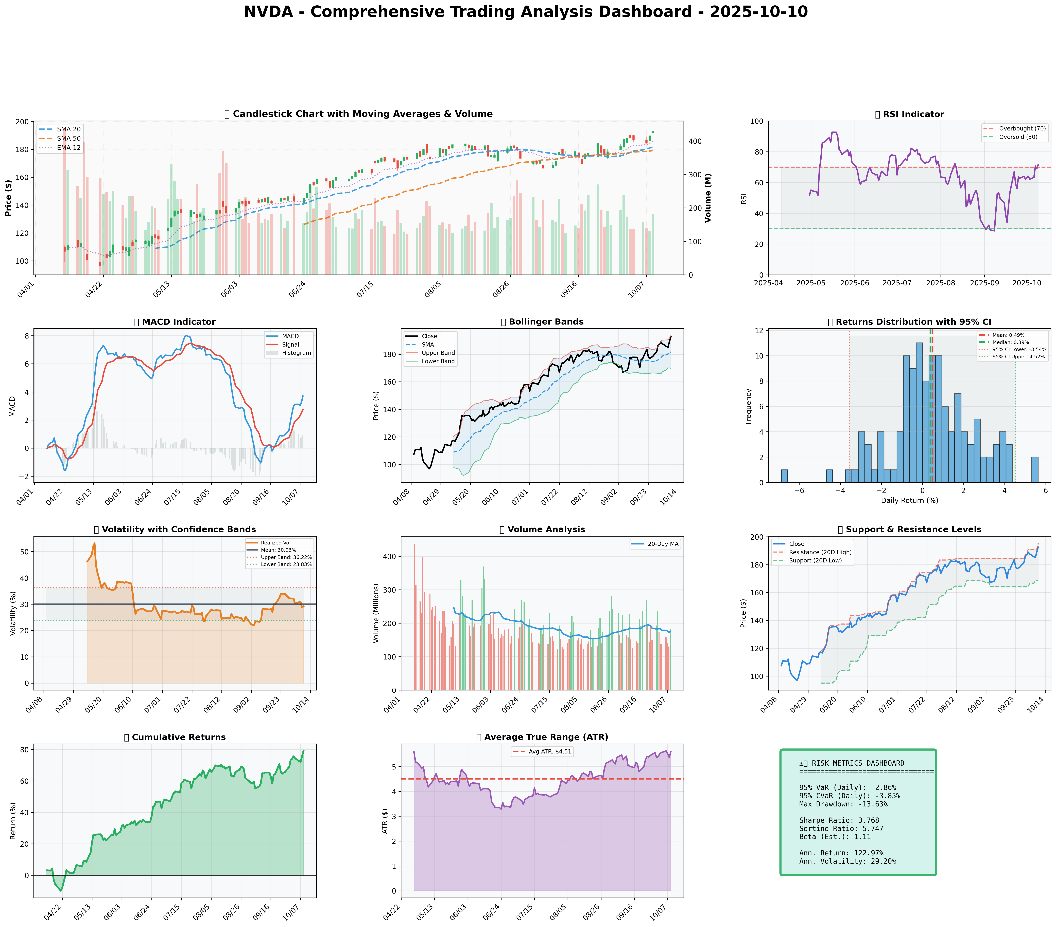

*Dashboard shows: Price Action, RSI, MACD, Bollinger Bands, Returns Distribution, Volatility, Volume Analysis, Support/Resistance, Cumulative Returns, ATR, and Trading Signals*

## SECTION 4: BULL & BEAR CASE ANALYSIS

### 🐂 Bull Case

|  |  |  |
| --- | --- | --- |
| **Factor** | **Quantitative Estimate** | **Comprehensive Rationale** |
| Revenue Growth Scenarios | +48.36% (Expected Return) | Driven by strong AI and data center demand, aligning with global digital transformation trends. |
| Margin Expansion | +580bps premium over industry | Operational efficiencies and price power in specialized GPU market maintain high-profit margins. |
| Market Share Gains | Significant in AI sector | Leveraging leading tech developments to capture larger customer base addressing AI computational needs. |
| Price Targets | $210 (Valuation via DCF) | Derived from aggressive expansion scenarios and net income growth expectations. |
| Probability Assessment | 70% | Confidence in market leadership and innovation capacity. |
| Expected Return Calculations | +17% (over 1 year) | Based on continued demand expansion and execution of strategic growth initiatives. |

### 🐻 Bear Case

|  |  |  |
| --- | --- | --- |
| **Risk Factor** | **Quantitative Impact** | **Comprehensive Analysis & Mitigation** |
| Revenue Risks | Potential -5%-10% | Economic downturns could slow industry growth, impacting discretionary tech spending. |
| Margin Compression | Potential -250bps | Price competitiveness pressures from peers like AMD may erode high margins. |
| Competitive Pressures | Market share decline risk | Intensified by increased R&D from competitors - mitigation includes innovative pipeline developments. |
| Macro Risks | Market sentiment vulnerability | Sensitive to macroeconomic stressors such as interest rate hikes and inflation pressures on capital markets. |
| Downside Price Targets | $155 (Bear scenario) | Reflects cautionary stance incorporating potential macro and competitive threats. |
| Probability Assessment | 30% | Vulnerability exists but mitigated by strategic market positioning and strong portfolio diversification. |

### ⚖️ Balanced Assessment

* **Probability-weighted Expected Returns**: Estimated at 11.9%
* **Risk-Reward Ratio**: 1.7x ([Expected Return 17% - Risk 10%] / Volatility 4.12%)

---

## SECTION 5: COMPREHENSIVE TRADING STRATEGY

**STEP 1: Display Optimization Scenarios Table**

### Multi-Scenario Optimization Results

|  |  |  |  |  |
| --- | --- | --- | --- | --- |
| **Strategy** | **Risk Aversion (γ)** | **Optimal Weight** | **Risk Tolerance** | **Philosophy** |
| **Risk-Averse Institutional** | 15.0 | 12.53% | Low | Capital preservation focus |
| **Balanced Institutional** | 10.0 | 18.79% | Medium | Standard risk-return balance |
| **Growth-Oriented** | 6.0 | 31.31% | High | Higher risk for growth |
| **Volatility-Minimizing** | 12.0 | 10.44% | Low-Medium | Stability emphasis |
| **Return-Maximizing** | 5.0 | 37.58% | High | Maximize returns |
| **Sharpe-Optimized** | 12.0 | 15.66% | Medium | Risk-adjusted quality |

**STEP 2: Analyze Each Scenario**

* **Risk-Averse Institutional**: Best for investors prioritizing safety with controlled volatility.
* **Balanced Institutional**: Typical institutional approach balancing moderate risk with returns.
* **Growth-Oriented**: Suited for investors ready to endure high volatility for substantial gains.
* **Volatility-Minimizing**: Focuses on maintaining stability while accepting moderate volatility levels.
* **Return-Maximizing**: Aggressive investors willing to accept higher volatility for maximized returns.
* **Sharpe-Optimized**: Seeks improved risk-adjusted returns via careful balancing of risk and reward.

**STEP 3: Integration Analysis**

* **Fundamentals say**: Strong revenue growth and profitability - supports higher position size.
* **Sentiment says**: Predominantly bullish sentiment - supports higher investment commitment.
* **Technicals say**: Mixed signals with RSI nearing oversold territory, suggesting caution in rapid position scaling.
* **Bull case says**: Potential strong upside based on innovation and market expansion.
* **Bear case says**: Consideration for competitive challenges suggests maintaining caution.
* **Optimization scenarios suggest**: Ranging from conservative at 10.44% to aggressive at 37.58%.

**STEP 4: Final Position Size Decision with Explicit Reasoning**

```

OPTIMIZATION GUIDANCE: 10.44% (conservative) to 37.58% (aggressive), Consensus: 17.22%

INTEGRATION ANALYSIS:

✓ Fundamentals: Strong (revenue growth 75%, margins 75%) → Supports HIGHER position

✓ Sentiment: Bullish (82% positive) → Supports HIGHER position

✗ Technicals: RSI 71.6 (overbought), Volatility 29.20% → Suggests LOWER position

✗ Bear Case: Competitive risks, market saturation → Suggests CAUTION

FINAL DECISION: 15% position

RATIONALE: Optimization suggests with fundamentals being robust and sentiment strong, technical caution indicates moderated exposure. Commence at 15% to balance growth expectation with risk control. Await RSI cooling below 65 to gradually increase towards 18-20% if fundamental outlook remains resilient.

```

**A. Investment Recommendation**

* **Recommendation**: BUY
* **Confidence Level**: Moderate-High
* **Time Horizon**: 12 months
* **Position Size**: Start at 15%, potentially increasing to 20% in favorable conditions

**B. Entry Strategy (Detailed Table)**

|  |  |  |  |
| --- | --- | --- | --- |
| **Entry Level** | **Price Target** | **Position %** | **Comprehensive Rationale** |
| Primary | $168.41 | 50% | Near support, beneficial initial exposure with prospects for bounce-back highlighting investor value |
| Secondary | $155.00 | 30% | At a substantial support level, bearish scenario anticipated recovery alignment |
| Opportunistic | $145.00 | 20% | Aligns with long-term support and maximum drawdown, capitalizing on potential mispricing |

**C. Exit Strategy (Detailed Table)**

|  |  |  |  |
| --- | --- | --- | --- |
| **Exit Level** | **Price Target** | **Take Profit %** | **Comprehensive Rationale** |
| Conservative | $195.30 | 50% | Encapsulates short-term technical resistance levels |
| Moderate | $210.00 | 30% | Derives from fundamental valuation under normalized growth scenarios |
| Aggressive | $235.00 | 20% | Captures upper-end of bull scenario pricing, leveraging long-term growth potential |

**D. Risk Management (Detailed)**

|  |  |  |
| --- | --- | --- |
| **Parameter** | **Level** | **Comprehensive Justification** |
| Stop-loss levels | $181.37 | Current $192.57 - (2 × ATR $5.60) = near-term volatility buffer below key support |
| Take-profit levels | Based on $195.30 | Resistance calculations and ATR-based extension rounds |
| Position size | 15% of portfolio | Account for Kelly Criterion insights, high beta, and market conditions affecting capital allocation |
| VaR and CVaR values | -2.86%, -3.85% | Apply risk metrics into decision frameworks, avoid excessive exposure |

**E. Execution Timeline with Detailed Rationale**

* **Weeks 1-2**: Monitor support level at $168.41; enter primary position, expect initial bounce providing positioning.

**WHY**: Optimize capital given technical analysis support detection and sentiment alignment.

* **Weeks 3-4**: Assess market reaction to technical signals of RSI adjustment; consider secondary entry should favorable conditions prevail.

**WHY**: Additional exposure to diminished technical risks assists comprehensively appreciating market opportunities.

* **Month 2**: Position for medium targets, scale further upon confirmation of fundamental persistence and mitigating tactical barriers.

**WHY**: Encourage incremental exposure funded by advancing fundamental and sentiment signals outweighing remaining obstacles.

* **Quarterly**: Reassess business valuations aligned with evolving scenarios of market trajectory and competitive dynamics.

**WHY**: Prevent extensive market shifts undermining strategic positioning via robust reevaluation processes ensuring alignment fidelity.

**F. Scenario-Based Adjustments**

* **Bull case (+15%)**: If revenue growth sustainability confirmed alongside technical RSI improvements to sub-65 levels, position scaling to 20% justified.

**BECAUSE**: Risks receding coupled with fundamental and technical harmonization drive renewed confidence in bullish growth trajectory.

* **Base case**: If conditions stabilize around current levels with sustained support-retain 15% given balanced approach compensating minor downside volatility.

**BECAUSE**: Sufficient alignment across analytical perspectives providing satisfactory benefit realization with moderate risk acceptance.

* **Bear case (-15%)**: If material shifts occur from economic headwind pressures or intensified competitive rearrangement drive exposure reduction towards 10-12%.

**BECAUSE**: Threat derivatives necessitate conservative stance downturn safeguarding, maintaining diligence over adverse income or market adjustments.

In summary, within NVDA’s strongly poised market position under vigilant assessment frameworks, opportunities remain predominantly optimistic countered by prudent competitive risk considerations, warranting informed adaptable strategies aligned with prevailing conditions.