Fast and Accurate Indoor Airflow Prediction Using Multi-Scale Attention Graph Neural Network
Xuqiang Shao^{1, 2}*, Xiaofan Liu¹, Sixuan Chen¹, Zhaobing Jiang*, Jiancai Huang^{1, 3}
¹Department of Computer, North China Electric Power University, Baoding, Hebei 071003, PR China
²Hebei Key Laboratory of Knowledge Computing for Energy & Power, Baoding, Hebei 071003, PR China
³Engineering Research Center of Intelligent Computing for Complex Energy Systems, Ministry of Education, Baoding, Hebei 071003, PR China
* Corresponding authors: E-mail addresses: shaoxuqiang@ncepu.edu.cn (X. Shao)
Abstract: With the rapid advancement of urbanization and the increasing amount of time individuals spend indoors, there has been a growing emphasis on indoor environmental quality. The accurate prediction of indoor airflow field is essential for optimizing building design, enhancing ventilation efficiency, minimizing energy consumption, and achieving low-carbon operations in enclosed environments. While Computational Fluid Dynamics (CFD) remains a powerful tool for simulating airflow through the solution of the Navier-Stokes equations, its dependence on fine mesh resolution and iterative computations restricts its real-time applicability, particularly in complex indoor environments. To facilitate efficient predictions of indoor airflow and address prevalent challenges associated with traditional Graph Neural Networks (GNN), such as node feature homogenization and ineffective long-range dependency transmission, this study introduces a Multi-Scale Attention Graph Neural Network (MSA-GNN). The model integrates a multi-scale graph architecture to enhance spatial feature representation and incorporates a self-attention mechanism to better capture long-range dependencies—critical for airflow prediction in rooms with narrow passages. Trained on time-resolved airflow data generated via CFD in realistic indoor scenes, the MSA-GNN achieves an R² accuracy of up to 0.98 and a computational speed improvement of approximately 7 to 10 times compared to CFD solvers. These results demonstrate its potential as a high-fidelity, real-time alternative for airflow prediction in building environmental design and smart ventilation control.
Keyworks：indoor airflow field; CFD; Deep Learning; Graph Neural Networks; Multi-Scale Attention
Highlights
- Proposed an MSA-GNN model for real-time indoor airflow field prediction.
- Integrating multi-scale graphs and self-attention for GNN.
- Achieved high-accuracy predictions with a speed 7–10 times faster than CFD.
- Accurately captured complex indoor airflow near obstacles and room boundaries.

1. Introduction
Indoor environments play a crucial role in public health and energy consumption, particularly in the context of dense urbanization and high indoor occupancy rates. Studies show that urban residents spend approximately 70–90% of their time indoors, where air distribution directly affects thermal comfort, air quality, and energy use. In this context, accurate prediction of indoor airflow is essential for designing energy-efficient ventilation systems and improving the performance of green buildings. In line with China’s national energy policy outlined in the “The 2024-2025 Energy Conservation and Carbon Reduction Action Plan” ^{[1]}, there is an urgent need for advanced predictive tools that support low-carbon, high-efficiency indoor air control.
CFD numerical simulation has long served as a fundamental approach for modeling indoor airflow field ^{[2]}. By solving the fundamental governing equations of fluid motion—namely, conservation of mass, momentum, and energy—CFD enables high-resolution predictions of airflow behavior within confined spaces. Depending on the turbulence modeling approach, CFD methods are typically categorized into Direct Numerical Simulation (DNS), Reynolds-Averaged Navier-Stokes (RANS), and Large Eddy Simulation (LES). DNS and LES offer high-fidelity modeling of indoor airflow by accurately capturing turbulent structures and pollutant transport. However, their application is severely limited by the substantial computational resources and time required. For example, Jiang et al. ^{[3]} utilized a domain decomposition-based DNS approach to simulate complex indoor vortex structures, but the method incurred extremely high computational costs. Similarly, Auvinen et al. ^{[4]} applied high-resolution LES to realistically reproduce turbulence details and pathogen dispersion, yet the associated computational overhead makes it unsuitable for real-time or large-scale applications.
In response to these limitations, Reynolds-Averaged Navier–Stokes (RANS) models have emerged as the mainstream solution in practical engineering due to their balance between accuracy and computational efficiency. Montazeri et al. ^{[5]} employed RANS modeling to analyze cross-ventilation strategies in buildings, assessing indoor thermal distributions and airflow effectiveness. Kong et al. ^{[6]} adopted the RNG k-ε turbulence model under eight different ventilation strategies, demonstrating a favorable trade-off between thermal comfort and energy savings. Despite its strong applicability and high predictive accuracy, CFD’s reliance on intensive mesh-based computation and time-consuming iterative processes limits its scalability for real-time airflow prediction and emergency response scenes in indoor environments ^{[7,8]}.
In response to the computational efficiency limitations of traditional CFD approaches, a range of acceleration techniques has been proposed ^{[9]}, including Multi-Zone Models, Fast Fluid Dynamics (FFD), and State-Space Fluid Dynamics (SFD). Abadie et al. ^{[10]} proposed a multi-zone model based on assumptions of homogeneous air conditions within each zone and simplified airflow and heat flux calculations at shared boundaries, enabling simulations at a second-level resolution. However, this macroscopic method neglects detailed turbulence information and thus struggles with real-time simulations of complex airflow scenes. Chen et al. ^{[10-12]} developed the FFD method, solving Navier-Stokes equations similarly to traditional CFD but using lower-order schemes to reduce computational costs. Nonetheless, this method suffers from reduced accuracy and excessive numerical dissipation, particularly causing physical distortions in regions of strong convection. Wang et al. ^{[13]} utilized State-Space Fluid Dynamics, reconstructing fluid control equations through linear equations, significantly reducing computational time while achieving accuracy comparable to traditional CFD on structured grids. Yet, this approach faces limitations in adapting to unstructured grids, restricting its applicability to complex architectural spaces. Although these methods demonstrate improved computational efficiency compared to traditional CFD, they inherently rely on iterative solutions of partial differential equations (PDEs), limiting their application in dynamic real-time scenes due to persistent computational resource demands.
Recent advancements in deep learning (DL) have opened new pathways for data-driven prediction of fluid dynamics, particularly for indoor airflow modeling, by enabling fast and flexible alternatives to conventional numerical solvers ^{[14]}. Among these, convolutional neural networks (CNNs) have been extensively explored for grid-structured airflow data. Kashefi et al. ^{[15]} used a multilayer perceptron (MLP) to predict steady-state laminar flow in simplified 2D domains mimicking indoor spaces. Guo et al. ^{[16]} developed CNN-based models capable of simulating 2D and 3D laminar flows with accuracy comparable to CFD and significantly reduced computation times. Sekar et al. ^{[17]} combined CNNs and MLPs for aerodynamic flow prediction, while Miyanawala et al. ^{[18]} proposed a geometry-aware CNN for transient flow around dynamic shapes. Despite their success in structured, canonical domains, these models show clear limitations when applied to indoor environments characterized by complex, irregular geometries and varying boundary conditions. Such indoor-specific challenges—like narrow corridors, sharp corners, and non-uniform airflow obstructions—often degrade CNN performance. For turbulent indoor scenes, Xiang et al. ^{[19]} combined CNNs with XGBoost to model high-resolution turbulent flows, yet their method struggled in spatially constrained indoor layouts, particularly in regions with strong flow gradients near architectural barriers.
To capture the temporal evolution of indoor airflow, recurrent neural networks (RNNs) and long short-term memory (LSTM) networks have also been employed. Wiewel et al. ^{[20]} introduced a ConvLSTM model that reduced temporal accumulation of errors in indoor scenes. Ribeiro et al. ^{[21]}proposed DeepCFD, a U-net-based framework capable of fast inference for complex indoor layouts encoded via signed distance functions, achieving high speed and accuracy trade-offs. However, most CNN- and RNN-based methods are inherently limited by their reliance on matrix-form input, making them less suited to indoor spaces characterized by irregular wall shapes, doors, and furnishings. Moreover, their fixed receptive fields and localized feature extraction limit the ability to capture long-range spatial dependencies critical for accurate indoor airflow modeling ^{[22]}.
To address the unstructured and highly variable nature of indoor architectural spaces, graph neural networks (GNNs) have emerged as a promising solution due to their natural compatibility with irregular mesh representations ^{[23]}. Pfaff et al. ^{[24]} pioneered MeshGraphNets, applying GNNs to simulate a range of physical systems including fluid flows and elastic materials. Their framework demonstrated the potential of GNNs to generalize across spatial resolutions and significantly accelerate simulation speed. Fortunato et al. ^{[25]} enhanced this approach by introducing multi-scale graph architectures that down-sample and up-sample graph representations, improving both computational efficiency and the capture of global spatial dependencies. Chen ^{[26]} proposed a GNN-based acceleration method using hierarchical adjacency matrices, which effectively reduced feature loss during mesh interpolation and improved prediction accuracy in 2D compressible flow tasks. Meanwhile, Han et al. ^{[27]} incorporated Transformer-based temporal attention to enhance autoregressive flow predictions, improving long-term temporal consistency. Despite these advancements, challenges remain: traditional GNNs aggregate features primarily through local neighborhood feature aggregation, which often proves insufficient for capturing long-range effects in indoor environments featuring strong airflow transitions across corridors, doorways, and partitioned rooms ^{[28,29]}. For example, airflow moving from corridors into adjacent rooms encounters drastic velocity changes at narrow doorways, which traditional fixed-hop GNN methods fail to effectively capture, thereby losing critical turbulence information ^{[30-33]}. Predicting indoor airflow dynamics requires concurrently modeling global diffusion trends and localized turbulence vortices. Single-scale graph structures often fail to simultaneously ensure prediction accuracy and computational efficiency, typically resulting in either detail loss or dramatic computational complexity increases. Additionally, most studies focus on idealized scenes or simplified geometries, neglecting the coupling effects between ventilation systems and real architectural boundaries, thus limiting their practical engineering generalizability.
To address these critical challenges, this study proposes a novel Multi-Scale Attention Graph Neural Network (MSA-GNN) framework for predicting indoor airflow fields in complex environments. Inspired by Transformer-based global dependency modeling ^{[34]}, the MSA-GNN model enhances long-range feature representation via a multi-scale graph architecture and utilizes self-attention mechanisms to improve long-range dependency information propagation efficiency. Experimental results on real-world indoor airflow datasets demonstrate that the proposed method accurately predicts airflow fields across various layouts, significantly outperforming traditional GNN methods in capturing turbulent features. Specifically, the airflow prediction R² reaches 0.98, with computational speed improvements of approximately 7-10 times compared to CFD numerical solvers.

2. Method

2.1 MSA-GNN Model Architecture
The MSA-GNN model adopts an encoder–processor–decoder architecture to predict the airflow field in indoor environments. Given the mesh structure and flow field data as inputs, the model forecasts the flow state at the next time step. The encoder encodes the input node and edge features into high-dimensional representations. The processor employs a message-passing layer based on a self-attention mechanism to enable information exchange among graph nodes. Through Graph Network (GN) message passing, the model extracts local structural information while integrating positional encodings embedded in edge features into node features to update edge representations. The self-attention mechanism computes Queries, Keys, and Values from node features enriched with structural and positional information, and facilitates message propagation by computing attention coefficients across nodes. Finally, the decoder transforms the updated node features into predicted physical field outputs. By iteratively repeating this process, the model effectively captures and predicts the dynamic evolution of the flow field over time. The overall architecture of the proposed MSA-GNN model for indoor airflow prediction is illustrated in Fig.1.
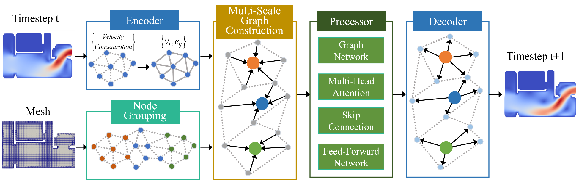
Fig. 1. Graph neural network prediction model for indoor airflow field evolution.

2.1.1 Encoder and Decoder Modules
The encoder primarily consists of multilayer perceptron (MLP) modules, which are responsible for feature dimensionality reduction and spatial transformation. At time step t, the CFD unstructured mesh is converted into a graph structure , where mesh nodes are transformed into graph nodes . Information on the mesh, including flow velocity and mesh type, is stored in the corresponding graph nodes . Shared edges between adjacent mesh elements and are converted into graph edges and. The relative positional relationship between these two nodes is preserved in the edge features, including the relative displacement vector and the corresponding Euclidean distance , where denotes the spatial position of node . After processing by the encoder, the node and edge features are encoded into 128-dimensional vectors and , respectively.
In Equation (1), denotes the spatial coordinates of a point, represents the flow velocity, indicates the mesh type, is the relative position between points and , and refers to the Euclidean distance between points and .
When processing graph-structured data, self-attention mechanisms treat spatially discrete nodes as independent feature points, which limits their ability to capture critical structural information such as airflow connectivity and obstruction effects caused by architectural barriers. To enhance the representational capacity of the graph, positional encoding is introduced into the self-attention architecture. This encoding is concatenated to the node feature vectors, allowing the Query-Key-Value computations to more effectively model complex relationships in the graph structure and improve the expressiveness of node features. By performing spectral decomposition of the Laplacian matrix of the indoor airflow graph, the spatial positions of the nodes are encoded as feature vectors. In the proposed airflow prediction model, these positional encodings are concatenated with physical node features such as pressure and velocity to form composite feature representations that capture both spatial structure and physical dynamics. Given the high computational cost of computing Laplacian encodings for large mesh-based graphs, this study instead encodes edge features using the relative position and Euclidean distance between the two nodes connected by each edge. This effectively integrates positional information into the graph representation while maintaining computational efficiency.
The decoder translates node and edge features updated by the graph network modules into output-dimensional node and edge results. Like the encoder, the decoder employs multilayer perceptron (MLP) modules to map the outputs from the high-dimensional latent space and attention modules (denoted as ) into the corresponding node output features (denoted as ). By integrating these output features over a fixed time step , the decoder aids in predicting the state at the next time step and subsequently updating node positions.

2.1.2 Multi-Scale Graph Construction
In indoor environment prediction tasks, the spatial distribution of nodes within the computational domain is often non-uniform, and complex correlations arise from both spatial proximity and variations in airflow fields. Directly processing high-resolution graph data poses challenges such as increased computational burden and potential loss of local feature details. To overcome these issues, this study employs a graph coarsening approach to construct multi-scale graphs, simplifying the high-resolution mesh into a lower-resolution graph structure. This process preserves key dynamic features while improving training efficiency. The low-resolution graph is obtained by grouping nodes from the high-resolution graph based on similarity, followed by feature aggregation within each group, thereby achieving graph coarsening.
2.1.2.1 Node Grouping
In unstructured meshes, relying solely on spatial distance for node grouping may lead to information loss—particularly in densely meshed regions. Merging nearby nodes based only on Euclidean distance can result in excessive aggregation within a single group, potentially erasing critical local dynamic details. To address this issue, this study employs a spectral clustering algorithm for node grouping. This method simultaneously considers spatial proximity and dynamic behavior similarity, enabling the grouping of nodes that are not only physically adjacent but also exhibit consistent diffusion patterns. Spectral clustering transforms the graph data into a Laplacian matrix and performs eigen decomposition to extract low-dimensional feature vectors, which are then used for clustering in a reduced space. Suppose the graph contains n nodes; the first step is to construct a similarity matrix between nodes. Spatial correlation is modeled using a Gaussian kernel function, defined as follows:
In Equation (3), denotes the spatial coordinate vector of a node, is a scaling parameter used to control the neighborhood range, and is a function that maps the Euclidean distance between nodes to the range [0,1], where closer distances yield similarity values closer to 1 and larger distances approach 0. Based on the resulting similarity matrix, a normalized Laplacian matrix is then constructed. This normalization enhances the robustness of the algorithm to variations in node degree distributions. The computation is performed as follows:
After computing the Laplacian matrix , eigen decomposition is performed to extract the feature vectors corresponding to the smallest non-zero eigenvalues. These vectors form the low-dimensional embedding matrix , where each row represents a node's embedding that captures both the structural properties and dynamic correlation patterns of the original graph. K-means clustering is then applied to the row vectors of the embedding matrix , dividing the n nodes into k groups. After clustering, nodes within the same group exhibit high similarity in both spatial distribution and diffusion behavior. To construct the low-resolution graph structure, each group is treated as a super node, completing the node grouping process.
2.1.2.2 Feature Aggregation
By aggregating the feature vectors of nodes within each group, the information of a group of nodes is merged into a single high-dimensional feature vector. This operation effectively reduces the complexity of the graph while enabling the extraction of global features. It facilitates the capture of the graph’s macroscopic structural characteristics while preserving essential node-level information. In this study, graph coarsening is performed using a Gated Recurrent Unit (GRU) ^{[35]}. Within each node group, the feature vectors of individual nodes are sequentially fed into the GRU in random order, and the final hidden state is used as the high-dimensional representation of the entire group. This resulting feature vector serves as the aggregated representation for the group. The specific formulation is as follows:
In equations (6) and (7), denotes the total number of nodes within a group, represents the group index, is the update function of the GRU module, refers to the input node feature vector, denotes the MLP module, and corresponds to the aggregated high-dimensional feature vector of the group.
Compared to traditional approaches such as arithmetic averaging or direct summation, the GRU-based aggregation mechanism dynamically adjusts the weighting of node features within each group. This allows for more effective integration of intra-group node information and enhances the model’s ability to learn the coupling between airflow and concentration fields in indoor pollutant dispersion scenes. Additionally, the construction of multi-scale graphs reduces the number of nodes the model must process while preserving essential physical information. Experimental results demonstrate that this design not only maintains the interpretability of spatiotemporal evolution patterns but also reduces computational complexity, providing an efficient topological abstraction framework for multi-physics coupling prediction.

2.1.3 Attention-Based Message Passing Layer
In indoor airflow field prediction, the attention-based message passing layer is composed of a Transformer module and a Graph Network (GN) module ^{[36]}. Relying solely on positional encoding within the graph constrains the self-attention mechanism’s ability to learn critical structural characteristics, such as airflow connectivity and obstacle distribution in architectural spaces ^{[37]}. Given that message passing excels at extracting local structural features from graphs ^{[29]}, the MSA-GNN model incorporates GN modules to capture structural information. Leveraging the inductive bias inherent in message passing, the model embeds geometric constraints—such as inlet and outlet locations and obstacle layouts—into the node feature extraction process. This module performs localized message propagation to effectively extract structural features from indoor airflow data, while the self-attention module performs global attention on structure-enhanced node features, thereby enabling comprehensive and deep transmission of long-range fluid dynamic dependencies within the flow field.
Each GN module contains multiple multilayer perceptrons (MLPs) designed to facilitate message passing between nodes and edges in the indoor airflow graph ^{[36]}. The module takes discretized indoor mesh data as input and updates the feature representations of nodes and edges through an iterative mechanism, ultimately producing updated graph data. During message propagation within the GN module, edge features are first updated via function , followed by node feature updates through function . This process is formally expressed as follows:
In a GN module, the update of node features relies on aggregating both the output node features from the previous layer and the features of edges connected to each node. This process enables the integration of edge features into node representations. Since edge features encode positional information, message passing allows the node features to incorporate both positional encoding and local structural characteristics. Through iterative updates across GN layers, the model gradually learns complex structural representations of the graph, ultimately capturing composite features that reflect the dynamic properties of indoor airflow fields.
The self-attention module performs global attention operations on node features that already embed graph structural information. Initially, the GN extracts both positional and structural encodings into the node features. At layer n+1, the input graph consists of both updated edge features and node features enriched with structural context.
The self-attention mechanism treats indoor airflow field data as a collection of graph nodes, dynamically assigning attention weights by computing similarities between nodes. Node features enriched with structural and positional encodings are used to compute the Query and Key vectors, while features are used to compute the Value. Attention coefficients between nodes are computed as defined in equation (11), and multi-head attention outputs are aggregated according to equation (12).
Following the multi-head attention module, a skip connection (equation (13)) and a feed-forward network (equation (14)) are applied. The skip connection employs a residual link that adds the module’s output to the original input, thereby preserving input information and mitigating gradient vanishing issues. The feed-forward network, typically implemented using multilayer perceptrons (MLPs), performs nonlinear transformations on the output of the MHA module to enable the learning of more complex feature representations.
The self-attention mechanism operates solely based on node features. To address its limitations in capturing structural information, the proposed attention-based message passing layer incorporates both structural and positional information into node features through message propagation. However, traditional message passing suffers from over-smoothing and feature compression, particularly when multiple GN layers are stacked. To mitigate these issues, this study decouples the message passing process by separately utilizing GN layers—responsible for local message propagation—and Transformer layers—responsible for global attention-based communication—rather than stacking multiple GN layers. In densely meshed boundary regions, long message paths may cause feature degradation or loss due to compression effects during propagation. In contrast, the self-attention mechanism enables each node to interact with all others across the graph when computing attention weights, allowing nodes to capture global contextual features. This design effectively overcomes the limitations of local receptive fields and significantly enhances the model’s ability to learn long-range dependencies in complex indoor architectural spaces.

2.2 Dataset Generation
The sample dataset used in this study consists of indoor airflow fields obtained through numerical simulations based on the PIMPLE algorithm. Taking the typical indoor spatial model shown in Fig.2(a) as an example, the fluid domain of the room is defined in a three-dimensional Cartesian coordinate system with dimensions of 11.6 m (x), 7.76 m (y), and 2.76 m (z), forming a complex rectangular space. The inlet and outlet are defined as windows within the room. A rectangular opening with dimensions 0.97 m (y) × 1.47 m (z) is set on the right wall to serve as the airflow inlet, while another opening with dimensions 2.12 m (y) × 1.29 m (z) is defined on the left wall as the airflow outlet.
To account for geometric variability among different room configurations in the training dataset, mesh parameters are adaptively set during the pre-processing phase by analyzing the extreme vertex coordinates of each model. This ensures that the mesh generation is compatible with varying spatial scales. The meshing process is completed using the snappyHexMesh and extrudeMesh utilities in OpenFOAM, which support boundary fitting, local refinement, and mesh compression. The final computational mesh for the fluid domain is shown in Fig.2(b).
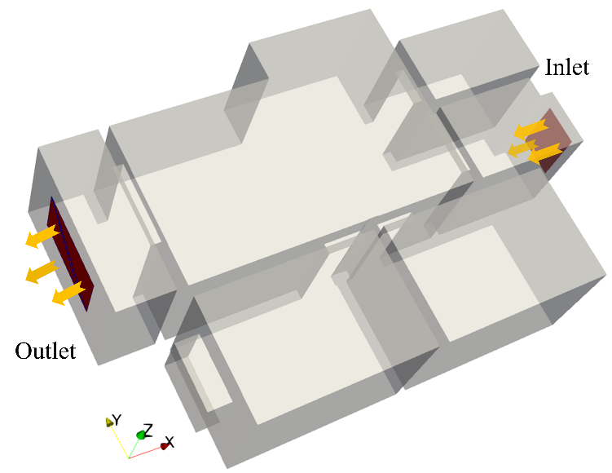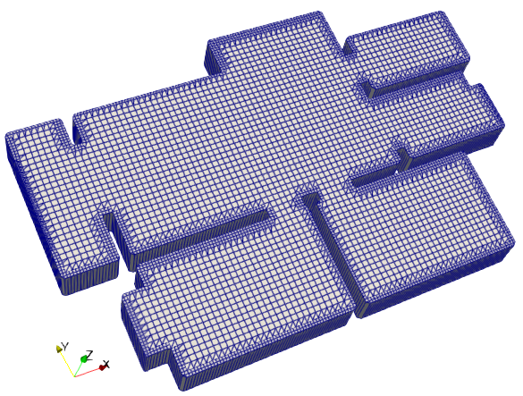
(a) Room Model (b) Meshing of the Room Model
Fig. 2. Room model and mesh generation overview.
To construct a diverse dataset of indoor airflow field evolution, the inflow boundary conditions were generated using a Gaussian random number generator. Specifically, the inflow velocity was randomly sampled within the range of 2 m/s to 10 m/s, and the inflow direction angle was randomly selected within the range of 45° to 135°. These two parameters were combined to form varied inflow condition configurations. Based on a realistic room model, a total of 300 distinct two-dimensional building scenes were generated, varying both architectural layouts and inflow settings. For each scenario, the simulation produced 300 consecutive time frames. Representative examples of the simulated airflow evolution results are shown in Fig.3. As illustrated, due to differences in initial wind speed, direction, and room geometry, the airflow patterns exhibit distinct spatial distribution characteristics across various indoor layouts.
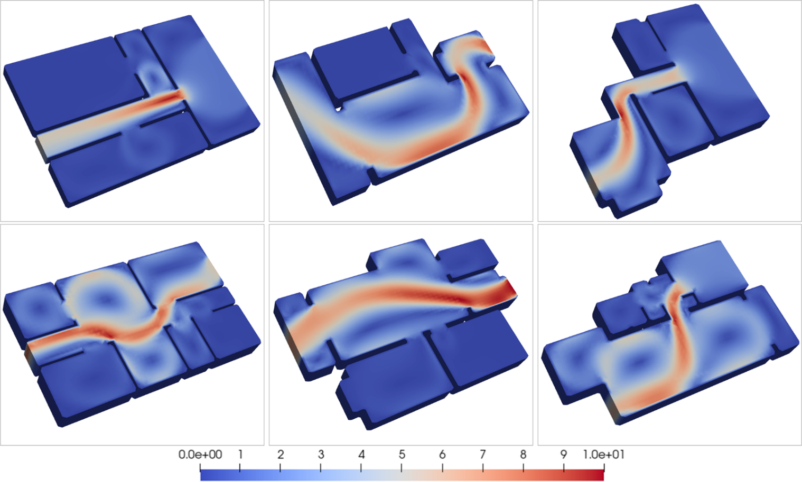
Fig. 3. Numerical simulation results of indoor airflow field evolution.

2.2.1 Random Obstacle Generation Method
To simulate the obstruction effects of indoor furniture and other obstacles on airflow dynamics—and to support the rational deployment of pollutant release sources in subsequent studies—developing an efficient and robust random obstacle generation method is a critical step. Considering the challenges of embedding obstacles into complex 3D building models, this study decomposes the problem into three sub-tasks: (1) High-precision segmentation of the computational domain into interior free space and exterior invalid regions, which is essential for identifying feasible embedding zones; (2) Candidate position sampling based on probabilistic models to construct a feasible spatial distribution of obstacle locations; (3) Collision avoidance under multi-obstacle constraints, where geometric rules are enforced to maintain minimum safe distances between obstacles and ensure compatibility with the flow simulation mesh. To address these challenges in complex indoor environments, we propose an algorithmic framework that integrates 3D space partitioning, probabilistic sampling, and geometric constraint enforcement. A schematic overview of the method is presented in Fig.4, which establishes a numerical foundation for coupled fluid–structure interaction simulations in indoor airflow modeling.
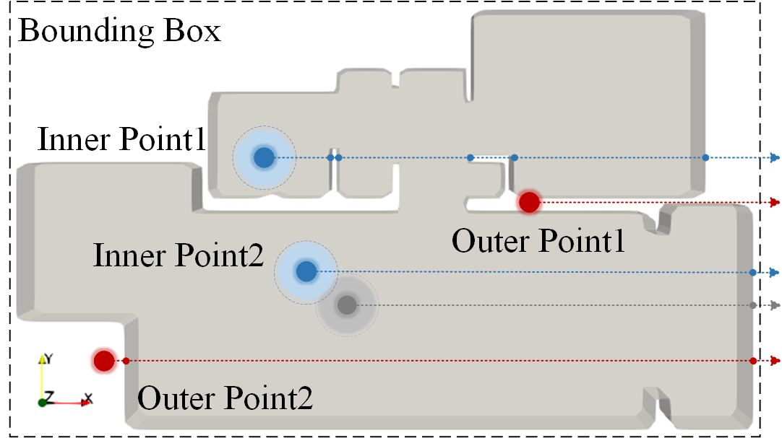
Fig. 4. Schematic illustration of the random obstacle generation method.
The ray casting method is employed to determine whether a randomly sampled point lies inside the model by counting the number of intersections between a ray and the model boundaries. The bounding box of the model is defined as . Within this bounding box, uniform sampling is performed to generate candidate points . The sampling is conducted according to the following equation:
Here, represents a uniformly distributed random number, while and other terms denote the range along each axis. Based on this method, a random sampling point is generated, and a ray is cast in an arbitrary direction (e.g., the positive x-axis). The number of intersections between the ray and the model surface is then counted. If the number of intersections is odd, the point is classified as being inside the model; otherwise, it is considered to be outside. This condition can be mathematically expressed as:
Where denotes the intersection test between the ray and the model boundary.
The resulting set of points obtained through the above method serves as the candidate positions for obstacle generation. However, when placing obstacles in complex building models, neglecting the minimum distance between obstacles may lead to infeasible layouts. To ensure spatial validity, collision detection and minimum distance constraints are applied to enforce reasonable obstacle placement and prevent overlaps. For each candidate point, the Euclidean distance to existing obstacles is checked against a threshold to determine its validity. Using this random obstacle generation approach, many room models containing obstacles can be efficiently created. By incorporating diverse obstacle topologies and varying initial conditions and parameters, this study generates a rich and diverse dataset of indoor airflow scenes.

2.2.2 Data Preprocessing
The data preprocessing stage plays a crucial role in enhancing the effectiveness and stability of model training. Raw simulation data often contain noise, missing values, and other inconsistencies that can disrupt the training process and reduce prediction accuracy. Preprocessing helps improve data quality by mitigating these issues, ensuring that features contribute more uniformly to the learning process. Additionally, the processed data are transformed into a format that aligns with the input requirements of the neural network, thereby facilitating efficient and reliable model training.
For the velocity distribution data in the airflow field sample set, Z-score normalization is applied to normalize the airflow field data. The normalization is performed using the following formula:
Where denotes the input data, represents the mean of the dataset, is the standard deviation of the dataset, and is the normalized data.
The core idea of this method is to transform the original data distribution into a standard normal distribution with a mean of 0 and a standard deviation of 1. This transformation maps data with different units and distribution characteristics into a unified numerical space, thereby eliminating scale discrepancies among features. The standardized data distribution better aligns with the assumptions of the graph neural network model used in this study. By ensuring consistent feature scales, it prevents features with larger magnitudes from dominating the training process. This normalization also facilitates more effective activation function behavior, ultimately enhancing the model’s generalization capability.

2.3 Experimental Design

2.3.1 Experimental Setup and Training Method
To enhance the stability of the model’s predictions, noise was added to the input data during training. During the training process, 80% of the dataset was randomly selected as the training set, while the remaining 20% was used as the test set, ensuring that no test samples appeared in the training set. The model parameters were optimized using the Adam optimizer [38], with an initial learning rate of 1e-4 that exponentially decayed to 1e-6. The loss function used during training was the L2 loss, which is computed as the mean squared difference between the predicted values and the ground truth values , and is defined as follows:

2.3.2 Model Parameters and Evaluation Metrics
In terms of model configuration, the proposed network comprises four attention-based message passing layers along with encoder and decoder modules. The encoder and decoder each adopt a multilayer perceptron (MLP) architecture with three fully connected layers, using ReLU as the activation function between layers and LayerNorm applied at the output for normalization. Within the attention-based message passing layers, both the node and edge aggregation and update functions in the GN modules are implemented using MLPs composed of two hidden layers with 128 dimensions, each followed by a ReLU activation function. The self-attention mechanism employs a multi-head attention module with two heads, a dropout rate of 0.1, and ReLU activation. All wind field data are normalized to have zero mean and unit variance to ensure consistency in feature distribution across input samples. To evaluate the prediction performance of the proposed model and enable fair comparison with CFD-based methods, we adopt Normalized Mean Square Error (NMSE) and as the evaluation metrics. The corresponding formulations are provided as follows:
In equations (19) and (20), and represent the predicted and true values of node , respectively. denotes the mean of all true values, and represents the mean of all predicted values. The metric ranges from 0 to 1, with a value of 1.0 indicating perfect agreement between predictions and ground truth. For the NMSE metric, its range extends from 0 to infinity, where a smaller value indicates better predictive performance of the model.
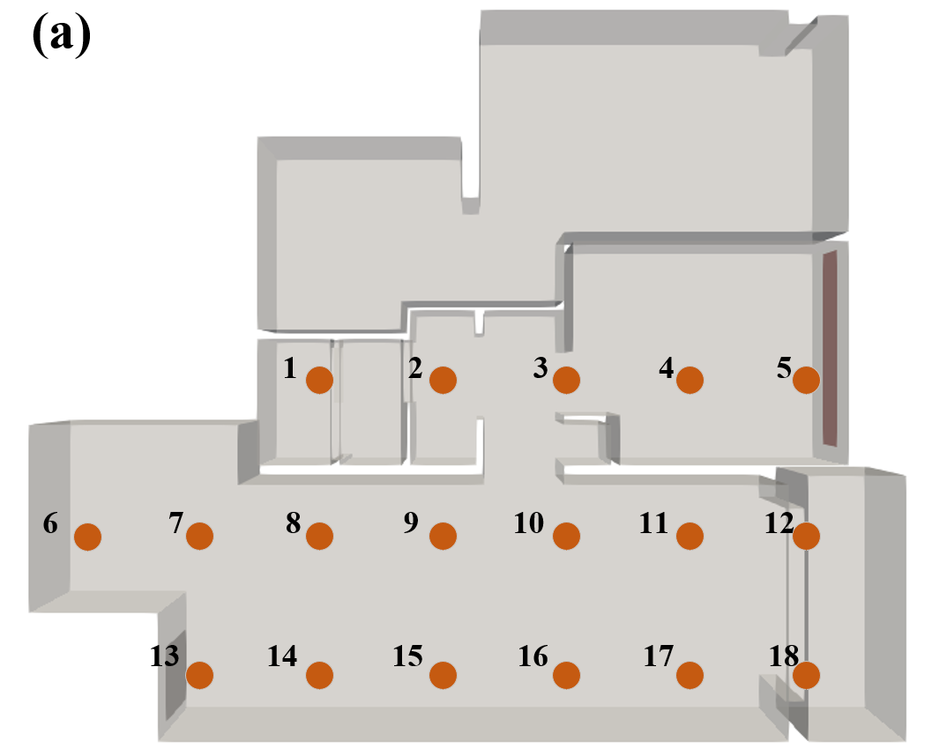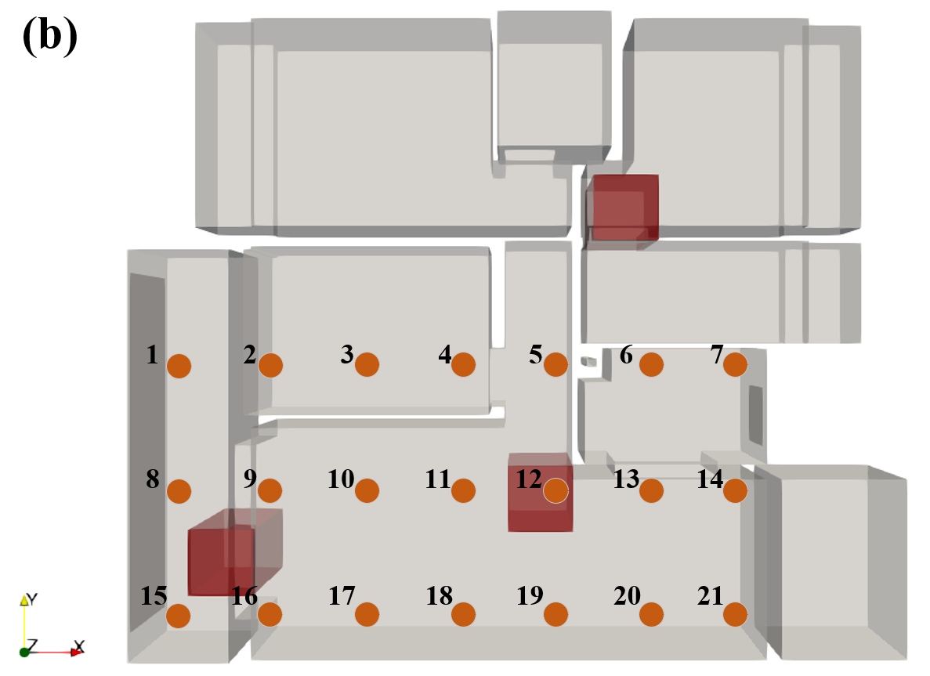
Fig. 5. Measurement point distribution of experimental scenes. (a) Measurement point distribution in obstacle-free indoor environment. (b) Measurement point distribution in indoor environment with obstacles
To quantitatively compare the prediction results of the network model with those of the CFD simulations, several measurement points were placed within the experimental scenes to record wind velocity. The spatial distribution of these measurement points is shown in Fig.5.

3 Prediction Results and Performance Analysis

3.1 Model Prediction Accuracy Evaluation
To comprehensively assess the predictive performance of the proposed MSA-GNN model in different indoor environments, this section selects two representative indoor scenes with distinct architectural structures for airflow field prediction and comparison. Through both visual and quantitative comparisons with CFD simulation results, the model’s adaptability and accuracy under varying levels of spatial complexity are effectively validated.
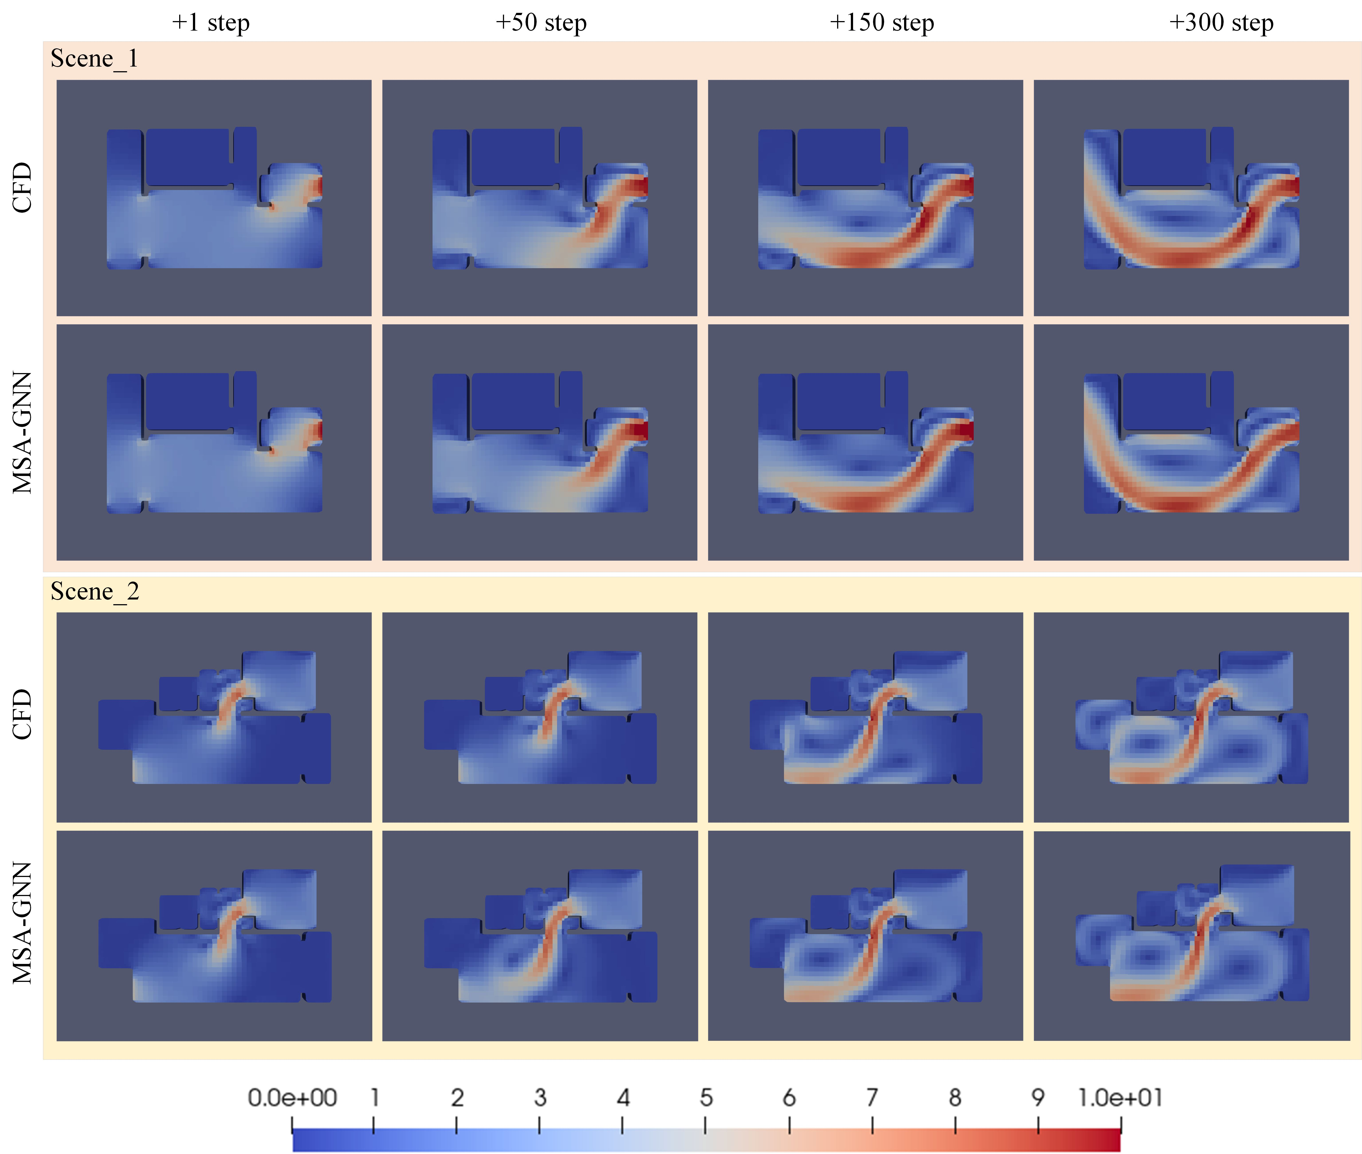
Fig. 6. Comparison of indoor airflow field predictions and CFD simulation results
Fig.6 presents a comparative visualization of the predicted and CFD-simulated airflow fields at the 1st, 50th, 150th, and 300th time frames across multiple indoor scenes, focusing on the horizontal plane at a breathing height of 1.6 m. The comparison demonstrates that the proposed neural network model effectively captures the dynamic features of airflow evolution. The predicted flow fields are continuous and smooth, accurately reflecting the influence of building boundaries on airflow behavior. The model successfully reproduces the generation, migration, and dissipation of vortex structures resulting from interactions between the airflow and surrounding walls, indicating strong predictive capability. However, discrepancies remain in some local regions between the predicted and CFD results. To further examine model performance under different conditions, a frame-by-frame analysis of representative scenes is conducted in the following section.
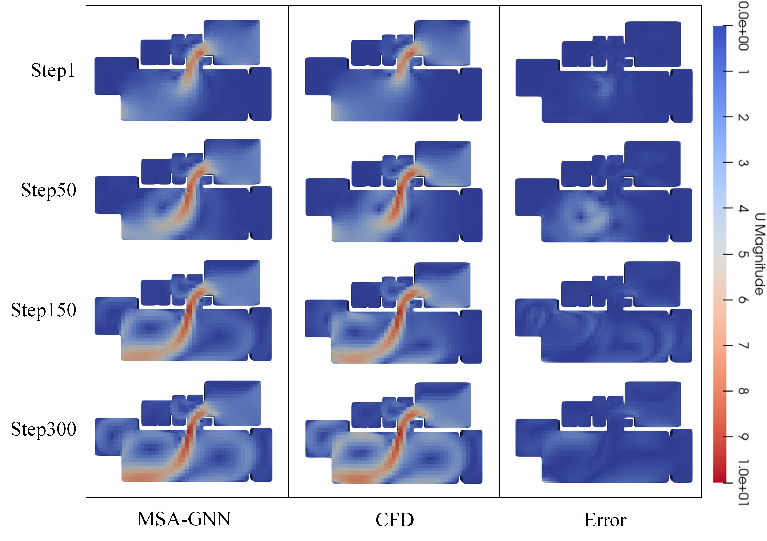
Fig. 7. Visualization of indoor airflow field predictions, CFD simulation results, and corresponding error distribution
Fig.7 presents frame-by-frame visualizations of the GNN-predicted airflow field, CFD simulation results, and the corresponding error distribution for one representative scenario. The comparison reveals that significant discrepancies appear near the room connection area at frame 1 and frame 50. These errors are attributed to the narrow geometry in this region, where rapid changes in wind velocity occur during the early stages of flow evolution. In later frames, localized prediction deviations are observed along the vortex boundary in the lower part of the room. This is likely due to the complex vortex structures in that region, which the model failed to capture accurately during training. Overall, the proposed model maintains physical consistency of the flow field while delivering predictive accuracy suitable for engineering applications. To further quantify the model’s performance in this scenario, wind speed values predicted at selected measurement points were extracted and compared with CFD simulation results.
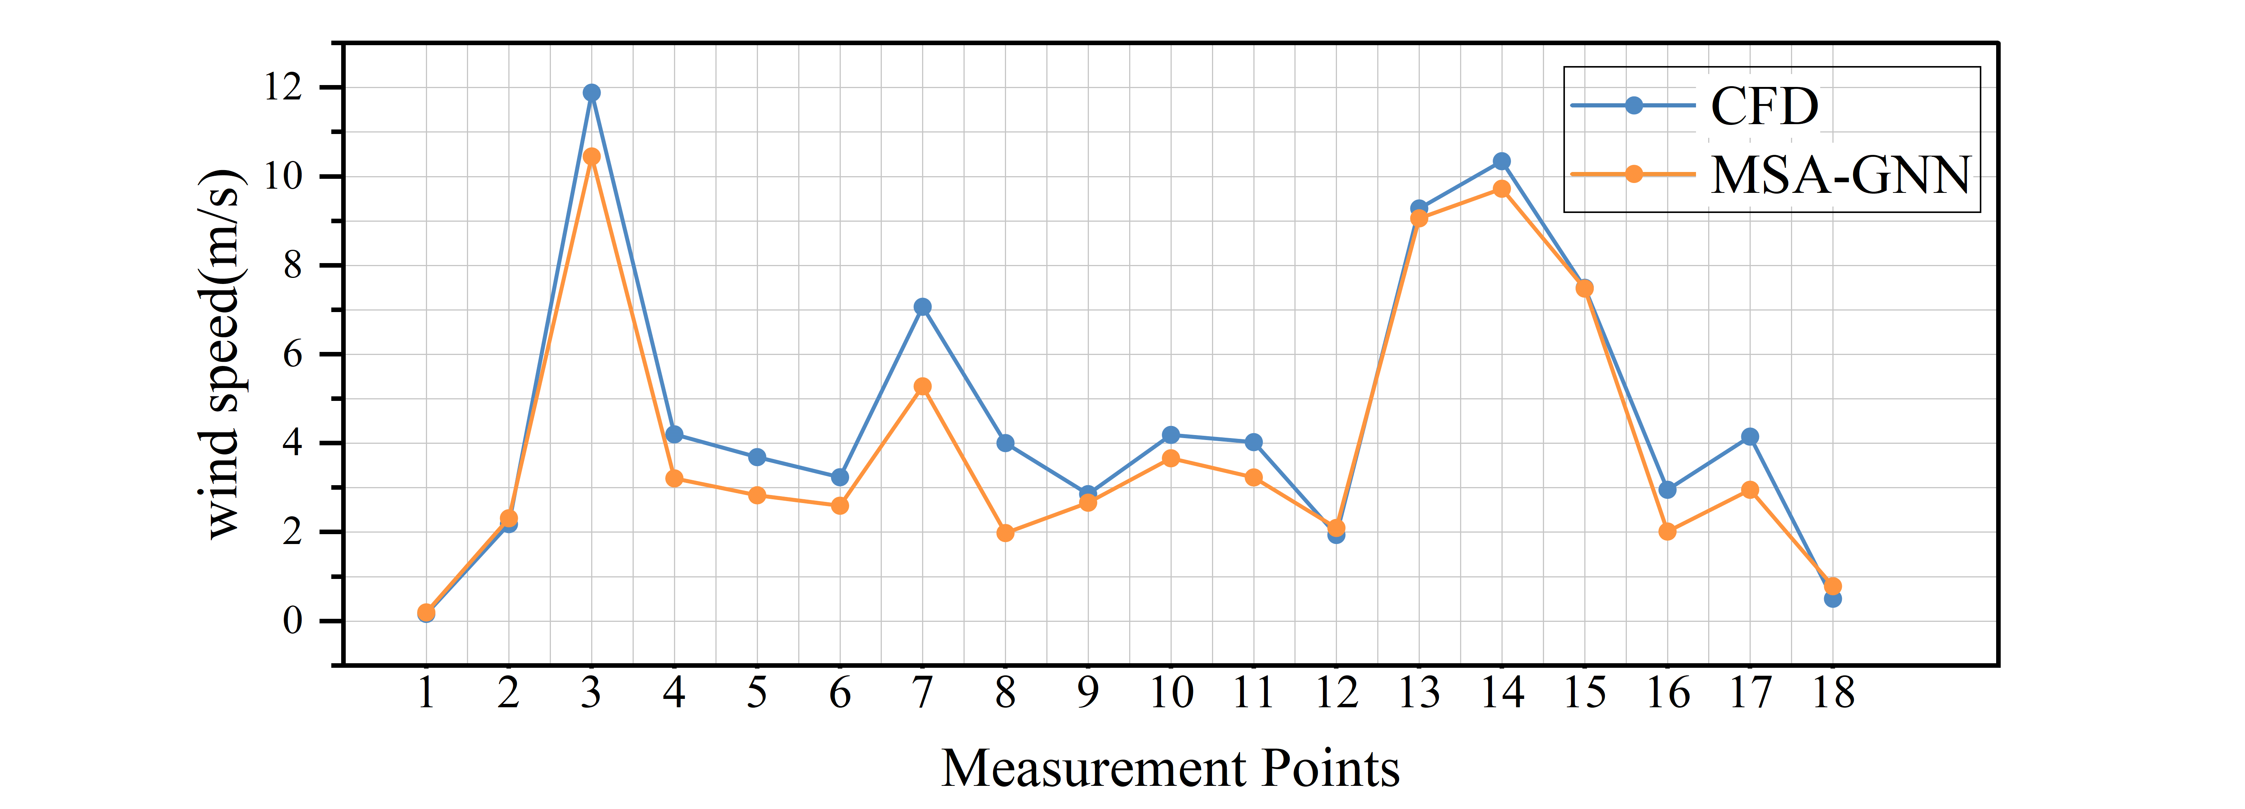
Fig. 8. Comparison of predicted wind speed and CFD results at measurement points in indoor environment
Fig.8 presents a comparison of wind speed values predicted by the proposed network model and those obtained from CFD simulations at different measurement points in the final frame. Quantitative analysis reveals that the average absolute error between the two results is 0.71 m/s, which falls within the acceptable range for engineering applications. Notably, over 70% of the measurement points exhibit local errors below the average, indicating that the model performs reliably across most spatial regions within the room. However, at certain localized areas—such as measurement points 7 and 8—significant prediction deviations are observed, with the maximum error reaching 2.02 m/s. Further analysis suggests that these discrepancies may be attributed to complex vortex structures at those locations, which the model may have struggled to learn effectively during training due to the non-stationary nature of the flow. Despite such localized deviations, the overall distribution pattern and trend of the predicted values show strong consistency with the CFD results. To further assess model performance, a comprehensive evaluation was conducted across multiple scenes in the training dataset. The results show that the overall NMSE remains around 0.06, while the coefficient of determination R² reaches up to 0.97. A summary of the quantitative evaluation metrics is provided in Table 1.
Table 1. Evaluation Metrics for Airflow Field Prediction
Region | R² | NMSE
Measurement Point | 0.92 | 0.009
Overall Region | 0.97 | 0.006
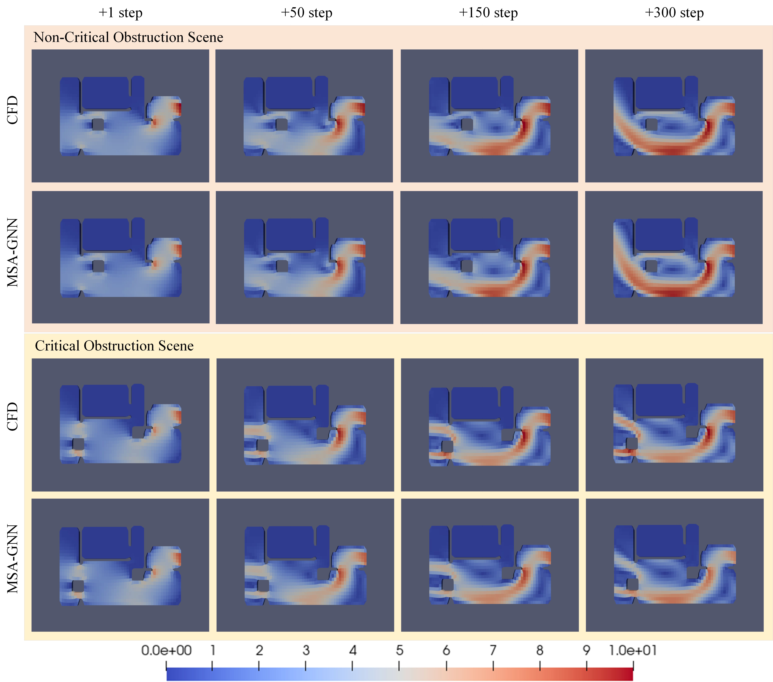
Fig. 9. Comparison of airflow field prediction results and CFD simulation results in indoor environment with obstacles
To investigate the impact of complex obstacle distributions on airflow behavior in realistic indoor aerodynamic environments, this study simulates furniture layouts by randomly generating polyhedral obstacle structures within the computational domain. The proposed model is trained and used to predict airflow fields under these conditions, producing the corresponding flow distribution maps. As shown in Fig.9, comparative analysis with CFD simulation results indicates that the model effectively reproduces complex flow phenomena such as flow separation and reattachment around obstacles. Quantitative evaluation reveals that in the wake regions behind obstacles, the predicted wind speed values correlate with CFD results at a coefficient above 0.92. However, localized regions still exhibit relative errors. These findings demonstrate the model's applicability under complex boundary conditions while also highlighting its limitations in capturing fine-scale flow features in certain regions.
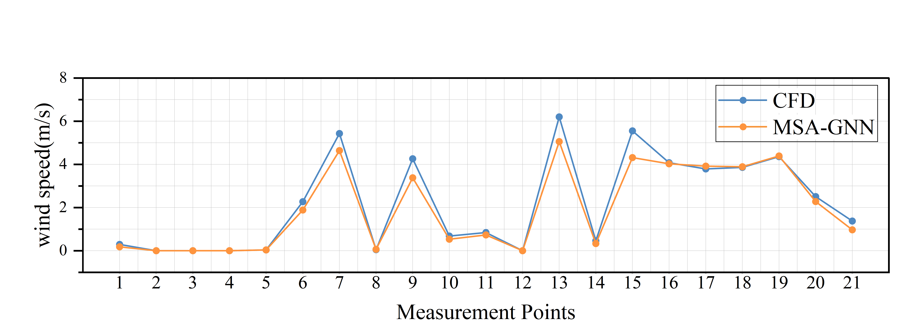
Fig. 10. Comparison of predicted and CFD wind speed values in indoor environment with obstacles
Fig.10 presents a comparison between the wind speed values predicted by the proposed network model and those obtained from CFD simulations at various measurement points in an indoor environment with obstacles. Quantitative analysis shows that the average absolute error between the two results is 0.28 m/s, which meets the accuracy requirements for engineering applications. Over 75% of the measurement points exhibit local errors below the average level, indicating that the model performs reliably across most regions of the indoor space. However, noticeable prediction deviations are observed at several points, such as measurement points 7, 9, 13, and 15, with the maximum error reaching 1.23 m/s. As indicated in Fig.5(b), points 7 and 9 are located in turbulent regions with high wind speed gradients, while points 13 and 15 are positioned near obstacles. These large errors are likely caused by the presence of complex vortex structures at those locations. Despite these localized discrepancies, the overall distribution and trend of the predicted values are consistent with the CFD results. To further assess the model’s performance, a set of evaluation metrics was established across multiple training scenes. The statistical analysis shows that the overall mean squared error (MSE) remains around 0.008, and the coefficient of determination R² reaches up to 0.95. A summary of the quantitative evaluation results is provided in Table 2.
Table 2. Evaluation Metrics for Airflow Field Prediction
Region | R² | NMSE
Measurement Points | 0.92 | 0.011
Overall Region | 0.95 | 0.008

3.2 Ablation Study
To systematically evaluate the impact of the self-attention mechanism on the predictive performance of the graph neural network model, a set of controlled ablation experiments was conducted. The experimental setup includes two comparison groups: a baseline model employing a standard GNN architecture, and an experimental model that incorporates both multi-scale graph construction and a self-attention mechanism within the GNN framework. Results show that, under the same number of training epochs, the proposed MSA-GNN model achieved an R² score of 0.97 and an NMSE of 0.13, while the baseline model yielded an R² of 0.64 and an NMSE of 0.74. 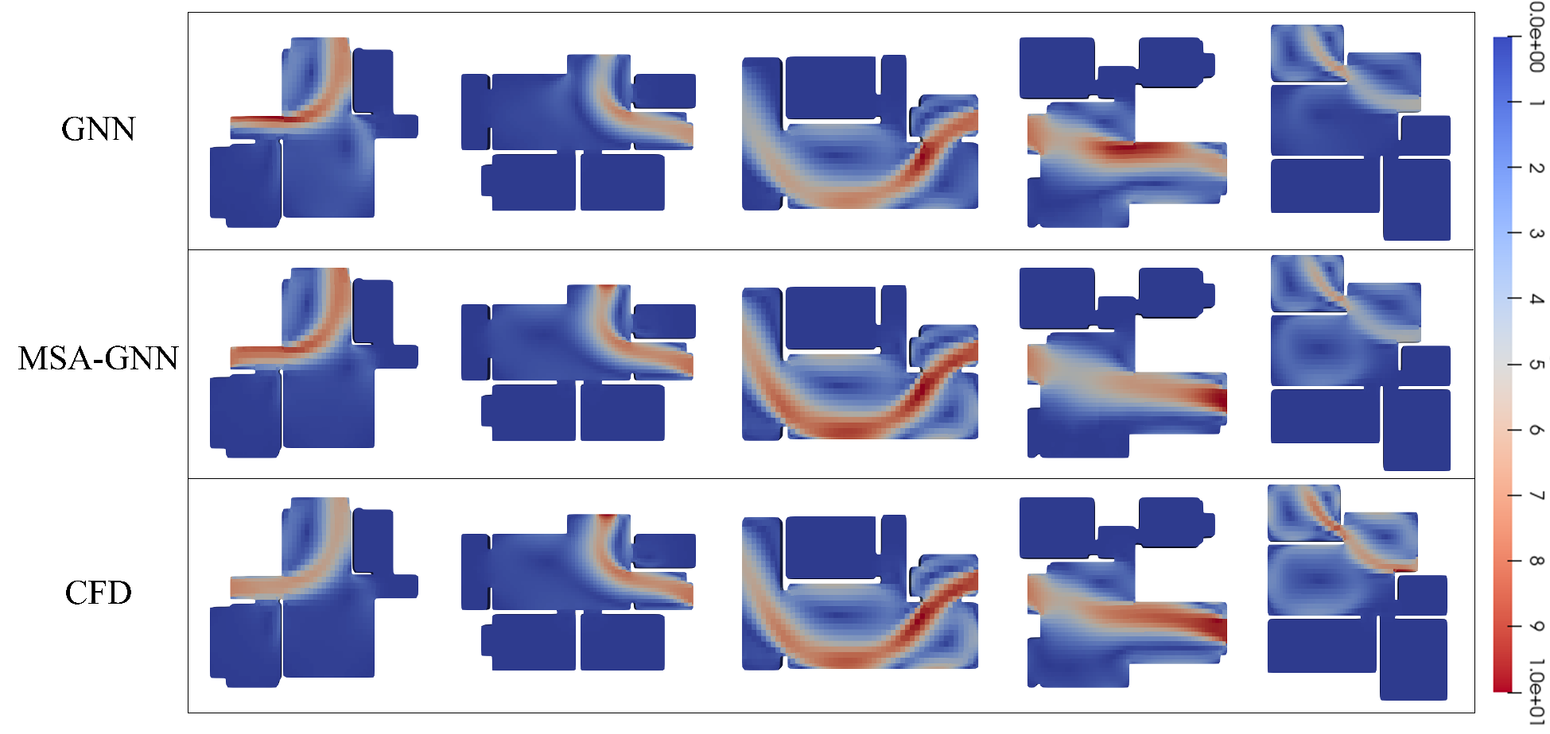
Fig. 11. Comparison of prediction results in ablation study on attention mechanism within the GNN model
Fig.11 compares the final-frame airflow predictions from the baseline GNN and the proposed MSA-GNN model with CFD simulation results. The results indicate that although both models are capable of capturing the overall airflow trend, the baseline GNN model exhibits noticeably larger prediction errors near building boundaries and within vortex regions. This discrepancy is primarily attributed to the higher mesh density and greater complexity of flow structures in those boundary-adjacent areas. With the same number of message-passing iterations, the baseline GNN suffers from a smaller receptive field and limited information capture. In contrast, the enhanced GNN model—incorporating multi-scale graph construction and a self-attention mechanism—shows improved predictive accuracy near boundaries, aligning more closely with CFD results and achieving convergence more efficiently. These findings demonstrate that the attention mechanism significantly enhances the model’s capability to represent fine-grained local features while capturing the global flow structure. To further quantify the performance differences, the evaluation metrics for each model are summarized in Table 3.
Table 3. Evaluation Metrics for Airflow Field Prediction by Different Models
Model | R² | NMSE
Baseline GNN Model | 0.64 | 0.74
MSA-GNN Model | 0.98 | 0.13

3.3 Prediction Speed Analysis
This section evaluates and analyzes the prediction speed of the MSA-GNN model across different scenes, with a primary focus on comparing its computation time against that of the CFD solver for airflow field forecasting.
The MSA-GNN model is implemented using the PyTorch framework with GPU acceleration, while the CFD simulations are performed using the pimpleFoam solver with 64-core parallel computing. The hardware configuration used in this study includes an NVIDIA GeForce RTX 4090 GPU (24 GB VRAM) and an Intel Xeon E5630 CPU. Table 4 summarizes the prediction time required by the MSA-GNN model and the pimpleFoam solver to simulate 20 seconds of airflow evolution across different scenes.
Table 4. Comparison of Prediction Time between MSA-GNN Model and CFD Solver
Scene | CFD Time Consumption (s) | MSA-GNN Time Consumption (s)
Scene 1 | 1.77 | 0.233
Scene 2 | 2.42 | 0.247
Scene 3 | 2.44 | 0.271
Scene 4 | 2.51 | 0.352
Table 4 presents the time consumption comparison between the MSA-GNN model and the pimpleFoam solver across different scenes. Each scenario involves varying inflow conditions and obstacle configurations, representing indoor environments of different complexity levels. The experimental results show that the MSA-GNN model consistently outperforms the pimpleFoam solver in terms of prediction speed across all test cases. According to the data in Table 4, the MSA-GNN achieves a speedup factor of approximately 7 to 10 times compared to CFD. The variation in acceleration ratios is primarily attributed to differences in mesh density across scenes—while the computational cost of CFD increases substantially with mesh size, the MSA-GNN model remains relatively insensitive to mesh scale due to its efficient GNN architecture.
In summary, the MSA-GNN model proposed in this study demonstrates a significant computational advantage over traditional CFD methods, achieving nearly an order-of-magnitude improvement in prediction speed. This performance supports the study’s goal of enabling rapid forecasting of indoor airflow dynamics.

4 Conclusion
- A Multi-Scale Attention Graph Neural Network (MSA-GNN) was proposed for transient indoor airflow prediction. To address the limited representational capacity of existing methods in modeling complex indoor airflow dynamics, this study developed an MSA-GNN model that integrates multi-scale graph structures with a self-attention mechanism. This design significantly enhances the model's ability to capture spatial-temporal features of airflow fields.
- A representative training dataset was constructed based on realistic indoor architectural scenes. The training data were generated from actual indoor layouts, incorporating a randomized obstacle generation algorithm to create diverse flow conditions. Time-series datasets of airflow evolution were obtained using CFD solvers to provide reliable supervision signals.
- The combination of multi-scale graph mapping and self-attention improved prediction accuracy and computational efficiency. The model maps high-resolution graph structures into lower-resolution spaces, reducing the memory footprint of the attention mechanism while preserving critical flow features. The self-attention mechanism enhances the ability to capture long-range dependencies and facilitates more effective feature aggregation during message passing. This strategy mitigates the issues of over-smoothing and feature compression commonly observed in traditional GNNs during deep propagation, thereby reducing prediction errors in complex flow regimes.
- Extensive experiments demonstrated the fast and accurate prediction capability of MSA-GNN. Across multiple realistic indoor test scenes and ablation studies, the predicted airflow distributions closely matched CFD simulation results. Wind speed values at various monitoring points exhibited high consistency, with key performance metrics (e.g., R²) exceeding 0.98. Additionally, the model achieved a 7–10× speed-up compared to conventional CFD solvers, offering an efficient and accurate solution for real-time airflow prediction in indoor environments.
Despite the promising performance, the proposed MSA-GNN model currently lacks validation across diverse real-world ventilation systems and dynamic occupant interactions, which may limit its generalizability in broader application scenes. Future work will focus on extending the model to incorporate additional physical factors such as thermal effects and occupant-induced disturbances, thereby enhancing its adaptability and predictive robustness in more complex indoor environments.

References
[1] State Council. Notice by the State Council of Issuing the 2024-2025 Energy Conservation and Carbon Reduction Action Plan[J]. Gazette of the State Council of the People's Republic of China, 2024: 11-16.
[2] Li Y, Nielsen P V. CFD and ventilation research: CFD and ventilation research[J]. Indoor Air, 2011, 21(6): 442-453.
[3] Jiang J, Jiang Z, Kwan T H, et al. Study of indoor ventilation based on large-scale DNS by a domain decomposition method[J]. Symmetry, 2019, 11(11): 1416.
[4] Auvinen M, Kuula J, Grönholm T, et al. High-resolution large-eddy simulation of indoor turbulence and its effect on airborne transmission of respiratory pathogens—Model validation and infection probability analysis[J]. Physics of Fluids, 2022, 34(1).
[5] Montazeri H, Montazeri F. CFD simulation of cross-ventilation in buildings using rooftop wind-catchers: Impact of outlet openings[J]. Renewable Energy, 2018, 118: 502-520.
[6] Kong X, Chang Y, Li N, et al. Comparison study of thermal comfort and energy saving under eight different ventilation modes for space heating[J]. Building Simulation, 2022, 15(7): 1323-1337.
[7] Cao S J. Challenges of using CFD simulation for the design and online control of ventilation systems[J]. Indoor and Built Environment, 2019, 28(1): 3-6.
[8] Dai T, Liu S, Liu J, et al. Development of a new dynamic smagorinsky model by an artificial neural network for prediction of outdoor airflow and pollutant dispersion[J]. Building and Environment, 2023, 243: 110624.
[9] Feng Z, Yu C W, Cao S J. Fast prediction for indoor environment: Models assessment[J]. Indoor and Built Environment, 2019, 28(6): 727-730.
[10] Abadie M O, De Camargo M M, Mendonça K C, et al. Improving the prediction of zonal modeling for forced convection airflows in rooms[J]. Building and Environment, 2012, 48: 173-182.
[11] Zheng S, Zhai Z J, Wang Y, et al. Evaluation and comparison of various fast fluid dynamics modeling methods for predicting airflow around buildings[J]. Building Simulation, 2022, 15(6): 1083-1095.
[12] Zuo W, Chen Q. Fast and informative flow simulations in a building by using fast fluid dynamics model on graphics processing unit[J]. Building and Environment, 2010, 45(3): 747-757.
[13] Wang Q, Pan Y, Zhu M, et al. A state-space method for real-time transient simulation of indoor airflow[J]. Building and Environment, 2017, 126: 184-194.
[14] Han J M, Ang Y Q, Malkawi A, et al. Using recurrent neural networks for localized weather prediction with combined use of public airport data and on-site measurements[J]. Building and Environment, 2021, 192: 107601.
[15] Kashefi A, Rempe D, Guibas L J. A point-cloud deep learning framework for prediction of fluid flow fields on irregular geometries[J]. Physics of Fluids, 2021, 33(2): 027104.
[16] Guo X, Li W, Iorio F. Convolutional Neural Networks for Steady Flow Approximation[C]//Proceedings of the 22nd ACM SIGKDD International Conference on Knowledge Discovery and Data Mining. San Francisco California USA: ACM, 2016: 481-490.
[17] Sekar V, Jiang Q, Shu C, et al. Fast flow field prediction over airfoils using deep learning approach[J]. Physics of Fluids, 2019, 31(5): 057103.
[18] Miyanawala T P, Jaiman R K. An Efficient Deep Learning Technique for the Navier-Stokes Equations: Application to Unsteady Wake Flow Dynamics[EB]. arXiv, 2017.
[19] Xiang S, Fu X, Zhou J, et al. Non-intrusive reduced order model of urban airflow with dynamic boundary conditions[J]. Building and Environment, 2021, 187: 107397.
[20] Wiewel S, Becher M, Thuerey N. Latent space physics: Towards learning the temporal evolution of fluid flow[C]//Computer graphics forum: Vol. 38. Wiley Online Library, 2019: 71-82.
[21] Ribeiro M D, Rehman A, Ahmed S, et al. DeepCFD: Efficient Steady-State Laminar Flow Approximation with Deep Convolutional Neural Networks[EB]. arXiv, 2020.
[22] Gu J, Wang Z, Kuen J, et al. Recent advances in convolutional neural networks[J]. Pattern Recognition, 2018, 77: 354-377.
[23] Gori M, Monfardini G, Scarselli F. A new model for learning in graph domains[C]//Proceedings. 2005 IEEE International Joint Conference on Neural Networks, 2005.: Vol. 2. Montreal, Que., Canada: IEEE, 2005: 729-734.
[24] Pfaff T, Fortunato M, Sanchez-Gonzalez A, et al. Learning Mesh-Based Simulation with Graph Networks[J]. 2020.
[25] Fortunato M, Pfaff T, Wirnsberger P, et al. MultiScale MeshGraphNets[EB]. arXiv, 2022.
[26] Chen D, Gao X, Xu C, et al. FlowDNN: a physics-informed deep neural network for fast and accurate flow prediction[J]. Frontiers of Information Technology & Electronic Engineering, 2022, 23(2): 207-219.
[27] Han X, Gao H, Pfaff T, et al. Predicting Physics in Mesh-reduced Space with Temporal Attention [EB]. arXiv, 2022.
[28] Morris C, Ritzert M, Fey M, et al. Weisfeiler and leman go neural: Higher-order graph neural networks[C]//Proceedings of the AAAI conference on artificial intelligence: Vol. 33. 2019: 4602-4609.
[29] Xu K, Hu W, Leskovec J, et al. How Powerful are Graph Neural Networks?[EB]. arXiv, 2018.
[30] Li Q, Han Z, Wu X M. Deeper insights into graph convolutional networks for semi-supervised learning[C]//Proceedings of the AAAI conference on artificial intelligence: Vol. 32. 2018.
[31] Chen D, Lin Y, Li W, et al. Measuring and relieving the over-smoothing problem for graph neural networks from the topological view[C]//Proceedings of the AAAI conference on artificial intelligence: Vol. 34. 2020: 3438-3445.
[32] Oono K, Suzuki T. Graph Neural Networks Exponentially Lose Expressive Power for Node Classification[EB]. arXiv, 2019.
[33] Alon U, Yahav E. On the Bottleneck of Graph Neural Networks and its Practical Implications[EB]. arXiv, 2020.
[34] Vaswani A, Shazeer N, Parmar N, et al. Attention is all you need[J]. Advances in neural information processing systems, 2017, 30.
[35] Cho K, van Merrienboer B, Gulcehre C, et al. Learning Phrase Representations using RNN Encoder-Decoder for Statistical Machine Translation[EB]. arXiv, 2014.
[36] Sanchez-Gonzalez A, Heess N, Springenberg J T, et al. Graph networks as learnable physics engines for inference and control[C]//International conference on machine learning. PMLR, 2018: 4470-4479.
[37] Chen D, O’Bray L, Borgwardt K. Structure-aware transformer for graph representation learning[C]//International conference on machine learning. PMLR, 2022: 3469-3489.
[38] Kingma D P, Ba J. Adam: A Method for Stochastic Optimization[EB]. arXiv, 2014.

