Solutions of Assignment #3 --- CSC320, Summer, 2018

Zhaocheng Li

V00832770

Q1-Answer:

Converting CFG to PDA by diagram:

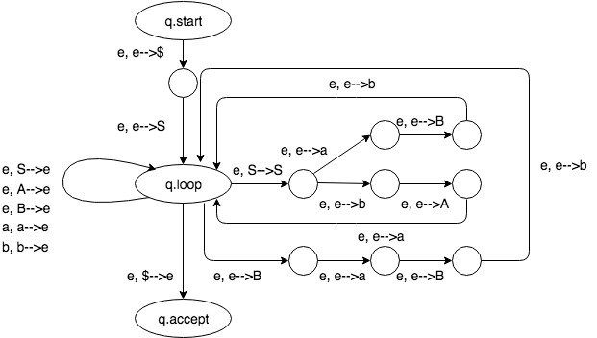

(here e stands for ε)

Q2-Answer:

Converting PDA to CFG using the standard procedure.

1. Preprocessing the PDA diagram:

* Single accept state? No. we convert it into:

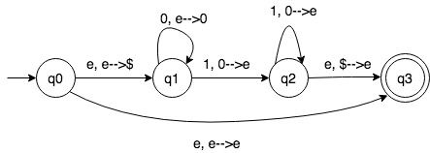

* Empty stack before accepting? Check.
* Pop/push each transition but not both? Check.

1. CFG construction.

Construct a CFG G = (V, ∑, R, S), where

* The start variable is S = Aq0q3;
* ∑ = {a, b}
* V = {Aq0q3, Aq0q1, Aq0q2, Aq1q2, Aq1q3, Aq2q3}
* And mostly importantly, the R is (by the construction rule): (note, the variables like A12 and A21 are identical)

Aq0q3 Aq1q2

Aq0q3 Aq0q1 Aq1q3, Aq0q3 Aq0q2 Aq2q3

Aq0q1 Aq0q2 Aq2q1, Aq0q1 Aq0q3 Aq3q1

Aq0q2 Aq0q1 Aq1q2, Aq0q2 Aq0q3 Aq3q2

Aq1q2 Aq1q0 Aq0q2, Aq1q2 Aq1q3 Aq3q2

Aq1q3 Aq1q0 Aq0q3, Aq1q3 Aq1q2 Aq2q3

Aq2q3 Aq2q0 Aq0q3, Aq2q3 Aq2q1 Aq1q3

Aq0q0 ε, Aq1q1 ε, Aq2q2 ε

Aq3q3 ε

Q3-Answer:

First of all, the class of languages this model recognize is regular languages only.

Since we can simulate any DFA on a Turing Machine with stay put instead of left,

The only non-trivial modification is to add transitions from state in *F (DFA)* to qaccept when reading a blank, and from states not in F to qreject when reading a blank.

Suppose the Turing machine M = (Q, ∑, Γ, δ, q0, qaccept, qreject) with stay put instead of left.

Then we can **prove by constructing a DFA** (Q’, ∑’, δ’, q0’, F) that recognizes the same language as M does.

Given the fact that M cannot move to the right and cannot read anything it has written on the tape as soon as it moves right. Hence it is actually a one-way access to the input, similar with a DFA.

Modification as follow:

* Add a new symbol so that M never writes blanks on the tape; M writes new symbol when it is going to write blanks
* The reading head moves to the right and never stays put when M transitions into qaccept or qreject;
* Set Q’ = Q, ∑’ = ∑, q0’ = q0, and set the transition function δ’ as follow: (q ∈ Q, and a ∈ ∑)
* δ’(q, a) = q if q ∈ {qaccept, qreject}
* δ’(q, a) = qreject if M starting at q and reading a keeps staying put, or
* δ’(q, a) = q’ where q’ is the state that M enters, when it first moves right when starting at q and reading a.

Observing that with such construction, we make F the set containing qaccept and all states q ∈ Q, q ≠ qaccept, qreject, such that M, starting at q and reading blanks, would enters qaccept in the end.

Q4-Answer: (prove by construction)

(a): suppose that L1 and L2 are two decidable languages and M1 and M2 be to deciders (Turing machines halting) for L1 and L2 respectively. Then there is a decider M for L1L2 where:

*Given the input w, M non-deterministically partitions w=w1w2; M calls M1 to run on w1 and calls M2 to run on w2; M accepts w if and only if M1 accepts w1 and M2 accepts w2.*

Since M1 and M2 halt, then so does M.

Prove done.

(b): Suppose L1 and L2 are two decidable languages and M1 and M2 be two deciders for L1 and L2 respectively (same as above). Then there is a decider M for L1∩L2 where:

Given the input w, M calls M1 to run on w, and calls M2 to run on w. Then M accepts w if and only if both M1 accepts w and M2 accepts w.

Since M1 and M2 halt, then so does M.

Prove done.

(c): Similarly, suppose L1 is a decidable language and M1 is a decider for M1. Then there is a decider M for Lhat (complement of L) where:

Given the input w; M calls M1 to run on w; M accepts w if and only if M1 rejects w.

Since M1 halts, then so does M.

Prove done.