stored procedure call:

MusicRepository->TrackRepository->GetArtistsOfTrack

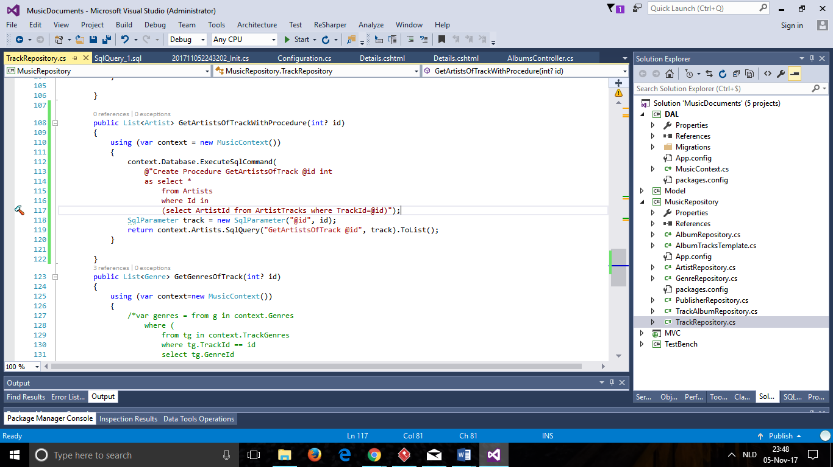

Inline sql query:

MusicRepository->ArtistRepository-> GetArtistById

