**ROS Case Study #1**

**Zhaofeng Tian**

1. **Assignment Description**

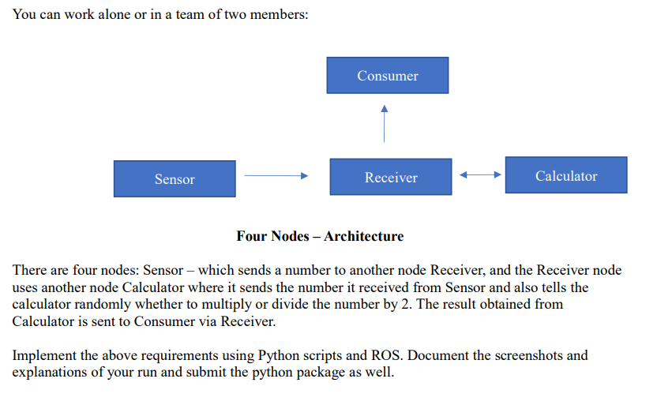

1. **Solution**

Initiate four nodes with names corresponding to the description by using four Python scripts respectively. Also, initiate four topics for convenient communication among four nodes. The structure is shown as below, a rqt_graph image.

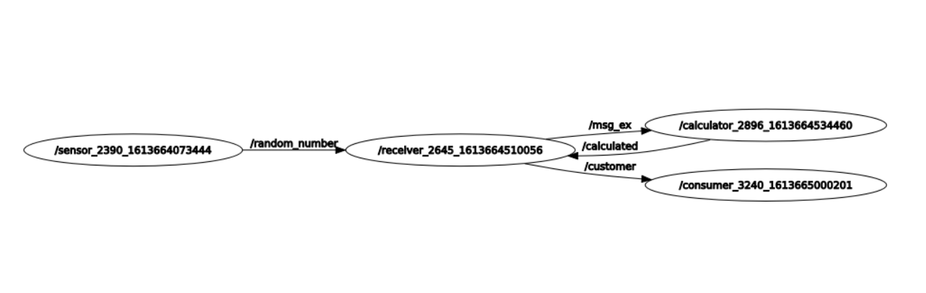

As we can see, random_number, msg_ex, calculated and customer, these four topics are generated.

1. **Results**

The results are shown as a gif image.



Description:

Sensor: publish a random number at 1 Hz to random_number topic.

Receiver: receive a number from random_number, and convert it into number_msg, then publish it as a calculation request to msg_ex topic. After getting a result from calculator via calculated topic in a number_msg, publish it into consumer node via customer topic.

Calculator: Randomly do multiply or divide the number received from receiver by 2, and then publish it to calculated topic.

Consumer: receive the result from receiver via customer topic.