**Question1 & Question2:**

**ER – diagram:**

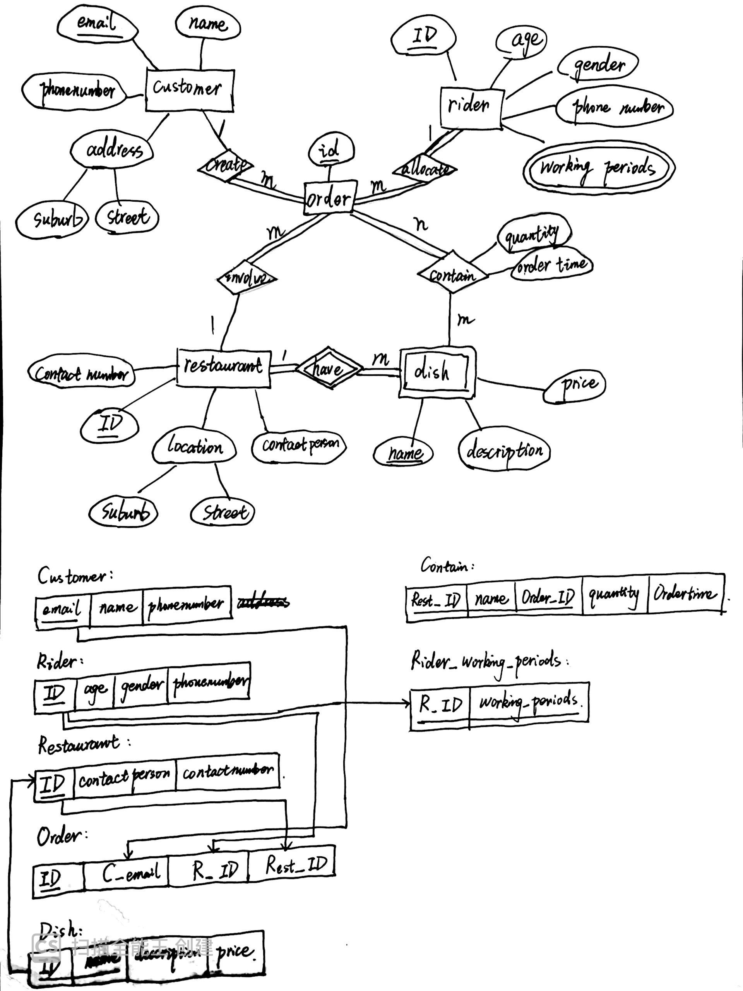

**Convert into a relational model:**

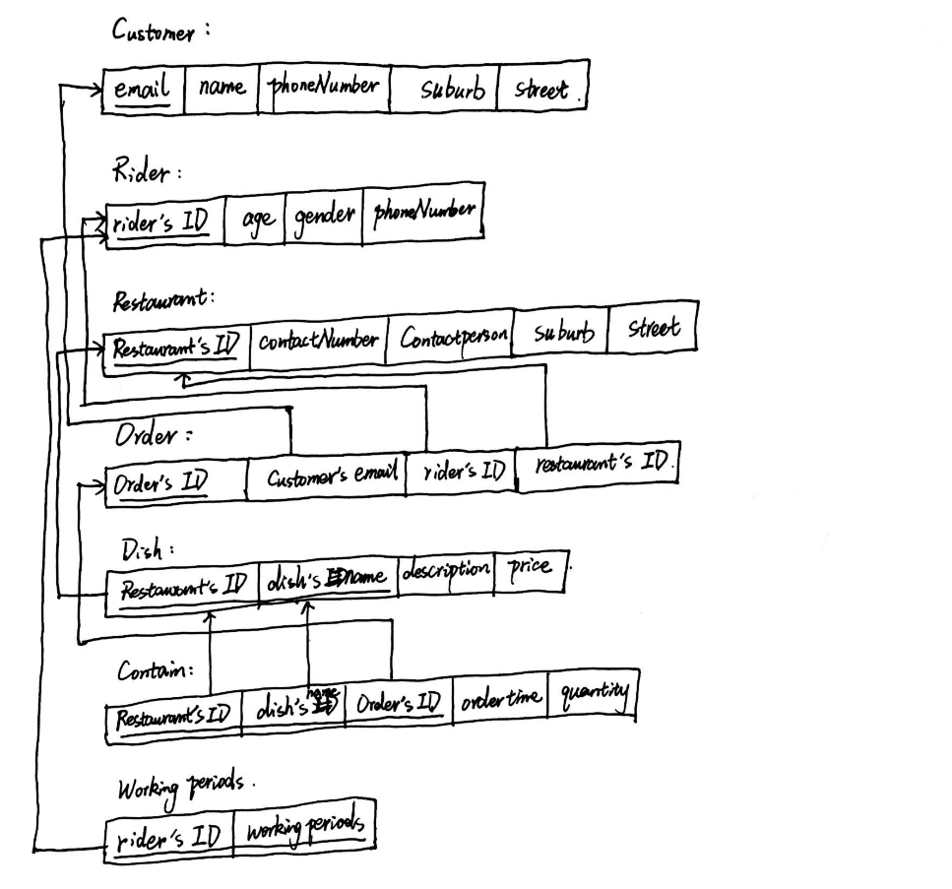

**Question3:**

(1)π**{title}**(σ**<name=‘Taylor Swif’ and genre=‘pop’>**(Song⋈GenreOfSong⋈SongCreating⋈Artist))

(2)π**{title}**(σ**<name=‘Taylor Swif’ or name=‘Ed Sheeran’ >**(Song⋈GenreOfSong⋈SongCreating⋈Artist))

(3)(π**{name}**(σ**<gender=‘female’ and Name=‘Universal Music Group’ and genre=‘pop’>**(GenreOfSong⋈SongCreating⋈Artist⋈JoinIn⋈Company))) – (π**{name}**(σ**<genre=‘hip-pop’>**(GenreOfSong⋈SongCreating⋈Artist)))

(4) let R1 = SongCreating⋈Artist

And R2 = SongCreating⋈Artist

((π**{name,genre}**(GenreOfSong⋈SongCreating⋈Artist))÷(π**{genre}**(GenreOfSong)))∩(π**{R2.name}**(σ**< R1.name＝‘Taylor Swift’ and R2.name≠‘Taylor Swift’>**(R1×R2))