Condition-Dependent Cognitive Processing：Exploring Sleep-Related Factors, Emotional Regulation and Cognitive Performance Using Secondary Data

1st Independent Secondary Data Analyses Project
On Github

Abstract:
Numerous studies have identified behavioral and psychological contributors associated with cognitive performance and emotional functioning. Based on current theories and a publicly available dataset, this project examined two research questions: (1) whether sleep-related factors were associated with emotional regulation, representing behavioral contributors to psychological functioning; and (2) whether psychological factors, including stress levels and emotional regulation, were associated with cognitive performance. For the first module, regression-based models were constructed to evaluate associations between sleep-related factors and emotional regulation, including the potential interaction effects between sleep duration and sleep quality. For the second module, Principal component analysis (PCA) was initially conducted to explore the potential commonality among cognitive measures, followed by analyses examining associations between psychological predictors including stress levels and emotion regulation, and individual cognitive outcomes. The findings provided insufficient evidence for population-level associations between any behavioral and psychological states and cognitive performance in terms of zero-order associations as well as in multiple linear regression between sleep, stress levels and emotion regulations. PCA did not indicate a unified cognitive performance component, suggesting the individual cognitive measures in the data represent distinct cognitive domains possibly. The intriguing findings, inconsistent with expectations, highlight the complexity of relationships among sleep, psychological states, and cognitive functioning **(最后改)

Introduction:
Cognitive processing is one of the most fundamental topics in psychology and neuroscience, as it provides a framework for understanding functionally segregated yet integrated information-processing mechanisms underlying the way individuals interact with the surrounding environment (Frank & Badre, 2015; Schall, 2004; Forstmann et al., 2011). Presented information may affect the outcomes, or observable performance, through both its direct role as processed input and its indirect role in shaping the state and condition under which processing occurs.
Certain studies support a broader conceptualization of cognitive processing as dynamically state-dependent, meaning that the expected processing outcome may be modulated by the current state even when the immediate processing input remains unchanged, thereby potentially altering an individual’s response (Flavell et al., 2022; Gilbert & Sigman, 2007). For the present framework and data analyses, conditions contributing to variation in cognitive processing can be broadly distinguished into two types. One can be conceptualized as a behavioral condition, referring to a condition generated by prior behavior or activity that subsequently alters the context under which information is processed, although the condition itself is not necessarily related to the properties of the immediate processing input. Examples include insufficient sleep and body posture (Alhola & Polo-Kantola, 2007; Khan & Al-Jahdali, 2023; Wainio-Theberge & Armony, 2025). In contrast, an internal psychological condition refers to a state manifested within the individual at a psychological or physiological level, such as emotional state, fatigue, or motivation (Flavell et al., 2022). For instance, the same stimulus may bias emotion perception depending on the perceiver’s current emotional state (Trilla et al., 2021; Harris et al., 2016). Although there is now substantial evidence suggesting that the effects are potentially through modulation of the neural and physiological mechanisms implementing cognitive processing, investigations into their effects on cognitive performance are ongoing since these behavioral conditions and internal psychological states may influence cognitive and behavioral outcomes either independently or interactively. Specifically, the effects of the two types of conditions on cognitive performance are not necessarily independent, and internal states may be induced by prior behavior or environmental conditions, while some states, such as trait anxiety and depression, suggested to impair attention, may persist and affect cognitive performance even in the absence of an immediate external trigger (Pacheco-Unguetti et al., 2010; Roca et al., 2015), or vice versa.
The publicly available Kaggle dataset used in the data analyses project provides a broad range of behavioral, psychological, and cognitive performance measures (Sacramento Technology, 2024). It provides an opportunity for the project to achieve two broad purposes: (1) the examination of the broader correlational structure among these variables to understand their standardized associations with cognitive performance differently, while also (2) selecting theoretically relevant conditions for more focused model-driven analyses. Accordingly, for the first purpose, an exploratory correlation matrix heatmap was first established, providing an overall presentation of all zero-order associations among variables.
For the second broad purpose, the present project focused on two representative conditions derived from the conceptual framework introduced above. Sleep hours and stress level were treated as conditions primarily originating from behavioral and psychological domains, respectively. A large body of studies has suggested that both factors are associated with performance across different cognitive tasks (Alhola & Polo-Kantola, 2007; Khan & Al-Jahdali, 2023; Nwikwe, 2025). Accordingly, the theory-driven analysis incorporated two specific aims. The first aim was to estimate the effects of these conditions on higher-order cognitive functioning. Specifically, the project examined the independent contributions and combined explanatory power of sleep hours and stress level in relation to a higher-order regulatory function. Emotion regulation was selected as the representative higher-order regulatory outcome since its success largely relies on the coordination of several basic cognitive processes such as selective attention, working memory, and inhibitory control (Koay & Meter, 2023). In addition, considering that the dataset contains measurements of basic cognitive skills through cognitive performance tasks, specifically, Stroop task reaction time (RT), N-back accuracy, and psychomotor vigilance test (PVT) RT are expected to primarily measure selective attention and inhibition, working memory, and sustained attention and behavioral alertness (Basner et al., 2021; Owen et al., 2005; Scarpina & Tagini, 2017), respectively. This raises the second aim of the project: to examine whether these reflected basic cognitive functions can be reasonably compressed and summarized to be one indication of a general cognitive ability, if any. The second aim was to estimate the effects of the conditions on basic cognitive functioning constructs, and an exploratory principal component analysis (PCA), attempting to compress the variables into any potential broad cognitive performance dimension, was conducted. Nevertheless, if a practically meaningful common component with sufficient information preservation could not be supported, the individual cognitive outcomes would instead be retained and examined separately. Subsequent model-based analyses were therefore conducted to estimate the associations of theoretically relevant behavioral and psychological conditions with their corresponding cognitive outcomes.
Overall, the exploratory secondary data analyses project subsequently combined exploratory correlational mapping with theory-driven analyses to examine how behavioral and psychological conditions are associated with emotional regulation and cognitive performance. Generally, for the first broad purpose, it is expected that certain statistically significant correlations will be found between behavioral or psychological states and the cognitive performance measures in the dataset. And for the second aim, it is expected that the theoretically selected behavioral and psychological conditions will show meaningful associations with their corresponding emotional and cognitive outcomes, while the exploratory PCA may identify whether the available cognitive measures can be reasonably summarized into a broader common cognitive performance dimension, thereby indirectly supporting existing theoretical and empirical evidence.

Data and Methods
The dataset titled Sleep Deprivation & Cognitive Performance is publicly available on Kaggle and was used for the present secondary data analyses (Sacramento Technology, 2024). The dataset contained 60 observations and 14 original variables. Descriptive statistics and an exploratory Pearson correlation heatmap were first used to summarize the overall data structure in terms of correlations among all continuous variables. Data preparation targeting predictor variables of interest was conducted before formal analyses, including mean-centering where appropriate. Continuous stress scores were operationally categorized into low-, moderate-, and high-stress groups for group-based analyses based on criteria derived from the Perceived Stress Scale (PSS-10) (Adamson et al., 2020; Cohen et al., 1983). Overall, the project operationalized emotion regulation (the higher-order outcome) using the emotion regulation score, and the two representative types of conditions using sleep hours and stress levels and its PSS-10 categorization version. Basic cognitive performance was assessed using the Stroop RT, N-back accuracy, and PVT RT variables. In the subsequent formal analyses for the first aim, examining associations between the conditions of interest as predictors and emotion regulation as the outcome, statistical analyses included simple and multiple linear regression, nested model comparison, and interaction analysis. For the second aim, examining associations between the theoretically selected predictive states and potential broader or individual task-specific cognitive performance, exploratory PCA, regression models, and ANCOVA were conducted. To support the validity and accuracy of statistical inference and estimation, model assumptions were evaluated for each fitted model using diagnostic procedures implemented as reusable functions in a separate module for consistent and convenient application. All analyses were conducted in R using RStudio.

PREPARATION: in prior to formal analysis
-Exploratory Data Analysis (EDA):
This project used the Dataset.csv file stored in the Report/Original_Dataset directory of the project repository. Prior to formal analyses, an initial descriptive and exploratory analysis was conducted. The dataset contained 60 observations and 14 variables. For these variables, only the variable gender is binary categorical variable (male vs. female), while all other variables are continuous. Descriptive statistics were subsequently examined to characterize the distributions and central tendencies of the variables in the dataset. Here, table 1 presents the descriptive summary of the primary continuous variables. Eventually, initial screening indicated that there are no missing values or duplicated values in this dataset as described, therefore, there is no need for imputation or further data cleaning

Table 1. Descriptive statistics for the primary continuous variables.
Variable | Min | Q1 | Median | Mean | Q3 | Max
Sleep Hours | 3.1 | 4.1 | 5.7 | 5.8 | 7.3 | 8.8
Sleep Quality | 0.0 | 4.0 | 8.0 | 8.3 | 13.0 | 20.0
Daytime Sleepness | 0.0 | 6.0 | 11.5 | 12.0 | 19.0 | 24.0
StroopTask Reaction Time | 1.6 | 2.6 | 3.3 | 3.2 | 4.0 | 4.5
N-Back Accuracy | 50.9 | 64.6 | 74.3 | 75.0 | 85.6 | 99.7
Emotion Regulation Score | 10.0 | 25.0 | 37.0 | 38.2 | 54.3 | 67.0
PVT Reaction Time | 201.6 | 257.5 | 327.2 | 332.5 | 402.8 | 494.6
Age | 18.0 | 21.8 | 28.5 | 29.5 | 36.0 | 43.0
BMI | 18.7 | 23.6 | 27.4 | 27.3 | 30.8 | 35.0
Caffeine Intake | 0.0 | 1.0 | 2.5 | 2.4 | 4.0 | 5.0
Physical Activity Level | 0.0 | 1.0 | 4.0 | 4.1 | 6.0 | 10.0
Stress Level | 0.0 | 8.8 | 17.5 | 17.9 | 26.3 | 40.0
Note : Q1 and Q3 represent first and first and third quartiles (25th percentile and 75th percentile)

Table 1 also indicates that for continuous variables, the means and medians are closely aligned, and the distances from the median to the upper and lower quartiles are roughly equivalent. This observation reveals that the marginal distributions of outcome and predictor variables are approximately symmetric. The evidence thus preliminarily supports the use of linear regression as the modeling framework, obviating the need for variable transformations. Further diagnostic procedures based on model residuals will be performed to evaluate the validity of the inferential assumptions in formal analyses.
The Correlation Matrix Heatmap (CMH), showing zero-order correlations among variables, is useful in EDA because it provides a matrix that can simultaneously display the direction and magnitude of pairwise correlation estimates among multiple variables. The CMH was therefore applied beforehand for multivariate EDA, as shown in Figure 1.2. Visually, the CMH indicates that the magnitude of the observed standardized correlations was generally small and that none of them were statistically significant, suggesting that, in the present sample, there was insufficient evidence to support non-zero population-level pairwise correlations among the examined variables. However, diagnostic assessment remains necessary because the validity of correlation-based inference depends on relevant statistical assumptions, and the absence of statistically significant zero-order correlations does not preclude the usefulness of further model-based analyses examining conditional associations and more specific theoretical relationships in subsequent formal analyses

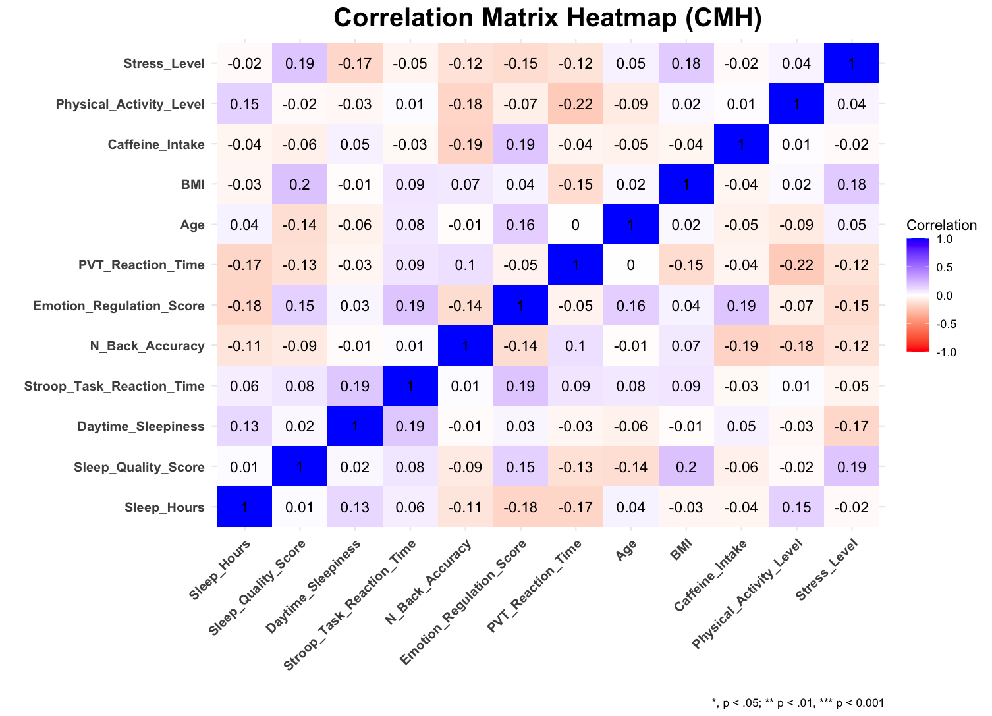
Figure 1.2
Correlation Matrix Heatmap (CMH) for Multivariate EDA
Note. Cell values represent zero-order Pearson correlation coefficients. Positive correlations are shown in blue and negative correlations in red, with color intensity indicating the magnitude of the correlation. No off-diagonal correlations reach statistical significance in the present sample.

-Analysis-Specific Data Preprocessing and Preparation
To provide a more practically meaningful interpretation of regression coefficients (e.g. 0 sleep hours, emotional regulation scores and stress level are meaningless and unrealistic), mean-centering was conducted for every predictor variable of interest by shifting the reference point from the original value of 0 to the corresponding sample means. Table 2 shows the descriptive summary of the mean-centered predictor variables and the outcome variables of interest. Emotion regulation scores were retained in both their original and mean-centered forms. As mathematically expected, the means of all mean-centered predictor variables were approximately 0, while the variance and standard deviation of the mean-centered emotion regulation scores were the same as those of the original scores.
The PSS-10 provides a basis for transforming continuous stress-level scores into a categorical variable. A commonly used PSS-10 categorization criterion which has been validated in previous popualtions was applied to stress-level scores in this module for the ANCOVA in Aim 2, where stress group was treated as the factor. Basically, if an individual’s stress-level score was less than 14, the individual was classified into the low-stress group; otherwise, if the score was between 14 and 26, the individual was classified into the moderate-stress group; otherwise, the individual was classified into the high-stress group (Adamson et al., 2020).

Table 2
Descriptive Statistics of Mean-centering Predictors and Outcomes
Variable | Mean | Variance | SD
C_Sleep Hours | 0.0 | 3.4 | 1.8
C_Emotion Regulation Scores | 0.0 | 293.6 | 17.1
C_Stress_Level Scores | 0.0 | 121.3 | 11.0
Emotion Regualtion Scores | 38.2 | 293.6 | 17.1
Stroop Task Reaction Time | 3.2 | 0.7 | 0.8
N-Back Accuracy | 75.0 | 186.9 | 13.7
PVT Reaction Time | 332.5 | 7708.9 | 87.8
Note: C_Sleep hours, C_emotion regulation scores and c_stress level scores represents mean-centering predictors respectively

-Construction of Functions for Assumptions Diagnostics
Conceptually and mathematically, since the OLS coefficient estimator is a linear function of population errors conditional on the predictor structure, its corresponding sampling distribution depends on the distributional and variance properties of those errors. Thus, assumptions targeting the population error structure, assessed indirectly through residuals, should be reasonably satisfied to support accurate estimation of uncertainty and valid inference based on the theoretical sampling distribution. Here, to facilitate this, I implemented diagnostic procedures as reusable functions in a separate module, allowing consistent application across fitted models (see the “Symbols” section in the code file, where the defined assumption-diagnostic functions are listed)

-Results
AIM1: Behavioural and Psychological Contributors and Emotion Regulation Ability

