**距离**

**欧氏距离**

from scipy.spatial.distance import Euclidean

distance=euclidean(point1, point2)

**曼哈顿距离**

from scipy.spatial.distance import cityblock

distance= cityblock(point1, point2)

**Cosine距离**

from scipy.spatial.distance import cosine

distance= cosine(point1, point2)

**一维插值**

from scipy import interpolate

interpolate_func= interpolate.interp1d (x,y)

y_interpolated=interpolate_func(x_new)

#基于x,y生成插值函数，再基于待插值位置x_new计算y_interpolated

#x_new需处于用于生成插值函数的x的范围中

**稀疏矩阵**

**创建稀疏矩阵**

from scipy.sparse import csr_matrix

res=csr_matrix(matrixdata)

print(res)

#记录非零元素行列位置、值

**非零元素计数**

res.count_nonzero()

**图**

**无向图邻接矩阵**

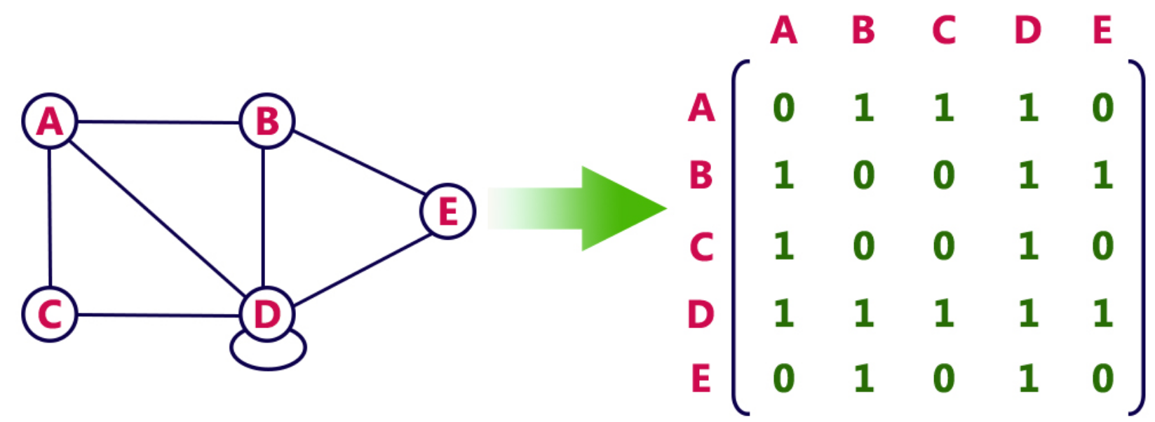

**有向图邻接矩阵**

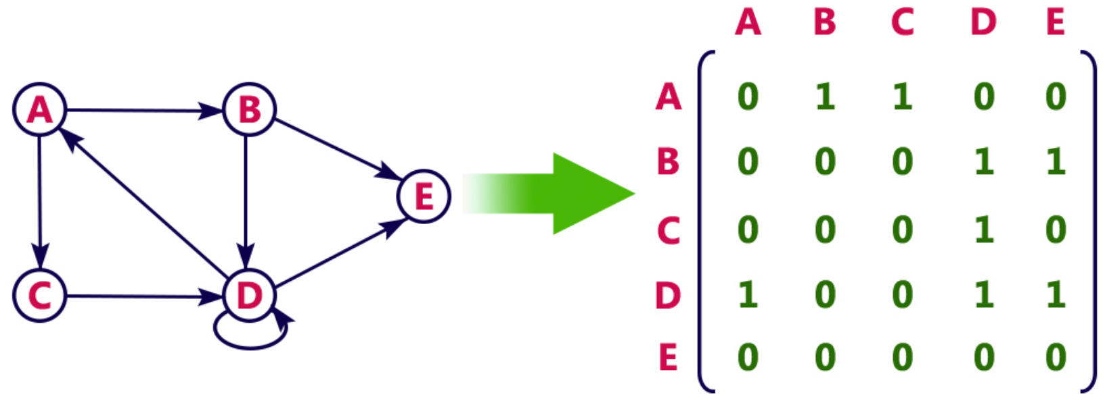

#有向图邻接矩阵列名为接收点，行名为发出点

**统计描述**

from scipy.stats import describe

res = describe(data)

**最优化**

用于求解在条件内使得目标函数fun取得最小值的参数list

from scipy.optimize import minimize

res=minimize(fun,x0=参数list起始估计值,bounds,constraints)

res.x #所估计参数

e.g.

fun=lambda x: x[0]+2x[1]-3x[2]

#常用于求最优参数，将fun设置为loss函数

e.g.

def loss(X_train,y_train, model_params):

return some_metric(y_train, model(X_train, model_params))

**假设检验**

**Anderson-Darling检验**

import scipy.stats as stats

stats.anderson(data_norm, dist='norm')

[**https://blog.csdn.net/qq_20207459/article/details/102863982**](https://blog.csdn.net/qq_20207459/article/details/102863982)

**KS test**

from scipy.stats import kstest

res = kstest(data, 'norm', alternative={'two-sided', 'less', 'greater'})

**直接正态检验**

from scipy.stats import normaltest

print(normaltest(data, nan_policy={'propagate', 'raise', 'omit'}))

**R2拟合优度**

RSS=sum(pow(y_pred-y_true,2))

ESS=sum(pow(y_pred-np.mean(y_true),2))

TSS=sum(pow(y_true-np.mean(y_true),2))

r=np.sqrt(ESS/TSS)

print('r value:',r)

**独立双样本t检验**

from scipy import stats

res=stats.ttest_ind(Group1,Group2, equal_var=True, nan_policy={'propagate', 'raise', 'omit'})

print(res)

#euqal_var控制默认两个群体方差是否相同

**配对t检验**

from scipy import stats

res=stats.ttest_rel(Group1,Group2, nan_policy={'propagate', 'raise', 'omit'})

print(res)

**获取p值**

res.pvalue

**单因素ANOVA**

from scipy import stats

res=stats.f_oneway(level1data,level2data,…)

print(res)

**F检验**

from scipy.stats import f_oneway

scipy.stats.f_oneway(data1,data2)

**卡方检验**

from scipy.stats import chi2_contingency

res=chi2_contingency(contingency_table)

print(res)

#return (chi2,p,自由度,理论频率)