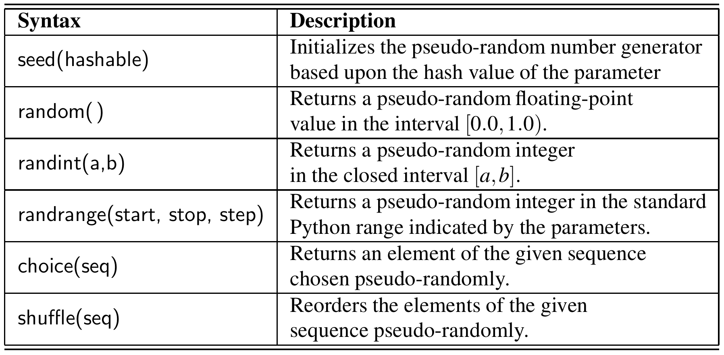

**不放回抽样**

random.sample(population,k=抽样数)

**放回抽样（可自定义权重）**

random.choices(population, *weights=各个体被抽中的概率,k=抽样数)