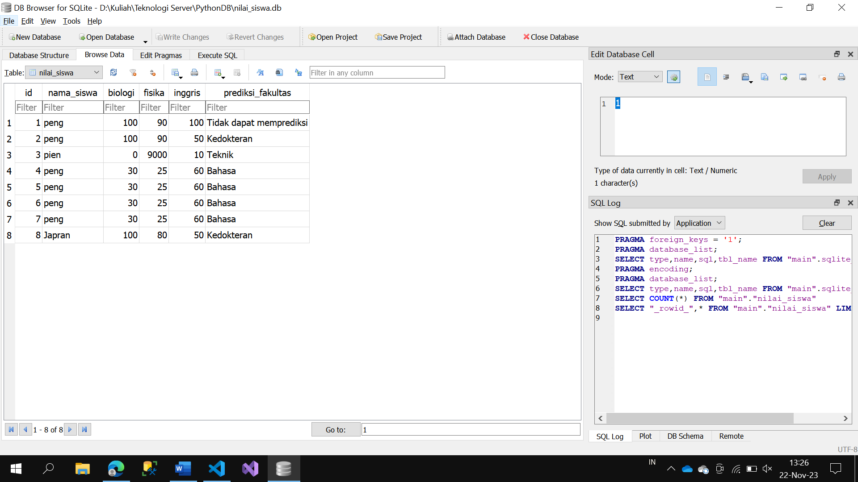

Link GitHub:

[Zharfan0/PythonDB_079 (github.com)](https://github.com/Zharfan0/PythonDB_079)