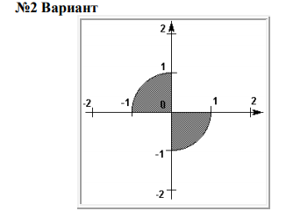**(x, y) чекиттердин координаталырын киргизип жана ал чекит сүрөттө келтирилген аймака таандык же таандык эместигин аныктагыла.**

**Келтирилген мисалдар жана алардын жооптору:**

* Enter values for X and Y:

0

0

Point (0, 0) is on line of a given figure

* Enter values for X and Y:

-0.995

0.1

Point (-0.995, 0.1) is on line of a given figure

* Enter values for X and Y:

0

1.1

Point (0, 1.1) is outside of a given figure

* Enter values for X and Y:

-0.8

0.1

Point (-0.8, 0.1) is inside of a given figure

**Программанын коду:**

using System;

class YOD3 {

public static void Main() {

Console.WriteLine("Enter values for X and Y:");

double x = Double.Parse(Console.ReadLine()), y = Double.Parse(Console.ReadLine());

if ((x > 0 && y > 0) || (x < 0 && y < 0)) {

Console.WriteLine("Point ({0}, {1}) is outside of a given figure", x, y);

} else if ((x == 0 && y <= 1 && y >= -1) || (x >= -1 && x <= 1 && y == 0)) {

Console.WriteLine("Point ({0}, {1}) is on line of a given figure", x, y);

} else {

if (x*x + y*y < 1) {

Console.WriteLine("Point ({0}, {1}) is inside of a given figure", x, y);

} else if (Math.Abs(1 - (x*x + y*y)) < 0.000001) {

Console.WriteLine("Point ({0}, {1}) is on line of a given figure", x, y);

} else {

Console.WriteLine("Point ({0}, {1}) is outside of a given figure", x, y);

}

}

}

}