

***using System;***

***public class YOD {***

***public static void Main() {***

***int count = 50, min = 100;***

***int[] arr = new int[count];***

***Random random = new Random();***

***for (int i = 0; i < count; i++) {***

***arr[i] = random.Next(-100, 100);***

***if (arr[i] < min && arr[i] > 0) {***

***min = arr[i];***

***}***

***Console.Write("\t{0}", arr[i]);***

***if (i%10 == 9) {***

***Console.WriteLine();***

***}***

***}***

***Console.WriteLine();***

***for (int i = 0; i < count; i++) {***

***if (arr[i] < 0) {***

***arr[i] = min;***

***}***

***Console.Write("\t{0}", arr[i]);***

***if (i%10 == 9) {***

***Console.WriteLine();***

***}***

***}***

***}***

***}***

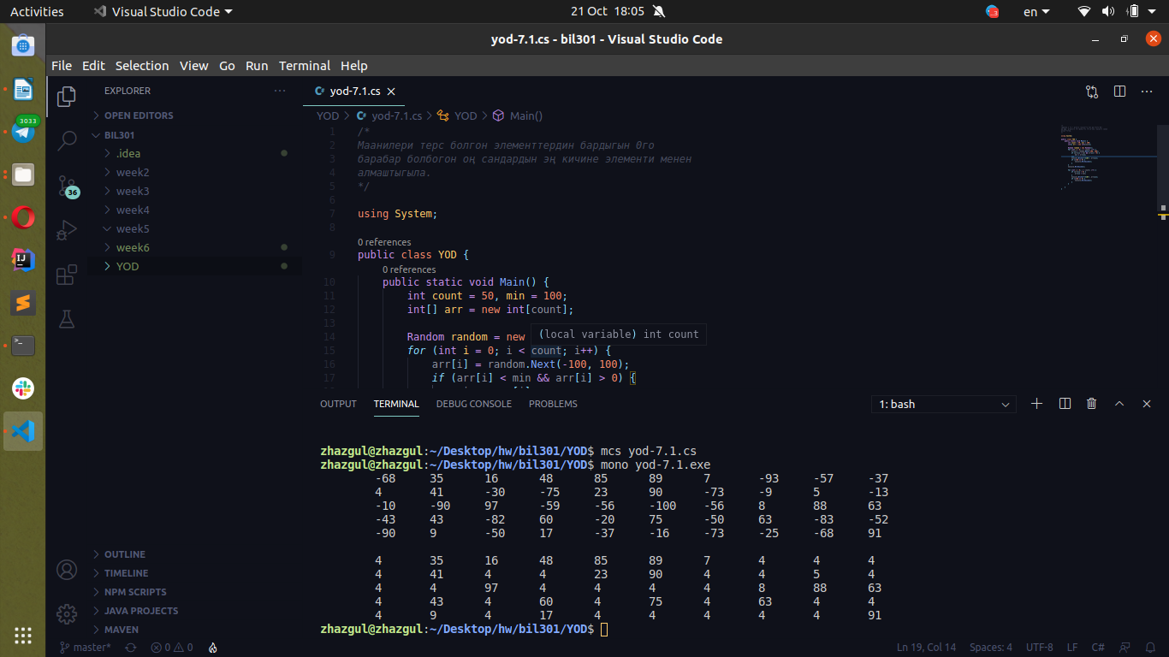

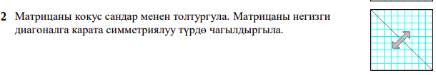***using System;***

***public class YOD {***

***public static void Main() {***

***Random random = new Random();***

***int[,] arr = new int[9, 9];***

***for (int i = 0; i < 9; i++) {***

***for (int j = 0; j < 9; j++) {***

***arr[i, j] = random.Next(0, 99);***

***Console.Write("\t{0}", arr[i, j]);***

***}***

***Console.WriteLine();***

***}***

***Console.WriteLine();***

***int k = 1;***

***for (int i = 0; i < k; i++) {***

***for (int j = 0; j < k; j++) {***

***arr[i, j] = arr[j, i];***

***}***

***if (k < 9) {***

***k++;***

***}***

***}***

***for (int i = 0; i < 9; i++) {***

***for (int j = 0; j < 9; j++) {***

***Console.Write("\t{0}", arr[i, j]);***

***}***

***Console.WriteLine();***





