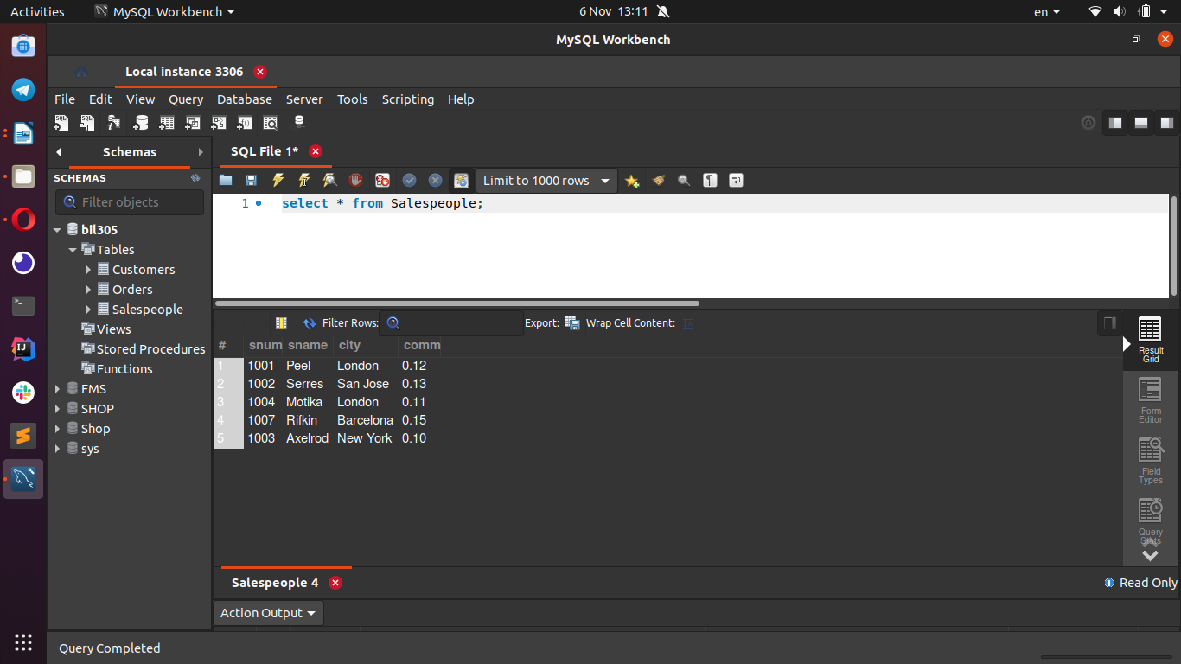use bil305;

create table Salespeople(

snum int,

sname char(10),

city char(10),

comm decimal);

insert into Salespeople value(

1001, 'Peel', 'London', 0.12);

insert into Salespeople values(

1002, 'Serres', 'San Jose', 0.13);

insert into Salespeople values(

1004, 'Motika', 'London', 0.11);

insert into Salespeople values(

1007, 'Rifkin', 'Barcelona', 0.15);

insert into Salespeople values(

1003, 'Axelrod', 'New York', 0.10);

------------------------------------------------------------------------------------------------------------------------

------------------------------------------------------------------------------------------------------------------------

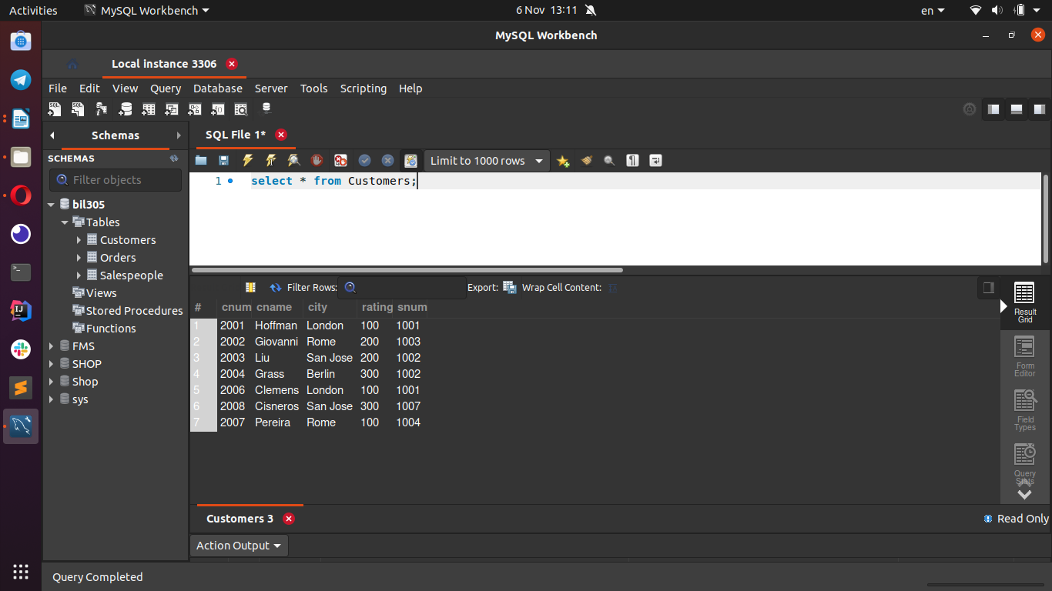create table Customers(

cnum int,

cname char(10),

city char(10),

rating int,

snum int);

insert into Customers value(

2001, 'Hoffman', 'London', 100, 1001);

insert into Customers value(

2002, 'Giovanni', 'Rome', 200, 1003);

insert into Customers value(

2003, 'Liu', 'San Jose', 200, 1002);

insert into Customers value(

2004, 'Grass', 'Berlin', 300, 1002);

insert into Customers value(

2006, 'Clemens', 'London', 100, 1001);

insert into Customers value(

2008, 'Cisneros', 'San Jose', 300, 1007);

insert into Customers value(

2007, 'Pereira', 'Rome', 100, 1004);

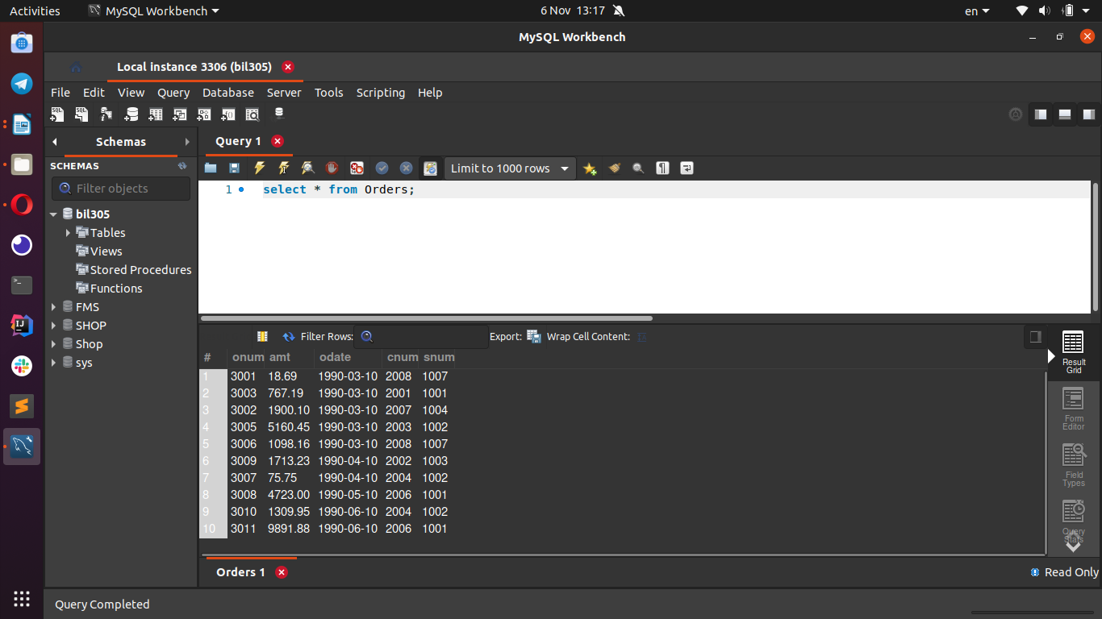create table Orders(

onum int,

amt decimal(10,2),

odate date,

cnum int,

snum int);

insert into Orders value(

3001, 18.69, '1990-03-10', 2008, 1007);

insert into Orders value(

3003, 767.19, '1990-03-10', 2001, 1001);

insert into Orders value(

3002, 1900.10, '1990-03-10', 2007, 1004);

insert into Orders value(

3005, 5160.45, '1990-03-10', 2003, 1002);

insert into Orders value(

3006, 1098.16, '1990-03-10', 2008, 1007);

insert into Orders value(

3009, 1713.23, '1990-04-10', 2002, 1003);

insert into Orders value(

3007, 75.75, '1990-04-10', 2004, 1002);

insert into Orders value(

3008, 4723.00, '1990-05-10', 2006, 1001);

insert into Orders value(

3010, 1309.95, '1990-06-10', 2004, 1002);

insert into Orders value(

3011, 9891.88, '1990-06-10', 2006, 1001);

