1704.01045 Atyrgul Nazarova
1804.01026 Zhazgul Kadyrbekova
1-3 --→ Meet
https://drive.google.com/file/d/1Zpm9F64jkF6saJD_j0e_RcafxvpKqgK-/view?usp=drivesdk
4-5 ----→ Meet
https://drive.google.com/file/d/1A8LEQwIhycuJ9kLYB1NJ28XbrHcYUCx2/view?usp=drivesdk
1
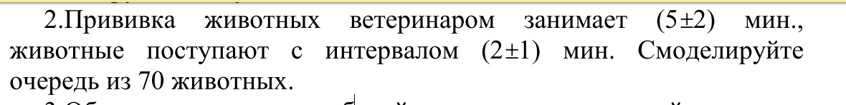
GENERATE 5,2
SEIZE AZS
ADVANCE 2,1
RELEASE AZS
TERMINATE 1
START 70

2.
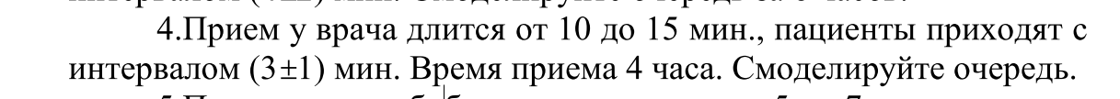
GENERATE 10,15
QUEUE ABC
SEIZE AZS
DEPART ABC
ADVANCE 3,1
RELEASE AZS
TERMINATE 1
START 240

3.
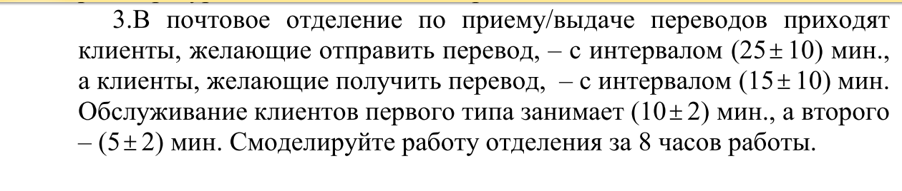
GENERATE 25,10
QUEUE ABC
SEIZE AZS
DEPART ABC
ADVANCE 10,2
RELEASE AZS
TERMINATE 1

GENERATE 15,10
QUEUE ABC
SEIZE AZS
DEPART ABC
ADVANCE 5,2
RELEASE AZS
TERMINATE 1

GENERATE 480
TERMINATE 1

START 1

4.
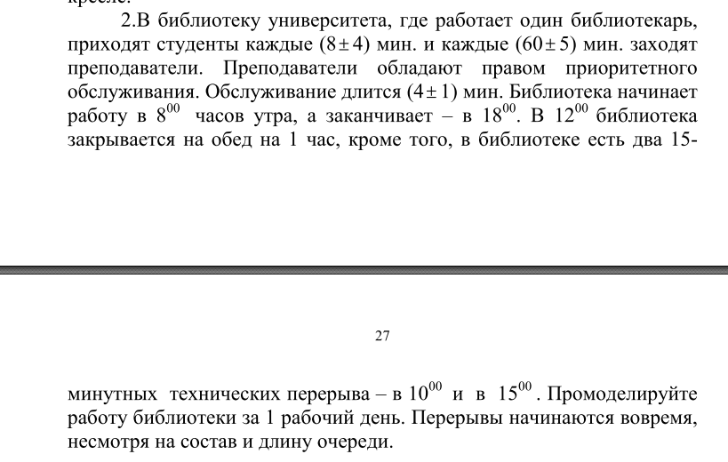

SIMULATE

GENERATE 60,5
QUEUE ABC
SEIZE AZS
DEPART ABC
ADVANCE 4,1
RELEASE AZS
TERMINATE 1

GENERATE 8,4
QUEUE ABC
SEIZE AZS
DEPART ABC
ADVANCE 4,1
RELEASE AZS
TERMINATE

GENERATE 510
TERMINATE 1

START 300

5.
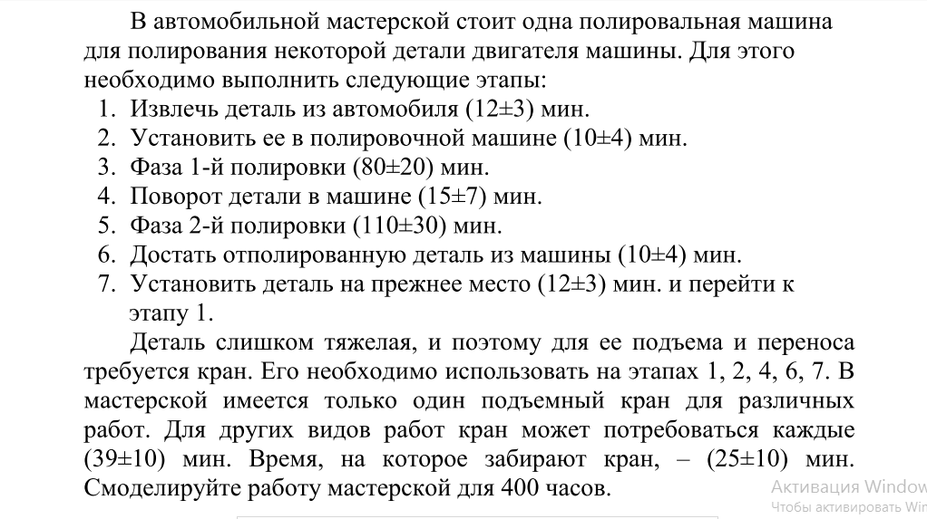
SIMULATE

GENERATE ,,,7
SEIZE KRAN
ADVANCE 12,3
ADVANCE 10,4
RELEASE KRAN
FAZA1 ADVANCE 80,20

SEIZE KRAN
ADVANCE 15,7
RELEASE KRAN
FAZA2 ADVANCE 110,30

SEIZE KRAN
ADVANCE 10,4
ADVANCE 12,3
RELEASE KRAN
TRANSFER ,FAZA1

GENERATE 39,10
QUEUE OTHERQ
SEIZE OTHER
DEPART OTHERQ
ADVANCE 25,10
RELEASE OTHER
TERMINATE

GENERATE 24000
TERMINATE 1

