Ministry of Education and Science of Republic of Kazakhstan



**Department of Computer Engineering and Information Security**

Web Technologies

**REPORT**

Project

Submitted by: **Zhazykbek Zhazira**

ID: 27689 **Group: ITNSA-1901**

Submitted to: Alpysbay N.E.

Almaty 2021

**Content**

1. *Title page*
2. *Content*
3. *Introduction*
4. *Main part (Solutions and descriptions of the laboratory work tasks)*
5. *Conclusion*
6. *References*

Introduction

I chose the beauty salon theme. And she called this salon Softpllow. This site has a home page. Main page (Home page), About page, Services page, Price page, Registration page, Template of admin panel (admin page). For this project I used languages like HTML, CSS, Bootstrap, JavaScript.

Code, Layout, Report I posted on https://github.com/Zhazira0502/pprroojjeecctt

Main part

In the first week, I planned out the structure of the site. That is, she listed all the pages of the site. Created a sketch of the map. And the layout.

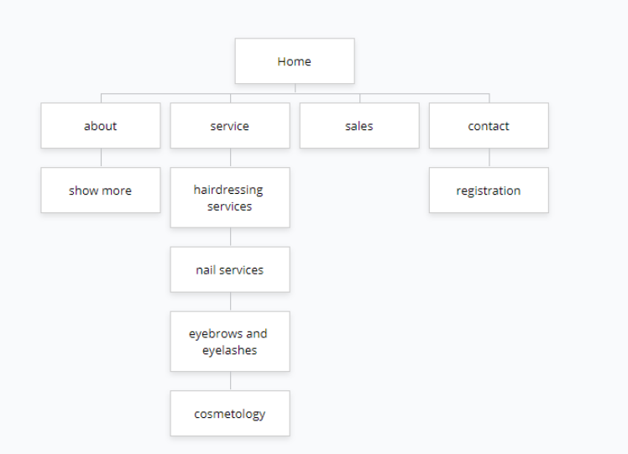

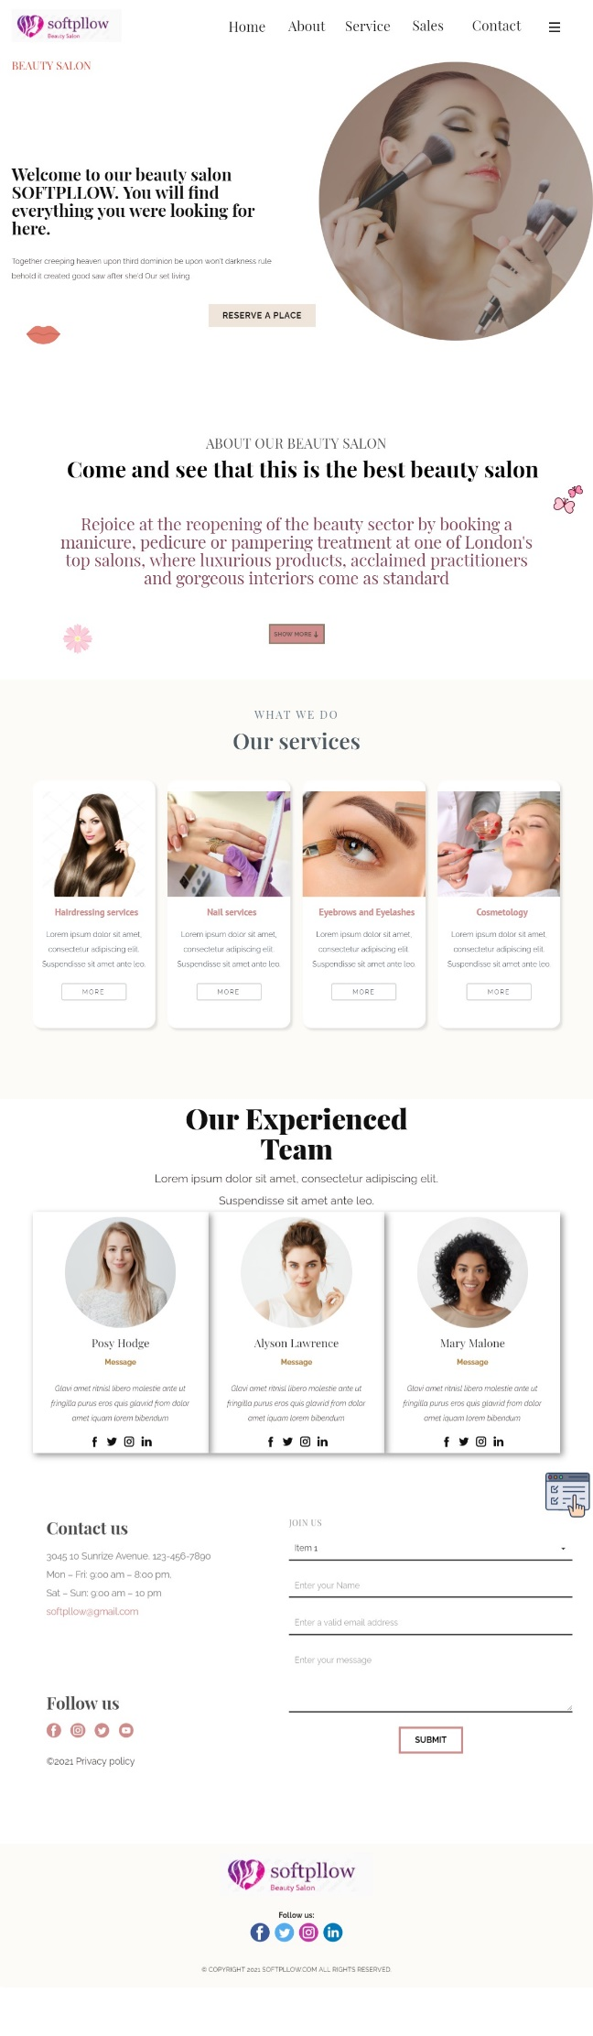

In the second week, I created a website template using HTML5 and CSS. And there I had a home page and a contact page.

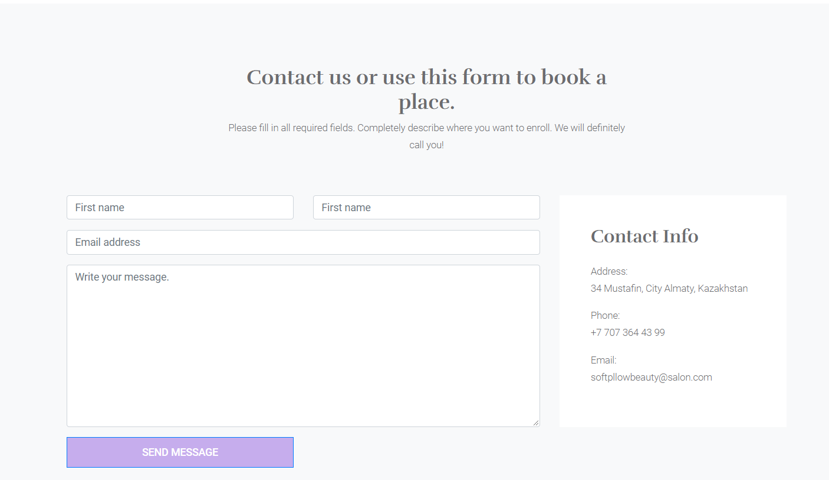

On the contacts page, in addition to text information, the address on the map was displayed.

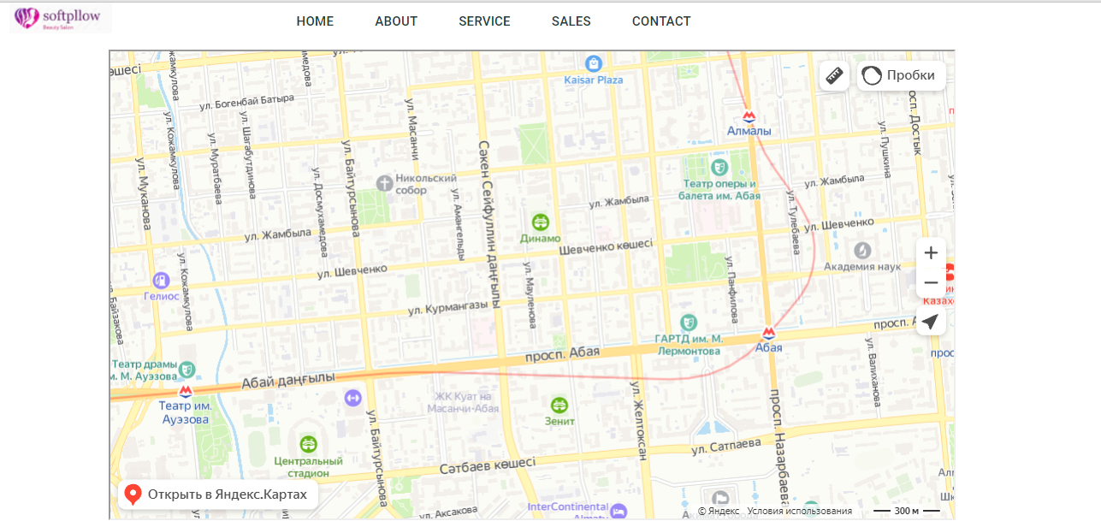

The next task was to create a website theme using Bootstrap. And I already had all the pages that I voiced at the beginning.

In the beginning, I selected pictures from the Internet, colors and fonts for the text. I also added cute icons.

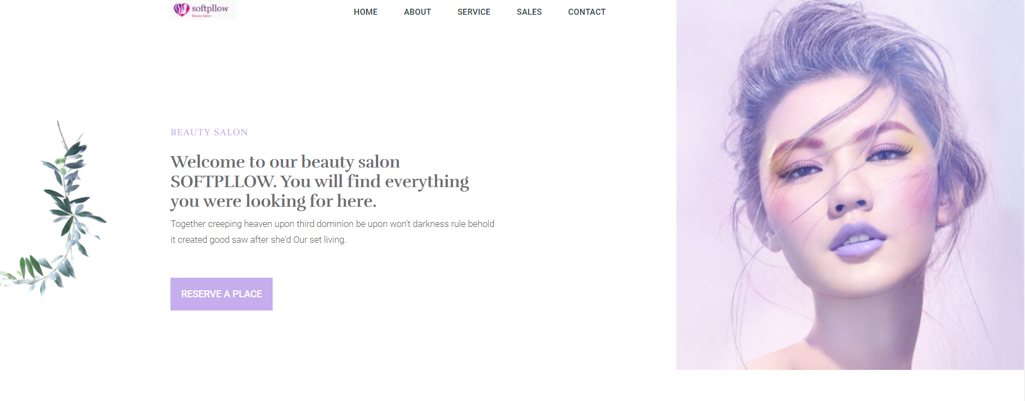

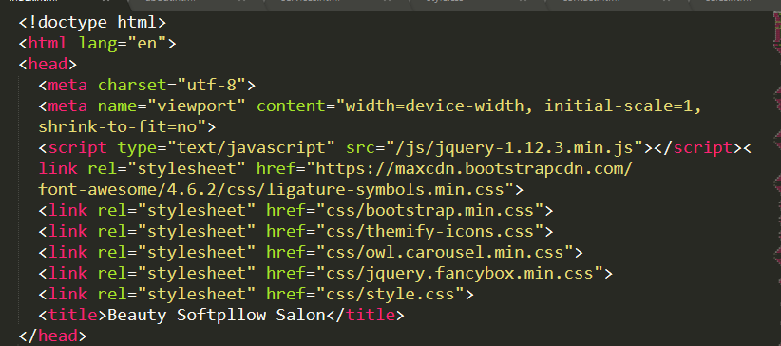

Here you can see that I used the Java script for the site during the demonstrations, you can notice this.

Also, my site has adaptability, that is, when you can look from any size of the gadget

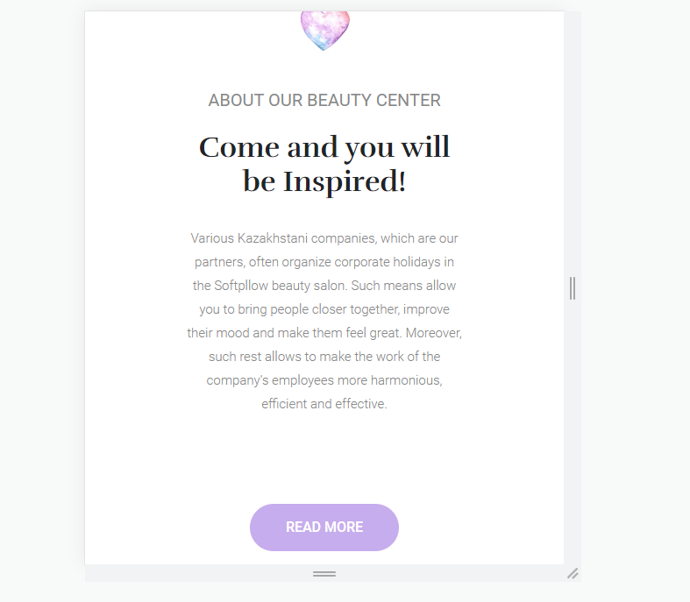

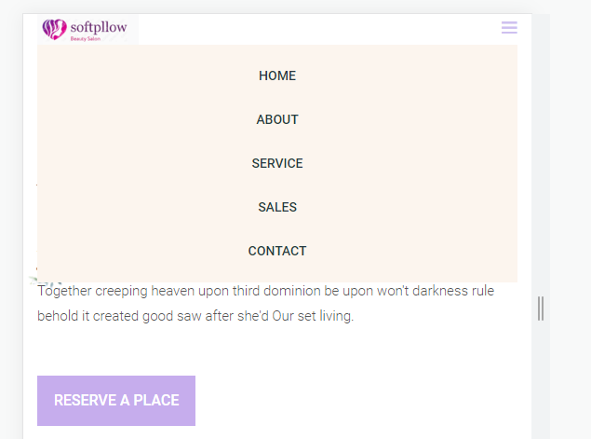

All these icons work. That is, when you click, it directs you to your own sites that the icon displays.

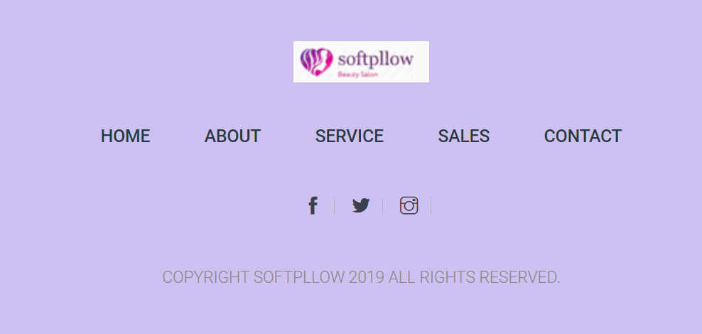

This is the admin panel. That is, here you can observe the site statistics. Users. Also the reviews. The interesting part of this page is the daily tasks we have to do.

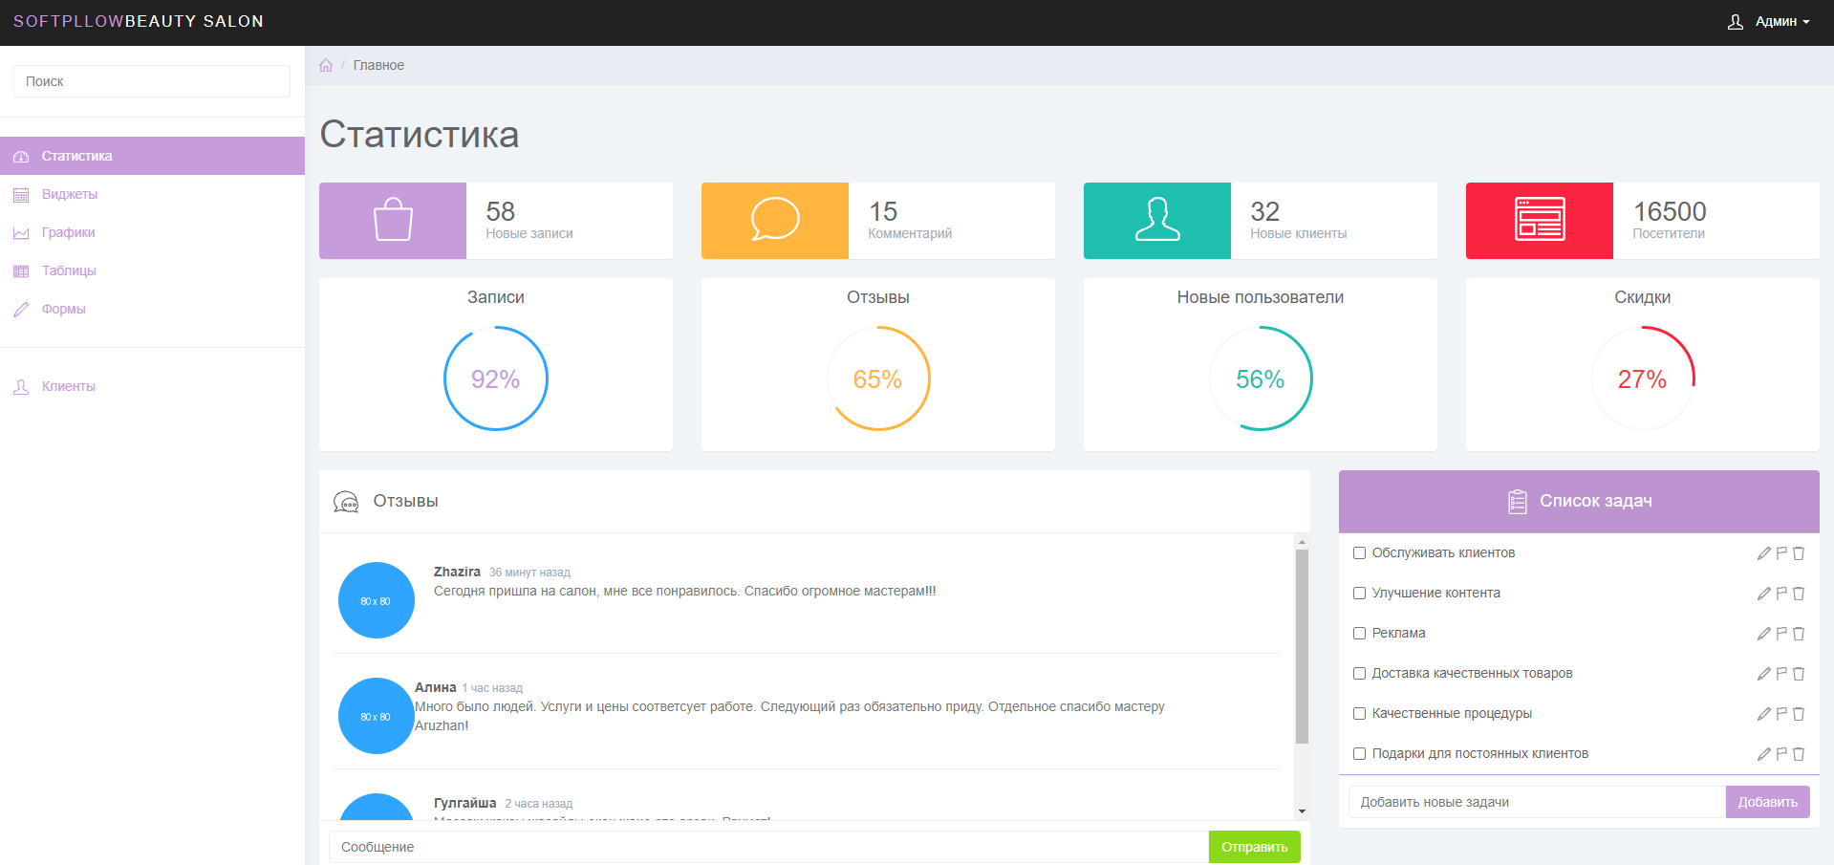

Conclusion

In short, the goal of my project is to help the clients of our salon. That is, to describe in more detail about our services, prices, and to do our job with high quality. For this I have created a website using languages such as HTML, CSS, Bootstrap, JavaScript. Read more about these codes in github.

Refrences

* <https://getbootstrap.com/docs/5.1/utilities/float/>
* <https://getbootstrap.com/docs/5.1/examples/footers/>
* <https://getbootstrap.com/docs/5.1/layout/containers/>
* <https://www.pinterest.com https://yandex.kz/maps/162/almaty/?ll=76.932547%2C43.245148&mode=routes&rtext=~43.248458%2C76.933706&rtt=auto&ruri=~&z=15>