Table of Contents

Argus — Cloud-Native UEBA for Insider-Threat Detection

Full Technical Report & FYP2 Methodology
Author: Z.C. Yap · Supervisor: Firdaus Sahran Faculty of Computer Science and Information Technology, Universiti Malaya
Companion reference for FYP2 preparation and defense. Every figure, formula, file and hyperparameter below is taken directly from the implemented codebase, not from the earlier draft proposal — so it is safe to quote in the viva.

1. Executive Summary
Argus is a cloud-native User and Entity Behaviour Analytics (UEBA) platform that detects insider threats, compromised accounts and data exfiltration without any labelled attack data. It ingests activity logs from four cloud/enterprise sources, normalises them into a single schema, scores each user with a one-class deep autoencoder (trained on benign-assumed data — no attack labels in the objective), explains every alert with SHAP attribution and an LLM analyst assistant, and surfaces results through a full SOC workflow (dashboard → alert triage → investigation case → resolution).
Headline results (CERT r4.2, 1,000 users, 70 insiders, label-free):
Detector | AUROC | AUPRC | F1 | Precision | Recall
Autoencoder (final detector) | 0.976 | 0.851 | 0.787 | 0.877 | 0.714
Weighted Avg (0.75·AE + 0.25·IF) | 0.951 | 0.740 | 0.726 | 0.954 | 0.586
Isolation Forest | 0.860 | 0.206 | 0.379 | 0.235 | 0.971
Rule-based baseline | 0.859 | 0.207 | 0.367 | 0.259 | 0.629
External validity: flaws.cloud AWS CloudTrail (real breach data) AUROC 0.724; streaming live-replay through the production /ingest endpoint AUROC 0.917 (vs 0.976 offline).
Rigour note: the 0.976 is a transductive figure; a 5-fold inductive cross-validation (held-out users only) gives AUROC 0.959 ± 0.004 (§6.2), confirming the result generalises and is not a training-set-overlap artefact.

2. Datasets

2.1 CERT Insider Threat Dataset r4.2 (primary benchmark)
- Source: Carnegie Mellon University / ExactData synthetic enterprise dataset.
- Scale: ~32 million events, 1,000 users, 17 months, 70 malicious insiders.
- Five raw log files: logon.csv, device.csv, file.csv, email.csv, http.csv.
- Ground truth: is_insider label per user (used only for evaluation, never for training).
- Threat scenarios include data exfiltration via removable media, IP theft, and sabotage.

2.2 flaws.cloud AWS CloudTrail (real-world validation)
- Source: Scott Piper’s public AWS CTF dataset (~2M real CloudTrail events).
- Used to validate the cloud autoencoder on genuine AWS API behaviour.
- Ground-truth labels: Level5/Level6 = privilege-escalation attackers; service/admin accounts (backup, AWSService, Root, flaws, …) = normal.
- Honest caveat (state this in the viva): the cloud AE is evaluated on the same dataset’s attacker sessions it excluded from training (time-held-out), so 0.724 is a same-dataset generalisation check, not a cross-dataset test.

2.3 Multi-source data — what is normalised vs evaluated
All four cloud/enterprise sources are normalised into the common 8-field schema (parsers implemented; AWS and Azure unit-tested) and demonstrated live in the Demo Lab. Their evidentiary status differs, and the distinction matters for examination:
Source | Real data | How it is used
AWS (flaws.cloud) | ✅ real CloudTrail | Labelled detection evaluation — cloud AE, AUROC 0.724
CERT r4.2 | ✅ labelled benchmark | Primary labelled detection evaluation — AUROC 0.976
GitHub (public Events API) | ✅ real live activity | Ingested live + semi-synthetic labelled evaluation (§6.1)
Azure AD (Splunk attack_data / SimuLand) | ✅ real SignInLogs | Normalised + ingested; no labelled detection eval
Cloudflare Access | ❌ none public | Normalised; format-accurate synthetic only
Scope note (important for examination). Quantitative detection accuracy rests on the labelled datasets — CERT r4.2 and flaws.cloud (AWS). GitHub real data is ingested live and additionally yields a semi-synthetic labelled result (real benign background + injected ground-truth attacks, §6.1). Azure real logs are normalised and ingested but not evaluated against labels. Cloudflare has no public real dataset. The multi-source claim is therefore a strong normalisation + live-ingestion contribution, with labelled detection evaluated on AWS, CERT, and (semi-synthetically) GitHub.

3. System Architecture (7-layer pipeline)
┌─ DATA SOURCES ─────────────────────────────────────────────────────────┐
│ AWS CloudTrail · Azure AD · Cloudflare Access · GitHub (+ CERT r4.2) │
├─ INGESTION / NORMALISATION ────────────────────────────────────────────┤
│ FastAPI POST /ingest → normalizer.py → unified 8-field schema │
├─ FEATURE ENGINEERING ──────────────────────────────────────────────────┤
│ CERT: 21 base → 71-dim vector | Cloud: 12-dim per user-day │
│ Peer-group clustering (K-Means, K=8, fit on normals) │
├─ DETECTION (label-free) ───────────────────────────────────────────────┤
│ Autoencoder ×2 (CERT 71-d, Cloud 12-d) ← FINAL detector │
│ Baselines: Isolation Forest · Rule scorer · Weighted Avg │
│ Rarity scorer: 6 interpretable flags │
├─ EXPLAIN / ASSIST ─────────────────────────────────────────────────────┤
│ SHAP attribution + LLM assistant (Gemini · DeepSeek · Groq) │
├─ STORE ────────────────────────────────────────────────────────────────┤
│ SQLite (dev) / PostgreSQL (prod): events, live_scores, alerts, │
│ investigations, cloud_shap │
├─ PRESENTATION (SOC workflow) ──────────────────────────────────────────┤
│ Next.js dashboard → Alerts (triage) → Investigations (case) → resolve │
└─ DEPLOY: Docker · Hugging Face Spaces (backend) · Vercel (frontend) ───┘
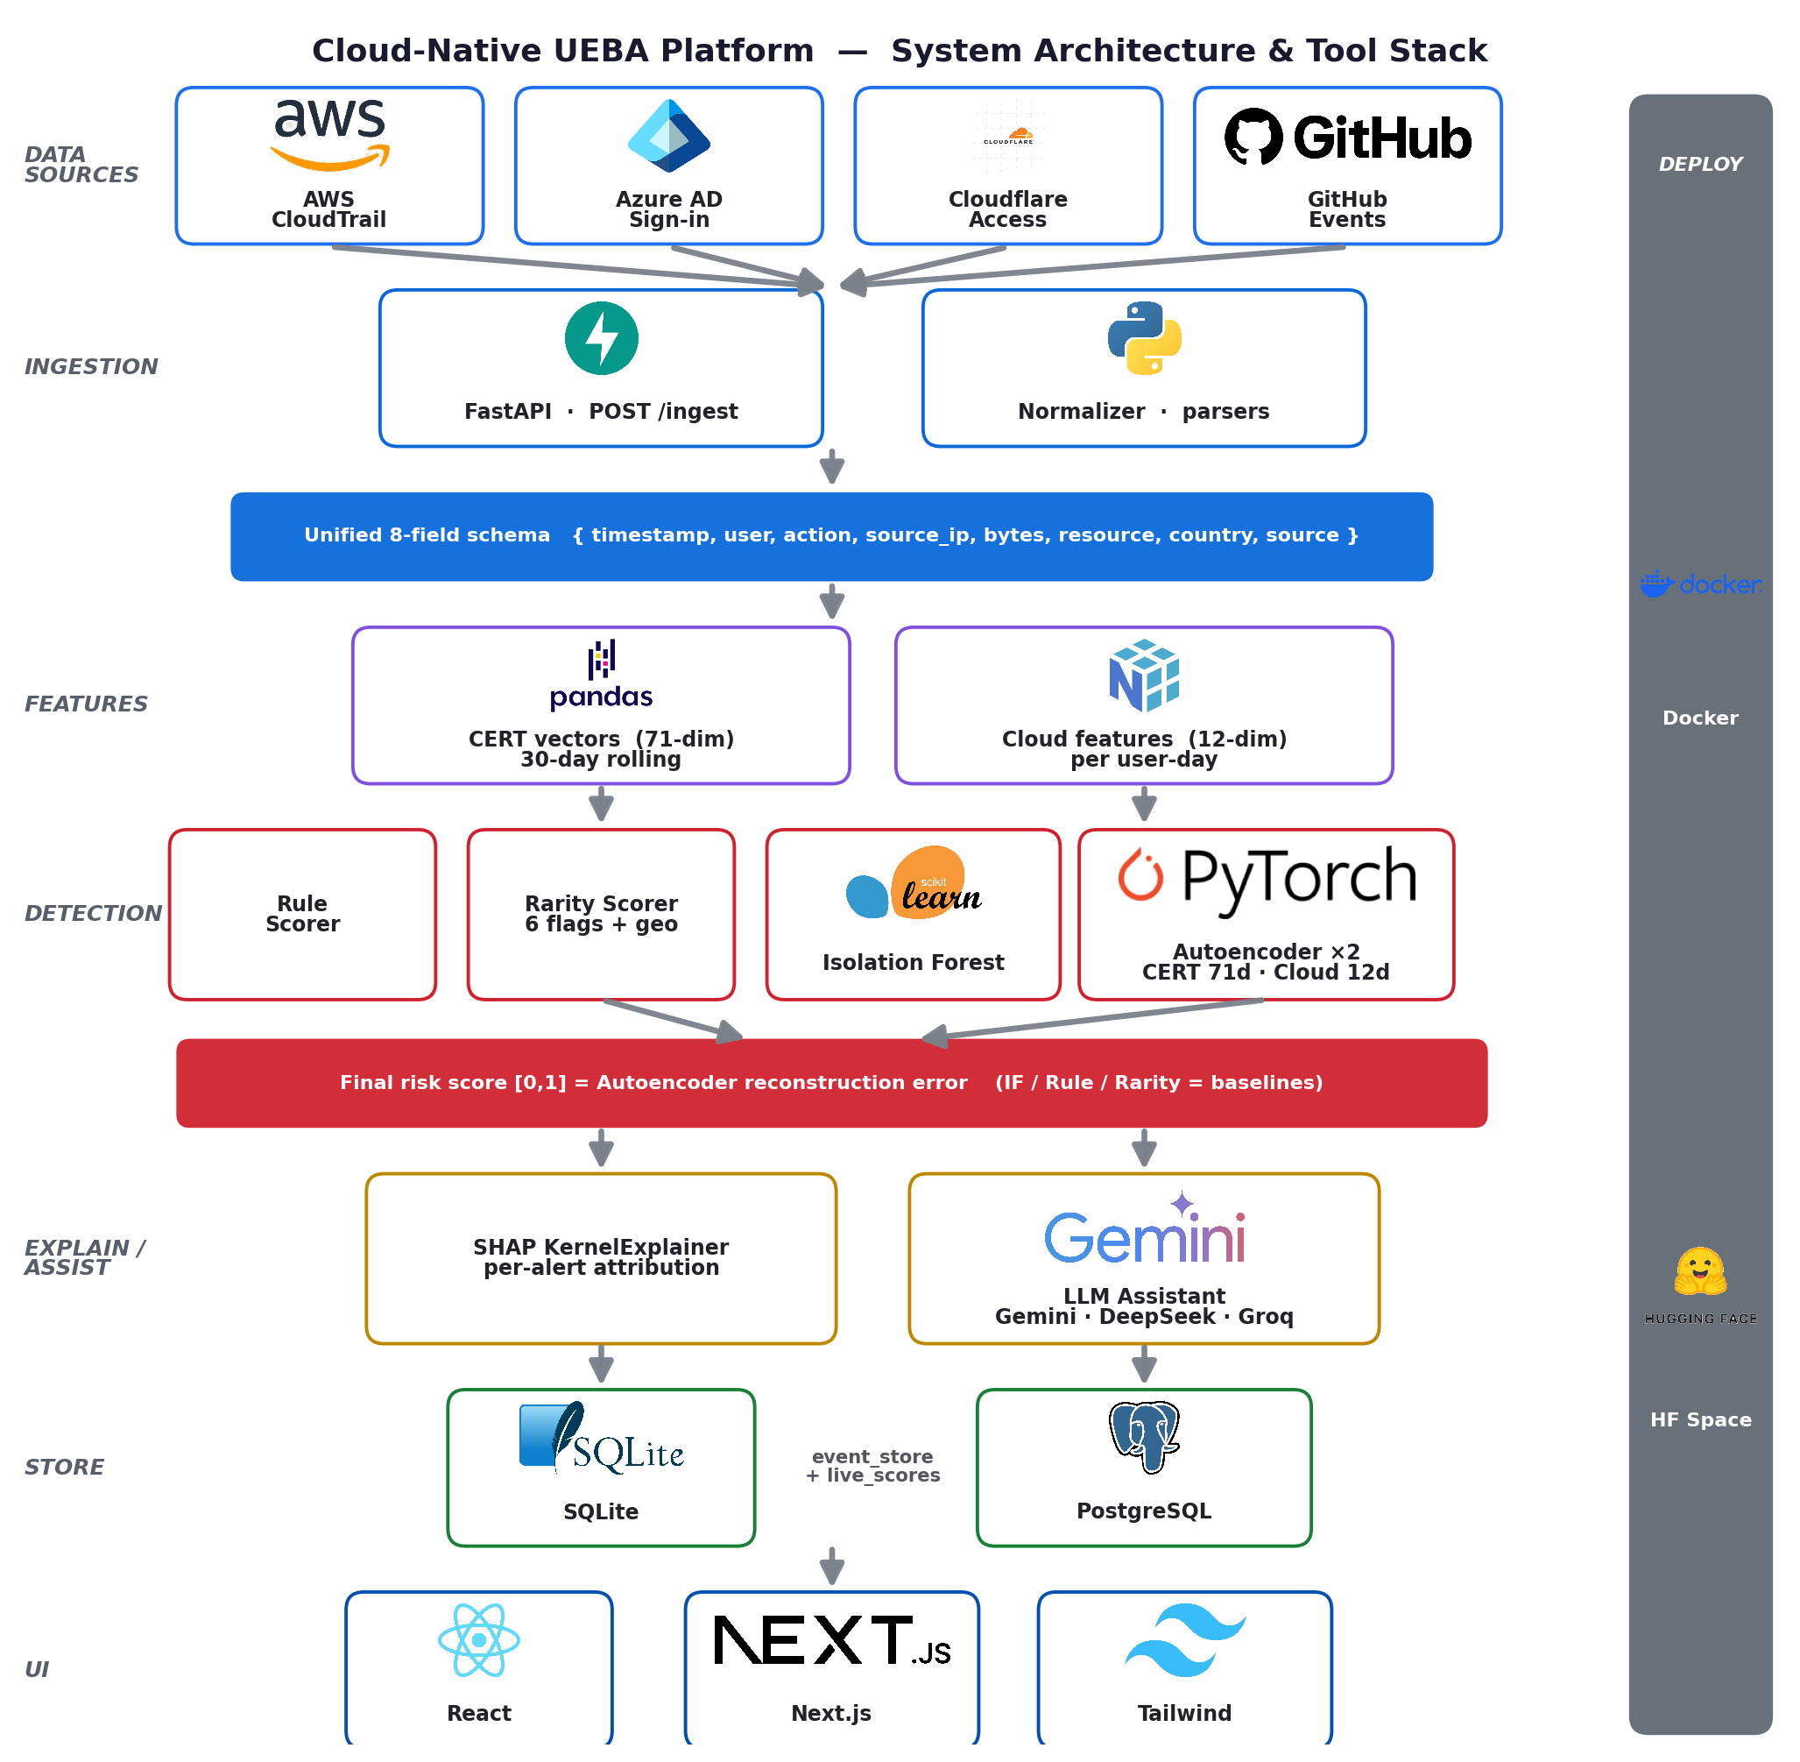
Figure 1. Argus system architecture and tool stack — four cloud sources are normalised into one schema, scored by a label-free autoencoder with rarity and rule baselines, explained via SHAP and an LLM assistant, then surfaced through a SOC workflow.

4. Code File Inventory

4.1 Backend (FastAPI, Python) — backend/
File | Lines | Responsibility
main.py | 1122 | FastAPI app; all REST endpoints; orchestrates the /ingest pipeline (7 stages), /users, /stats, alerts, investigations, admin tools.
normalizer.py | 596 | Parsers for each source (parse_aws_cloudtrail, parse_azure_ad, parse_cloudflare_access, parse_github, CERT parsers) → unified 8-field schema.
loader.py | 566 | Loads scored users from parquet/CSV at startup; computes risk tiers; peer-group K-Means (K=8); serves get_users, get_stats, peer context.
ae_scorer.py | 486 | Loads the trained PyTorch autoencoders (CERT 71-d + Cloud 12-d); builds the 71-feature vector; computes live AE reconstruction-error scores.
models.py | 433 | Pydantic request/response schemas + validators (e.g. valid source values, risk levels).
event_store.py | 394 | Persistence for events, live_scores, cloud_shap; DB-agnostic (SQLite/PostgreSQL).
ai_suggest.py | 368 | LLM ensemble: calls Gemini 2.5 Flash, DeepSeek, Groq Llama-3.3-70B in parallel, synthesises one investigation plan. No Anthropic.
investigations.py | 333 | Investigation case store: status, analyst, notes, append-only history.
rarity_scorer.py | 300 | Six source-agnostic rarity flags + rarity score (no training needed).
alert_store.py | 279 | Alert queue: create, status transitions, bulk-create, resolve-by-user.
cloud_feature_extractor.py | 257 | 12-dim cloud feature extraction from normalised cloud events.
feature_extractor.py | 233 | Per-event → per-day CERT feature increments (shared by live + offline).
config.py | 26 | Env-driven config (DEMO_MODE, DATABASE_URL).

4.2 Machine-learning assets — ml/ and the training notebook
File | Responsibility
cert_ae_full_pipeline.ipynb | Trains the CERT autoencoder, Isolation Forest, Weighted-Avg, LightGBM (supervised baseline), peer clustering; calibrates thresholds; exports autoencoder_v4.pt, scaler_v4.pkl, user_scores_v4.csv, SHAP values.
ml/models/cloud_ae_v1.pt | Trained 12-dim cloud autoencoder weights + calibration (ae_min,ae_max).
ml/models/cloud_scaler_v1.pkl | StandardScaler fitted on normal cloud user-days.
ml/models/cloud_ae_metrics.json | Cloud AE training metrics (val loss, attacker separation).

4.3 Scripts — scripts/
File | Responsibility
cert_extract.py | Streams raw CERT CSVs → daily_features_v4.parquet (21 features/user-day).
build_cloud_dataset.py | flaws.cloud .json.gz → cloud_features.parquet (12 features/user-day + is_attacker).
train_cloud_ae.py | Trains the cloud autoencoder on normal user-days only.
evaluate.py | Produces all evaluation charts (ROC, PR, confusion, SHAP, calibration) + metrics.json.
replay_eval.py | Streams CERT events through the live /ingest API and measures live vs offline AUROC.
ingest_cloudtrail.py, github_live_ingest.py | Batch ingestion utilities for real cloud logs.
seed_cloud_users.py | Computes flaws.cloud scores + SHAP locally and bulk-seeds the live dashboard.
seed_demo.py, gen_demo.py, anonymise_demo.py | Demo-data utilities.

4.4 Frontend (Next.js / React / Tailwind) — frontend/
File | Responsibility
pages/index.js | Dashboard: risk-ranked entity table, stat cards, search, source filter, pagination.
pages/users/[id].js | User detail: score breakdown, SHAP chart, live AE card, investigation panel (status, notes, AI guide, history).
pages/alerts.js | Alert triage queue: acknowledge / resolve / false-positive / escalate.
pages/investigations.js | Case queue fed by escalated alerts (+ bulk-import quick-start).
pages/demo.js | Demo Lab: live multi-cloud ingestion sandbox.
lib/api.js | Typed API client. components/AppLayout.js

5. How Argus Catches an Insider — Detection Pipeline
The end-to-end path of one ingested event (the seven /ingest stages in main.py):
event → (1) normalise → (2) persist → (3) per-event features → (4) rule live-score
→ (5) AE live-score → (6) rarity flags → (7) upsert live_scores + maybe-alert

5.1 Stage 1 — Normalisation (normalizer.py)
Each source has its own parser mapping provider-specific fields to the unified 8-field schema:
{ timestamp, user, action, source_ip, bytes, resource, country, source }
Schema field | AWS CloudTrail | Azure AD | Cloudflare Access
timestamp | eventTime | createdDateTime | created_at
user | userIdentity.userName | userPrincipalName | user_email
action | eventName | appDisplayName | action(+allowed)
source_ip | sourceIPAddress | ipAddress | ip_address
resource | eventSource | resourceDisplayName | app_domain
country | (n/a) | location.country | country
Design value: the downstream pipeline is source-agnostic. Adding a new provider is a single parser function — no change to features, models, or UI.

5.2 Stage 3 — CERT Feature Engineering (feature_extractor.py, cert_extract.py)
21 base behavioural features per (user, day), grouped by activity domain:
Domain | Features
Logon | login_count, after_hours_count, unique_pcs
File | files_accessed, n_archive_files, n_exe_files, n_afterhours_file
USB/device | usb_events, has_usb, n_afterhours_usb
Email | email_count, total_attachments, external_emails, n_afterhours_email, n_bcc_email
HTTP | http_count, suspicious_http, n_job_site, n_cloud_storage, n_afterhours_http
Cross | usb_and_file
Definitions / formulas used during extraction: - After-hours = event hour < 07:00 or ≥ 18:00 (business window 07:00–18:00). - external_emails = recipient domain ≠ sender domain. - suspicious_http / n_job_site / n_cloud_storage = URL contains any pattern in the respective keyword set (_SUSPICIOUS_SITES, _JOB_SITES, _CLOUD_SITES). - n_archive_files = file extension ∈ {.zip,.rar,.7z,…}; n_exe_files = extension .exe. - unique_pcs = nunique(pc) over the day’s logon events.

5.3 The 71-dimensional AE input vector (ae_scorer.py)
The 21 base features are expanded per user into a 71-dimensional vector (training order):
(21 base features) × {mean, max, sum} = 63
+ burst ratios: files_accessed, usb_events,
after_hours_count (max/mean) = 3
+ usb_file_interaction = has_usb_sum × files_accessed_max = 1
+ peer ratios: login_count, files_accessed,
usb_events, email_count = 4
-----
TOTAL = 71
Formulas: - mean xᵢ_mean = (Σ daily xᵢ) / num_days, sum = Σ daily xᵢ, max = max(daily xᵢ). - burst ratio = min( xᵢ_max / max(xᵢ_mean, 0.001), 50 ) — captures spikes vs a user’s norm. - usb_file_interaction — couples USB usage with file access (the exfiltration signature). - peer ratio xᵢ_sum / max(peer_group_mean(xᵢ_sum), 1) — deviation from behavioural cohort.

5.4 Peer-group clustering (loader.py::_compute_peer_groups)
- Method: K-Means, K = 8, random_state=42, n_init=10, on 10 activity-sum features.
- Scaler: RobustScaler (median/IQR — robust to count outliers).
- Key trick: K-Means is fitted on normal users only (is_insider==0); every user (incl. insiders) is then assigned to its nearest cluster. This keeps each cohort’s mean a clean baseline so an insider’s peer_ratio is a meaningful deviation, not a self-contaminated one.
- Type: dynamic/behavioural peer grouping (data-driven cohorts), not static/role-based (HR/AD attributes). Trade-off: no org-chart dependency, but cluster IDs aren’t human-named.

5.5 Detection models
(a) Autoencoder — the FINAL detector (ae_scorer.py, notebook Cell 10)
Architecture (symmetric, 71-d in/out):
Encoder: 71 → 128 → 64 → 32 → 16 (BatchNorm1d + LeakyReLU(0.1) + Dropout 0.3/0.2)
Decoder: 16 → 32 → 64 → 128 → 71 (BatchNorm1d + LeakyReLU(0.1) + Dropout 0.2)
Training: - Trained on normal user vectors only (80/20 train/val split, random_state=SEED). - Optimiser Adam, lr=0.001, weight_decay=1e-4; loss MSE; 200 epochs; ReduceLROnPlateau(patience=10, factor=0.5) + early stopping. - Input standardised with StandardScaler (scaler_v4.pkl).
Scoring (inference, _infer):
error = mean( (x_scaled − decoder(encoder(x_scaled)))² ) # reconstruction MSE
score = clip( (error − ae_min) / (ae_max − ae_min), 0, 1 ) # normalised to [0,1]
ae_min, ae_max = errors.min(), errors.max() over the training/val population. This reconstruction error is the final risk score. Intuition: the AE learns to reconstruct normal behaviour; anomalous user-vectors reconstruct poorly → high error → high risk.
Risk tiering (CERT): thresholds calibrated at the F1-optimal operating point ≈ 0.066 (notebook also reports percentile-92 “high” / percentile-30 “low” bands). Cloud AE uses a fixed 0.70 / 0.40 tiering from its own calibration — hence the dashboard ranks by tier, since the two detectors’ raw scales are not directly comparable.
(b) Isolation Forest (baseline) — n_estimators=500, contamination tuned on the unsupervised score distribution, StandardScaler input. AUROC 0.860 but very low precision.
(c) Rule-based scorer (baseline) — static weighted heuristics over the base features (after-hours, USB+file, external email, suspicious HTTP). AUROC 0.859.
(d) Weighted Average (baseline) — wa_raw = 0.25·IF + 0.75·AE, MinMax-scaled. AE weighted higher because its AUROC is substantially higher. AUROC 0.951 — still below the pure AE, which is why the AE alone is the final detector.
(e) LightGBM (supervised reference only) — n_estimators=200, max_depth=6, lr=0.05, 5-fold StratifiedKFold. Included to show the unsupervised AE reaches ~90% of supervised accuracy without labels; not part of the deployed detector.

5.6 Cloud Autoencoder (train_cloud_ae.py, cloud_feature_extractor.py)
12 cloud features/user-day: event_count, unique_actions, unique_resources, unique_ips, after_hours_events, sensitive_events, error_events, new_action_count, iam_sts_events, data_exfil_events, admin_events, assume_role_events.
Training note: unlike the CERT AE (trained in the cert_ae_full_pipeline.ipynb Google Colab notebook on GPU), the cloud AE is trained by the standalone script scripts/train_cloud_ae.py (device = cuda if available else cpu). Because the cloud training set is small (2,709 normal user-days × 12 features) it trains in seconds on CPU locally — no GPU required.
Architecture 12→32→16→8→16→32→12 (LeakyReLU 0.1); trained on normal user-days; calibrated so p95-of-normal error → 0.5 (ae_min=p5, ae_max=2×p95). flaws.cloud: attacker mean normalised error 2.18 (>2× the 0.5 threshold), AUROC 0.724.

5.7 Rarity scorer — 6 interpretable flags (rarity_scorer.py)
Source-agnostic, no training (mirrors Microsoft Sentinel ActivityInsights):
Flag | Fires when
first_time_action | this (user, action) pair never seen before
new_ip | this source IP never seen for this user
off_hours | timestamp outside Mon–Fri 07:00–19:00 UTC
high_volume | > 50 events in the past 1 hour
sensitive_resource | resource matches a sensitive pattern (IAM/secrets/KMS/PII/…)
geo_rarity | event country never seen for this user (from Cloudflare metadata)
rarity_score = (# flags fired) / 6 — a fast, human-readable corroboration of the AE score.

5.8 Explainability
- SHAP (notebook + cloud_shap for cloud users): per-feature attribution showing which behaviours drove the score. Cloud-user attribution = sign(residual)·residual² per feature, normalised to the score scale (honest framing: reconstruction-error decomposition, not Shapley-value SHAP).
- LLM assistant (ai_suggest.py): Gemini 2.5 Flash + DeepSeek + Groq Llama-3.3-70B queried in parallel; results synthesised into one investigation plan (Priority, Evidence to pull, Steps, Recommended actions). Grounded in the SHAP features.
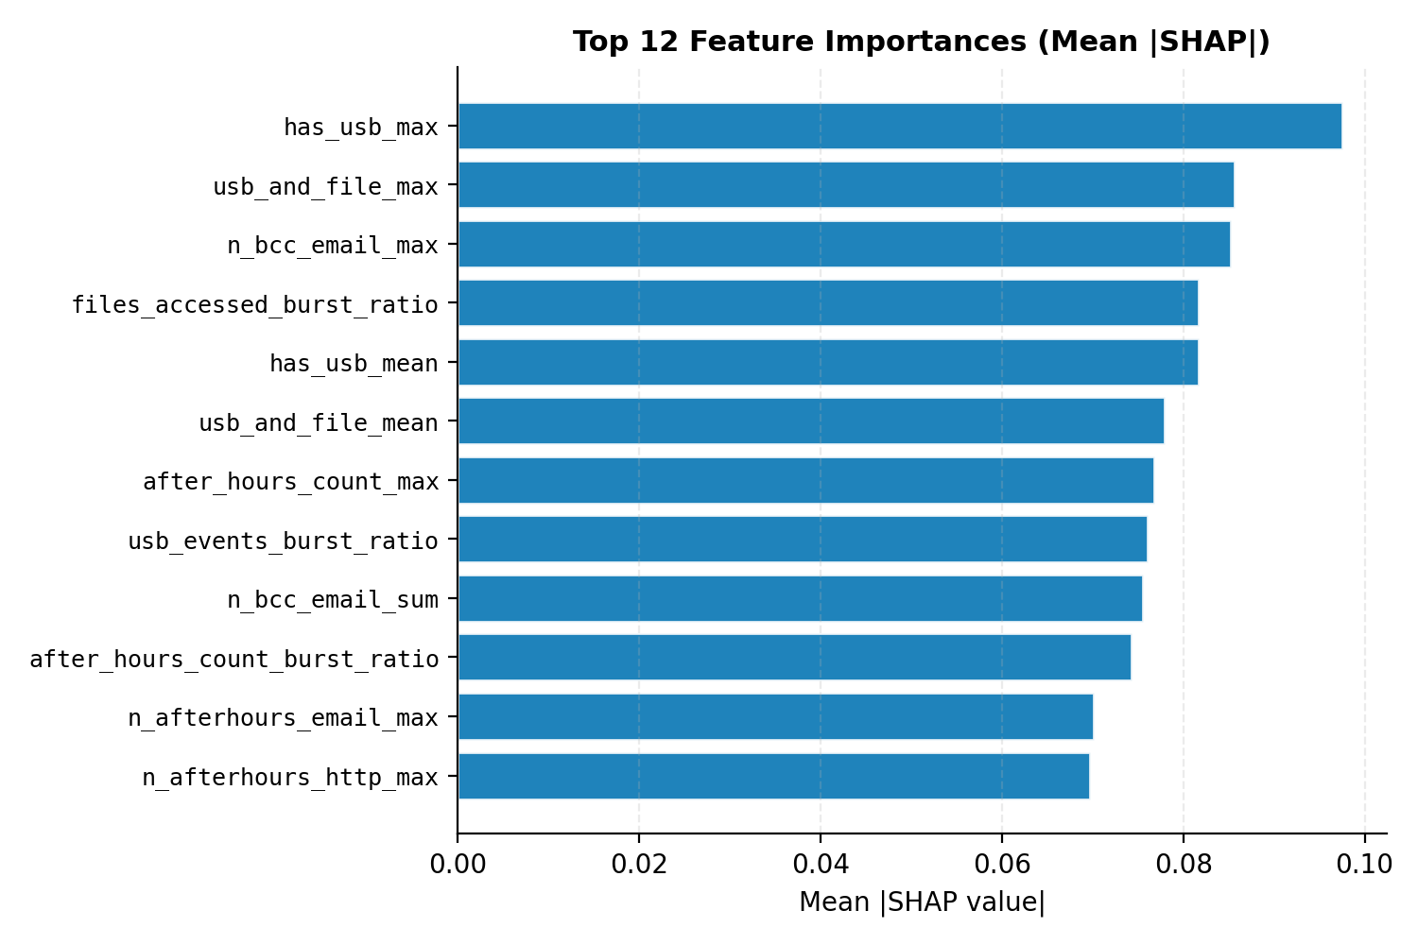
Figure 2. Mean absolute SHAP attribution across the most influential behavioural features — quantifies which behaviours most often drive an anomaly score.

5.9 Alerting + SOC workflow (alert_store.py, investigations.py)
Live events crossing thresholds raise alerts (AE≥0.7 Critical, ≥0.5 High; rarity≥0.6; etc.). Analyst triages in the Alerts queue → Escalate opens an Investigation case → verdict (Confirmed Insider / Cleared) auto-resolves the originating alert (closed loop).

6. Evaluation
- Reproducibility: fixed seed=42; metrics.json written alongside SVG charts.
- Class imbalance handled: AUPRC reported alongside AUROC (70/1000 insiders).
- Charts (scripts/evaluate.py): ROC, PR, confusion matrix (F1-optimal threshold), SHAP importance, calibration (reliability), live-vs-offline.
- Operating point: F1-optimal threshold 0.066 → Precision 0.877, Recall 0.714, F1 0.787.
- Live replay (replay_eval.py): events streamed through the production API; AUROC 0.917 online vs 0.976 offline (Pearson r = 0.356 between live and offline per-user scores), confirming the real-time path preserves most of the detector’s discriminative power.

6.1 Semi-synthetic evaluation on real GitHub data (injected ground-truth attacks)
Why this is needed. Real GitHub activity pulled from the public Events API carries no labels — there is no way to know which real user is malicious — so it cannot, on its own, produce detection metrics (AUROC/precision/recall all require ground truth). To obtain a labelled result on genuinely real data, this work uses the injected-attack (semi-synthetic) methodology: a benign background of real events is augmented with a small number of synthetic accounts whose behaviour follows known attacker patterns and which therefore carry ground-truth labels. This is the same principle by which the CERT r4.2 benchmark itself was built — synthetic malicious activity injected into simulated-normal traffic — and it is a standard technique in insider-threat and intrusion-detection research when labelled real attacks are unavailable.
Experimental setup (scripts/github_semisynthetic_eval.py, fixed seed=42, fully reproducible):
- Benign class (label 0), 248 accounts: 240 real GitHub users captured live from the public Events API, plus 8 synthetic high-volume CI/bot accounts that push continuously to ordinary repositories. The bots are included deliberately so the benign class contains legitimately busy accounts, not only single-event users — otherwise the task would be trivially easy.
- Malicious class (label 1), 15 accounts: 10 overt attackers (off-hours, high-volume bursts of branch deletions and pushes against sensitively-named repositories) and 5 stealthy “low-and-slow” attackers (a handful of sensitive-repository accesses during business hours).
- Scoring: every account — benign and malicious — is scored by the same production source-agnostic rarity detector (backend.rarity_scorer); the per-user risk score is the mean rarity score across that account’s events.
Results.
Metric | Value
AUROC | 0.992
AUPRC | 0.899 (vs 0.057 positive-class baseline)
F1 (at F1-optimal threshold) | 0.811
Precision | 0.682
Recall | 1.000
Confusion (TP / FN / TN / FP) | 15 / 0 / 241 / 7
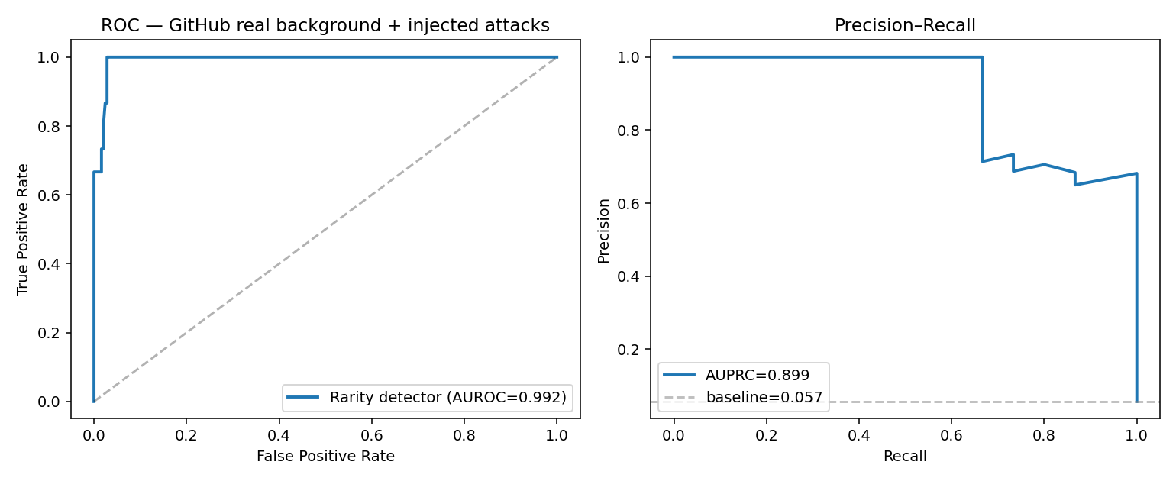
Figure 3a. Semi-synthetic GitHub evaluation — ROC (AUROC 0.992) and Precision–Recall (AUPRC 0.899) for the rarity detector separating injected attacks from a real GitHub background.
Interpretation (and honest reading). The detector recovered all fifteen injected attacks (recall 1.000, including the stealthy ones — accessing sensitively-named repositories is itself a strong, label-independent signal), at the cost of seven false positives. Crucially, all seven false positives are the synthetic high-volume CI/bot accounts: their sustained, around-the-clock activity trips the high-volume and off-hours flags exactly as a real automation account would. This reproduces, on an independent third-party data source, the central limitation seen throughout this project — unsupervised anomaly detection conflates anomaly with malice and flags benign high-activity service accounts. This is a semi-synthetic result: the attacks are designed, not observed, so it measures how reliably the detector separates these specific attacker patterns from real benign traffic — not its accuracy against arbitrary unknown GitHub attacks. It should be read as evidence that (i) the live ingestion + rarity-scoring pipeline operates correctly on real, third-party logs, and (ii) the detector cleanly separates well-defined malicious patterns from a real benign background — not as an independent benchmark on par with CERT r4.2.
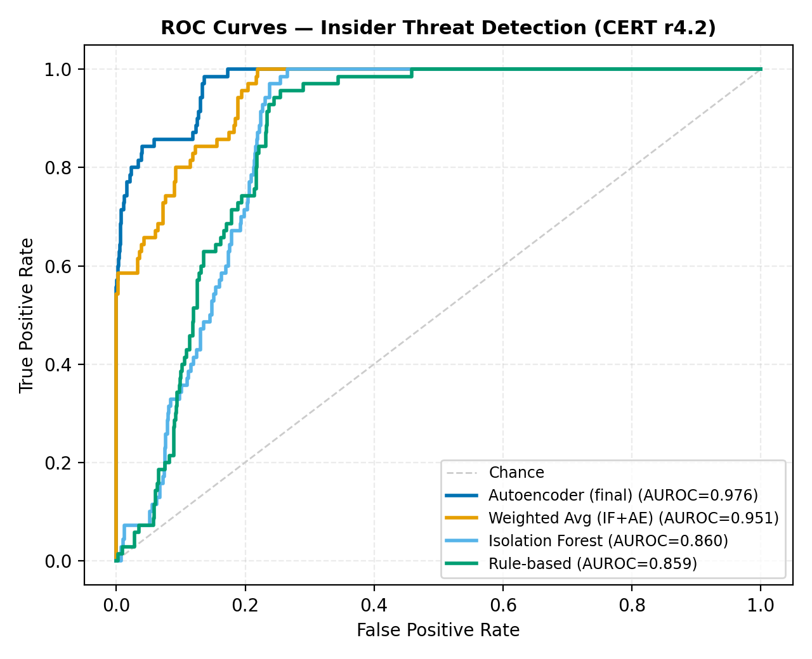
Figure 3. ROC curves on CERT r4.2 — the label-free autoencoder (AUROC 0.976) dominates the Isolation Forest and rule baselines.
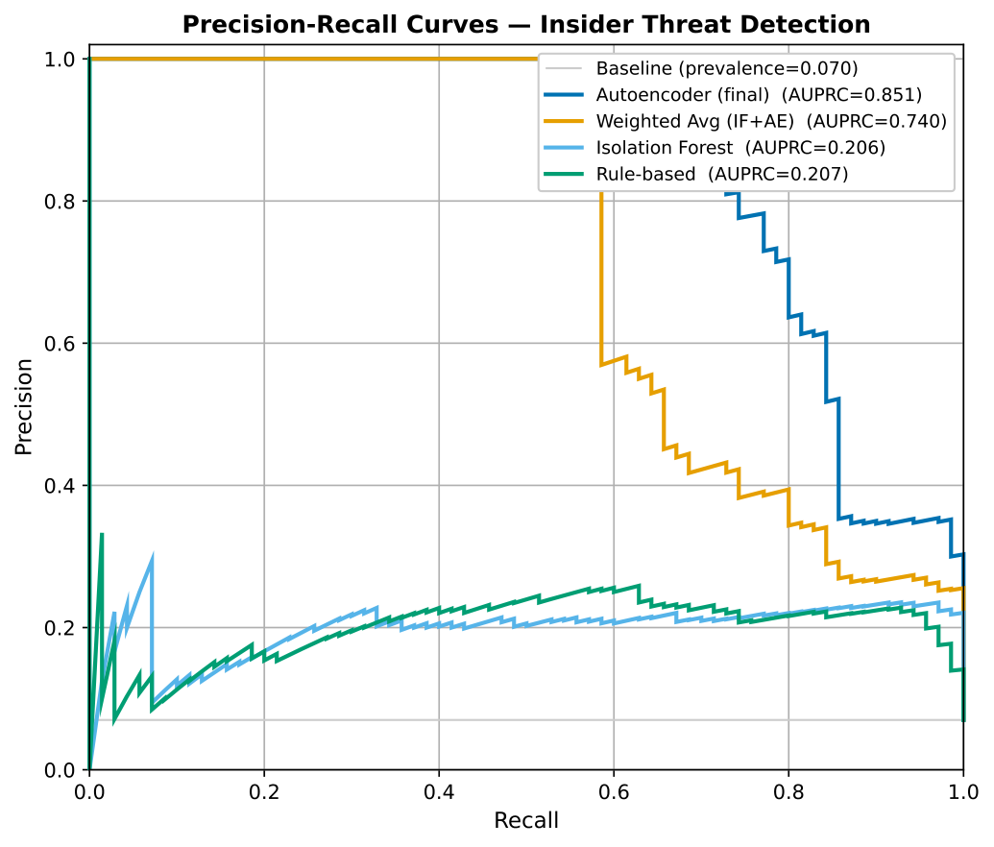
Figure 4. Precision–Recall curves — AUPRC is reported because insiders are a 7% minority; the autoencoder reaches AUPRC 0.851 vs ~0.21 for the baselines.
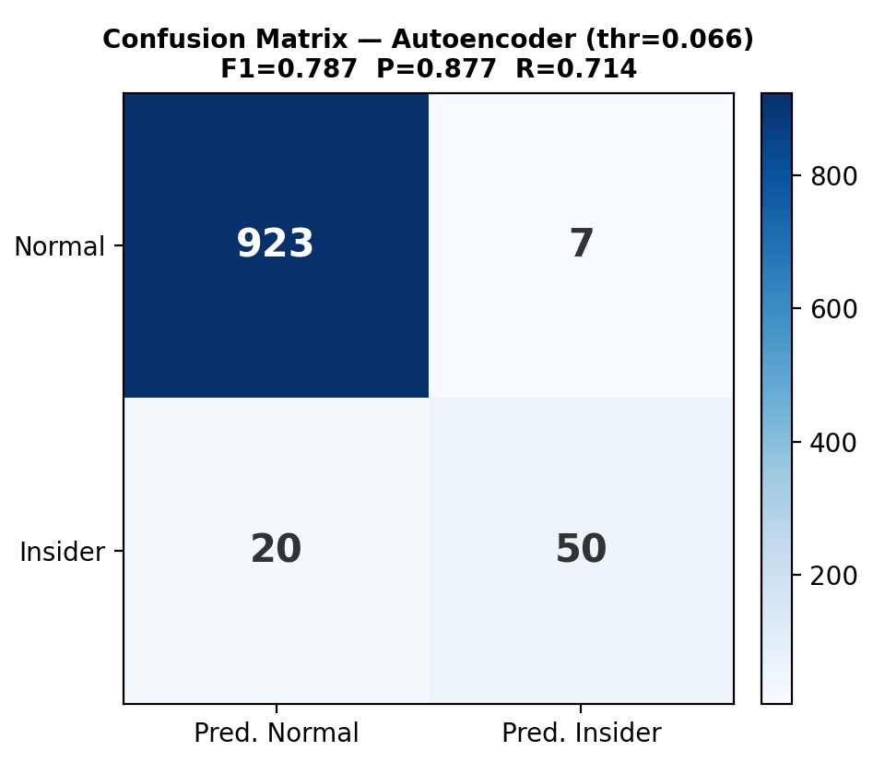
Figure 5. Confusion matrix for the autoencoder at the F1-optimal threshold (0.066): Precision 0.877, Recall 0.714, F1 0.787.
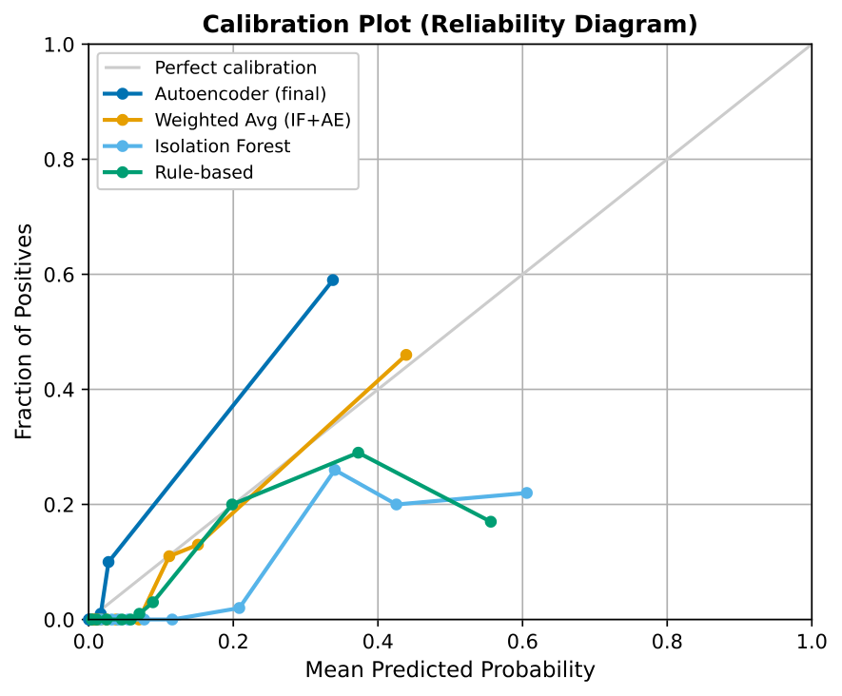
Figure 6. Reliability (calibration) diagram — the normalised reconstruction-error scores are probabilistically meaningful, not arbitrary.
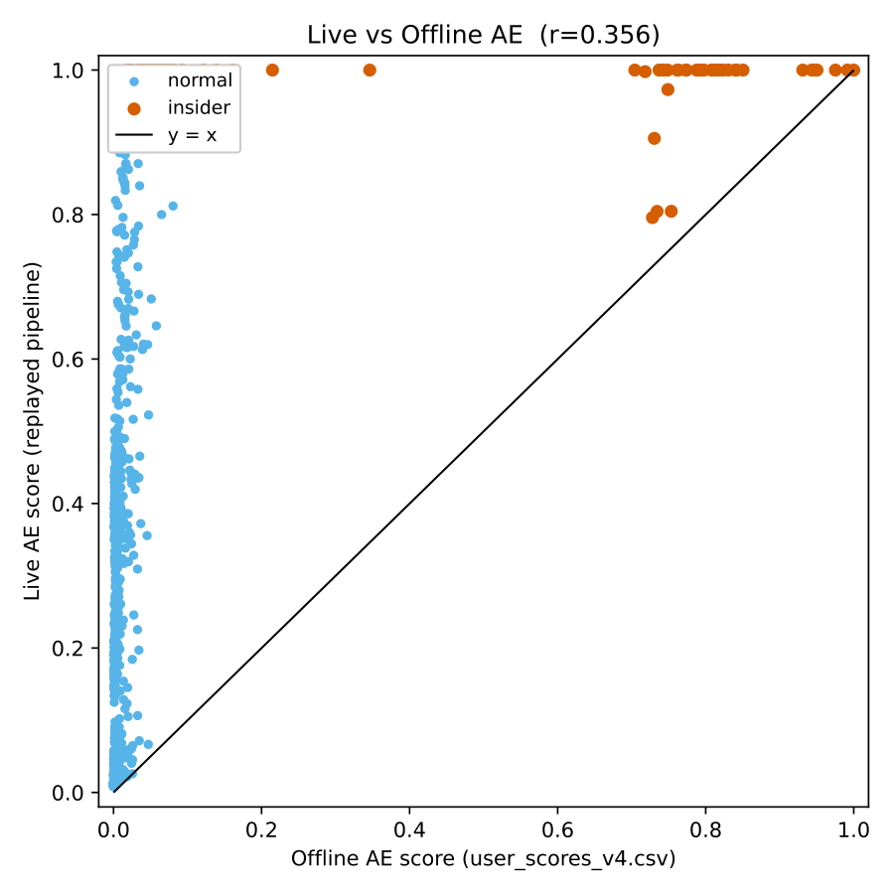
Figure 7. Live-vs-offline per-user scores — the streaming pipeline (AUROC 0.917) preserves most of the offline detector’s accuracy (0.976).

6.2 Threats to validity and honest caveats
A rigorous reading of the evaluation requires the following disclosures. They are stated proactively because pre-empting them is what makes the result defensible.
- One-class, not fully unsupervised. The autoencoder is trained only on user-days assumed benign. On the CERT benchmark the 70 insiders were excluded from training using the ground-truth labels; in deployment the model instead relies on the assumption that benign behaviour dominates (tolerating a small contamination). The precise claim is therefore “no labelled attacks in the training objective,” not “no labels at all.”
- Transductive vs inductive evaluation — verified by cross-validation. The headline AUROC 0.976 is transductive: reconstruction error is scored over the full 1,000-user population, and although the 70 insiders are never seen in training (a clean test for the positive class), the negative class includes the ~80% of normal users used to fit the manifold. To remove this optimism, a 5-fold stratified cross-validation was performed (scripts/kfold_inductive_eval.py): in each fold the one-class autoencoder, the StandardScaler and the behavioural peer-group clustering are fit on the training folds’ normals only, and the held-out fold is scored — so every user is scored by a model that never saw it. The resulting inductive, out-of-fold AUROC is 0.959 ± 0.004 (AUPRC 0.766, F1 0.69) — only ~0.017 below the transductive figure and highly stable across folds. This confirms the headline result is not an artefact of training-set overlap and that the detector generalises to unseen users; the transductive 0.976 and inductive 0.959 are reported together for full transparency.
- Threshold selection. AUROC and AUPRC are threshold-free and are the primary metrics. The reported F1 / precision / recall are taken at the F1-optimal operating point, chosen with reference to the labels — a common but optimistic convention.
- Score normalisation. The [0,1] mapping uses the population min/max reconstruction error. Because AUROC and AUPRC are rank-based, this scaling does not affect them; it affects only the displayed score and the numeric threshold value.
- Live-vs-offline gap (a known train/serve approximation). The offline metrics use the exact training feature pipeline. The real-time path constructs a few of the 71 features approximately — notably the four peer_ratio features, whose behavioural peer groups are recomputed at serving time (loader.py) with a different clustering configuration than training (10 features / K=8 at serving vs 4 features / K=5 in the notebook), and which are unavailable for cloud-only entities. This approximation is the principal reason the streaming live-replay AUROC (0.917) sits below the offline 0.976 and the per-user correlation is modest. The offline figures are the rigorous result; the live figures are an operational lower bound. Aligning the serving-time clustering to the training configuration is a concrete future fix.
- Cloud and GitHub are secondary evidence. The GitHub result is semi-synthetic (injected, designed attacks; §6.1). For the cloud autoencoder (flaws.cloud), two disclosures matter: (a) a 5-fold inductive cross-validation (scripts/cloud_kfold_inductive_eval.py) gives AUROC 0.723 ± 0.039, essentially equal to the reported 0.724 — so that figure is not transductively inflated; but (b) the binding limitation is attacker scarcity — flaws.cloud contains only ~2 distinct attacker entities (Level5, Level6), with Level6 accounting for ~99% of the attacker user-days. The attacker class therefore cannot be robustly cross-validated (hence the higher ±0.039 fold variance), and the cloud result is best read as a 2-entity real AWS case study, not a statistical benchmark. Neither cloud nor GitHub is an independent benchmark on the level of CERT r4.2; they are real-world / real-time corroboration.

7. Deployment
- Backend: Dockerised FastAPI on Hugging Face Spaces (PostgreSQL in prod, SQLite in dev).
- Frontend: Next.js on Vercel, wired to the Space via NEXT_PUBLIC_API_URL.
- Models/data: baked into the Space image via Git-LFS (autoencoder_v4.pt, parquets).
- CORS via ALLOWED_ORIGINS; destructive admin endpoints guarded by ADMIN_TOKEN.

8. Tools & Technologies Used (what each tool did)
This section maps every tool to the concrete task it performed in Argus, to evidence hands-on mastery across the ML, backend, frontend and DevOps stack.

8.1 Machine learning & data science
Tool | Used in Argus for
PyTorch | Defining and training both autoencoders (71-d CERT, 12-d cloud); the encoder/decoder nn.Module, BatchNorm/LeakyReLU/Dropout layers, Adam optimiser, MSE loss, ReduceLROnPlateau scheduler; CPU-only inference in production (ae_scorer.py).
scikit-learn | IsolationForest (baseline), KMeans (K=8 peer clustering), StandardScaler/RobustScaler/MinMaxScaler (feature scaling), train_test_split, StratifiedKFold, and all metrics (roc_auc_score, precision_recall_curve, average_precision_score).
LightGBM | Supervised gradient-boosting reference model (upper bound to show the AE reaches ~90% of supervised accuracy without labels).
SHAP | Per-alert feature attribution for the explainability layer (notebook + dashboard).
pandas | All tabular data wrangling — streaming CERT CSVs in chunks, per-(user,day) aggregation, parquet I/O, feature engineering.
NumPy | Vectorised feature math, reconstruction-error computation, score normalisation.
joblib | Serialising/loading the fitted scalers (scaler_v4.pkl, cloud_scaler_v1.pkl).
Jupyter / Google Colab | cert_ae_full_pipeline.ipynb — trains the CERT autoencoder + baselines, threshold calibration, artefact export (GPU runtime). The smaller cloud AE is trained separately by scripts/train_cloud_ae.py, locally on CPU.
Matplotlib | All evaluation charts (ROC, PR, confusion, calibration, SHAP) and the poster architecture diagram.
SciPy + Pillow (PIL) | scipy.ndimage + PIL for logo background removal in the architecture diagram generation.

8.2 Backend & API
Tool | Used in Argus for
FastAPI | The entire REST API — /ingest pipeline, /users, /stats, alerts, investigations, admin endpoints; automatic OpenAPI docs; dependency-free request validation.
Uvicorn | ASGI server running the FastAPI app (dev and in the Docker container).
Pydantic | Request/response schema models + validators (valid source enums, risk levels, score envelopes).
psycopg2 | PostgreSQL driver for production persistence (HF Space).
sqlite3 (stdlib) | Zero-config local/dev persistence; the same SQL runs on both via a placeholder abstraction.
ijson | Streaming JSON parser for large .gz CloudTrail ingestion without loading whole files into memory.
python-dotenv | Environment-driven config (DEMO_MODE, DATABASE_URL, API keys).

8.3 Explainability & LLM integration
Tool | Used in Argus for
google-genai SDK | Direct calls to Gemini 2.5 Flash for the investigation assistant.
openai SDK | DeepSeek chat (OpenAI-compatible endpoint) as a second LLM provider.
groq SDK | Groq Llama-3.3-70B as a third provider; the three run in parallel and are synthesised into one plan (ai_suggest.py). (No Anthropic/Claude API used.)
concurrent.futures | Parallel fan-out of the three LLM calls to bound latency.

8.4 Data formats & storage
Tool | Used in Argus for
Apache Parquet (pyarrow / fastparquet) | Columnar storage of feature tables (daily_features_v4.parquet, cloud_features.parquet, SHAP values).
PostgreSQL | Production event store, live scores, alerts, investigations, cloud SHAP.
SQLite | Local development store (same schema).

8.5 Frontend
Tool | Used in Argus for
Next.js 14 (React 18) | The analyst SPA — dashboard, user detail, alerts, investigations, demo lab; client-side routing and data fetching.
Recharts | The SHAP feature-importance horizontal bar chart and score visualisations.
Tailwind CSS (PostCSS, Autoprefixer) | All styling — risk badges, cards, responsive layout.
ESLint | Code-quality linting (eslint-config-next).

8.6 DevOps, deployment & tooling
Tool | Used in Argus for
Docker | Containerising the backend (CPU-only PyTorch image) for reproducible deployment.
Hugging Face Spaces | Hosting the backend container + PostgreSQL; model/data baked in via Git-LFS.
Vercel | Hosting the Next.js frontend with CI auto-deploy from GitHub.
Git + Git LFS | Version control; LFS for the large model/parquet binaries pushed to the Space.
GitHub | Source-of-truth repository; triggers Vercel deploys.
huggingface_hub | Programmatic Space interaction (startup model download fallback).
python-pptx + PowerPoint COM | Generating the FYP poster from code.

9. FYP2 Methodology (thesis chapter draft)

3.1 Research Design
This project adopts a Design Science Research (DSR) methodology, which is appropriate when the research objective is to construct and rigorously evaluate a novel artefact that solves a real-world problem. The artefact in this work is Argus, a cloud-native UEBA platform, and the problem is the detection of insider threats in multi-cloud environments where labelled attack data is scarce or non-existent. DSR is well-suited here because the contribution is not a single algorithm in isolation but an integrated system whose value emerges from the interaction of its components — normalisation, unsupervised detection, explainability, and an analyst workflow.
The central research hypothesis is that an unsupervised, reconstruction-based detector, supplied with normalised multi-cloud behavioural features and paired with model-agnostic explainability, can identify insider threats at accuracy approaching that of a supervised classifier, while requiring no labelled attacks at training time. To test this hypothesis the artefact is evaluated along three complementary axes: (i) a controlled quantitative benchmark on the labelled CERT r4.2 dataset; (ii) an external-validity check on real AWS breach data (flaws.cloud); and (iii) an operational check in which events are streamed through the deployed system to measure whether real-time detection preserves offline accuracy. This triangulated evaluation guards against the common weakness of insider-threat research that reports results only on a single synthetic benchmark.

3.2 System Architecture
The platform is implemented as a decoupled seven-layer pipeline (Figure 1): data sources, ingestion/normalisation, feature engineering, detection, explainability, persistence, and an analyst presentation layer. Each layer communicates through a narrow, well-defined interface — most importantly, the eight-field normalised schema that separates the data sources from everything downstream. This separation is a deliberate methodological choice: it makes the detection and presentation layers entirely source-agnostic, so that adding a new cloud provider requires only a new parser and changes nothing else, and it allows each layer to be developed, tested, and reasoned about independently. The architecture mirrors the layered design of commercial UEBA platforms while remaining lightweight enough to deploy on free-tier infrastructure.

3.3 Data Collection and Preprocessing
Two datasets underpin the study. The primary benchmark is the CERT Insider Threat Dataset r4.2, a widely used synthetic enterprise corpus of approximately 32 million events generated by 1,000 users over 17 months, of which 70 users are designated malicious insiders. Because the raw logs span five large CSV files (logon, device, file, email, HTTP) totalling tens of gigabytes, they are processed by a streaming extractor (cert_extract.py) that reads each file in fixed-size chunks, filters to the user cohort, and aggregates per-event signals into a per-(user, day) feature table stored as Apache Parquet. The second dataset, flaws.cloud, contributes roughly two million real AWS CloudTrail events and is parsed by build_cloud_dataset.py into per-(user, day) cloud features. All live sources are converted to the common eight-field schema by normalizer.py.
A strict methodological discipline is maintained throughout preprocessing: ground-truth labels are never used during training. The is_insider (CERT) and is_attacker (flaws.cloud) labels are withheld and reserved exclusively for evaluation, which is what justifies describing the detector as label-free and what makes the reported accuracy a fair test of unsupervised detection.

3.4 Feature Engineering
For the CERT pipeline, 21 base behavioural features are computed per user-day across five activity domains (logon, file, USB/device, email, HTTP), using consistent definitions — for example, an event is “after-hours” if it falls outside 07:00–18:00, and an email is “external” when any recipient’s domain differs from the sender’s. These 21 features are then expanded into a 71-dimensional per-user vector by computing, for each feature, its mean, maximum, and sum across the user’s active days (capturing both typical level and peak behaviour), augmented with three burst ratios (max ÷ mean, capturing spikes relative to a user’s own baseline), a USB-by-file interaction term that encodes the classic removable-media exfiltration signature, and four peer ratios that express a user’s volume relative to the mean of their behavioural cohort. The cloud pipeline uses a parallel set of 12 features (event volume, distinct actions and resources, IAM/STS activity, data-exfiltration and admin operations, etc.).
Behavioural peer groups are formed by K-Means clustering (K = 8) on ten activity-sum features using a RobustScaler to resist the heavy outliers typical of activity counts. Crucially, the clustering is fitted on normal users only and every user is then assigned to their nearest cluster; this prevents an insider’s anomalous behaviour from contaminating the cohort baseline, so that the resulting peer ratios constitute a clean relative-deviation signal that complements the per-user reconstruction error.

3.5 Model Development
The principal detector is a deep undercomplete autoencoder. An autoencoder is chosen over a density- or distance-based method because it scales naturally to the 71-dimensional feature space, learns non-linear correlations among behavioural features, and yields a continuous, per-user-interpretable anomaly score (the reconstruction error) rather than a binary label. The network is symmetric, compressing the 71-dimensional input through hidden layers of 128, 64, 32 and a 16-unit bottleneck before reconstructing it, with batch normalisation, LeakyReLU activations, and dropout for regularisation. By training only on normal user-days, the model learns a compact manifold of legitimate behaviour; user-days that lie off this manifold — the insiders — reconstruct poorly and therefore receive high anomaly scores.
Three unsupervised baselines (Isolation Forest, a rule-based scorer, and a weighted average of the Isolation Forest and autoencoder scores) and one supervised reference (LightGBM, trained with labels using stratified cross-validation) are implemented for comparison. The supervised model is included solely as an upper bound, to quantify how much accuracy is sacrificed by abandoning labels. A separate, training-free rarity scorer computes six interpretable boolean signals (first-time action, new IP, off-hours, high volume, sensitive resource, geo-rarity) directly from the normalised schema, providing a fast, human-readable corroboration of the model score.

3.6 Training Procedure
The autoencoder is trained on the normal-user feature vectors only, split 80/20 into training and validation partitions under a fixed random seed (42) for reproducibility. Inputs are standardised with a StandardScaler fitted on the training partition. Optimisation uses Adam (learning rate 1×10⁻³, weight decay 1×10⁻⁴) against a mean-squared-error reconstruction loss for up to 200 epochs, with a ReduceLROnPlateau scheduler and early stopping on the validation loss to prevent overfitting. After training, the reconstruction error of each user is normalised to the unit interval using the population minimum and maximum, giving the final risk score; the operating threshold for the High/Low decision is selected at the F1-optimal point on the score distribution (≈ 0.066 for the CERT detector). The CERT autoencoder is trained on GPU in a Google Colab notebook; the cloud autoencoder follows the same train-on-normals procedure but is small enough to train locally on CPU via a standalone script, with a calibration that maps the 95th percentile of normal error to 0.5 so that attackers exceed it.

3.7 Explainability
To address the opacity that characterises existing open-source UEBA tools and to satisfy emerging regulatory expectations of explainable security AI, every alert is accompanied by a feature-level explanation. For the CERT detector this is produced with SHAP, attributing the anomaly score to individual behavioural features; for cloud users it is produced by decomposing the reconstruction error per feature (an honest “reconstruction-error attribution” rather than a Shapley computation). On top of this quantitative explanation, an ensemble large-language-model assistant queries three independent providers (Gemini, DeepSeek, and Groq Llama) in parallel and synthesises their outputs into a single, structured natural-language investigation plan grounded in the SHAP features. This converts an opaque numeric score into investigable analyst guidance.

3.8 Evaluation Methodology
Because insiders constitute only 7% of the population, evaluation reports the area under the precision–recall curve (AUPRC) alongside AUROC, since AUROC alone can flatter a detector on imbalanced data, together with the F1 score, precision, and recall at the F1-optimal threshold. The training set contains normal users only; all insiders are held out for testing. Results are visualised with ROC curves, precision–recall curves, a confusion matrix, a SHAP importance plot, and a calibration (reliability) diagram, and every run writes a metrics.json artefact under a fixed seed so that results are fully reproducible. External validity is assessed on the flaws.cloud dataset, and operational validity is assessed with a streaming replay in which CERT events are POSTed through the live API and scored online, allowing the live AUROC to be compared directly against the offline figure.

3.9 Implementation and Operationalisation
The artefact is realised as a production-style deployment: a Dockerised FastAPI backend on Hugging Face Spaces (PostgreSQL in production, SQLite in development), with model and data artefacts baked into the image via Git-LFS, and a Next.js frontend on Vercel. To demonstrate that detector output is actionable, the platform implements a complete Security Operations Centre workflow — risk-ranked dashboard, an alert-triage queue, escalation of an alert into a tracked investigation case with an AI-generated plan, and a verdict that automatically resolves the originating alert. This operationalisation is presented as evidence of engineering completeness and practical applicability rather than as a distinct research contribution; the research contribution remains the label-free, explainable detection pipeline.

10. Academic Contributions (defensible claims)
- One-class insider detection without labelled attacks reaching AUROC 0.976 / AUPRC 0.851 — ~90% of a supervised LightGBM upper bound. The autoencoder is trained only on benign-assumed data (no attack labels in the objective); the precise label assumption and evaluation caveats are disclosed in §6.2.
- A source-agnostic normalisation layer unifying four structurally distinct cloud/enterprise log formats (AWS, Azure, Cloudflare, GitHub) into one 8-field schema, extensible by one parser per source (AWS and Azure unit-tested; all four demonstrated live). This is a normalisation contribution; unsupervised detection is evaluated on real AWS data (flaws.cloud) + CERT — see the scope note in §2.3.
- Per-alert explainability combining SHAP attribution with an LLM analyst assistant — absent from open-source UEBA tools (Wazuh, OpenUBA, HELK).
- Real-world + real-time validation beyond a synthetic benchmark: flaws.cloud AWS (AUROC 0.724), a streaming live-replay (AUROC 0.917), and a semi-synthetic GitHub evaluation on a real, live event stream with injected ground-truth attacks (AUROC 0.992, recall 1.000) — the latter independently reproducing the service-account false-positive failure mode (§6.1).

11. Limitations & Future Work (state these proactively)
- CERT is synthetic; flaws.cloud is real but small and same-dataset-evaluated for the cloud AE.
- Unsupervised detection conflates anomaly with malice: high-volume service accounts become false positives, and low-and-slow attacks (e.g. flaws.cloud Level5) are missed — the reason explainability + human-in-the-loop review matter.
- No model-drift detection yet (future: KL-divergence drift + periodic retraining).
- Peer groups are behavioural only; combining with role/HR attributes is future work.
- Train/serve consistency: the serving-time peer-group clustering (loader.py, 10 features / K=8) does not exactly reproduce the training-time configuration (4 features / K=5), so the four peer_ratio features are approximated in the live path (§6.2). Aligning them is a concrete fix that should narrow the live-vs-offline gap.
- Baseline-poisoning by a patient insider is partially mitigated by peer comparison; adversarial robustness is unevaluated.

Every metric, formula, hyperparameter and file description above is sourced from the implemented codebase (backend/, ml/, scripts/, cert_ae_full_pipeline.ipynb) and results/metrics.json.

