# Create the 3D model

We make advantage of Autodesk 123D catch (online free App) for creating the 3D model for different object. The following website provide some video tutorials and important tips for making the 3D model: <http://www.123dapp.com/howto/catch>

Usually, the process includes taking photos and uploading to 123D catch.

# Edit the 3D model

1. After 123D catch return the result on the website, you need to edit the 3D mesh in the online app to remove unnecessary artifacts and objects.
2. Also, use the hole filling function to fill the holes in the model.
3. After downloading the model with texture, you need to use MAYA or other mesh editing software to move the model to the center.

# Render the model

With the above steps done, now we can use the rendering code to render the model from different perspective. I also uploaded my rendering code to Github <https://github.com/ZheC/rendering> . The code uses OpenGL and Assimp library to render “.obj” model with texture.

## Assimp dependency

You can download assimp library from the following link: <http://sourceforge.net/projects/assimp/files/assimp-3.0/>

I use the version assimp--3.0.1270-full.zip

cd to the directory

mkdir build

cd build

cmake ..

If you get the error below, ignore it. Minizip is optional ([ref](https://sourceforge.net/p/assimp/discussion/817653/thread/96b393d2/)).

-- checking for module 'minizip'

-- package 'minizip' not found

make

sudo make install

Assimp is the Open Asset Import Library. It imports various file formats, holds them in memory and can then export them in other formats. Here is a list of supported [import](http://assimp.sourceforge.net/main_features_formats.html) (PLY and OBJ are two of such formats; here is some [code](http://www.lighthouse3d.com/cg-topics/code-samples/importing-3d-models-with-assimp/) to import files, search for Import3DFromFile) and [export](http://assimp.sourceforge.net/main_features_export.html) (OBJ is one format) formats.

To use assimp library properly, make sure your computer have installed these library. **SDL2**, **glew** and **SDL_image 2.0**

## **2. SDL2 dependency**

Get version [2.0.3](https://www.dropbox.com/sh/tsqp5sxxnb676re/AADOz66kILlPQ9mA83IgqPY2a/SDL2-2.0.3.tar.gz?dl=0).

Unzip / tar xvf

Then “sudo ./configure; sudo make; sudo make install” as derived from the INSTALL.txt file

Libraries end up in /usr/local/lib-lGLEW -lassimp `pkg-config --cflags --libs opencv

**3. glew dependency**

Download from [here](http://glew.sourceforge.net/index.html)

cd to the directory

make

make install # “sudo make install” if needed

**4. For the program**

nvcc model.cu -o render -lIL -lGL -lglut -lGLEW -lassimp `pkg-config --cflags --libs opencv`

(you can also use do “make”)

then ./render

If you get an error about libGLEW cannot be found, update the LD_LIBRARY_PATH (export LD_LIBRARY_PATH=/usr/lib64:$LD_LIBRARY_PATH) and then recompile.

This process may take one day for the first time. Once you familiar the procedure, the time will be shorter.

**5. Coordinate Systems**

Rx 90 degrees (template 0 and 1)

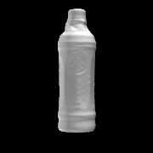 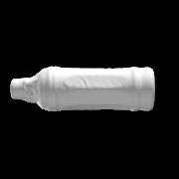

Ry 90 degrees (template 0 and 1)

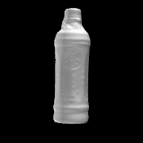 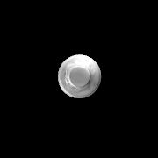

Rz 90 degrees (template 0 and 1)

 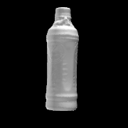

./render ./input/textured.obj ./output/scissorsa 10 10 10 1 1 36 0 0 0