**Question 2**

i) Construct a fault tree for the event *Disease response centre unable to provide refrigerated vaccine storage* down to the level of detail provided in the description of the system and diagram above.

Construct a fault tree for **top event** *Refrigerated Storage Fail*, down to the level of components identified in Figure and in the description above. Once the refrigerated storage fail, represent to the *main refrigerated storage fail* *and refrigerated shipping container fail*.



Figure :

Main refrigerated store fail can be developed into four cases; *Power Supply Fail*, *Compressor Fail*, *Heater Exchange Fail* and *Thermostat Fail*. As main refrigerated store fail, one of these cases fail would effect on the refrigerated store, and cause failure. These four cases all implies some sort of failure. As the result, these event needs to development.



Figure :

Using *Power Supply Fail* event as the **example** to demonstrate the analysis process. According to question, the main refrigerated store system has two power system, which could be switch on or off based on the main power supply situation. As the result, the power supply fail event could develop to two case, *Main Electrical Supply Fail* and *Backup Electrical Supply Fail*.



Figure :

The main electrical supply fail can be caused by two events, *No Power by Power Company* and *Supply Wire Broken*.



Figure :

The No Power by Power Company is the initiating fault and there is no need to be further analysis in this fault tree analysis. The Supply Wire Broken, is the undeveloped event, which not developed further because it is considered unnecessary. The wire broken may cause by several situation, like burnout, cut, wrong connection. In this fault tree analysis, these kinds of tiny detail situation would be undeveloped, and assign the event to undeveloped event.

Continue to analysis the fault tree like above approach, and the following four figures are the complete fault tree for Refrigerated Storage Store Fail.

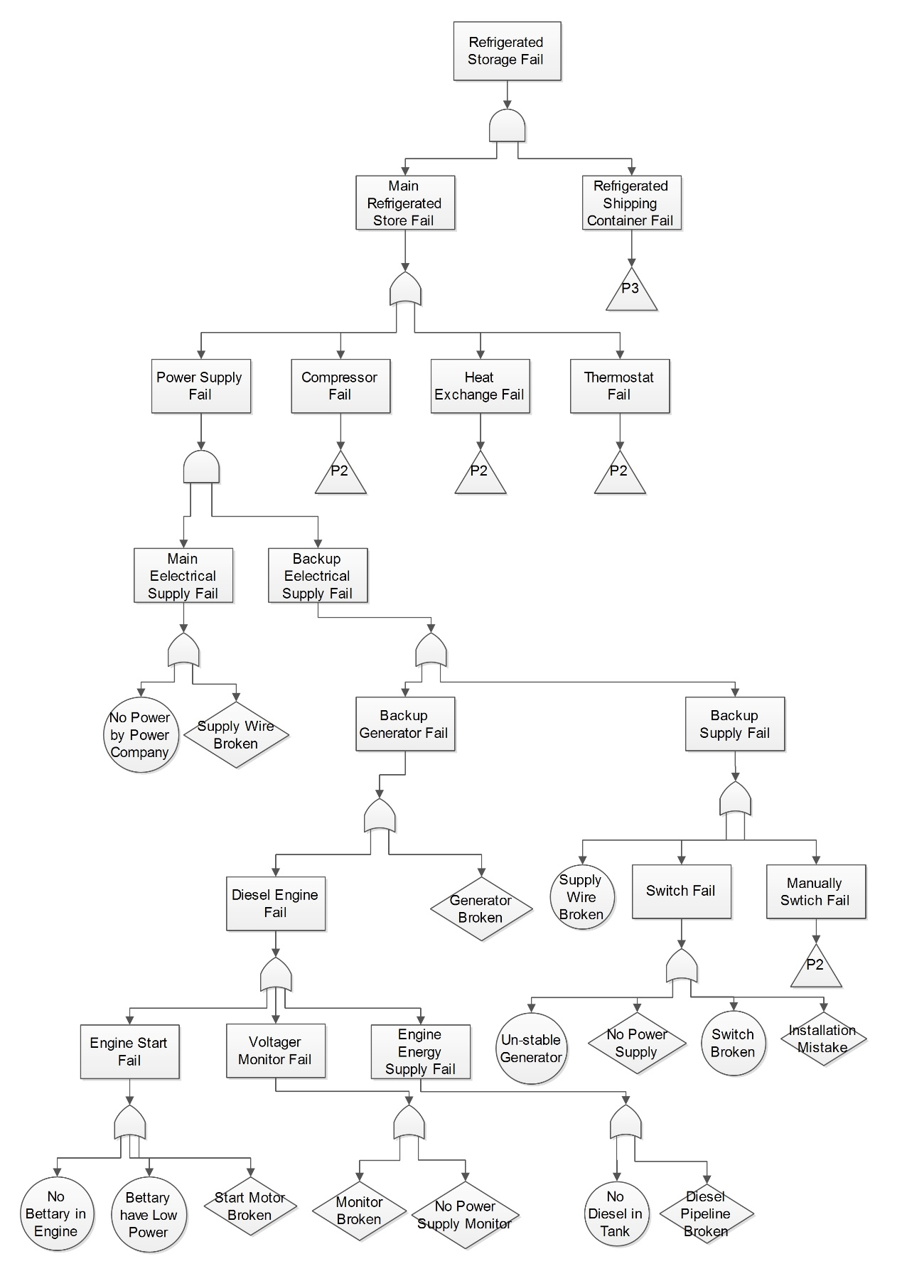

Figure : Fault Tree of Refrigerated Storage Store Fail - P1

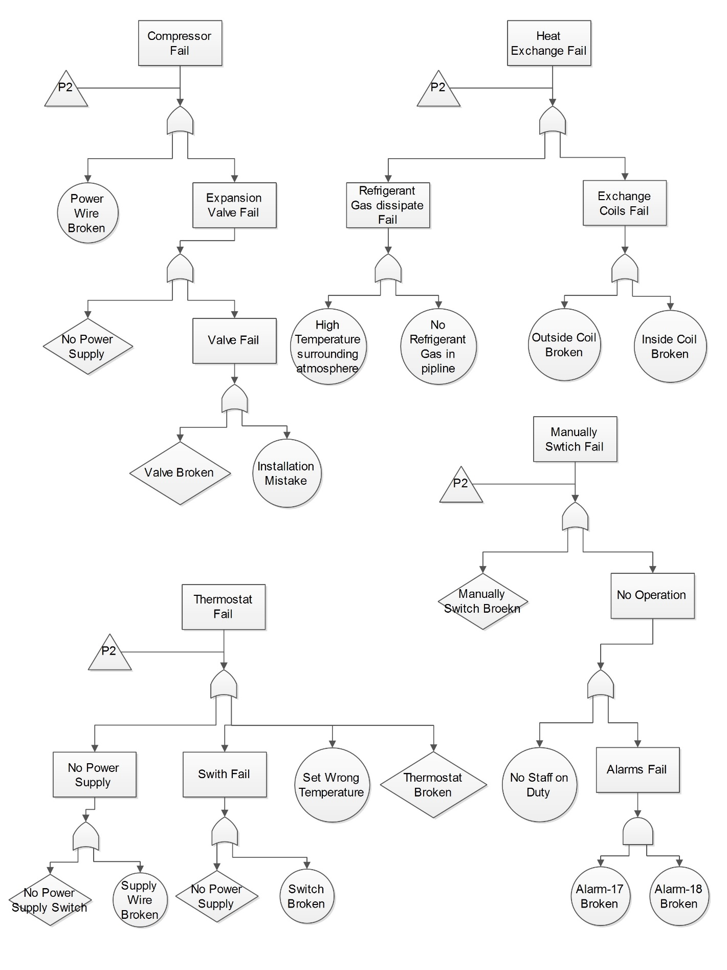

Figure : Fault Tree of Refrigerated Storage Store Fail - P2

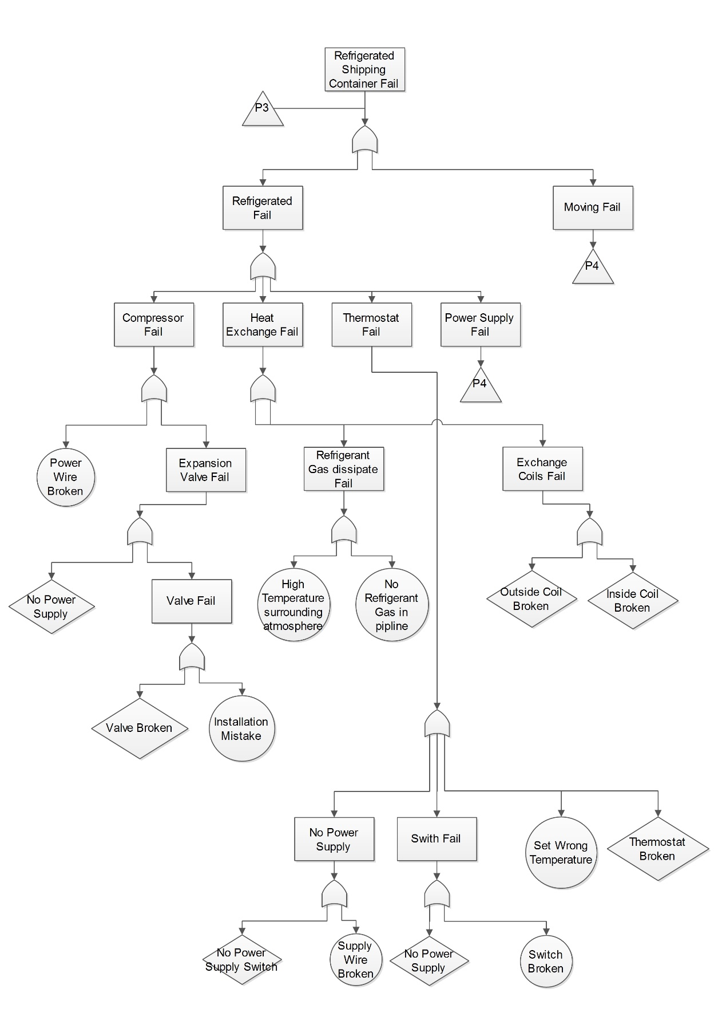

Figure: Fault Tree of Refrigerated Storage Store Fail - P3

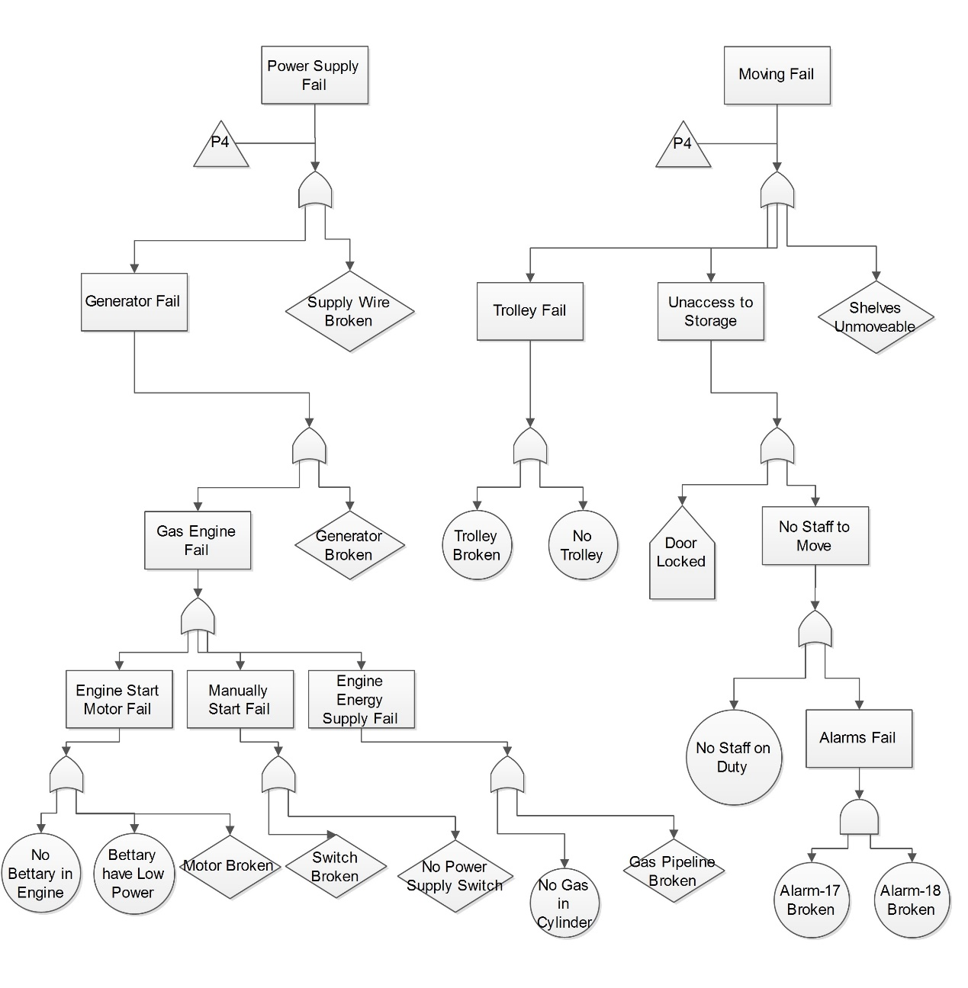

Figure: Fault Tree of Refrigerated Storage Store Fail - P4

ii) Identify which events in your tree represent potential dormant failures

**Solution**: A fault tree is a model that logically and graphically represents the various combinations of possible events, both fault and normal, occurring in a system that lead to an undesired event or state. As the result, **the potential dormant failures** in the fault tree analysis is the event which occurrence of these **indirect system effect**, for example, the **redundant system** / **item automatic takes** / **backup item** / **emergency state** over or when the failure only is **problematic during specific mission** or system **states**. As the result, in this fault tree, these actions should be analysis as potential dormant failures.

Event - 1: **Door Locked** in page 4, which come from *procedures prohibit staff from opening the door unless the refrigeration system in working*. According to this statement, it is easy to understand if refrigeration system fail, the door access to storage would be locked. As the result, when there is a failure happened on the main refrigeration system, the door would be locked and **stop** staff to **access**. In the other words, this action event would be one potential format failure.

Event - 2: **Un-stable Generator** in page 1, which come from the *once the generator has stabilized,* *switch will switch over automatically so that the backup supply powers the refrigeration system*. According to this statement, it is easy to find that the backup supply system would be switch on to supply refrigeration system. However, for the situation which the generator would not stable, the backup supply power system would not perform.

Event – 3: **Installation Mistake** in page 1, which come from the *switch will switch over automatically so that the backup supply powers the refrigeration system*. For this automation switch, once it has been installation in the wrong direction, the main supply and backup supply system would be connect together, and raise failure.

Event – 4: **High Temperature Surrounding Atmosphere** in page 2, which come from *…and dissipate heat to the surrounding atmosphere*. According to the general physical knowledge, the process of heat dissipate to surrounding atmosphere require the atmosphere temperature lower than the exchange coil outside of the store. However, for the situation which outside temperature is high enough, and it would effect on the heat dissipate process of outside coil. As the result, this is a potential failure of system because it would effect on refrigeration system and without respond approach.

Event – 5: Battery Has Low Power in page 1, which come from *starting the diesel engine requires that the battery is well charged*. According to the question description, the backup power supply system keep closed situation when the main power supply is stable. As the result, these failure was dormant in the normal operation process, and would trigger failure when backup system started.