1.

I modify the following function to construct a spanning tree. Please refer to the code in bft_w_obj_nodes.py.

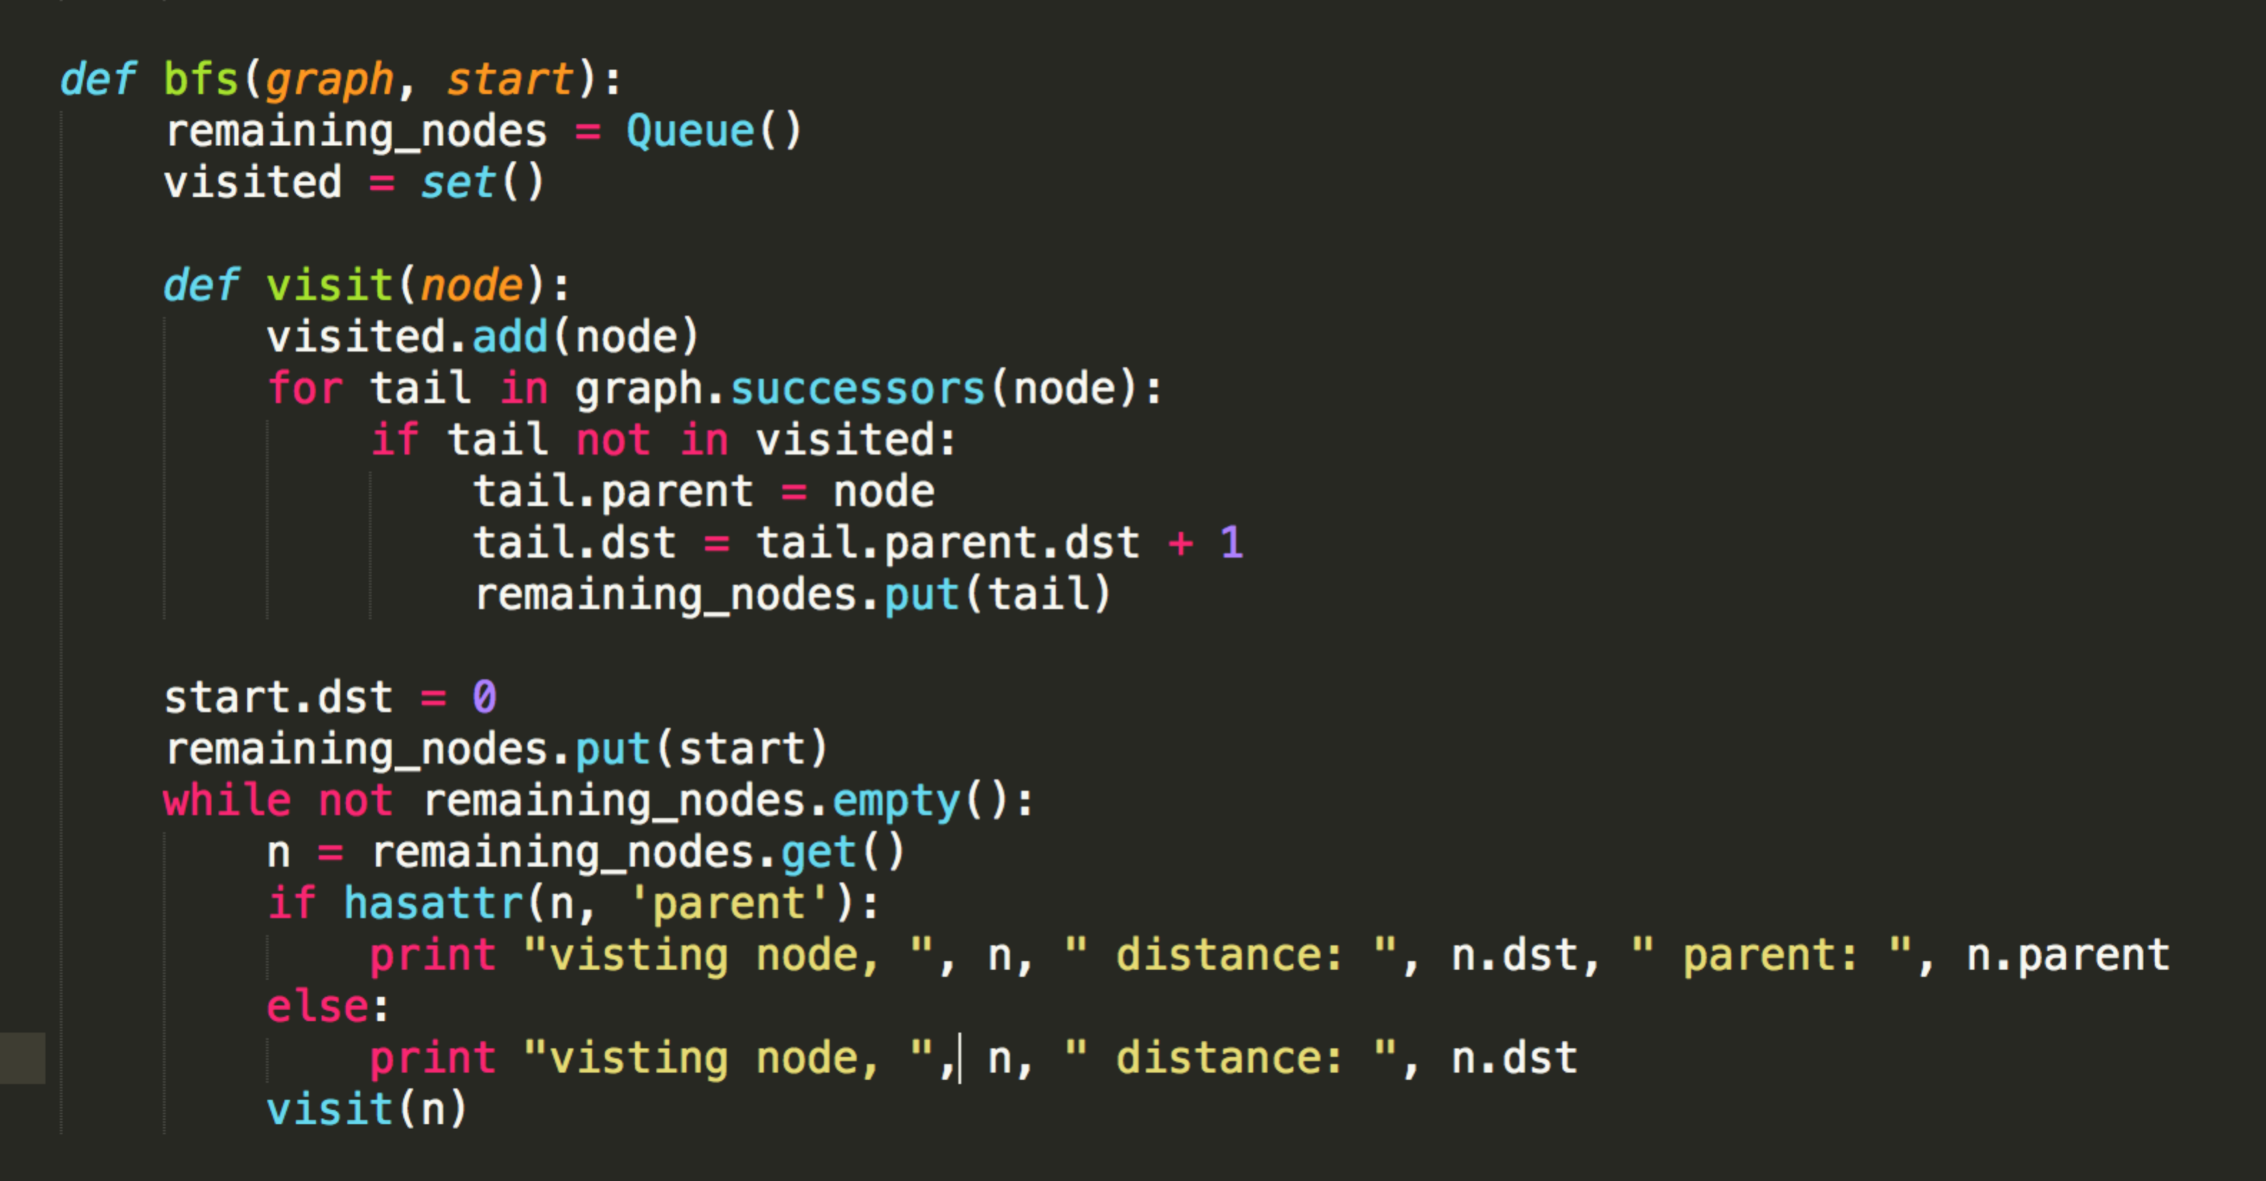

2. I modify the following code to allow every node record the distance (number of edges) from the start node to each node that a path can reach. Please refer to the code in bft_w_obj_nodes.py.



|  |  |  |  |  |  |  |  |  |
| --- | --- | --- | --- | --- | --- | --- | --- | --- |
| Step | a | b | c | d | e | f | g | Add |
| 1 |  |  |  |  |  |  |  | a |
| 2 | 0 | 10 | 5 |  |  |  |  | c |
| 3 | 0 | 10 | 5 |  |  |  |  | b |
| 4 | 0 | 10 | 5 | 13 | 15 |  |  | d |
| 5 | 0 | 10 | 5 | 13 | 15 |  | 21 | e |
| 6 | 0 | 10 | 5 | 13 | 15 | 17 | 21 | f |
| 7 | 0 | 10 | 5 | 13 | 15 | 17 | 21 | g |
| Final Step | 0 | 10 | 5 | 13 | 15 | 17 | 21 |  |

3.